Interaction of CO with Poly-crystalline Gold

AUTHOR NAMES (alphabetical order) Karen Chan, Ib Chorkendorff, Johan Ehlers, Henrik H. Kristoffersen, Jens K. Nørskov, Brian Seger, Thomas V. Hogg, Sudarshan Vijay

AUTHOR ADDRESS **Department of Physics, Technical University of Denmark, 2800 Kgs. Lyngby, Denmark**

AUTHOR INFORMATION

Corresponding Author

ABSTRACT   
  
**TOC GRAPHICS**

**KEYWORDS**

Gold is often considered a noble metal, incapable of binding small organic molecules strongly. At the same time, it is known to be a versatile material that is capable of catalyzing several reactions. In the gas phase, gold nanoparticles catalyze CO-oxidation1. In an electrochemical environment, gold is capable of carrying out CO electro-oxidation at anodic potentials2 and CO2 reduction (CO2R) to CO at cathodic potentials3. It’s 100 facet has also shown to be active for the oxygen reduction reaction in alkaline media4. Furthermore, reactions such as oxidation of alcohols have been studied5. This dichotomous relationship between the binding strength of Gold and its catalytic ability points to a need for a fundamental analysis of theoretical and experimental methods used to calculate its properties.

In the context of energy storage, a particularly interesting reaction that Gold catalyzes well is CO2R. Despite being one of the only transition metals that produces almost exclusively CO from CO2, little is known about its facet dependence. While it is clear that CO binds weakly to Gold6, it is unclear how weakly it binds at different conditions. It is also unclear what the equilibrium coverage of CO on a gold step or terrace is, either in atmospheric conditions or in an electrochemical environment.

To understand structure sensitivity of gold facets, Lead UPD was performed in an earlier study. < Something else about UPD? >

Adsorption energies, limiting potential analyses and reaction kinetics have been carried out for several reactions involving CO on Au. However, most of these ab-initio calculations have focused on prediction of activity using charge-neutral calculations, without explicitly including the effect of solvent. This approximation excludes critical effects such as the effect of the interfacial electric field and competitive adsorption of water, which might significantly alter the nature of their predictions.

This work presents a joint experimental and theoretical investigation on the binding characteristics of CO on Au. We first benchmark DFT adsorption energies to available experimental TPD data. Simulating TPD spectra shows that up to 0.5ML of CO may be present on an Au(211) step. By carrying out lead under-potential deposition, active CO adsorption sites are blocked. This experiment is rationalized by surface Pourbaix diagrams which show that lead covers 211 and 100 facets, while the 111 facet is covered only at more reducing conditions. Ab-initio molecular dynamics calculations show the impact of competitive water adsorption on the 211-step sites is more prominent than compared to 100-terrace sites. This investigation uses state of the art methods to provide a fundamental understanding of the interface at CO2R condition on different gold facets, while showing that predictive reaction energetics is still a challenge.

**CO adsorption under atmospheric conditions**

In order to determine if CO adsorbs under CO2R conditions, we first investigate what the coverage of CO would be under atmospheric conditions. Previously published TPD data7 allows us to determine the adsorption energies as a function of the temperature and coverage. This is done by assuming CO desorption is a first order kinetic process, given by the following rate equation

where, and

To determine the binding energy as a function of the coverage, we make the following assumptions. 1) CO desorbs into vacuum in the TPD experiment, i.e. there is no re-adsorption of CO, once it has been removed from the gold surface. 2) The entropic contribution associated with the transition state of CO desorption is the same as the adsorbed CO molecule. This assumption is equivalent to saying that a late transition state is observed, which has been shown in the SI. This allows us to write as:

Figure 1a shows the variation of with . The binding energy is larger at lower coverages due to minimal adsorbate-adsorbate interactions. However, as the coverage starts to increase, the binding energy decreases exponentially. 

Figure : a) Adsorption energy as a function of the coverage under vacuum conditions b) Coverage obtained under conditions of 1bar CO as a function of the temperature c) Free energies for CO adsorption calculated at different coverages

Since we are interested in the coverage of CO at atmospheric conditions (1bar CO, 300K), we translate the obtained into the free energy of adsorption using frequencies obtained from DFT calculations of CO adsorbed on the corresponding Gold facet (Further details in the SI).

The coverage at atmospheric conditions can be calculated by assuming an equilibrium between adsorbed CO and CO in the gas phase. The relative coverage obtained from the TPD experiment is shown in Figure 1b. At 300K, Au(211) is shown to have a certain coverage, while Au(111) has zero coverage. The absolute value of the coverage cannot be determined directly from a TPD experiment, unless a saturation coverage is known.

DFT calculations of different monolayer coverages can be used to determine a rough estimate of the absolute experimental coverage at given temperature. All possible surface sites were sampled to determine the minimum adsorption energy at a given surface coverage (Details in the SI). Figure 1c shows that the energy as a function of the coverage stays roughly constant up to 0.5ML and increasing to lower binding energies at higher coverages. Thus, up to 0.5ML of CO may be adsorbed on an Au(211) step under atmospheric conditions, while there is no coverage of CO on Au(111).

**CO adsorption in an electrochemical environment**

In the case of polycrystalline surfaces, a convolution of deposition on various sites is observed. During Pb deposition, a broad wave corresponding to deposition on stepped surfaces and defects is initially observed.

< Further explanation of experiment and CO coverages at reducing potentials >

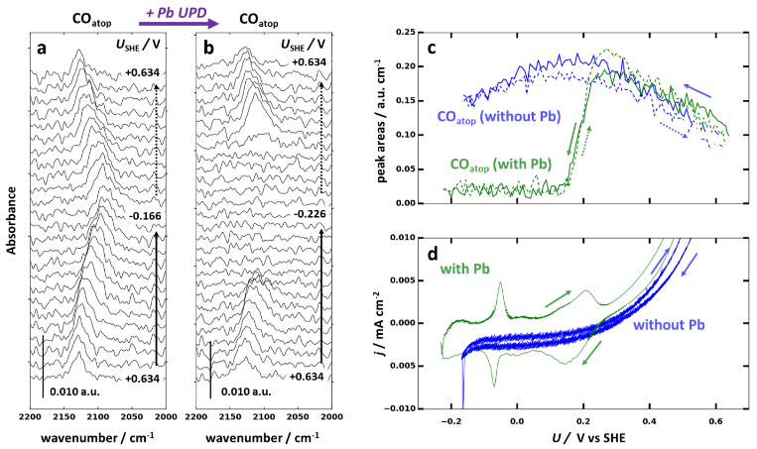

Figure 2: Lead UPD < insert more description here >

To determine the surface facet that binds Pb strongest, we carry out a surface Pourbaix analysis. We choose three prototype gold surfaces – 111 and 100 terraces and a 211 step site. Pb adsorption energies were calculated on all possible adsorption sites to determine the most favorable state. The adsorbed Pb can be referenced to the corresponding ion using the standard reduction potential of Thus, the overall reaction for the adsorption of lead is

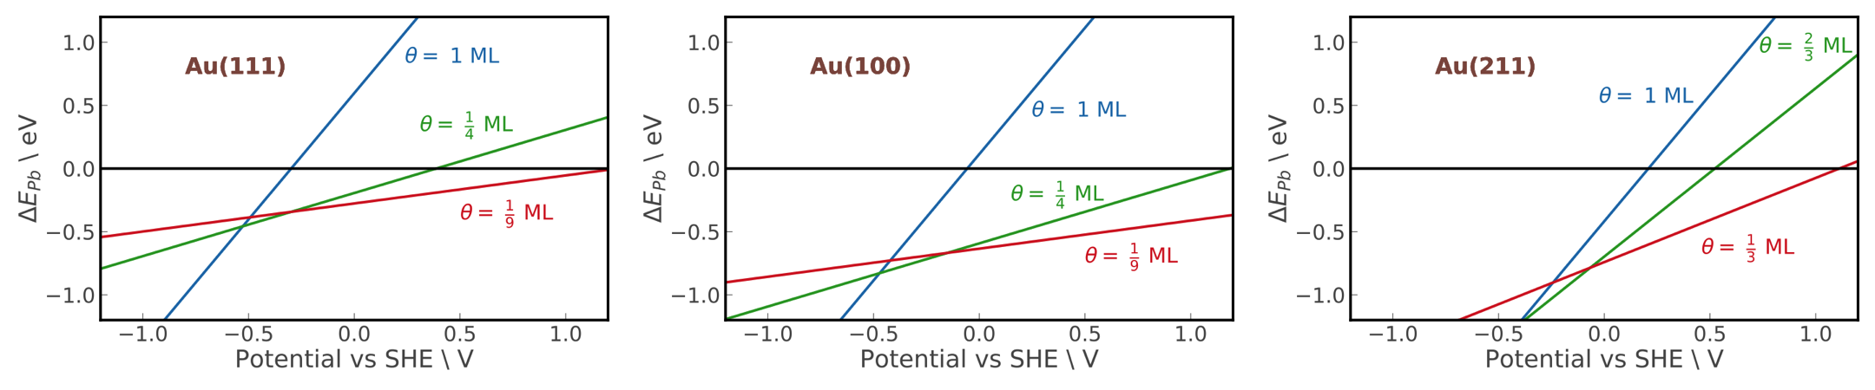

Figure : Surface Pourbaix diagram showing the coverage of Pb at different potentials

The free energy for this reaction can be determined as a function of potential at a given surface coverage as

Where is the free energy referenced to , is the potential referenced to the standard hydrogen electrode and is the standard redox potential of is the normalization factor to ensure that two electrons are transferred for every Pb atom.

Figure 3 shows the surface Pourbaix diagram for different coverages of Pb adsorbed on the three different surface facets of Au. Au(111) has the lowest coverage of Pb at any potential range, followed by Au(100) and Au(211) respectively. This facet dependency implies that the surface would be covered by Pb at more positive potentials for a step site like 211, as opposed to a terrace site of 111. This result agrees with previous studies of current voltammograms for Pb UPD on different single crystal surface facets8.

Figure 3 also agrees well with the experimental finding of Figure 2 showing that the CO signal drops to zero as more negative potentials are scanned as Pb replaces adsorbed CO.

**Electrochemical Reaction Energetics**

At potentials where CO is adsorbed on the surface, there are two possible effects that could alter its adsorption energy as compared to that in atmospheric conditions. Firstly, there is the interfacial electric field produced by the double layer, which may stabilize or destabilize an adsorbate depending on the surface dipole moment. By applying a series of electric fields to a DFT unit cell, the effect of the Helmholtz layer can be mimicked. The energies vary by the following relationship.

Where is the free energy of adsorption at zero applied field, refers to the surface dipole moment, is the polarizability and is the applied electric field. Equation 5 can be converted to a relationship between adsorption energy and surface charge by using Gauss’ law.

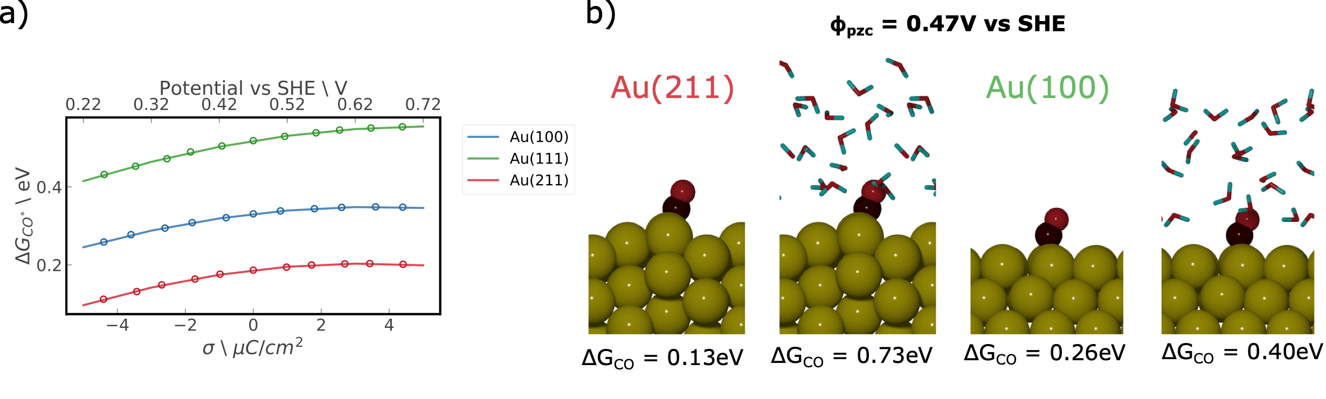

Figure a) Dependence of free energy of adsorption of CO on surface charge and potential – points are from DFT calculations, lines are best fit curves b) Increase in energies of CO adsorption due to competitive water adsorption

Figure 4a shows the dependence of the free energy of CO with the associated surface charge and potential. There is as little as 0.1eV change in the adsorption energy over a potential range of 0.5eV. This is indicative of the fact that the surface dipole moment of CO is not very large. Thus, the interfacial electric field does not play a large role in determining energetics for CO adsorption for any of the three surface facets considered.

The second effect is caused by the presence of solvent near the electrode surface. In this work, we investigate the effect caused by water near two surface facets – 100 and 211. A polar solvent such as water can change the adsorption energy in two ways – 1) creating a large interfacial dipole moment due to its net orientation and 2) weakening CO binding by competitive adsorption. Both effects can be probed simultaneously using AIMD simulations (Details in the SI).

Figure 4b compares the change in adsorption energies of vacuum DFT and AIMD predictions. AIMD simulations are run without any added excess charge. The potential of zero charge (pzc) as predicted by AIMD simulations (0.47V) are close to that seen in experiment for a range of electrolytes9.

There is an under-prediction of binding energy for both surface facets. CO adsorption on Au(211) is increased by 0.6eV, while that of Au(100) is increased by 0.14eV. This extreme increase in adsorption energy in the case of Au(211) as compared to Au(100) is due to that fact that water binds stronger on a step as compared to a terrace. Thus, at certain potentials, water at the interface might cause an increase in the adsorption energy.

**Conclusions**

CO adsorption on Au is a particularly important reaction for several electrochemical processes and more broadly, for heterogeneous catalysis. However, there is still controversy regarding the adsorption energy as well as the surface coverage. In this letter, we use a joint experimental and theoretical approach to elucidate binding characteristics of CO on Au using several state-of-the-art methods. Adsorption energies of CO in atmospheric conditions are determined by simulating TPD rates. It is found that up to 0.5ML of CO may be present on a 211 step site, but there is likely no coverage on a terrace site. Lead UPD is used to block active CO adsorption sites in order to study the CO adsorption on the 111 terrace site as a function of the potential. Surface facets most favorable for Pb adsorption are determined using surface Pourbaix diagrams. Finally, we investigate the role of the electrochemical interface by performing calculations are different field strengths and AIMD simulations. The effect of the interfacial field appears to be small while that of competitive water adsorption appears to be 0.6eV for a 211 step, but less than 0.2eV for a 100 terrace. This investigation shows that there are several possibilities for dominant effects at the electrochemical interface and that predictive reaction energies are still an open challenge.

1. Lopez, N. *et al.* On the origin of the catalytic activity of gold nanoparticles for low-temperature CO oxidation. *J. Catal.* **223**, 232–235 (2004).

2. Rodriguez, P. & Koper, M. T. M. Electrocatalysis on gold. *Physical Chemistry Chemical Physics* **16**, 13583–13594 (2014).

3. Chen, Y., Li, C. W. & Kanan, M. W. Aqueous CO2 reduction at very low overpotential on oxide-derived au nanoparticles. *J. Am. Chem. Soc.* **134**, 19969–19972 (2012).

4. Markovic, N. M., Tidswell, I. M. & Ross, P. N. *Letters Oxygen and Hydrogen Peroxide Reduction on the Au(100) Surface in Alkaline Electrolyte: The Roles of Surface Structure and Hydroxide Adsorption*. *The ACS Journal of Surfaces and Colloids* **10**, (1994).

5. Kwon, Y., Lai, S. C. S., Rodriguez, P. & Koper, M. T. M. Electrocatalytic oxidation of alcohols on gold in alkaline media: Base or gold catalysis? *J. Am. Chem. Soc.* **133**, 6914–6917 (2011).

6. Hammer, B. & Norskov, J. K. Why gold is the noblest of all the metals. *Nature* **376**, 238–240 (1995).

7. Kim, J., Samano, E. & Koel, B. E. CO adsorption and reaction on clean and oxygen-covered Au(211) surfaces. *J. Phys. Chem. B* **110**, 17512–17517 (2006).

8. Hammer, B. & Nielsen, O. H. *Structure sensitivity in adsorption: CO interaction with stepped and reconstructed Pt surfaces*.

9. Hamelin, A. The surface state and the potential of zero charge of gold (100): a further assessment. *Journal of Electroanalytical Chemistry* **386**, 1–10 (1995).