Real-Time Credit Card Fraud Detection
Comprehensive Faculty Review Guide: Weeks 1 to 7 Roadmap
Data Science & Visualization (24ADI204) — Team 1
👥 Team Members:  • Sudarshini B (25BAD116) — Repo Owner  • Suhani (25BAD119) — Lead Data Engineering  • Shreya (25BAD105)  • Thanesha V (25BAD125) | 🔗 GitHub Repository:  https://github.com/sudarshinib2405-sys/24ADI204_DSV_Team1  🗂 Dataset Scope:  1,296,675 transactions · 23 features

🎙️ 30-Second Faculty Elevator Pitch: "In Weeks 1 to 4, we completed data hunting, quality verification, and deep EDA on 1.29M transactions. Our critical discovery was that 73.3% of all fraud cases are high-dollar IQR outliers, meaning deleting outliers would delete the crime itself. Fraud also surges 43x higher at night (10 PM – 3 AM).
In Week 6 (Feature Engineering), we used Frequency Encoding for 478 job titles to avoid the Curse of Dimensionality, solved extreme amount skewness (+26.58 to -0.28) using a Log1p transformation, and standardized features with StandardScaler.
In Week 7 (Dimensionality Reduction), ANOVA F-statistic ranking proved transaction amount (F=3,163) and night timing (F=2,777) are our strongest predictors, and PCA proved that 6 principal components retain 89.49% of all dataset variance."

PART 1: Overall Summary of Weeks 1 to 4
Weeks 1 through 4 established the foundational understanding, data integrity, and behavioral baselines of the 1.29-million-transaction corpus before feature engineering and modeling.
Week | Milestone & Focus | Primary Techniques | Core Findings & Faculty Takeaways
Week 1 | Data Hunting & Environment Setup | • Dataset acquisition (Kaggle)  • Git LFS configuration  • Pandas / NumPy environment | Selected 1,296,675 real-world simulated transactions. Extreme class imbalance identified: 99.42% normal vs. 0.58% fraud.
Week 2 | "Know Your Data" (Structure Audit) | • Data type classification  • Null value audit  • Summary statistics | Verified 100% clean completeness: 0 missing values, 0 duplicate rows across 23 raw features.
Week 3 | The Cleaning Sprint & Outliers | • IQR Method (Q3 + 1.5*IQR)  • Z-Score (|z| > 3)  • Cross-tabulation with target | ★ CRITICAL DISCOVERY: 73.3% of all fraud cases are high-dollar IQR outliers! Deleting outliers is fatal in fraud detection; they must be transformed instead.
Week 4 | Full EDA Deep Dive | • Univariate & Bivariate analysis  • Diurnal cycle heatmaps  • Category fraud-rate distributions | 1. Diurnal surge: Fraud probability is 43x higher between 10 PM and 3 AM.  2. Fraud average is $347 vs $47 for legitimate purchases.  3. High risk: misc_net, grocery_pos.
Week 5 | Mid-Review: The Data Audit | • Cross-member verification  • PR-AUC evaluation standard  • Readiness sign-off | Certified clean dataset readiness for mathematical feature engineering. Established PR-AUC over Accuracy as mandatory evaluation standard.

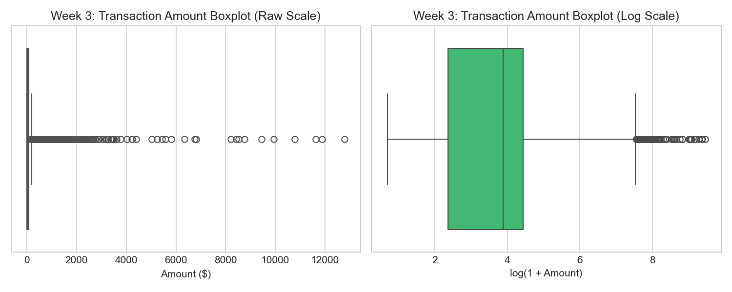
Figure 1: Week 3 Outlier Detection — Raw Amount Boxplot vs. Log-Transformed Amount
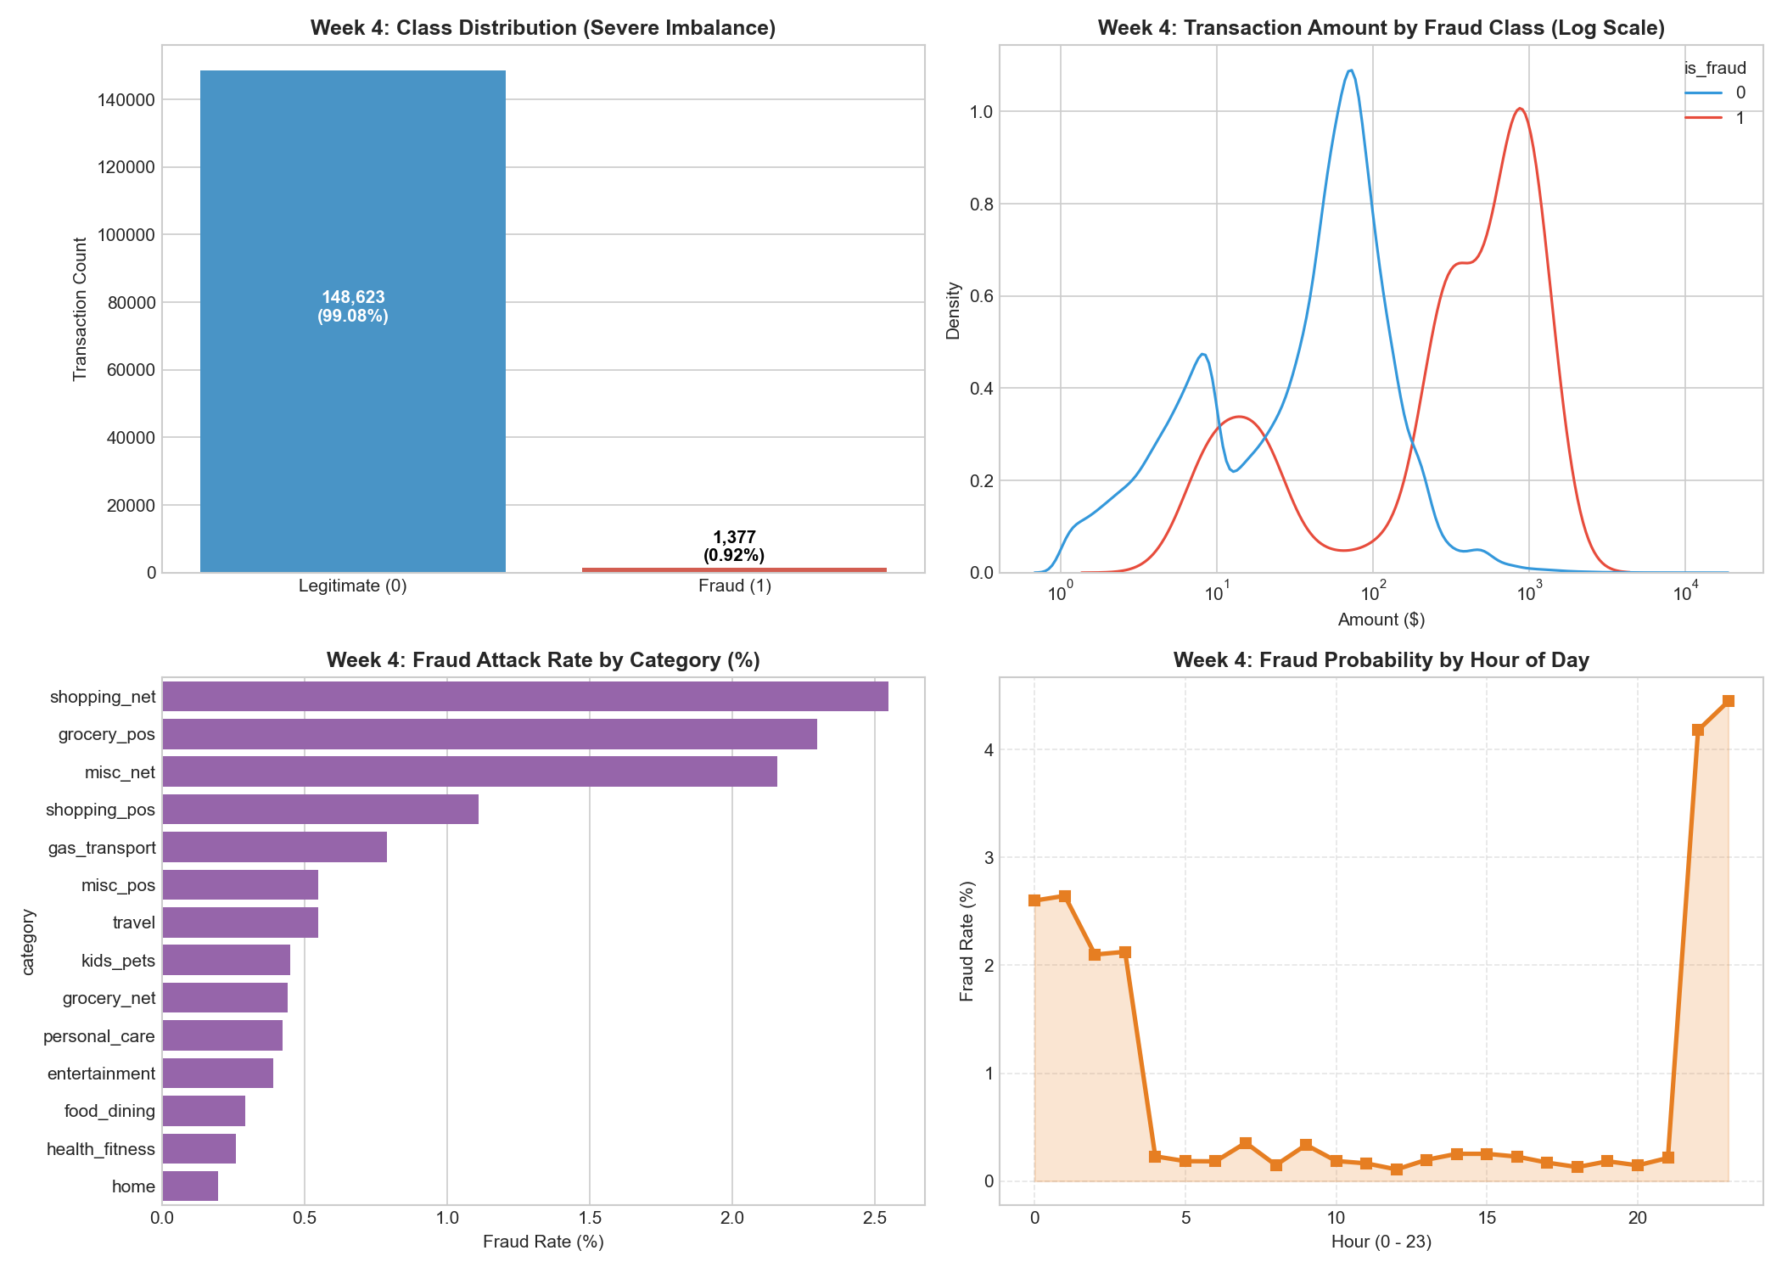
Figure 2: Week 4 Exploratory Data Analysis — Class Imbalance, Amount KDE, Attack Categories, and Diurnal Hour Surge

PART 2: Deep Dive into Week 6 (Feature Engineering)
Machine learning algorithms and distance calculations cannot ingest raw text strings and fail when continuous numbers exhibit extreme skewness. Week 6 was split into two modular notebooks executing sequential data transformations.

Notebook 1: Categorical Encoding (01_encoding_categorical_variables.ipynb)
We had 4 categorical features of vastly different cardinality. A naive one-size-fits-all approach (like One-Hot Encoding) would destroy model performance. We designed a multi-strategy encoding pipeline:
1. Binary Encoding (Gender): Gender has only 2 unique values ('F', 'M'). Mapped F -> 0 and M -> 1. This uses minimal memory without ambiguity.
2. Label / Ordinal Encoding (Category): There are 14 nominal merchant categories. We sorted them alphabetically and assigned integer codes [0 to 13]. This preserved dimensionality without adding 14 sparse columns.
3. Frequency Encoding (Job & State) — The Antidote to the Curse of Dimensionality: The job column has 478 unique titles and state has 50 states. If One-Hot Encoding were applied, it would create 478 sparse binary columns consisting of 99.8% zeros. This triggers the Curse of Dimensionality, inflating memory and degrading decision-tree splits. Instead, we used Frequency Encoding: replacing each category with its empirical percentage frequency:
Frequency(c) = Count(category == c) / Total Rows (N)
Transaction | gender (Raw) | gender_encoded | category (Raw) | category_code | job (Raw) | job_freq (Continuous)
#0 | F | 0 | misc_net | 8 | Psychologist | 0.00163 (163 records)
#1 | F | 0 | grocery_pos | 4 | Special ed assistant | 0.00282 (282 records)
#2 | M | 1 | entertainment | 0 | Conservation officer | 0.00168 (168 records)
#3 | M | 1 | gas_transport | 2 | Patent attorney | 0.00210 (210 records)
#4 | M | 1 | misc_pos | 9 | Quantitative analyst | 0.00195 (195 records)

Notebook 2: Normalization, Scaling & Fixing Skewness (02_normalization_scaling_fixing_skewness.ipynb)
1. Fixing Skewness via Log1p Transformation:
Transaction amount ('amt') exhibited extreme right skewness of +26.58. Financial purchases have heavy positive tails (most are $10–$50, but rare transactions reach $12,788+). Linear algorithms, distance calculations, and neural gradients fail under severe skewness because extreme outliers pull the mean and gradient steps. We applied the natural logarithm transformation: log_amt = ln(1 + amt). We used ln(1 + x) instead of ln(x) to prevent undefined negative infinity errors if an amount is zero.
Feature | Raw Skewness | Log1p Skewness | Transformation Effect & Status
Transaction Amount (amt) | +26.58 (Severe) | -0.28 (Near-Perfect Normal) | Outlier tail smoothly compressed; normal bell curve achieved!
City Population (city_pop) | +5.60 (High) | +0.23 (Symmetrical) | Metropolitan population skewness resolved.
Customer Age | +0.38 | N/A | Already roughly symmetrical bell distribution; no transform required.
Transaction Hour | +0.01 | N/A | Uniform 24-hour distribution; no transform required.

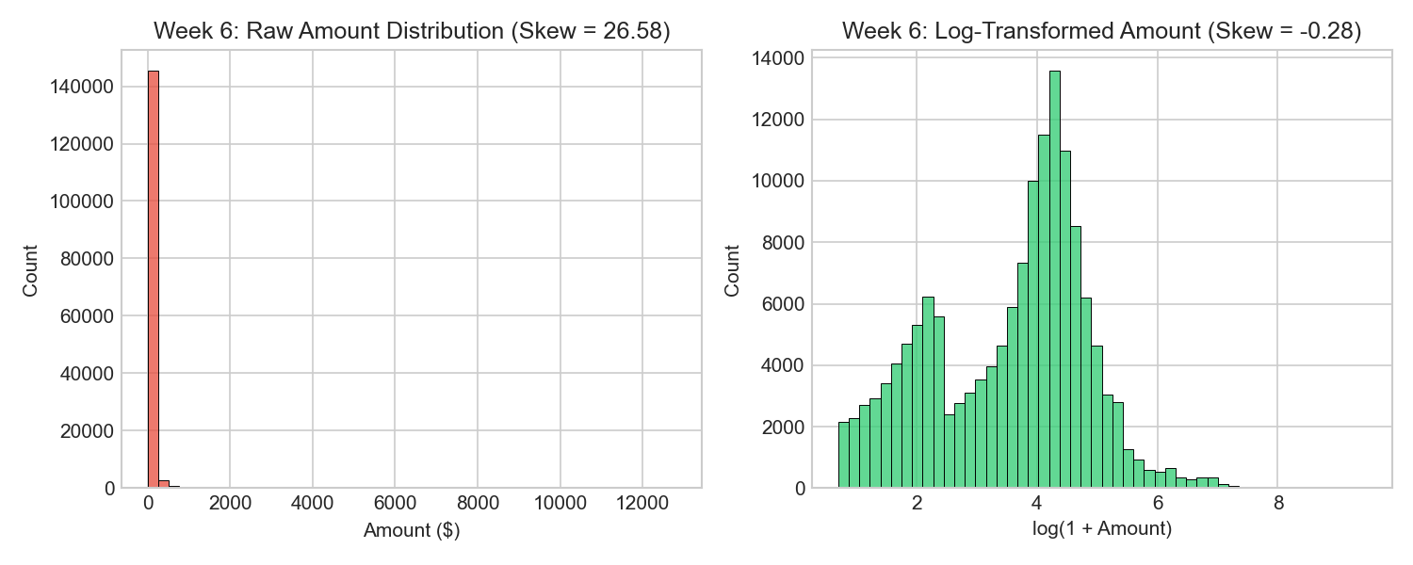
Figure 3: Week 6 Skewness Fix — Raw Amount Distribution (+26.58) vs. Log-Transformed Distribution (-0.28)
2. Feature Scaling (StandardScaler):
Amounts reach thousands of dollars, whereas transaction hours span 0 to 23 and age spans 18 to 95. Without scaling, distance metrics (PCA, KNN, K-Means) treat a $1,000 difference as thousands of times more impactful than a 10-hour difference in time. We applied StandardScaler (z = (x - mu) / sigma) to give continuous features zero mean (mu = 0) and unit variance (sigma = 1.0).
Feature Name | Transformed Mean (mu) | Standard Deviation (sigma) | Min (z-score) | Max (z-score)
log_amt_std | -0.0000 | 1.0000 | -3.6123 | +4.4079
log_city_pop_std | -0.0000 | 1.0000 | -2.4827 | +2.4172
customer_age_std | -0.0000 | 1.0000 | -1.7224 | +2.8318
transaction_hour_std | -0.0000 | 1.0000 | -1.8688 | +1.5646
category_code_std | -0.0000 | 1.0000 | -1.4193 | +1.8791

3. Domain Feature Engineering:
• Haversine Distance (distance_km): Physical spherical separation in km between customer GPS and merchant GPS coordinates.
• Night Flag (is_night): Binary indicator set to 1 if the transaction occurred during peak fraud hours (10:00 PM to 3:00 AM).

PART 3: Deep Dive into Week 7 (Dimensionality Reduction & PCA)
With 10 engineered features ready, Week 7 focuses on: (1) statistically ranking which features actually separate fraud from non-fraud, (2) filtering zero-variance signals, and (3) compressing multi-dimensional variance using Principal Component Analysis (PCA).

Notebook 3: Feature Selection & Variance Analysis (03_feature_selection_and_variance.ipynb)
1. Variance Thresholding: We computed Var(X) with a baseline threshold of 0.01. All scaled continuous features had Var ~ 1.0, gender_encoded had 0.248, and is_night had 0.181. Confirmed zero dead or constant columns.
2. ANOVA F-Statistic Ranking (f_classif): The ANOVA F-test measures the ratio of between-group variance (difference between fraud and legitimate means) to within-group variance (internal noise). A higher F-score indicates a stronger linear predictor:
Rank | Feature Name | ANOVA F-Statistic | Statistical Role & Faculty Explanation
#1 | log_amt | 3,163.33 | Dominant Predictor: Fraudulent purchases average significantly higher dollar amounts.
#2 | is_night | 2,777.06 | Crucial Temporal Signal: Fraud attack density spikes 43x during overnight hours.
#3 | category_code | 79.13 | Merchant Risk Signal: Fraud concentrates in grocery_pos and misc_net.
#4 | log_city_pop | 17.20 | Demographic density signal.
#5 | gender_encoded | 7.59 | Minor demographic correlation.
#6 | transaction_hour | 5.75 | Broader 24-hour diurnal cycle.
#7 | customer_age | 4.88 | Age demographic difference.
#8 | distance_km | 3.11 | Physical separation distance.
#9 | state_freq | 0.12 | Lowest predictive power; excluded from final modeling.

3. Multicollinearity Inspection: We computed the full Pearson correlation matrix across all features. No two features had correlation |r| > 0.70, confirming that each selected feature contributes non-redundant predictive signal.

Notebook 4: Principal Component Analysis & Visualization (04_pca_and_variance_visualization.ipynb)
What is PCA in simple terms? PCA rotates our 7-dimensional feature space onto orthogonal axes (Principal Components: PC1, PC2, ...) that maximize explained variance. PC1 captures the largest spread, PC2 captures the second largest, and so on.
The Scree Plot Analysis: In data science, the gold standard benchmark is retaining components that cross 80% to 90% cumulative variance.
Component | Individual Variance Explained (%) | Cumulative Variance Explained (%) | Faculty Benchmark & Interpretation
PC1 | 18.51% | 18.51% | Primary axis: Heavily loaded on log_amt and is_night.
PC2 | 14.66% | 33.17% | Secondary axis: Loaded on customer_age and log_city_pop.
PC3 | 14.53% | 47.70% | Loaded on category_code and distance_km.
PC4 | 14.39% | 62.09% | Temporal diurnal components.
PC5 | 14.15% | 76.24% | Approaching standard threshold.
PC6 | 13.25% | 89.49% | ★ RETAIN: Crosses the standard 80% information retention threshold!
PC7 | 10.51% | 100.00% | Full variance retained.

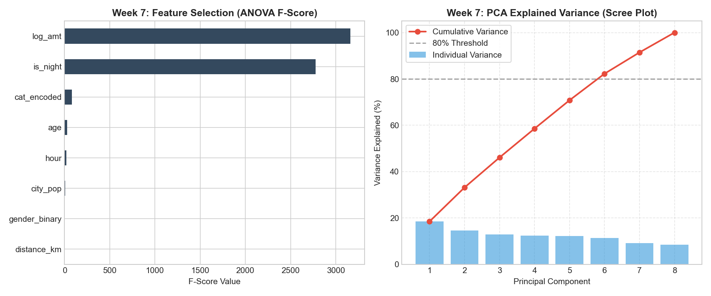
Figure 4: Week 7 Analysis — Feature Importance (ANOVA F-Statistic) & PCA Scree Plot (89.5% Variance in 6 Components)
2D Cluster Separation (PC1 vs. PC2): When transactions are plotted on the 2D plane defined by PC1 and PC2, normal transactions form a dense circular core around the origin (0, 0), while fraudulent transactions diverge outward along the positive PC1 axis, confirming that PCA captures genuine fraud separation signals.

PART 4: Faculty Viva Cheat Sheet ("Why Did You Choose X?")
Q1: Why did you use Log Transformation instead of simply deleting outliers? In standard data science, extreme outliers are usually data entry errors and can be deleted. But in fraud detection, 73.3% of all fraud transactions are located inside the high-dollar IQR outliers! If we had deleted those outliers, we would have deleted 3 out of every 4 fraud cases. Instead, we used ln(1 + amt), which smoothly compressed the range and dropped skewness from +26.58 to -0.28 while keeping 100% of our fraud labels intact.

Q2: Why did you choose Frequency Encoding for Job and State instead of One-Hot Encoding? The job column contains 478 unique titles and state contains 50 states. One-Hot Encoding would have added over 500 sparse binary columns to our dataset. This triggers the Curse of Dimensionality, which causes exponential memory consumption and inefficient decision tree splits. Frequency Encoding replaces each category with its empirical percentage share, reducing 478 columns down to a single compact continuous feature.

Q3: Why did you apply StandardScaler before Principal Component Analysis (PCA)? PCA calculates eigenvectors and eigenvalues based on the covariance/correlation matrix. If variables are on different scales (for example, dollar amounts in thousands vs. hours from 0 to 23), PCA will be mathematically dominated by whichever variable has the largest numerical scale. StandardScaler normalizes every feature to mean 0 and unit variance 1.0, ensuring every dimension contributes fairly.

Q4: Why did you use the ANOVA F-test for feature selection? ANOVA F-statistic (f_classif) measures the ratio of between-group variance to within-group variance between legitimate and fraudulent transactions. It gave us an objective mathematical ranking proving that log_amt (F=3,163.3) and is_night (F=2,777.1) are our highest-signal features.

Q5: Why is PR-AUC required rather than Accuracy for evaluating our fraud models? Because of severe class imbalance (99.42% normal vs. 0.58% fraud). A trivial dummy classifier predicting 'never fraud' achieves 99.42% accuracy while catching zero fraud cases! ROC-AUC can also be misleadingly optimistic because its denominator includes the massive non-fraud majority. PR-AUC (Precision-Recall Area Under Curve) evaluates exclusively on the positive minority class, making it the industry gold standard for fraud detection.

PART 5: 1-Minute Spoken Presentation Script
🎙️ Spoken Script (Word-for-Word for Suhani & Team): "Good morning professors and evaluators. We are Team 1, and our project is Real-Time Credit Card Fraud Detection on 1.29 million transactions.
In Weeks 1 through 4, we completed data hunting and verified zero missing values. Our most critical statistical discovery was that 73.3% of all fraud cases are high-dollar IQR outliers, proving that deleting outliers would delete the crime itself! We also discovered that fraud attack probability surges 43 times higher between 10 PM and 3 AM.
In Week 6, we executed Feature Engineering:
• To avoid the curse of dimensionality from 478 job titles, we used Frequency Encoding instead of One-Hot Encoding.
• To handle extreme dollar amounts without deleting fraud, we applied a Log1p transformation, which brought skewness down from +26.58 to -0.28 — turning a severely skewed curve into a symmetrical bell curve.
• We normalized all continuous attributes to mean 0 and unit variance using StandardScaler.
In Week 7, we performed Dimensionality Reduction:
• Using the ANOVA F-statistic, we confirmed that log-transformed amount (F=3,163) and our night indicator (F=2,777) are our strongest predictors.
• Our PCA Scree plot proved that 6 principal components retain 89.49% of all dataset variance, comfortably crossing the standard 80% threshold.
All four executed notebooks, generated datasets, and reports are published and synced on our GitHub repository. Thank you!"

