24CSI024-DATA STRUCTURES AND ALGORITHMS UNIT 1-INTRODUCTION TO DATA STRUCTURES AND ALGORITHMS Arrays and Array-Based Techniques (Two-Pointer, Sliding Window, Prefix Sums) LAB WORKBOOK-16.07.2026
CATEGORY: EASY
Question 1: Merging Two Sensor Logs (Two-Pointer) Two weather stations, A and B, each recorded temperature readings independently and stored them in non-decreasing sorted order. Divya needs to merge both logs into a single sorted array for her analysis dashboard — without using any built-in sort function, and in O(N + M) time. She uses the two-pointer merge technique:
1. Initialize a pointer i at index 0 of array A and a pointer j at index 0 of array B.
2. Compare A[i] and B[j]. Copy the smaller value into the output array and advance that pointer.
3. Repeat until one array is exhausted.
4. Copy any remaining elements of the other array directly into the output.
• The first line of input consists of two space-separated integers N and M — the sizes of arrays A and B.
• The second line consists of N space-separated integers (array A, sorted).
• The third line consists of M space-separated integers (array B, sorted).
• Print a single line of N + M space-separated integers representing the merged sorted array.
• 1 • ≤ N, M ≤ 104 ≤ 10000 ≤ arr[i]
Input 1:
5 4
1 3 5 7 9
2 4 6 8
Output 1:
1 2 3 4 5 6 7 8 9
Input 2:
2 2
0 0 -1 4
Output 2:
-1 0 0 4
Aim:
To merge two sorted arrays into a single sorted array using the Two-Pointer Technique in O(N + M) time without using any built-in sorting function.
Pseudocode:
START

Read N and M.

for (i = 0; i < N; i++)
{
read A[i];
}

for (j = 0; j < M; j++)
{
read B[j];
}

i = 0;
j = 0;
k = 0;

while (i < N && j < M)
{
if (A[i] <= B[j])
{
C[k] = A[i];
i++;
}
else
{
C[k] = B[j];
j++;
}

k++;
}

while (i < N)
{
C[k] = A[i];
i++;
k++;
}

while (j < M)
{
C[k] = B[j];
j++;
k++;
}

for (k = 0; k < N + M; k++)
{
print C[k];
}

STOP
Code:
#include <stdio.h>

int main()
{
int N, M;
scanf("%d %d", &N, &M);

int A[N], B[M], C[N + M];

for (int i = 0; i < N; i++)
scanf("%d", &A[i]);

for (int j = 0; j < M; j++)
scanf("%d", &B[j]);

int i = 0, j = 0, k = 0;

while (i < N && j < M)
{
if (A[i] <= B[j])
{
C[k] = A[i];
i++;
}
else
{
C[k] = B[j];
j++;
}
k++;
}

while (i < N)
{
C[k] = A[i];
i++;
k++;
}

while (j < M)
{
C[k] = B[j];
j++;
k++;
}

for (k = 0; k < N + M; k++)
{
printf("%d ", C[k]);
}

return 0;
}
Screenshots of the output:
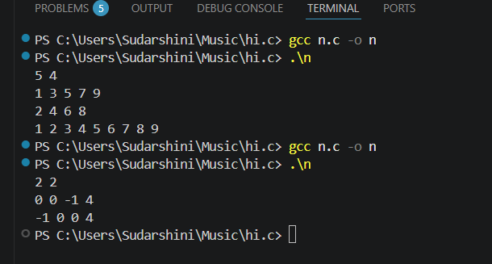

Result:
The two sorted arrays were successfully merged into a single sorted array using the Two-Pointer Technique with O(N + M) time complexity, and the correct merged sorted array was obtained.
Question 2: Locating the First Below-Threshold Reading (Linear Search)
Farhan monitors battery voltage readings from a fleet of IoT sensors, logged in the order they were received (not sorted). He needs to find the position of the first reading that drops below a safe voltage threshold T, so maintenance can pinpoint when the fault began.
• The first line of input consists of two space-separated integers N and T.
• The second line consists of N space-separated integers representing the voltage readings, in the order recorded.
• Print a single integer: the 0-indexed position of the first reading strictly less than T. If no such reading exists, print -1.
• 1 ≤ N ≤ 10000
• ≤103 ≤ arr[i], T ≤ 103
Input 1:
6 5
9 7 6 4 8 3
Output:1
3
Input 2:
4 0
1 2 3 4
Output 2:
-1
Pseudocode:

START

Read N and T.

for (i = 0; i < N; i++)
{
read arr[i];
}

for (i = 0; i < N; i++)
{
if (arr[i] < T)
{
print i;
STOP;
}
}

print -1;

STOP
Code:
#include <stdio.h>

int main()
{
int N, T;
scanf("%d %d", &N, &T);

int arr[N];

for (int i = 0; i < N; i++)
{
scanf("%d", &arr[i]);
}

for (int i = 0; i < N; i++)
{
if (arr[i] < T)
{
printf("%d", i);
return 0;
}
}

printf("-1");

return 0;
}
Screenshots of the output:
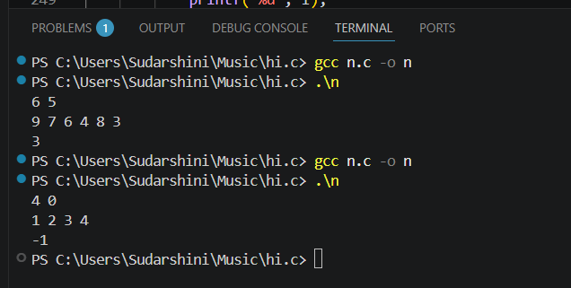
Result:
The first array element that was strictly less than the threshold value T was successfully located using the Linear Search technique. The program displayed its 0-indexed position, or -1 if no such element existed.
CATEGORY: MEDIUM
Question 3: Maximum Rainwater Between Towers (Two-Pointer) A telecom company has N transmission towers of varying heights standing in a row. During heavy rain, water can collect in the “well” formed between two towers, bounded by the shorter of the two. Meera wants to find the two towers that can trap the maximum volume of water between them, so she can plan drainage. She solves it in O(N) using two pointers instead of checking every pair:
1. Initialize left = 0 and right = N – 1, and maxWater = 0.
2. Compute the water trapped between left and right: min(height[left], height[right]) * (right – left). Update maxWater if this is larger.
3. Move the pointer at the shorter tower inward — it can never form a better pair with anything closer than the taller side already offers.
4. Repeat until left meets right.
• The first line of input consists of an integer N — the number of towers.
• The second line consists of N space-separated non-negative integers representing tower heights.
• Print a single integer representing the maximum water that can be trapped, in the format: Max Water: X
2 • 0≤ N ≤ height[i] ≤ 10000 ≤ 104
Aim:
To find the maximum amount of water that can be trapped between any two towers using the Two-Pointer Technique in O(N) time.
START

Read N.

for (i = 0; i < N; i++)
{
read height[i];
}

left = 0;
right = N - 1;
maxWater = 0;

while (left < right)
{
if (height[left] < height[right])
water = height[left] * (right - left);
else
water = height[right] * (right - left);

if (water > maxWater)
{
maxWater = water;
}

if (height[left] < height[right])
left++;
else
right--;
}

print maxWater;

STOP
Code:
#include <stdio.h>

int main()
{
int N;
scanf("%d", &N);

int height[N];

for (int i = 0; i < N; i++)
{
scanf("%d", &height[i]);
}

int left = 0;
int right = N - 1;
int maxWater = 0;

while (left < right)
{
int water;

if (height[left] < height[right])
water = height[left] * (right - left);
else
water = height[right] * (right - left);

if (water > maxWater)
maxWater = water;

if (height[left] < height[right])
left++;
else
right--;
}

printf("Max Water: %d", maxWater);

return 0;
}
Screenshots of the output :
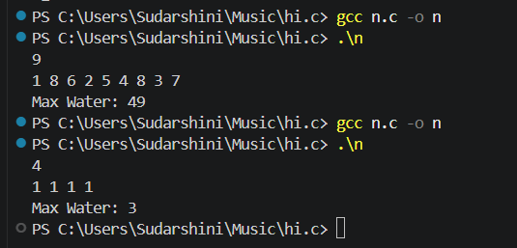
Result:
The maximum amount of water that can be trapped between two towers was successfully determined using the Two-Pointer Technique with O(N) time complexity, and the correct maximum water value was displayed.
Question 4: Finding the Insertion Point for a New Calibration Value (Binary Search) A lab keeps a sorted array of calibration reference values. Whenever a new value arrives, Ibrahim needs to find the exact index where it should be inserted to keep the array sorted — without scanning the whole array. He uses a binary search variant that finds the first index whose value is greater than or equal to the new value:
1. Initialize low = 0, high = N.
2. While low < high: compute mid = low + (high - low) / 2.
3. If arr[mid] < target, set low = mid + 1. Otherwise, set high = mid.
4. When the loop ends, low is the correct insertion index.
• The first line of input consists of two space-separated integers N and target.
• The second line consists of N space-separated integers in non-decreasing order.
• Print a single integer: the index at which target should be inserted, in the format: Insert At: X. • 1 • ≤ N ≤ 104 ≤ 10000 ≤ arr[i], target ≤ 104
Aim:
To find the correct insertion index of a target value in a sorted array using the Binary Search technique.
Pseudocode:
START

Read N and target.

for (i = 0; i < N; i++)
{
read arr[i];
}

low = 0;
high = N;

while (low < high)
{
mid = low + (high - low) / 2;

if (arr[mid] < target)
{
low = mid + 1;
}
else
{
high = mid;
}
}

print low;

STOP
Code:
#include <stdio.h>

int main()
{
int N, target;
scanf("%d %d", &N, &target);

int arr[N];

for (int i = 0; i < N; i++)
{
scanf("%d", &arr[i]);
}

int low = 0;
int high = N;

while (low < high)
{
int mid = low + (high - low) / 2;

if (arr[mid] < target)
{
low = mid + 1;
}
else
{
high = mid;
}
}

printf("Insert At: %d", low);

return 0;
}
Screenshot of the output :
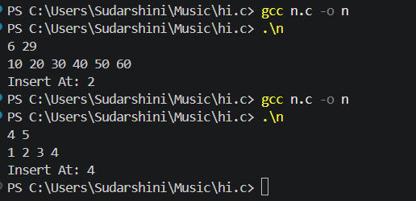
Result:
The correct insertion index of the target element in the sorted array was successfully determined using the Binary Search technique with O(log N) time complexity, and the insertion position was displayed correctly.
Question 5: Locating a Packet in a Rotated Log Buffer (Modified Binary Search) A circular network buffer stores log entries sorted by timestamp, but because it wraps around, the array as read out is a rotated sorted array (e.g., the oldest entries appear after the newest due to the wraparound point). Sana needs to locate a specific timestamp T in O(log N) time — a plain binary search won’t work directly since the array isn’t fully sorted end-to-end. She adapts binary search to handle the rotation:
1. Initialize low = 0, high = N - 1.
2. Compute mid. If arr[mid] == target, return mid.
3. Determine which half (low to mid, or mid to high) is properly sorted by comparing arr[low] and arr[mid].
4. Check if target lies within the value range of the sorted half. If it does, recurse/iterate into that half; otherwise, search the other half.
5. Repeat until found or the range is empty.
• The first line of input consists of two space-separated integers N and target.
• The second line consists of N space-separated distinct integers representing the rotated sorted array.
• Print a single integer: the 0-indexed position of target in the array, in the format: Found At: X. If not present, print Found At: -1.
• 1 • ≤ N ≤ 105 ≤ 10000 ≤ arr[i], target ≤ 105
• The array is a sorted array rotated at some unknown pivot; all elements are distinct.
Aim:
To locate a target element in a rotated sorted array using the Modified Binary Search technique in O(log N) time.
Pseudocode:
START

Read N and target.

for (i = 0; i < N; i++)
{
read arr[i];
}

low = 0;
high = N - 1;

while (low <= high)
{
mid = low + (high - low) / 2;

if (arr[mid] == target)
{
print mid;
STOP;
}

if (arr[low] <= arr[mid])
{
if (target >= arr[low] && target < arr[mid])
{
high = mid - 1;
}
else
{
low = mid + 1;
}
}
else
{
if (target > arr[mid] && target <= arr[high])
{
low = mid + 1;
}
else
{
high = mid - 1;
}
}
}

print -1;

STOP
Code:
#include <stdio.h>

int main()
{
int N, target;
scanf("%d %d", &N, &target);

int arr[N];

for (int i = 0; i < N; i++)
{
scanf("%d", &arr[i]);
}

int low = 0;
int high = N - 1;

while (low <= high)
{
int mid = low + (high - low) / 2;

if (arr[mid] == target)
{
printf("Found At: %d", mid);
return 0;
}

if (arr[low] <= arr[mid])
{
if (target >= arr[low] && target < arr[mid])
{
high = mid - 1;
}
else
{
low = mid + 1;
}
}
else
{
if (target > arr[mid] && target <= arr[high])
{
low = mid + 1;
}
else
{
high = mid - 1;
}
}
}

printf("Found At: -1");

return 0;
}
Screenshot of the Output:
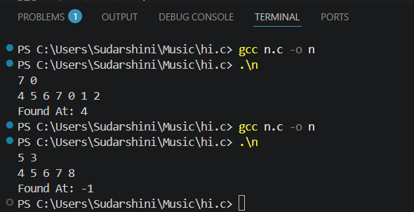
Result
The target element in the rotated sorted array was successfully located using the Modified Binary Search technique with O(log N) time complexity. The program correctly displayed the 0-indexed position of the target, or -1 if the target was not present.
VIVA
1. Why must the array be sorted in binary search? What breaks if it isn't?
Answer:
Binary search works only on a sorted array because it decides which half to discard by comparing the middle element with the target. If the array is not sorted, this decision is invalid, and the target may be discarded even though it exists.
2. Contrast the best-case and worst-case time complexity of linear search. When can it outperform binary search?
Answer:
- Best Case: O(1) (target is the first element)
- Worst Case: O(N) (target is the last element or not present)
Linear search can outperform binary search for small arrays or when the required element is usually near the beginning, since it has very little overhead.

3. Why can't we simply check arr[mid] < target in a rotated sorted array?
Answer:
A rotated array is not completely sorted. We must first determine which half is sorted (left or right), then check whether the target lies within that sorted half before deciding which side to search.
4. Why is the two-pointer merge algorithm better than sorting the concatenated array?
Answer:
The merge algorithm takes O(N + M) time because both arrays are already sorted. Concatenating and sorting again takes about O((N + M) log(N + M)), which is slower.
5. Why is it safe to move the pointer at the shorter tower?
Answer:
The water level is limited by the shorter tower. Moving the taller tower cannot increase the water level because the shorter tower still limits it. Only moving the shorter tower may find a taller boundary and increase the trapped water.
6. Why use low + (high - low) / 2 instead of (low + high) / 2?
Answer:
It prevents integer overflow. If low and high are very large, low + high may exceed the maximum value of an int in C, producing an incorrect midpoint.
7. What is the trade-off of recursive binary search?
Answer:
Recursive binary search uses extra stack memory because each recursive call creates a new stack frame. Iterative binary search uses constant memory (O(1)), making it better for embedded systems with limited stack space.
8. How do you modify binary search to find the last occurrence of a repeated value?
Answer:
When the target is found, store its index and continue searching in the right half (low = mid + 1). The last stored index is the last occurrence.
9. Why can't the two-pointer merge technique be used if one array is unsorted?
Answer:
The technique depends on both arrays being sorted. If one array is unsorted, we cannot determine which element is smaller. We must sort the unsorted array first or use a different approach.
10. Why can linear search be faster than binary search on small arrays?
Answer:
Linear search accesses memory sequentially, which is cache-friendly and has low overhead. Binary search jumps around the array, causing more cache misses. Therefore, for small arrays, linear search can be faster despite its higher time complexity.

