24CSI024-DATA STRUCTURES AND ALGORITHMS UNIT 1-INTRODUCTION TO DATA STRUCTURES AND ALGORITHMS Arrays and Array-Based Techniques (Two-Pointer, Sliding Window, Prefix Sums) LAB WORKBOOK-09.07.2026
Name: Sudarshini B
Roll No: 25BAD116
Department: AI&DS

Question 1
Aim:
To write a C program that squares each element of a sorted array containing both negative and positive integers and returns the squared values in sorted order using the Two-Pointer technique.
Pseudocode:
Start

Read the number of elements N.

Read the sorted array A.

Create an output array O of size N.

Initialize:
l = address of first element of A
r = address of last element of A
h = N - 1

While l <= r
If absolute value of *l is less than absolute value of *r
O[h] = (*r) × (*r)
Move r one position to the left
Else
O[h] = (*l) × (*l)
Move l one position to the right
End If

Decrement h

End While

Print all elements of array O.

Stop
Code:
#include <stdio.h>
#include <stdlib.h>

int main()
{
int n;
scanf("%d", &n);

int a[n], O[n];

for(int i = 0; i < n; i++)
scanf("%d", &a[i]);

int *l = a;
int *r = &a[n - 1];

int h = n - 1;

while(l <= r)
{
if(abs(*l) < abs(*r))
{
O[h] = (*r) * (*r);
r --;
h --;
}
else
{
O[h] = (*l) * (*l);
l ++;
h --;
}
}

for(int i = 0; i < n; i++)
printf("%d ", O[i]);

return 0;
}
Output Screenshot:
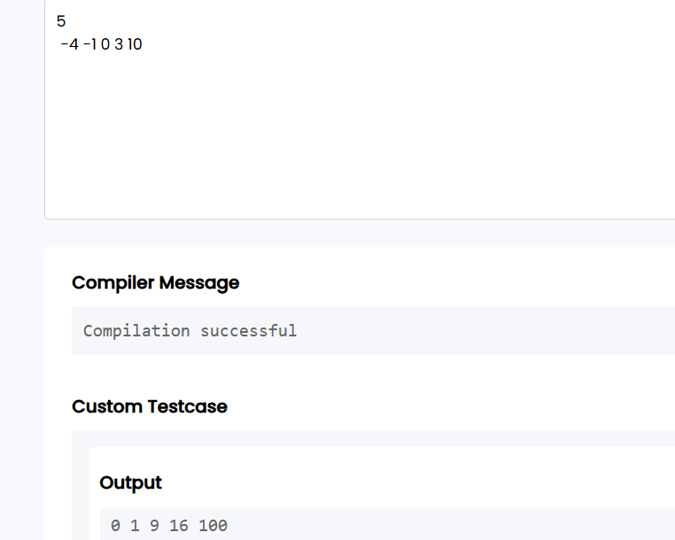
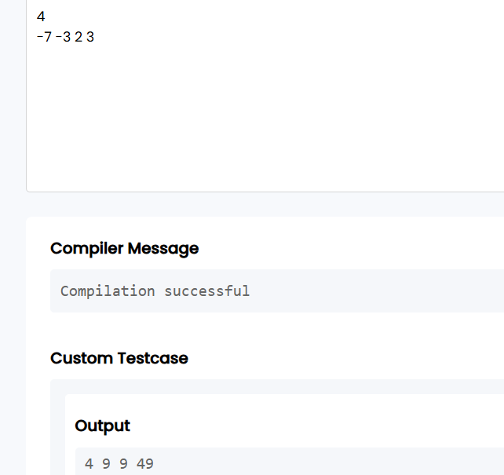
Question 2: Cumulative Resource Consumption (Prefix Sum)
Aim:
To write a C program to compute the prefix sum (cumulative running sum) of an array using the Prefix Sum technique.
Pseudocode:
START

Read the number of elements N.

Read the array A.

Create a prefix sum array P of size N.

Set P[0] = A[0].

For i = 1 to N-1
P[i] = P[i-1] + A[i]
End For

Print the prefix sum array P.

STOP
Code:
#include <stdio.h>

int main()
{
int n;
scanf("%d", &n);

int a[n], P[n];

for(int i = 0; i < n; i++)
{
scanf("%d", &a[i]);
}

P[0] = a[0];

for(int i = 1; i < n; i++)
{
P[i] = P[i - 1] + a[i];
}

for(int i = 0; i < n; i++)
{
printf("%d ", P[i]);
}

return 0;
}
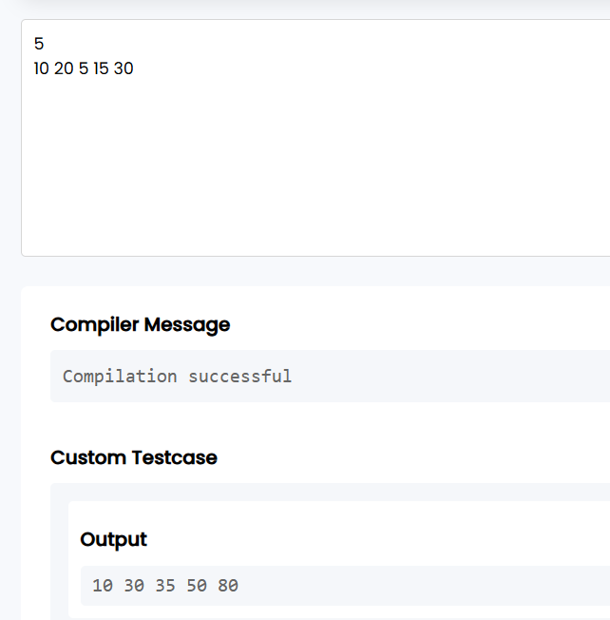
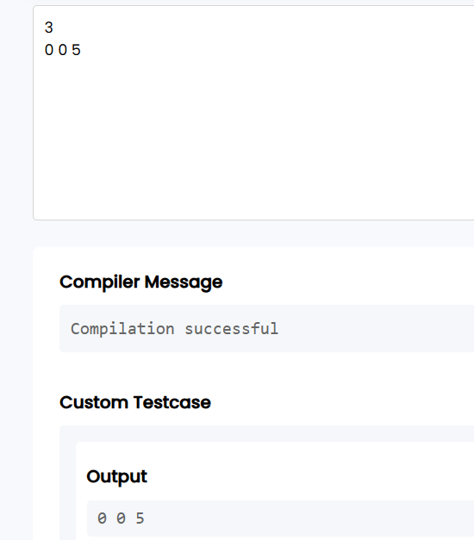
Question 3: Grouping Active Sectors (Fixed-Size Sliding Window)
1. Aim
To write a C program to find the minimum number of swaps required to group all the 1s together in a binary array using the Fixed-Size Sliding Window technique.
Pseudocode:
START

Read N.

Read the binary array.

Count the total number of 1s and store it in C.

If C is 0 or 1
Print "Min Swaps: 0"
Stop

Count the number of 1s in the first window of size C.

Store this count as maxOnes.

Slide the window one element at a time:
Add the new element entering the window.
Remove the element leaving the window.
Update maxOnes if current count is greater.

Minimum Swaps = C - maxOnes.

Print Minimum Swaps.

STOP
Code:
#include <stdio.h>

int main()
{
int n;
scanf("%d", &n);

int arr[n];

for(int i = 0; i < n; i++)
scanf("%d", &arr[i]);

int ones = 0;

for(int i = 0; i < n; i++)
{
if(arr[i] == 1)
ones++;
}

if(ones <= 1)
{
printf("Min Swaps: 0");
return 0;
}

int current = 0;

for(int i = 0; i < ones; i++)
current += arr[i];

int maxOnes = current;

for(int i = ones; i < n; i++)
{
current = current + arr[i] - arr[i - ones];

if(current > maxOnes)
maxOnes = current;
}

printf("Min Swaps: %d", ones - maxOnes);

return 0;
}
Screenshot of the output:
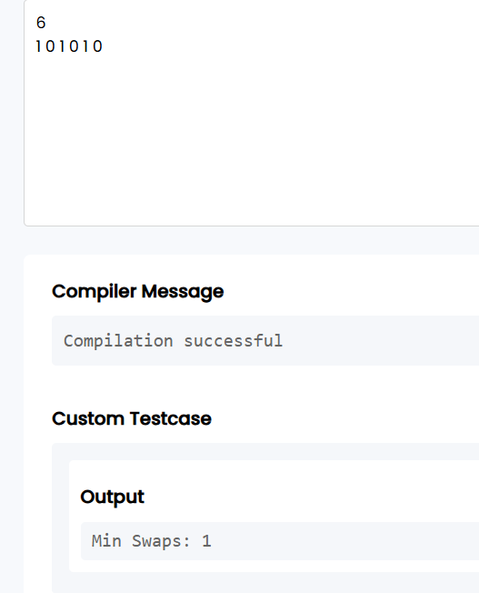
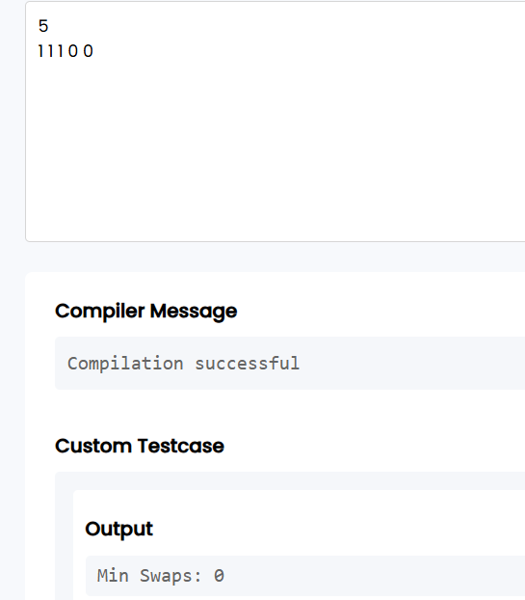
Question 4: Maximum Task Window Within Budget (Variable-Size Sliding Window)
Aim:
To write a C program to find the maximum number of consecutive tasks whose total energy consumption does not exceed the given power limit using the Variable-Size Sliding Window technique.
Pseudocode:
START

Read N and P.

Read the array of task energy costs.

Initialize:
start = 0
current_sum = 0
max_length = 0

For end = 0 to N-1

Add arr[end] to current_sum.

While current_sum > P
Subtract arr[start] from current_sum.
Increment start.
End While

If current window length is greater than max_length
Update max_length.
End If

End For

Print max_length.

STOP
Code:
#include <stdio.h>

int main()
{
int n, p;
scanf("%d%d", &n, &p);

int arr[n];

for(int i = 0; i < n; i++)
scanf("%d", &arr[i]);

int start = 0;
int current_sum = 0;
int max_length = 0;

for(int end = 0; end < n; end++)
{
current_sum += arr[end];

while(current_sum > p)
{
current_sum -= arr[start];
start++;
}

if(end - start + 1 > max_length)
max_length = end - start + 1;
}

printf("Max Length: %d", max_length);

return 0;
}
Screenshot of the output:
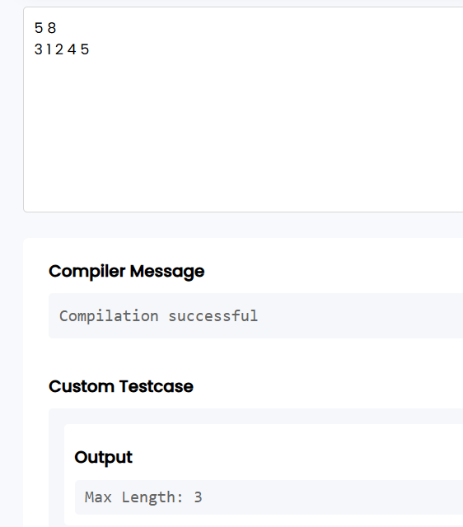
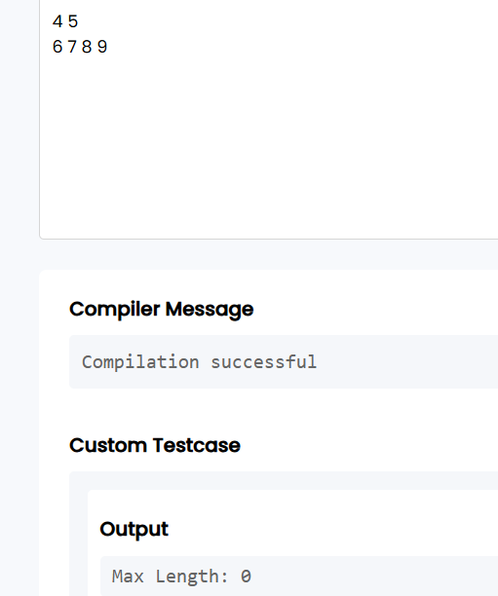
Question 5: Sliding Window Maximum Peak (Monotonic Window Queue)
Aim:
To write a C program to find the maximum element in every sliding window of size K using a monotonic deque for an O(N) time complexity.
Pseudocode:
START

Read N and K.

Read the array.

Create an array to act as a deque.

Initialize front and rear.

For each index i from 0 to N-1

Remove indices from the front if they are outside
the current window.

Remove indices from the rear while the current
element is greater than or equal to the elements
represented by those indices.

Insert the current index at the rear.

If the first window is formed
Print the element whose index is at the
front of the deque.
End If

End For

STOP
Code:
#include <stdio.h>

int main()
{
int N, K;
scanf("%d %d", &N, &K);

int arr[10000];
int deque[10000];

int front = 0, rear = -1;

for (int i = 0; i < N; i++)
scanf("%d", &arr[i]);

for (int i = 0; i < N; i++)
{
while (front <= rear && arr[deque[rear]] <= arr[i])
rear--;

deque[++rear] = i;

if (deque[front] < i - K + 1)
front++;

if (i >= K - 1)
printf("%d ", arr[deque[front]]);
}

return 0;
}

Screenshot of the output:
