100轮，size=256
VAL (best.pth): {
"mIoU": 84.06355850049178,
"IoU_landslide": 71.06330601098527,
"Precision_fg": 84.36079211040082,
"Recall_fg": 81.84570520956274,
"F1_fg": 83.08421913279491,
"Precision_macro": 91.3698482384878,
"Recall_macro": 90.24360677797787,
"F1_macro": 90.79712523993715,
"Accuracy": 97.26129237994347
}
示例
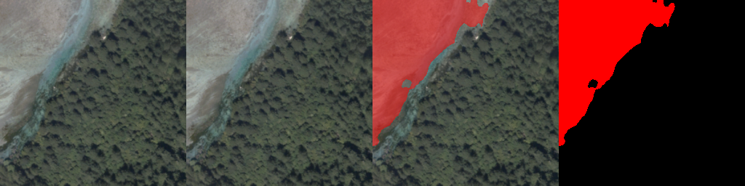 | 误判
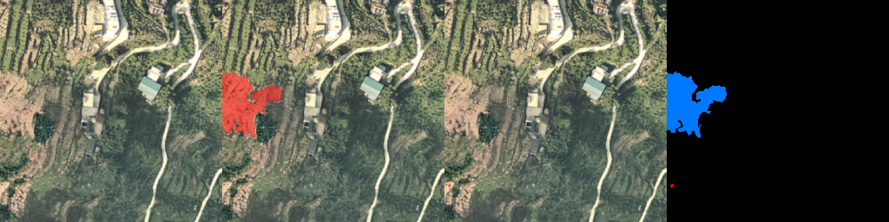 | 漏判
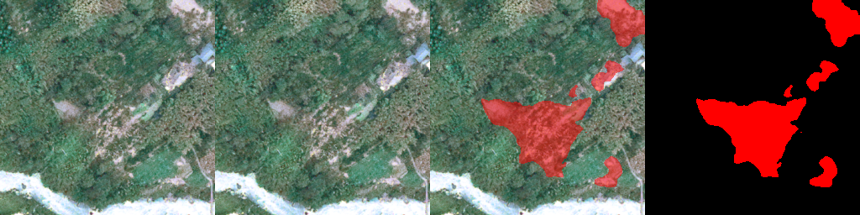 | 误判。把裸地识别为滑坡
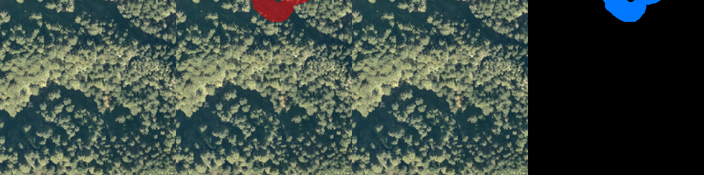 | 可以删除该样本
 | 错误样本
 | 错误样本


