4 Oct 2019: SABRE + FP sample plots from PSD-PHA daq system in Compass

19F(p,alpha)16O
Run 265 (with bad, smeared-out back delay-line signals)
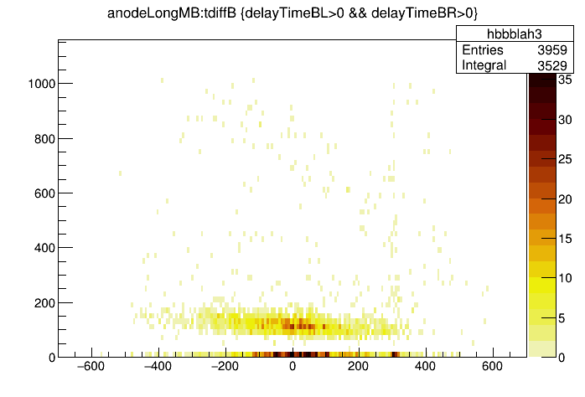

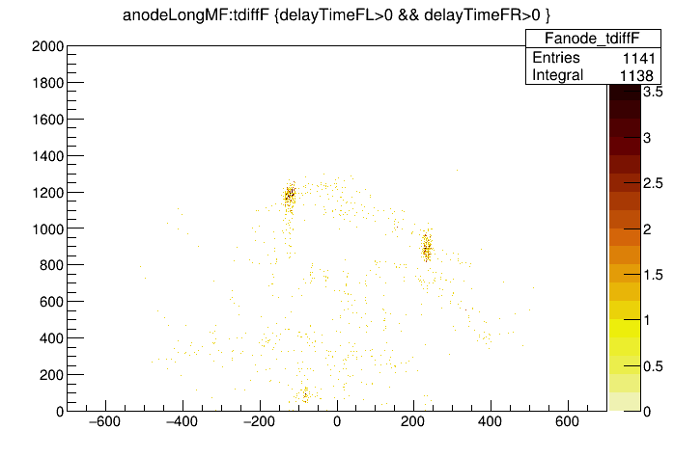

19F(p,alpha)16O at different energies
Run 319 (7x more data exists that is not included in the analysis below)
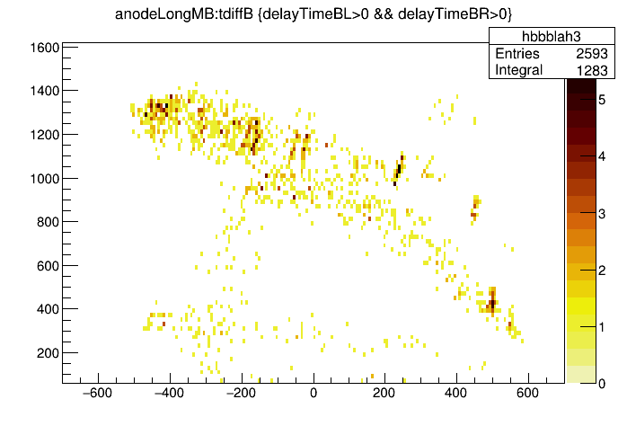

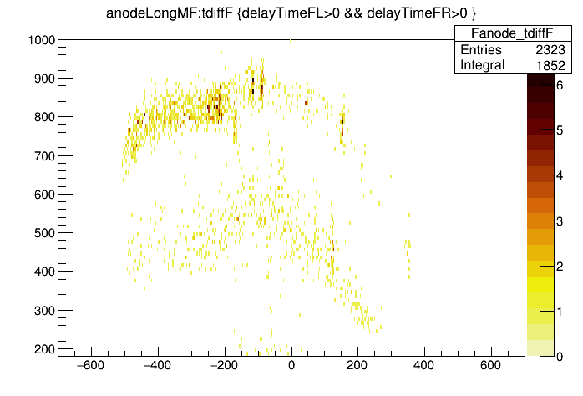

Run 116: CaF2 target, 19F(p,alpha) demonstration of anode-scintillator dE-E gating.

Proton-gate on run116

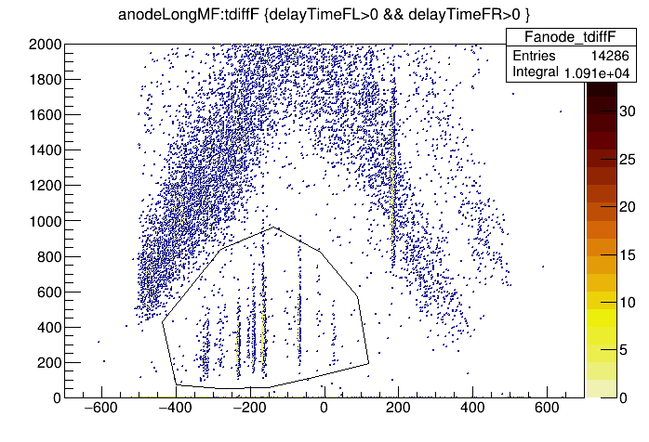
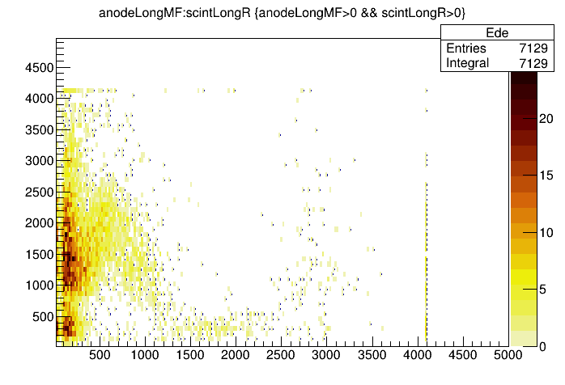

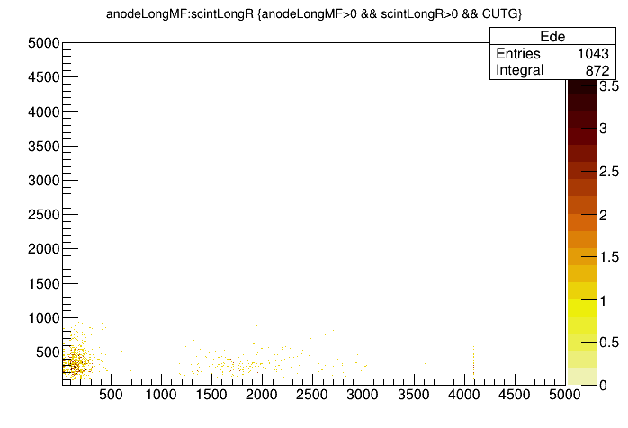
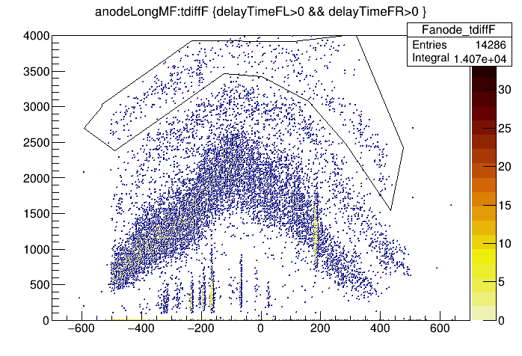
alpha gated

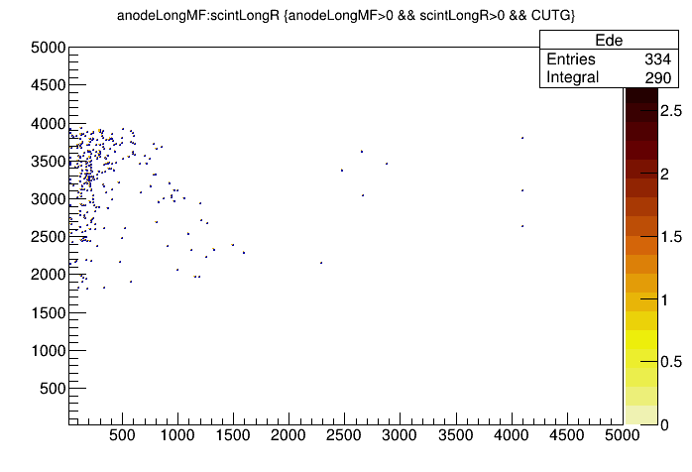
alpha gated de-E for run 116(above)

