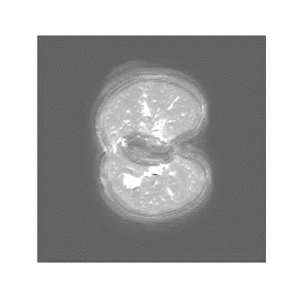 | 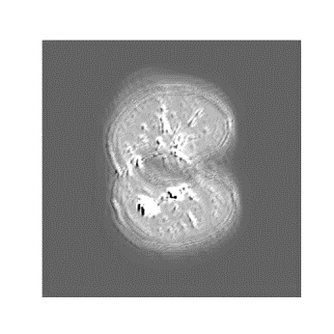 | 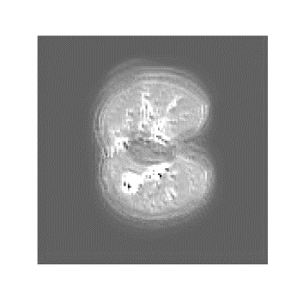 | 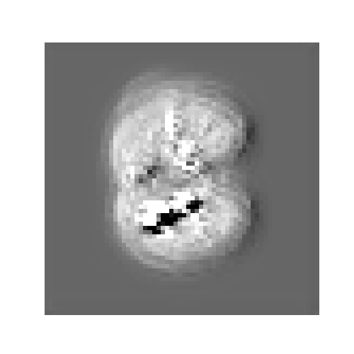 | 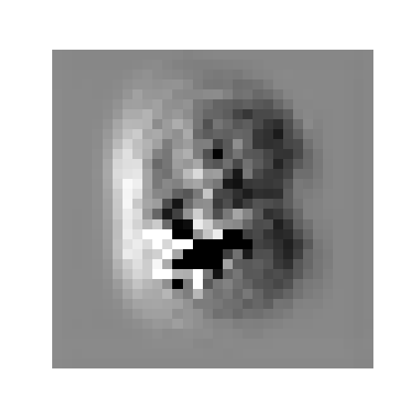
conv2d_1 (index: 1)  Low-level edges | conv2d_3 (index: 5)  Texture patterns | conv2d_5 (index: 7)  Refined textures | conv2d_7 (index: 11)  Complex structures | conv2d_9 (index: 15)  High-level features
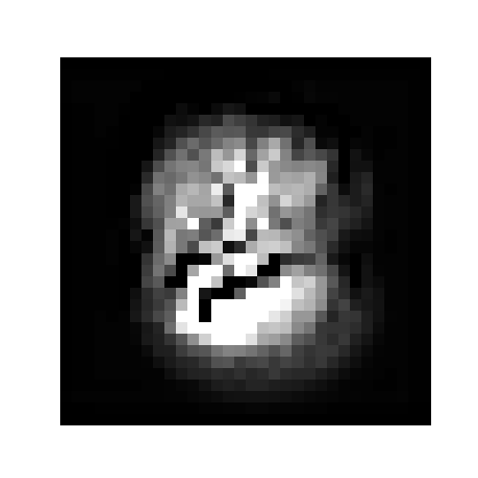 | 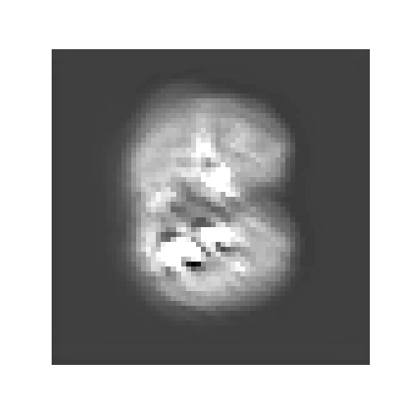 | 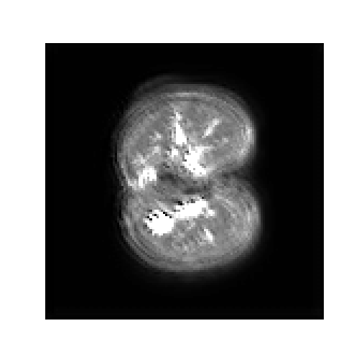 | 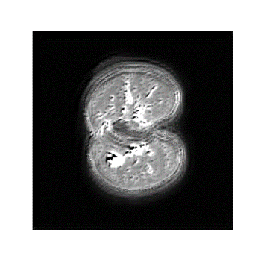 | 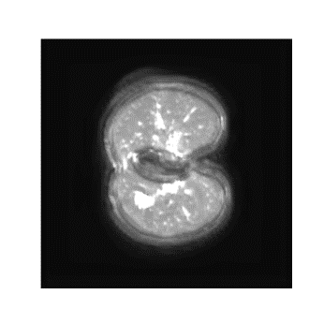
BiFPN_1_P7_relu (index: 19)  Coarse-grained features | BiFPN_1_P6_relu (index: 24)  Fused features (scale 6) | BiFPN_1_P5_relu (index: 31)  Fused features (scale 5) | BiFPN_1_P4_relu (index: 38)  Fused features (scale 4) | BiFPN_1_P3_relu (index: 44)  Fine-grained features
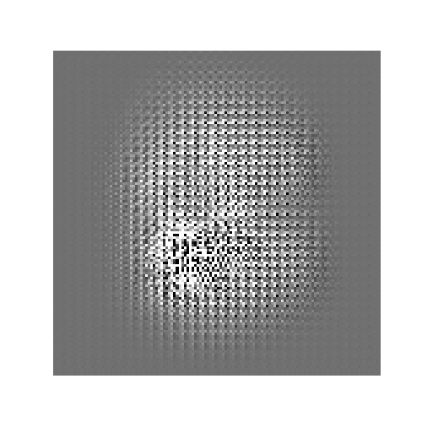 | 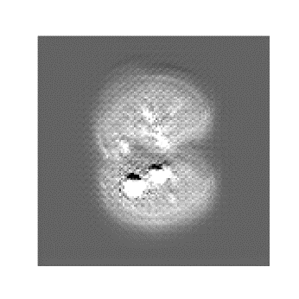 | 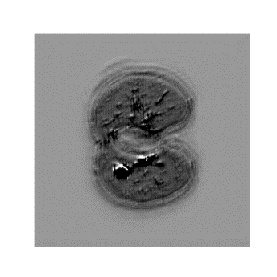 | 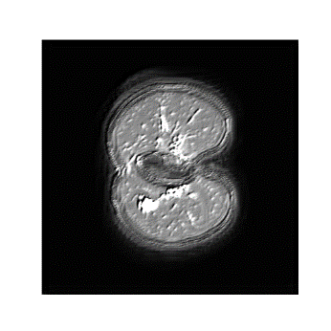 | 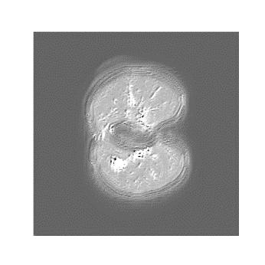
concatenate (index: 70)  Upsampled features (scale 1) | concatenate_1 (index: 73)  Upsampled features (scale 2) | concatenate_2 (index: 76)  Upsampled features (scale 3) | concatenate_3 (index: 79)  Upsampled features (scale 4) | conv2d_18 (index: 82)  Segmentation mask

