

UNIVERSITY OF BUEA

**Faculty of Engineering and Technology**

CEF440

**INTERNET PROGRAMMING AND MOBILE PROGRAMMING**

**Design and Implementation of a Mobile-Based Archival and Retrieval of Missing Objects Application using Image Matching**

*Submitted to:*

Dr. Nkemini Valery

2023/2024

**Group 17 Members**

1. DJIALEU TANKOUA KEANE RANDY FE21A170
2. MBELI NGO NOEL  FE21A229
3. NANGLEFACK LEODIA FIETSOP FE21A244
4. NKEMZI FOLEFACK GIL FE21A276
5. NSIELA SUHBISI DENZEL FE21A286

**TABLE OF CONTENTS**

1. INTRODUCTION 4

1.1 Introduction to UI/UX: 4

1.2 What’s UI/UX design? 4

1.3 Use of UI/UX 5

1.4 Definition of Key Terms 5

2. INTRODUCTION TO FIGMA 6

2.1 AIM AND SCOPE 6

a. AIM: 6

b. SCOPE: 6

3. DESIGN 7

3.1 Admin Section 7

4. Implementation 10

# INTRODUCTION

## Introduction to UI/UX:

The term UI/UX stands for user interface/user experience design and refers to the practice of designing digital products with a user-first approach. In other words, the point of UI/UX design is to create a product that will be both visually appealing and highly pleasant to interact with.

UI design relates to the appearance and feel of a digital product. It focuses on visual factors like buttons, fonts, colour schemes, images, interactive elements, etc. Ultimately, the final product is meant to be pleasant-looking, functional and give users a fantastic experience in terms of performance and navigation.

## What’s UI/UX design?

User interface (UI) design is about building interfaces with a focus on styling and interactivity. The UI designer’s goal is to create an interface the user finds easy to use and aesthetically pleasing. 11 The word “interface” refers to the access point where a user interacts with a software application (Figma), a browser-based website, or a hardware device (e.g., a smartphone touchscreen). A UI designer explores all the interactions and behaviours a user takes with a product to create an interface that best adapts to the user’s needs.

User experience (UX) design is the process designers use to create products that deliver relevant and valuable experiences to users. According to Don Norman, the co-founder of Nielsen Norman Group and the one who coined the phrase “user experience,” the term includes “all aspects of the end-user’s interaction with the company, its services, and its products.” User experience (UX) design is the process designers use to create products that deliver relevant and valuable experiences to users. According to Don Norman, the co-founder of Nielsen Norman Group and the one who coined the phrase “user experience,” the term includes “all aspects of the end-user’s interaction with the company, its services, and its products.”

## Use of UI/UX

You can use it to do all kinds of graphic design work from wireframing websites, designing mobile app interfaces, prototyping designs, crafting social media posts, and everything in between. Figma is different from other graphics editing tools

## Definition of Key Terms

1. **Colour:** Colour refers to the visual property of light as it is perceived by the human eye and interpreted by the brain
2. **Wireframe**: A basic visual representation of a web page or app interface, outlining the layout and structure without detailed design elements.
3. **Mock-up**: A more detailed static representation of a web page or app interface, often including visual design elements such as collars, fonts, and imagery.
4. **Prototype**: A functional model of a web page or app interface, allowing users to interact with the design and provide feedback before final implementation.

# INTRODUCTION TO FIGMA

Figma is a collaborative interface design tool that’s taking the design world by storm. Figma is entirely browser-based, and therefore works not only on Macs, but also on PCs running Windows or Linux, and even on Chromebooks. It also offers a web API, and it’s free!

Another big advantage of Figma is that it allows real-time collaboration on the same file.

## AIM AND SCOPE

### AIM:

The idea of this project is to design user interface for an archival and retrieval mobile application to help people find their missing objects. This is attractive to the users as they can have complete control over their devices and can easily get regular updates on their missing objects. As a result of this, a lot of people have already lost interest in the traditional method of searching for their missing objects.

### SCOPE:

* Greater Market Outreach: Within our context in Cameroon, most phone owners have in possession at least an Android phone as seen during interviews. So, with this mind, our target was based on android so as to make the app responsive, less storage needed, run on slow devices and function as needed on android devices.
* Availability of Better Plugins: Integration of Java third-party plugins increase the functionality of the application and speed up the process of mobile app. We the developers can choose from the various widgets and can meet the demand of our users by customizing the app leveraging useful plugin libraries.

# DESIGN

The design was based on the *Admin section* and the *User section*.

## Admin Section

The admin section was based on web application. requires the admin to login with provided login details. This is done, so as to ensure only appropriate and approved persons have the admin logins.

Below is the login design:

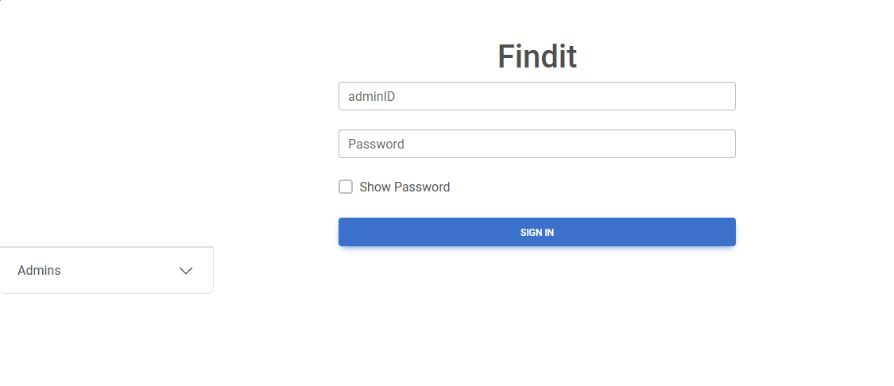

On the bottom left, there is a drop box. The drop box shows the admins present in the system.

Upon successful login by the admin based on the given login credentials, he/she now has full access to this system. This is how it looks like.

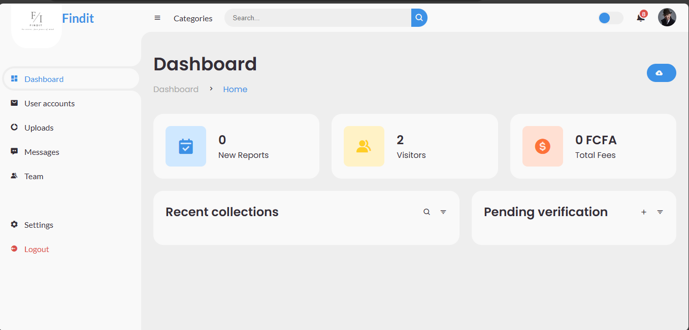

Figure : Admin Dashboard

We have five key components which make up our front screen on the admin page. These are:

1. **Dashboard**

From here, the admin gets to see new reports of missing objects, number of people who visits the app as well as total amount received so far, when the app starts offering paid bonuses. Also, present, recent collections so as to track completion of someone possessing their lost items. Pending verification is also seen on the dashboard, this is to ensure that all users are verified before they can start claiming for missing items or posting lost but found items.

1. **User accounts**

The admin gets to see the accounts that is owners of various registered accounts within the system. From here, the admin can delete an account if suspected of doing fraud or fishy business.

1. **Uploads**

The admin gets to see all uploads done within this mobile app. This is achieved by secured connection to a database.

1. **Messages**

In cases where a user needs help or finds difficulties while using the app and decides to leave a feedback, the admin gets to see it from here.

1. **Team**

Team here refers to the admins in cases where they are two or more. This enables them virtually communicate and work effectively.

# Implementation

* At first, we have to create a frame in Figma to get started with the project.
* We can add the required texts to the frame by creating a text layer.
* We can also add designs and colours to the frame to make it aesthetic.
* To make sure that the spacings are correct, we can add a column grid.
* After completing the app screen, we can align and refine the layout.
* To generate the code for the screen, Figma has a pre-installed plugin in the library called Inspect.
* This converts the UI screen to HTML code which can be further used in browser for our use. This makes Figma an interactive and an easy software to use.
* Below we have the screens of our app:

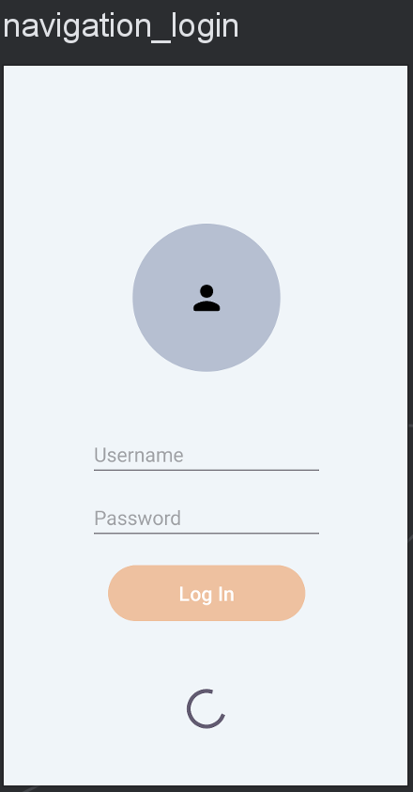

Figure : Login Screen

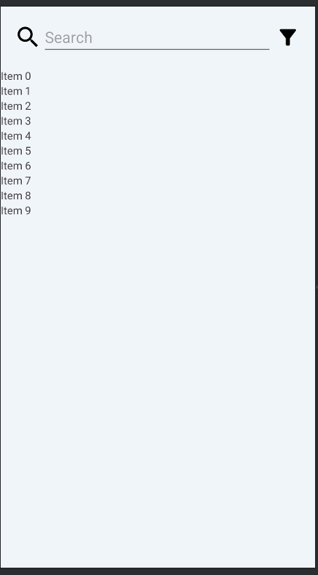

Figure : Home Page

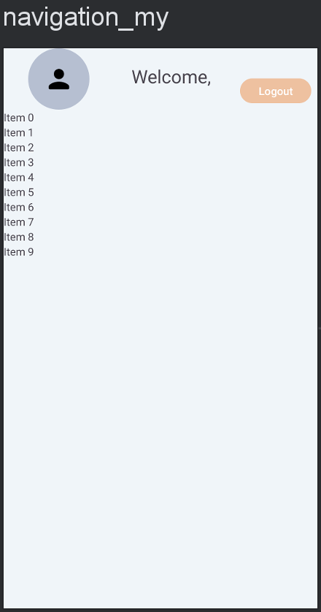

Figure : User Profile

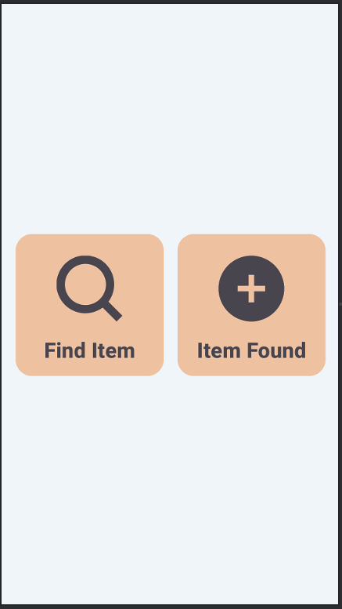

Figure : Search/Find Screen

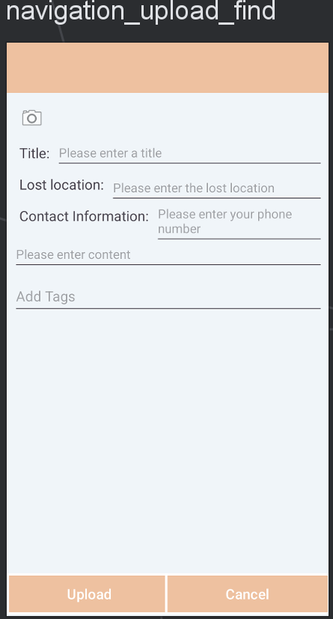

Figure : Declare Lost Item

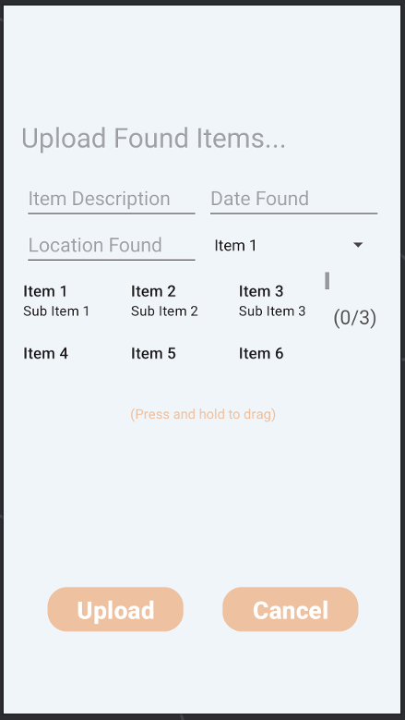

Figure : Upload Found Item

# REFERENCES

[1] [www.google.com](http://www.google.com)

[2] [Principles of UI/UX Design - GeeksforGeeks](https://www.geeksforgeeks.org/principles-of-ui-ux-design/)

[3] <https://UI/UX.dev/?gclsrc=ds&gclsrc=ds>

[4] <https://developers.googleblog.com/2019/05/UI/UX-io19.htm>

[5] [A Complete Guide to Colour Palettes | AND Academy](https://www.andacademy.com/resources/blog/graphic-design/complete-guide-to-colour-palettes/)

[6] [Primary & Secondary Action Buttons | by Nick Babich | UX Planet](https://uxplanet.org/primary-secondary-action-buttons-c16df9b36150)

[7] [Java For Android - Building Your First Android App - GeeksforGeeks](https://www.geeksforgeeks.org/java-for-android-building-your-first-android-app/)

[8] <https://medium.com/weareroam/some-of-the-best-ux-design-references-ive-found-along-the-way-8705f1b35e2c>

[9] <https://www.userinterviews.com/blog/ux-research-presentations-reports-templates-examples>

[10] <https://www.grafiati.com/en/literature-selections/ui-ux-design/journal/>

[11] <https://www.figma.com/community/file/1240044807712255008/20-outstanding-ux-ui-design-case-studies>