**GENETIC ALGORITHM :**

***CROSSOVER* :**

**CrossOver** is said to be Generic Operator which is used in Genetic Algorithm. It takes

more than one chromosome from parent solution and, by remodeling the order of a chromosome which produces

a new child solution. There are different crossover methods which is used to transform the String or Chromosome

to get better solution.

**(i) One point crossover:**

For Instance, Take two parent chromosome (Ex: Parent1 and Parent2) and

Generate a random number (e.g Random number <= chromosome length) as a crossover position.

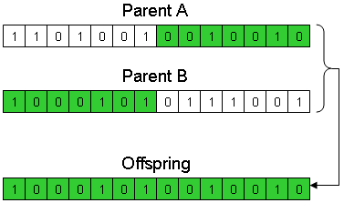

**(ii)Two point crossover:**

Generate a two random numbers as a cross over position and it produce a new child chromosome.

parent_1: parent_2:

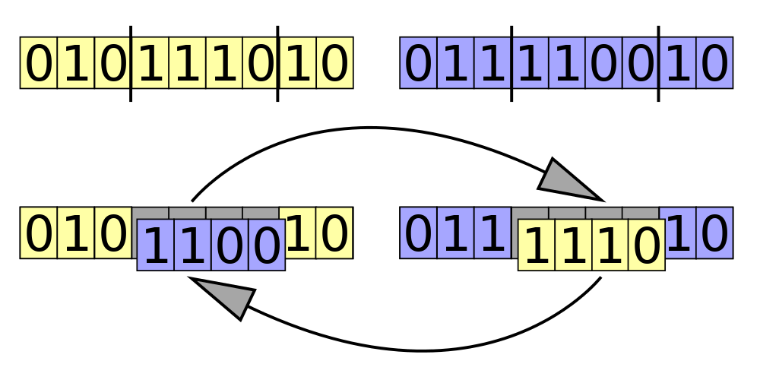

**(iii) Uniform crossover:**

Uniformly generate a random numbers as a crossover position.

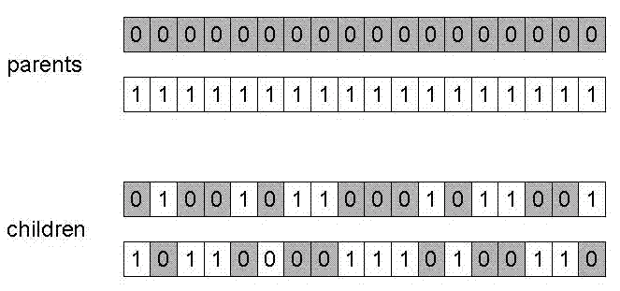

***MUTATION* :**

In biology, it is a natural process of changing the DNA sequence. Same in GA, it is used to alter

the one of the value in chromosome sequence. By doing this the solution might be entirely different from previous population.

Hence it can give a better solution.

For Example,

It will randomly generate a position and swap the value in that position.

