**Phase 2: Innovation**

**Problem statement:** **Image Recognition with IBM Cloud Visual Recognition**

My problem statement requires the use of IBM cloud visual recognition software which is available in the IBM. So my first step is to create an account in the IBM cloud. After creating an account the steps to be followed to carry out the project is given below:

**Procedure:**

**Step 1:** Click Watson and then click Image Recognition. This displays the Work with Watson Visual Recognition screen.

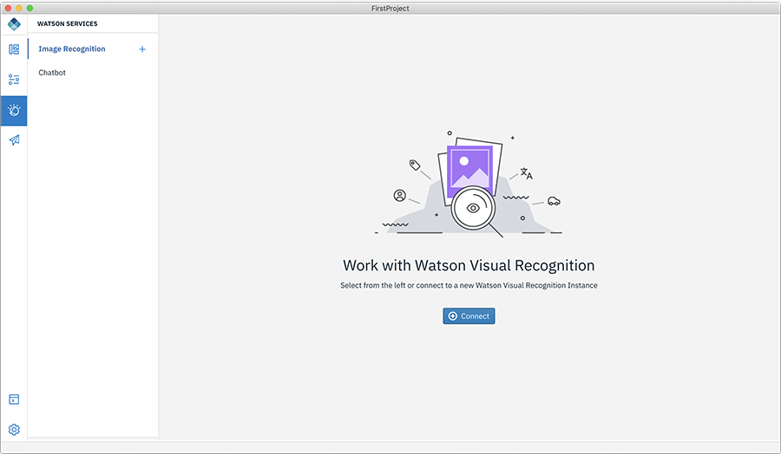

**Step 2:** Click Connect to your Watson Visual Recognition instance.

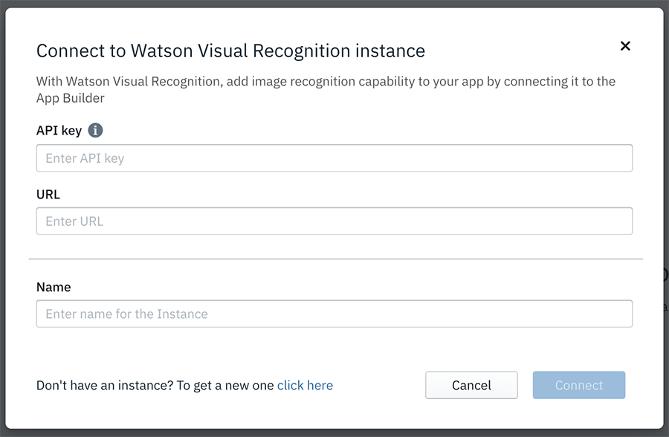

**Step 3:** Enter the API key details and specify the URL of your Watson Visual Recognition instance.

**Step 4:** Provide a Name to your Image Recognition instance in the app and click Connect. This displays the dashboard for your model.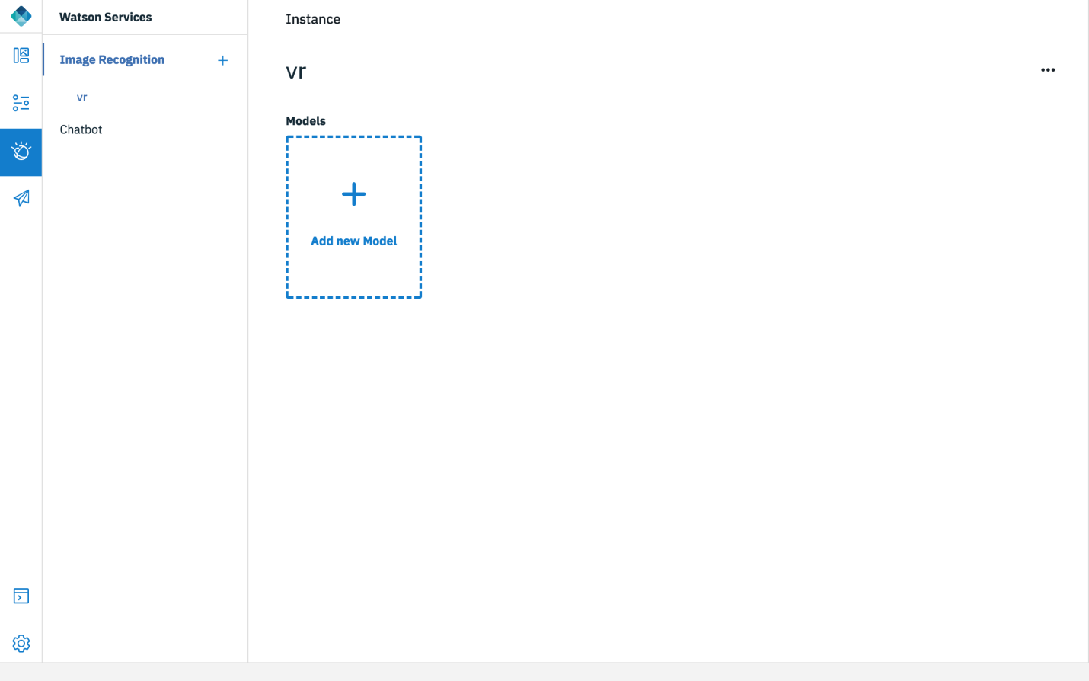

**Step 5:** Click Add new model to create a new model. This will display Create a new Model popup.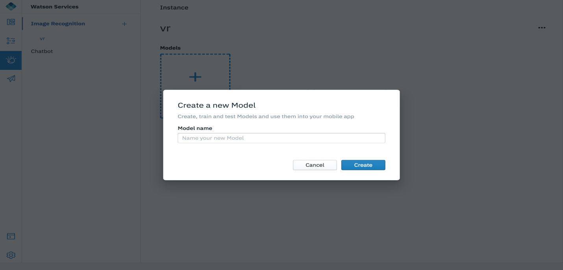

**Step 6:** Enter the Model name and click Create. This will display the classes for that model and a Negative class.

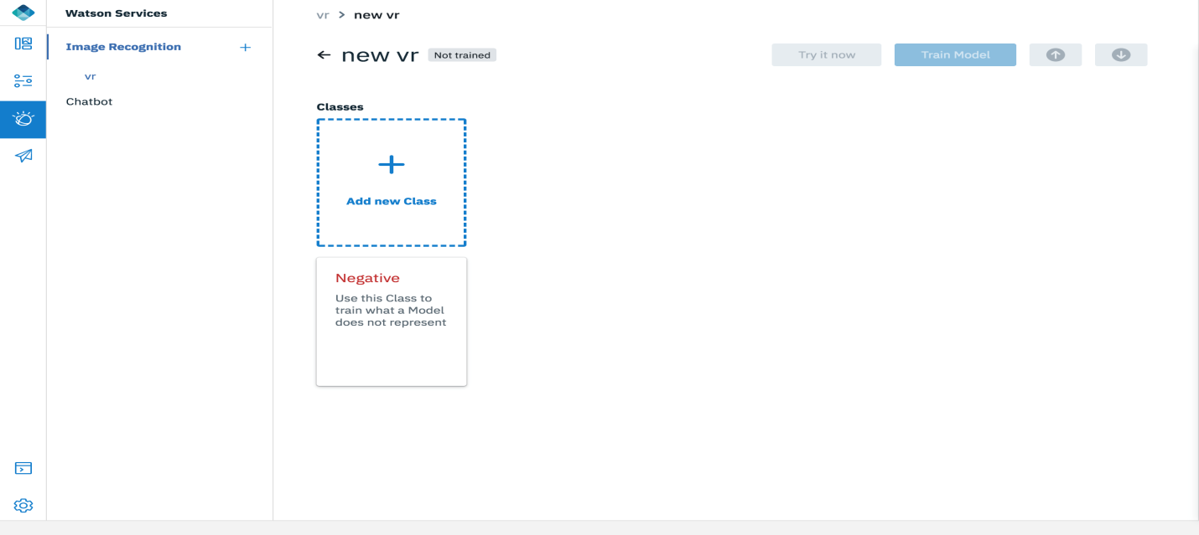

**Step 7:** Click Add new class. This will display a popup to specify a name for the new class.

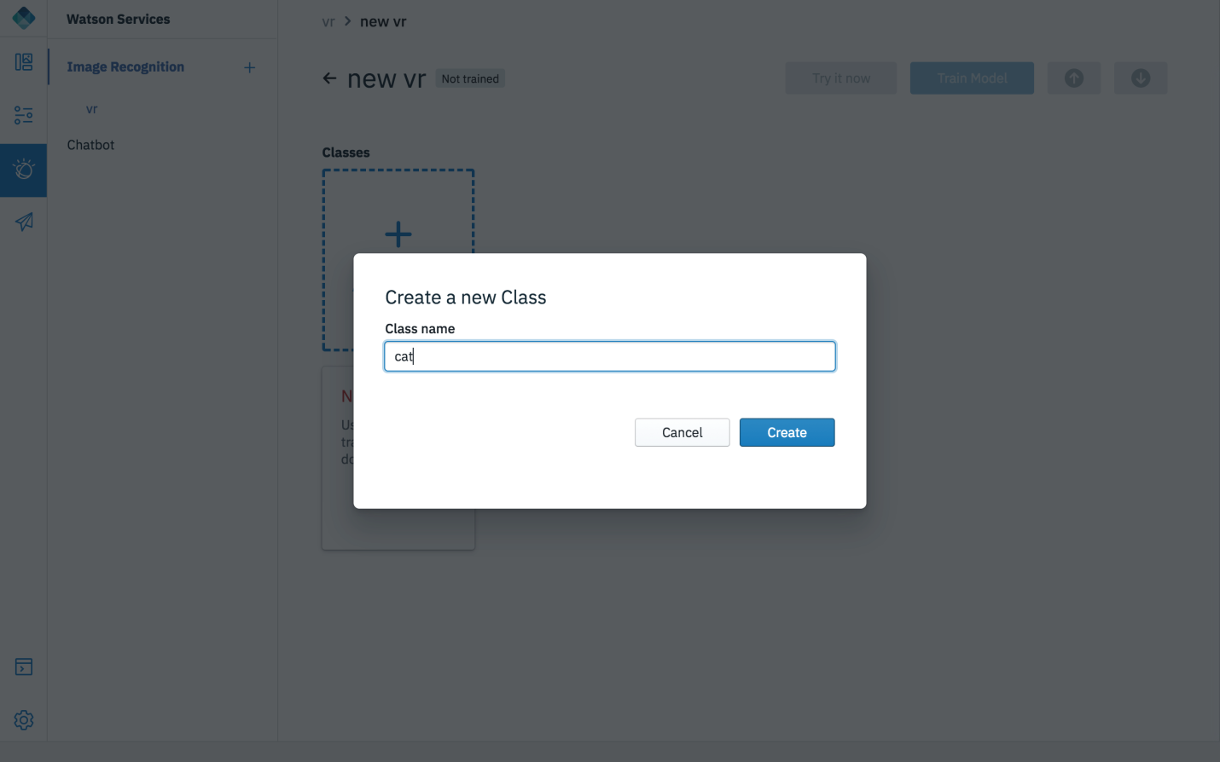

**Step 8:** Enter the Class name for the new class and click Create. This will display the workspace to add your images for training the model.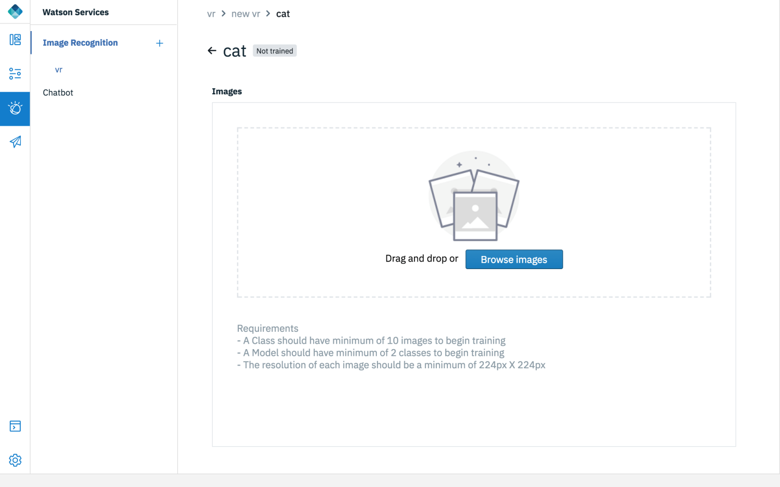

**Step 9:** Add the images to the model either by drag and drop them into the workspace or use Browse to access the images.

**Step 10:** You can go back to your workspace after adding the images and test by clicking Test Model.

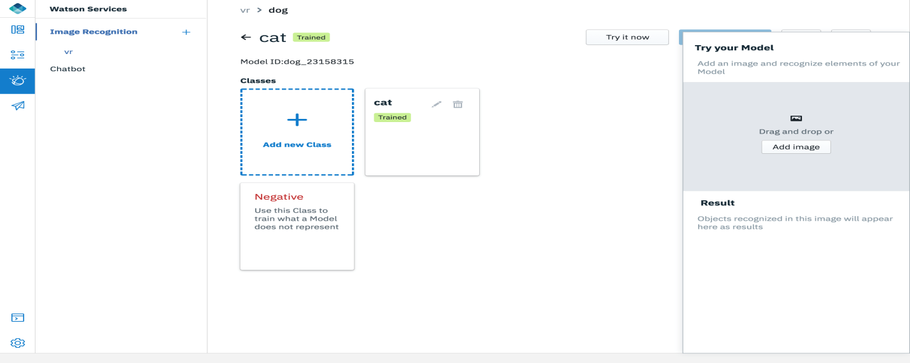

**Step 11:** In the Try your model section, add an image and then result is displayed.