**OBJECTIVES :**

## To review recent findings on the epidemiology, burden, diagnosis, comorbidity, and treatment of depression, particularly in general medical settings; to delineate barriers to the recognition, diagnosis, and optimal management of depression in general medical settings; and to summarize efforts under way to reduce some of these barriers.

### DESIGN

## Medline searches were conducted to identify scientific articles published during the previous 10 years addressing depression in general medical settings and epidemiology, co-occurring conditions, diagnosis, costs, outcomes, and treatment. Articles relevant to the objective were selected and summarized.

## **METHODS**

## Medline searches were conducted to identify scientific articles published during the previous 10 years addressing depression in general medical settings and epidemiology, co-occurring conditions, diagnosis, costs, outcomes, and treatment. Articles relevant to the objective were selected and summarized.

## Major depression is the depressive disorder on which most research has been conducted. Other depressive disorders, such as dysthmyic disorder (“chronic” depression) and mixed depressive-anxiety states, are also common in general medical settings but have been studied far less. Similarly, most research has been done in adult populations; this report notes a few instances of information about children. Except for comoribidity, most of the research in this area has been in primary care settings rather than in more specialized medical environments; most research on treatment has been conducted in specialty mental health settings.

## **DIAGONISE:**

## The diagnosis of major depression is fundamentally clinical. As with most psychiatric disorders, it is made on the basis of a careful clinical interview and mental status examination. Considerable evidence suggests that such an interview is comparable in sensitivity and specificity to many radiologic and laboratory tests commonly used in medicine. The criteria in the DSM-IV ([Table 1](https://www.ncbi.nlm.nih.gov/pmc/articles/PMC1496741/table/tbl1/)) are generally considered the standard diagnostic approach. Major depression is a syndromal diagnosis

## 

## The primary care version of DSM-IV provides in abbreviated form the DSM-IV diagnostic criteria of the mental disorders most commonly seen in primary care settings, including depression.[32](https://www.ncbi.nlm.nih.gov/pmc/articles/PMC1496741/#b32) It also contains symptom-driven algorithms to move from a patient's complaint to a specific diagnosis. A pediatric version has been developed by the American Academy of Pediatrics.

|  |  |  |
| --- | --- | --- |
|  | **TABLE 1:**Five (or more) of the following symptoms have been present during the same 2-week period and represent a change from previous functioning; at least one of the symptoms is either (1) depressed mood or (2) loss of interest or pleasure.† | |
|  | 1. Depressed mood most of the day, nearly every day, as indicated by either subjective report (e.g., feels sad or empty) or observation made by others (e.g., appears tearful). *Note: In children and adolescents, can be irritable mood.* | |
|  | 2. Markedly diminished interest or pleasure in all, or almost all, activities most of the day, nearly every day (as indicated by either subjective account or observation made by others). | |
|  | 3. Significant weight loss when not dieting or weight gain (e.g., a change of more than 5% of body weight in a month), or decrease or increase in appetite nearly every day. *Note: In children, failure to make expected weight gains.* | |
|  | 4. Insomnia or hypersomnia nearly every day. | |
|  | 5. Psychomotor agitation or retardation nearly every day (observable by others, not merely subjective feelings of restlessness or being slowed down). | |
|  | 6. Fatigue or loss of energy nearly every day. | |
|  | 7. Feelings of worthlessness or excessive or inappropriate guilt (which may be delusional) nearly every day (not merely self-reproach or guilt about being sick). | |
|  | 8. Diminished ability to think or concentrate, or indecisiveness, nearly every day (either by subjective account or as observed by others). | |
|  | 9. Recurrent thoughts of death (not just fear of dying), recurrent suicidal ideation without a specific plan, or a suicide attempt or a specific plan for committing suicide. | |
|  | The symptoms do not meet criteria for a Mixed Episode. | |
|  | The symptoms cause clinically significant distress or impairment in social, occupational, or other important areas of functioning. The primary care version of DSM-IV provides in abbreviated form the DSM-IV diagnostic criteria of the mental disorders most commonly seen in primary care settings, including depression.[32](https://www.ncbi.nlm.nih.gov/pmc/articles/PMC1496741/#b32) It also contains symptom-driven algorithms to move from a patient's complaint to a specific diagnosis. A pediatric version has been developed by the American Academy of Pediatrics. | |
|  | |  | |

## **COMORBIDITY:**

## Depression occurs frequently with anxiety disorders and with substance use disorders, including alcoholism. More recent research highlights the relation between nicotine addiction and depression.[35](https://www.ncbi.nlm.nih.gov/pmc/articles/PMC1496741/#b35) Diagnosis of co-occurring depression and substance abuse is complicated, as either condition may overshadow the other. A number of recent textbooks and review articles are devoted to issues of diagnosing and treating depression and other psychiatric disorders in general medical

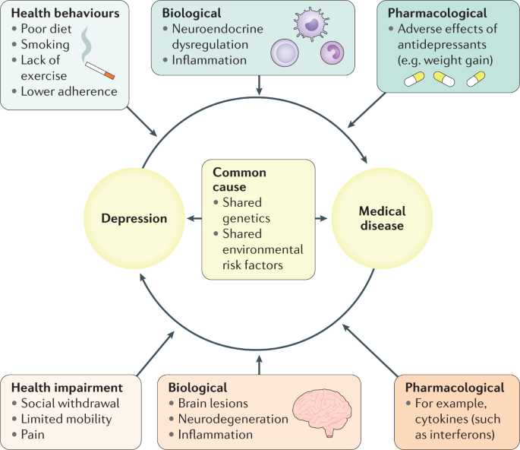

Recent studies and reviews confirm the high rates of depression and its morbidity seen in many general medical conditions, especially those that affect the central nervous system. [Table 2](https://www.ncbi.nlm.nih.gov/pmc/articles/PMC1496741/table/tbl2/) summarizes some of the studies examining the rates of depression in various medical condition.

## **Table 2**

## Rates of Depression Co-Occurring with Other Medical Conditions.

| **Condition** | **Depression Rate, %** | **Comment** |
| --- | --- | --- |
| Myocardial infarction | 20–40 | In 6 months after myocardial infarction |
| Parkinson's disease | 40 | About half major depression, half dysthymia |
| Huntington's disease | 50 | About half major depression, half dysthymia |
| Alzheimer's disease | 30–35 | Generally early in illness course |
| Stroke | 25–50 | Major depression in first year after stroke; risk correlates with site of lesion |
| Cancer | 3–50 | Varies with type, location, stage |
| HIV/AIDS | 10–20 | In later stages, 4%–11% in asymptomatic seropositive |
| Rheumatoid arthritis | 12 | Up to 42% lifetime |
| Diabetes mellitus | 14–18 | 33% lifetime |
| Chronic pain | 30 | 60% lifetime |
| Disabling tinnitus | 60 | 75% lifetime |
| End-stage renal disease | 5–22 |  |
| Spinal cord injury | 37 |  |

## Advanced age also may be an important factor that exists concurrently with depression. Depression in the elderly may be particularly hazardous and costly if untreated, and it also may be more complicated to treat.[39](https://www.ncbi.nlm.nih.gov/pmc/articles/PMC1496741/#b39)–[41](https://www.ncbi.nlm.nih.gov/pmc/articles/PMC1496741/#b41) Finally, untreated depression in the presence of terminal medical illness is one of several psychosocial factors associated with patient requests for physician assistance in dying.[42](https://www.ncbi.nlm.nih.gov/pmc/articles/PMC1496741/#b42)

## **TRENDS OF TREATMENT:**

## Recent trends in the treatment of depression have been driven by scientific advances as well as changes in the practice environment. Over the past 10 years, nine newly marketed antidepressants (fluoxetine [Prozac], sertraline [Zoloft], paroxitene [Paxil], bupropion [Wellbutrin], venlafaxine [Effexor], fluvoxamine [Lu-vox], nefazodone [Serzone], mirtazapine [Remeron], and citalopram [Celexa]) were released in the United States. These drugs are structurally and pharmacologically quite different from the older tricyclic and monoamine oxidase inhibitor agents.

## **:**

## 

## For the most part, these drugs exhibit a more benign side effect profile, a simplified dosing strategy, better patient adherence, and a lower risk of death in overdose situations compared with the older drugs. As a result, they have quickly been adopted in medical settings, and several are among the most commonly prescribed drugs in all of medicine. These newer drugs do, however, continue to demonstrate the delay in full therapeutic action (several or more weeks) seen with older drugs, they generally lack a clear relation between serum drug level and therapeutic response, and some pose risks of significant drug-drug interactions with other medications.43 (e.g., bipolar, psychotic, suicidal, other co-occurrent psychiatric disorders such as substance use disorders) or treatment-refractory illnesses, or those requiring specialized treatments (e.g., electroconvulsive therapy, light therapy, cognitive-behavioral psychotherapy) may be followed in the specialty mental health sector.

## There has been a dramatic rise in recent years of mental or behavioral health “carve outs,” where an organizational entity contracts with a managed care organization or other general health provider to provide all services for patients identified as in need of mental health services. This entity may be clinically or geographically distinct from the primary medical care setting.

## **MANAGEMENT IN GENERAL MEDICAL SETTINGS:**

## A number of studies indicate that about half of those with psychiatric disorders (including depression) are detected in primary care settings.[54](https://www.ncbi.nlm.nih.gov/pmc/articles/PMC1496741/#b54) Only about half of these receive any treatment, and that occurs largely (50% to 75% of the time) in the primary care setting rather than in the mental health care system.

## A multisite outpatient study of health care system factors in the recognition and care of depressed patients found that 46% to 51% of these patients were recognized by medical clinicians, while 78% to 87% were recognized by mental health specialists.[55](https://www.ncbi.nlm.nih.gov/pmc/articles/PMC1496741/#b55) Among the medical clinicians, depression was less likely to be recognized or treated under a prepaid system than under fee-for-service care. Nonetheless, depression outcomes in the general medical sector were similar under prepaid and fee-for-service care (because rates of treatment were similarly low to moderate in both payment systems).[56](https://www.ncbi.nlm.nih.gov/pmc/articles/PMC1496741/#b56)

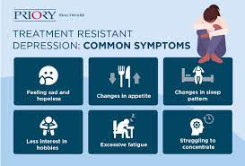

## Several studies have examined physician factors that may influence recognition of depression. In one study, high physician interest in psychosocial issues did not correlate with the type of interviewing behaviors necessary to diagnose depression. Several specific interviewing behaviors did, however, lead to great recognition of depression, including open-ended questioning, periodically summarizing the patient's information, and responding to nonverbal and emotional patient cues.[57](https://www.ncbi.nlm.nih.gov/pmc/articles/PMC1496741/#b57) Robbins and colleagues found that primary care physicians who were more sensitive to affective and nonverbal patient cues made more psychiatric diagnoses, and physicians who tended to blame patients for their depression made fewer and less accurate diagnoses.[58](https://www.ncbi.nlm.nih.gov/pmc/articles/PMC1496741/#b58) Overall, these authors found that false-positive psychiatric diagnoses were uncommon.

## **BARRIERS TO OPTIMAL MANAGEMENT:**

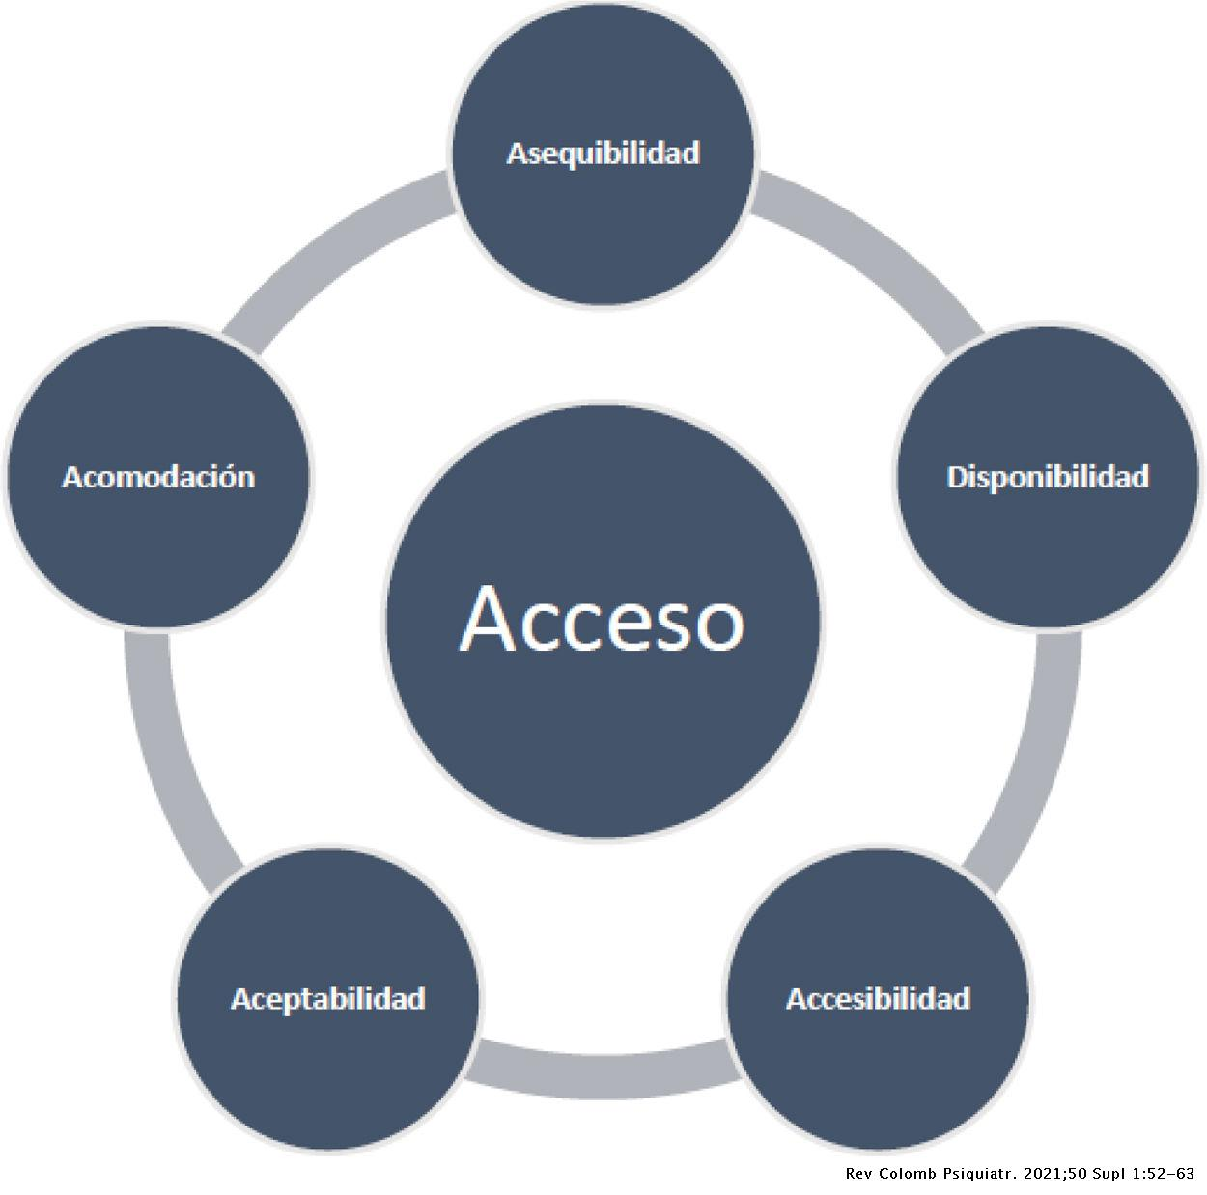

## Because of the stigma still attached to psychiatric illnesses, many patients are reluctant to acknowledge to themselves or their physicians that they are experiencing emotional distress. Patients may deny or minimize symptoms, rationalize them as expectable because of life stresses or as due to other general medical problems, believe them to be failures of will or moral shortcomings, or not see them as within the physician's purview or capabilities. These attitudes may be reinforced by familial or cultural beliefs. Similarly, patients may be reluctant to disclose information they fear could be included in insurance or employment records; they may be especially concerned about having a psychiatric diagnosis recorded.[80](https://www.ncbi.nlm.nih.gov/pmc/articles/PMC1496741/#b80)

## Attention also has been called to physician deficits in this area.[81](https://www.ncbi.nlm.nih.gov/pmc/articles/PMC1496741/#b81),[82](https://www.ncbi.nlm.nih.gov/pmc/articles/PMC1496741/#b82) Some physicians harbor the belief that depression is not a “real” illness. Some believe that depression reflects a personal shortcoming or laziness and is thus something the patient could improve with more effort, willpower, or “positive thinking.” Others are doubtful about the existence of depression as a clinical entity because of the absence of confirmatory laboratory or radiologic studies. These doubts may take different forms, from simply never inquiring about depressive symptoms to having an unduly high threshold for considering depression in the differential diagnosis of a patient's chief complaint.

### Diagnostic Barriers:

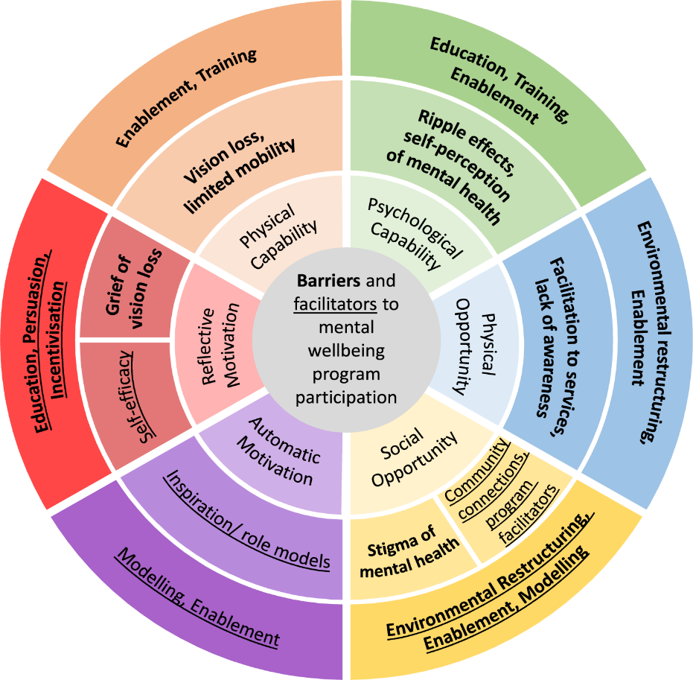

## The DSM-IV criteria were developed largely in psychiatric settings, and some have questioned their applicability to primary care and other medical situations. One controversy concerns patients who meet some but not all criteria for major depression, a group encountered far more often in primary care than psychiatric settings. Another problematic group are those with mixed symptoms of depression and anxiety that fall short of DSM-IV thresholds for a disorder. Patients in either of these groups may be symptomatic and have functional impairment but, because they fail to meet full diagnostic criteria, may not be appropriately diagnosed or treated.

## **ACTIVITIES TO REDUCE BARRIERS:**

## Many professional organizations and advocacy groups have drawn attention to the under treatment of depression and the need to increase public and professional awareness. For example, a consensus panel sponsored by the National Depression and Manic-Depressive Association issued a report on under treatment of depression,[93](https://www.ncbi.nlm.nih.gov/pmc/articles/PMC1496741/#b93) proposing five immediate steps to reduce the gap between knowledge about depression and actual treatment received: enhancing the role of patients and families, developing performance standards for behaviour health care, increasing provider knowledge and awareness, enhancing collaboration among providers for disease management, and conducting research for new treatments.

**CONCLUSIONS:**

## Depression occurs commonly, causing suffering, functional impairment, increased risk of suicide, added health care costs, and productivity losses. Effective treatments are available both when depression occurs alone and when it co-occurs with general medical illnesses. Many cases of depression seen in general medical settings are suitable for treatment within those settings. About half of all cases of depression in primary care settings are recognized, although subsequent treatments often fall short of existing practice guidelines. When treatments of documented efficacy are used, short-term patient outcomes are generally good. Barriers to diagnosing and treating depression include stigma; patient somatization and denial; physician knowledge and skill deficits; limited time; lack of availability of providers and treatments; limitations of third-party coverage.

**Keywords**: depression, mental health, knowledge, attitudes, practice, health service accessibility, comorbidity

BY

SANJAI.C

**712521104035**