**Theft Control Methodology**

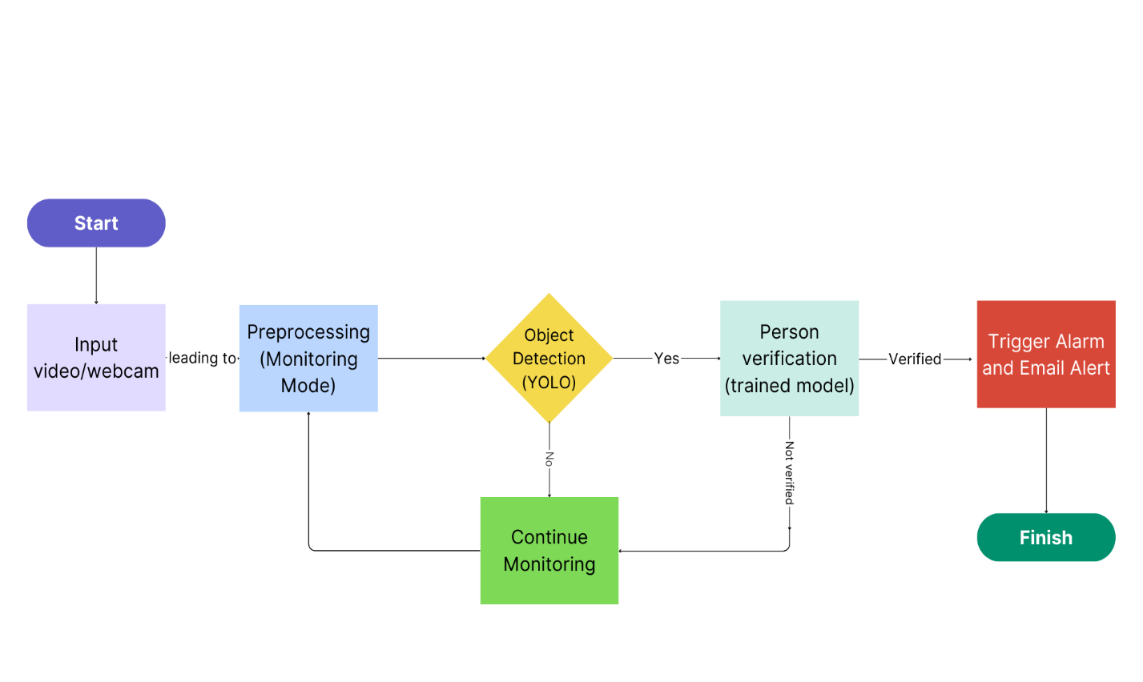

**Input:**

The input source is the webcam of your laptop. The webcam continuously captures video frames of the jewellery shop's interior.

**Preprocessing:**

Preprocess the raw video frames to enhance the quality and reduce noise if necessary. This step may include resizing, normalization, or noise reduction techniques.

**Object Detection with YOLO (You Only Look Once):**

Apply the YOLO algorithm to the pre-processed video frames. YOLO detects objects, including persons, in the video frames.

**Person Verification (trained model):**

Utilize our trained model/weights for person detection.

Pass the detected objects from the YOLO output through the model to confirm the presence of a person accurately.

**Alarm Activation and Email Notification:**

If a person is detected with sufficient confidence, trigger the alarm system.

Upon person detection, send an email notification to the owner's designated email address.