Password Manager Design Document
CSE 222 Advanced Programming Workshop I - Python
Student | Sudenur Olmus
Current milestone | Milestone 3 - Password Entry Management
Private GitHub repository | https://github.com/sudenurolmus013-hub/F26_CSE222_sudenur_olmus_password

Project Description
The Password Manager is a desktop application written in Python with Tkinter. It will allow a user to create an account, log in, add unique password records, search for records, delete records, and display saved records alphabetically. Account and password-entry data will persist between sessions, and password entries will be encrypted before they are stored in a file.
This document records the design decisions and implementation status for each project milestone. Milestones 1 and 2 are implemented in the current repository. Later milestones remain planned work and will be updated as development continues.

Milestone 1 Initial GUI Create Account Login Cancel
Milestone 1 established the application structure. The opening window presents Create Account, Login, and Cancel controls. Create Account and Login each open a separate class in the gui folder. Both secondary windows are centered over the main window and include Cancel controls so the user can close them safely without exiting the application.

Implementation Steps
1. Created the application entry point. The main.py file creates the MainWindow object and starts Tkinter's event loop. Keeping the entry point small makes the program easier to extend without mixing startup logic and interface code.
2. Built the opening window. MainWindow inherits from tk.Tk and uses ttk widgets to provide the three required buttons. The window is centered, sized consistently, and includes directions for the user.
3. Separated account and login windows. AccountGUI and LoginGUI each inherit from tk.Toplevel and are stored in separate files in the gui folder. This meets the class-and-module requirement and keeps each interface focused on one responsibility.
4. Prepared the next milestone's inputs. The account form contains username, password, and confirmation fields. The login form contains username and password fields. Password entries are masked and input is right aligned as required for later login work.
5. Added safe navigation. The Cancel button in the Create Account window and the Cancel button in the Login window both call destroy on their own dialog. This closes only the active dialog and leaves the opening application window available.

Error Handling
Milestone 1 establishes safe window behavior. Each action uses a dedicated command handler, and a dialog can be cancelled without closing the entire application. Input validation and data errors are addressed in the Milestone 2 section.
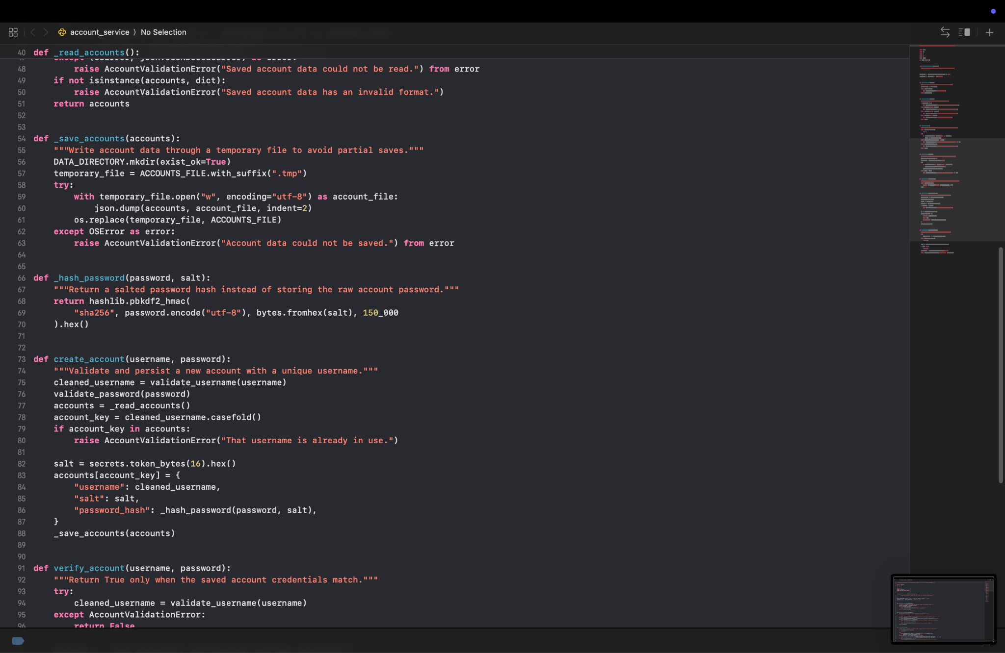
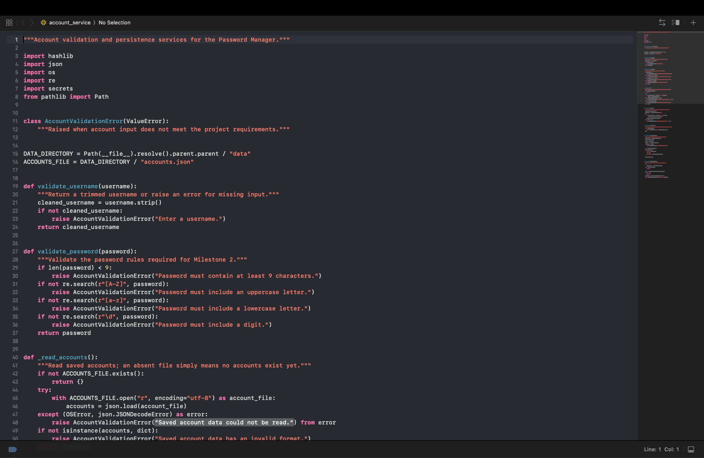
Program Screenshots

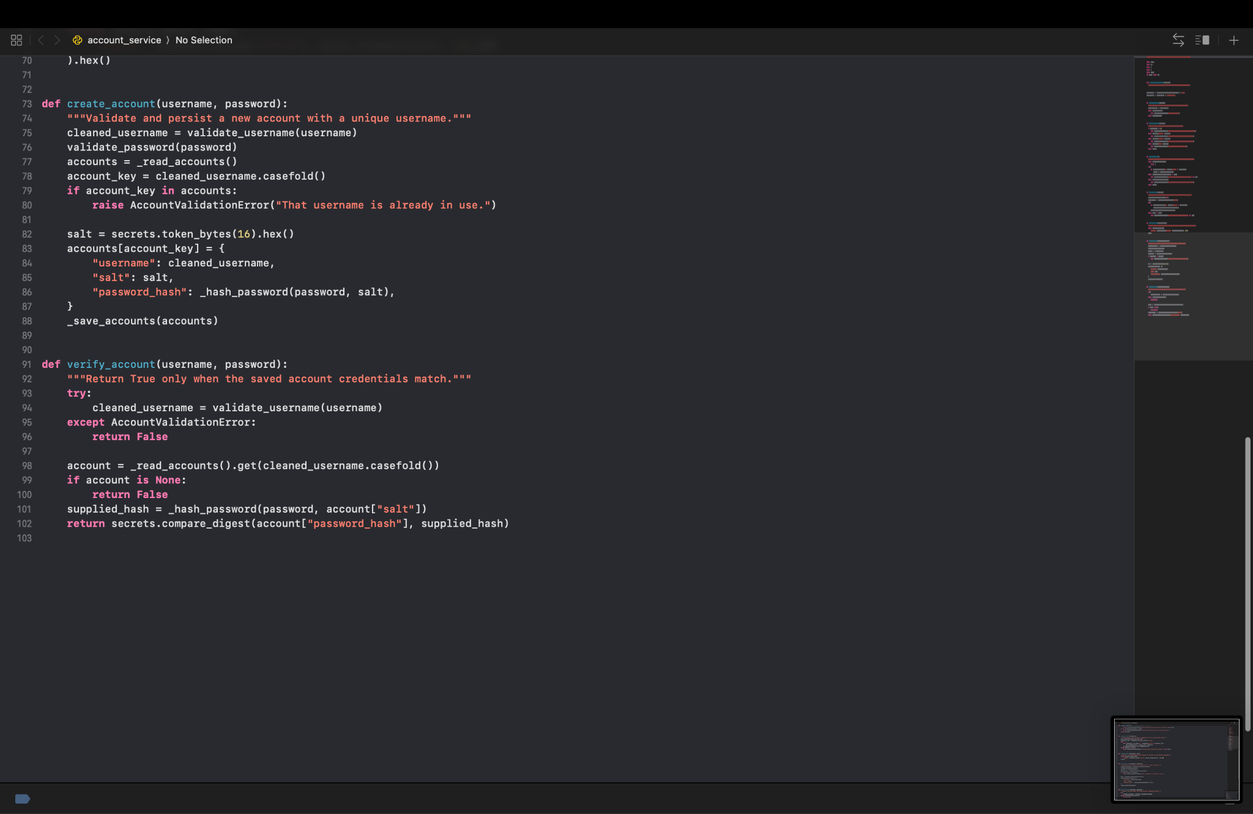
Milestone 2 Create Account Login and Main Interface

Implementation Steps
1. Isolated account rules in application/account_service.py. Validation and file operations are separated from the GUI so that the same account rules are used consistently by the Create Account and Login windows. This also made the service possible to test without opening Tkinter windows.
2. Validated each password requirement. The service rejects a password that has fewer than nine characters or lacks an uppercase letter, lowercase letter, or digit. Username input is trimmed and must not be blank.
3. Stored accounts safely. Accounts are saved in data/accounts.json. Usernames are stored case-insensitively to prevent duplicates such as Student and STUDENT. Passwords are stored as salted PBKDF2 hashes rather than plaintext, and a temporary file is replaced only after the JSON write succeeds.
4. Completed account creation. The Account Creation window compares the two password fields, displays specific error messages, clears invalid password input, saves valid accounts, and closes after confirming success. Its Cancel button closes only that dialog.
5. Completed login behavior. The Login window calls verify_account through its own handler, supports the Enter key, right-aligns inputs, disables Login while a verification attempt is running, clears the password field after an invalid attempt, and restores the button for another attempt. The Cancel button closes the dialog.
6. Added the prepared main interface. After successful login, the main root window is rebuilt rather than opening an unmanaged duplicate. It includes Description, Username, and Password fields with Update, Search, Display All, and Log Out controls. Update stays disabled until all three fields contain text, while the later-milestone commands remain disabled because no records exist yet.
7. Verified the account layer. Automated tests cover a valid saved login, duplicate usernames, invalid passwords, and an incorrect password. The tests use a temporary data directory so they do not alter a user's actual account file.

Error Handling
- Blank usernames, short passwords, and missing uppercase, lowercase, or digit characters display an Account Error message.
- Duplicate usernames are rejected case-insensitively before any account file is overwritten.
- A password-confirmation mismatch clears both password fields, allowing the user to retry without retaining a visible password.
- Unreadable or malformed account data produces a user-facing Account Error or Login Error instead of crashing the program.
- Invalid login credentials clear the password entry, return focus to it, and re-enable the Login button.

Git Progression
The following Milestone 2 commits record the incremental development of the feature set
- e52d481 - Add Milestone 2 account validation rules
- e120e8f - Persist unique accounts in local data file
- a7473e6 - Connect account window to validation and storage
- 9238287 - Add saved account credential verification
- 5588e95 - Complete login validation and cancel control
- 95d3c37 - Show prepared main interface after login
- 1e07991 - Fix login dialog button layout
- dc7ceb8 - Test account validation and login persistence

Milestone 3 Accept and Store New Information
Planned implementation for this milestone:
- Accept a unique description, username, and password from the main interface.
- Alert the user when a duplicate description is entered and retain valid records between sessions.
- Add screenshots and a peer-review record after the milestone is completed.
Add step-by-step evidence, error-handling details, and real screenshots when this milestone is implemented.
Milestone 3 Accept, Store, Search, and Display Password Entries — Completed

Purpose and result
Milestone 3 connects the post-login form to persistent password-entry storage. A user can add an entry with Update, search by its description, and view all entries in a separate alphabetically sorted window. These features turn the earlier form into a usable entry-management workflow while keeping duplicate descriptions out and avoiding plaintext password display in the GUI.

Update: validation and saving
Update reads the description, username, and password fields. It rejects a field that is empty or contains only whitespace before attempting storage. It then loads the existing records and compares descriptions after trimming surrounding spaces and applying case-folding. This prevents duplicates such as “Email” and “ email ” while preserving the original spelling used for display. A new record is appended to the existing list, and the success message is shown only after saving completes. The separation is important: a success notification must not imply that a failed write worked.

Persistent JSON storage and safe writes
PasswordEntryStorage uses data/password_entries.json by default. Loading a missing file starts with an empty list; malformed JSON, invalid records, and file-read errors are reported through PasswordEntryStorageError. Saving validates the complete list, writes a temporary file in the same folder, and replaces the destination with os.replace. This reduces the chance that an interrupted write leaves a partly written file. Existing malformed data is not silently replaced. Password values are currently stored as ordinary JSON text and are not encrypted at rest; encryption remains future work.

Duplicate and input validation
The GUI rejects whitespace-only form fields before saving. The storage service also validates every record when reading or saving, requiring nonempty string descriptions, usernames, and passwords. Descriptions must be unique without regard to case or surrounding spaces. Keeping checks in the storage layer protects saved data even when it is read from a file rather than entered through the GUI.

Searching by description
Search requires a nonblank description, loads current entries from disk, and finds a case-insensitive, whitespace-trimmed match. A match fills the existing username and password fields. A missing match gets a helpful message, and a storage error is displayed instead of crashing the application. The password input is created with Tkinter’s show="*" option, so the retrieved value remains masked in the form.

Displaying all entries
The main form also masks the password input field with Tkinter:
self._add_main_entry(frame, "Password:", self.entry_password, 5, show="*")
Display All loads the saved entries and opens a separate scrollable Treeview window. Entries are sorted by description.casefold(), so alphabetical ordering does not depend on capitalization. The table includes description and username, but inserts a fixed asterisk mask for every password; it never puts the stored password into the display table. Empty storage produces an informational message, and read errors produce a storage-error message.

Representative code from the project
The Update callback validates required values, checks for a duplicate description, and only then saves the new entry alongside the records already loaded:
if not all(value.strip() for value in (description, username, password)):
messagebox.showerror(
"Missing Information",
"Please enter a description, username, and password before updating.",
parent=self,
)
return

storage = PasswordEntryStorage()
description_key = description.strip().casefold()
if any(
entry.description.strip().casefold() == description_key
for entry in storage.entries
):
messagebox.showerror(
"Duplicate Description",
"An entry with this description already exists. Please choose a unique description.",
parent=self,
)
return

storage.save_entries(
storage.entries + [PasswordEntry(description, username, password)]
)
The storage service writes JSON to a temporary file and atomically replaces the destination after the write succeeds:
with tempfile.NamedTemporaryFile(
mode="w",
encoding="utf-8",
dir=self.file_path.parent,
prefix=f"{self.file_path.stem}-",
suffix=".tmp",
delete=False,
) as entries_file:
temporary_file = Path(entries_file.name)
json.dump(
[entry.__dict__ for entry in validated_entries],
entries_file,
indent=2,
)
os.replace(temporary_file, self.file_path)
The storage service normalizes the description in the same way for searching:
description_key = description.strip().casefold()
for entry in self.entries:
if entry.description.strip().casefold() == description_key:
return entry
return None
Display All sorts by a normalized description and passes only a fixed mask into the table:
sorted_entries = sorted(
entries, key=lambda saved_entry: saved_entry.description.casefold()
)
for entry in sorted_entries:
entry_table.insert(
"",
"end",
values=(entry.description, entry.username, "********"),
)

Error handling and data safety
The GUI catches PasswordEntryStorageError for Update, Search, and Display All, then displays an error dialog. Tests confirm that corrupt JSON is not overwritten and that failed writes preserve the previous file contents. Search and Display All read data only; neither feature modifies the saved entries file.

Automated and manual testing
Automated verification was run with /usr/local/bin/python3 -B -m unittest discover -s tests -v. The complete suite passed all 34 tests. GUI callbacks are tested with mocks rather than opening real windows, and storage tests use temporary directories and fake credentials. Coverage includes multiple entries, reload after creating a fresh storage instance (simulating an application restart), case-insensitive duplicate rejection, successful and missing searches, empty fields, corrupted storage, write failure preservation, alphabetical display order, and masking passwords in the table.
Manual testing: Update, Search, and Display All were tested in the running application. The owner confirmed that saving a demonstration entry showed a success dialog, Search repopulated saved fields, and Display All showed DemoSO1 before NetflixTest in alphabetical order with masked passwords. Insert the original screenshots below to document these checks; no screenshot has been embedded in this version.

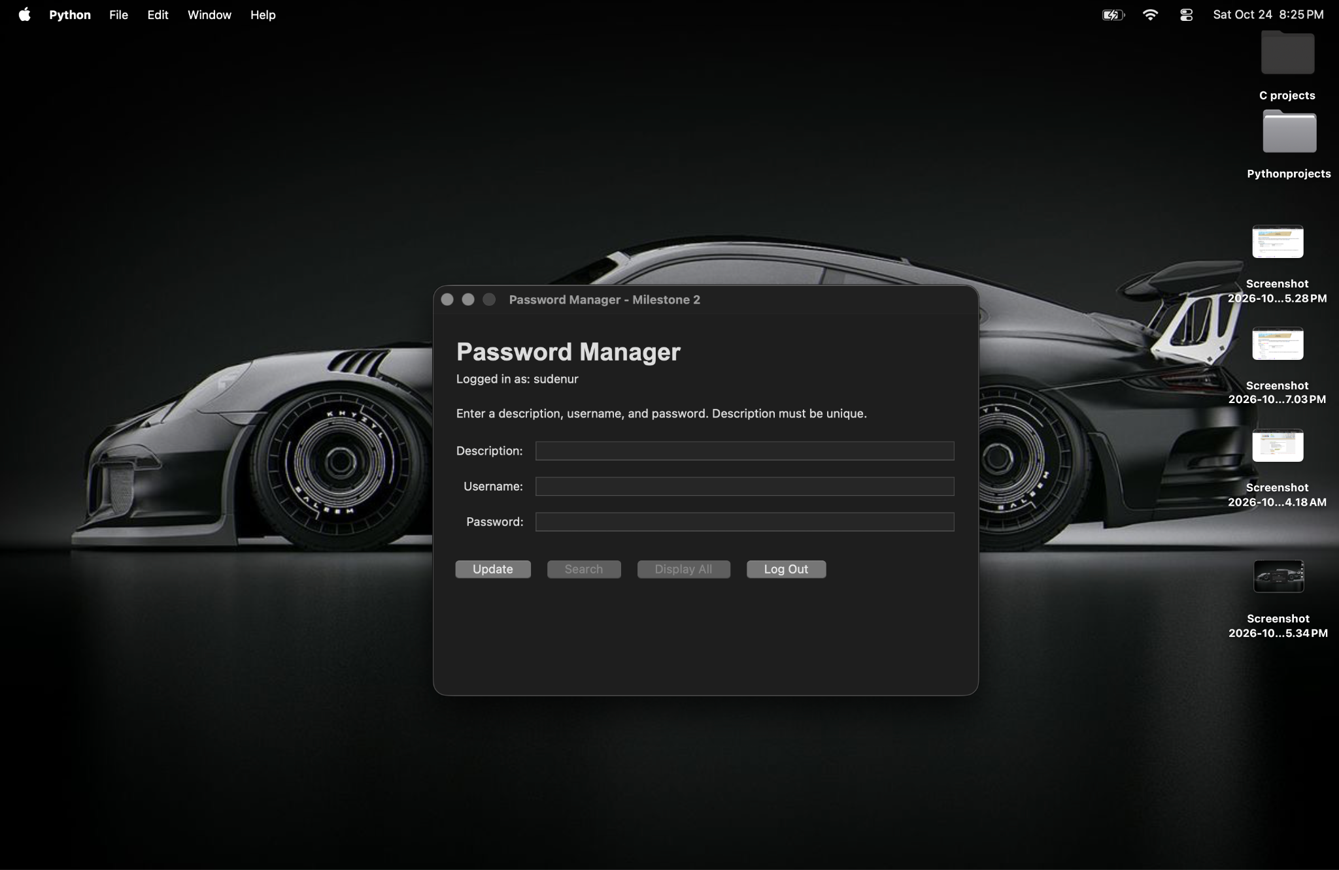
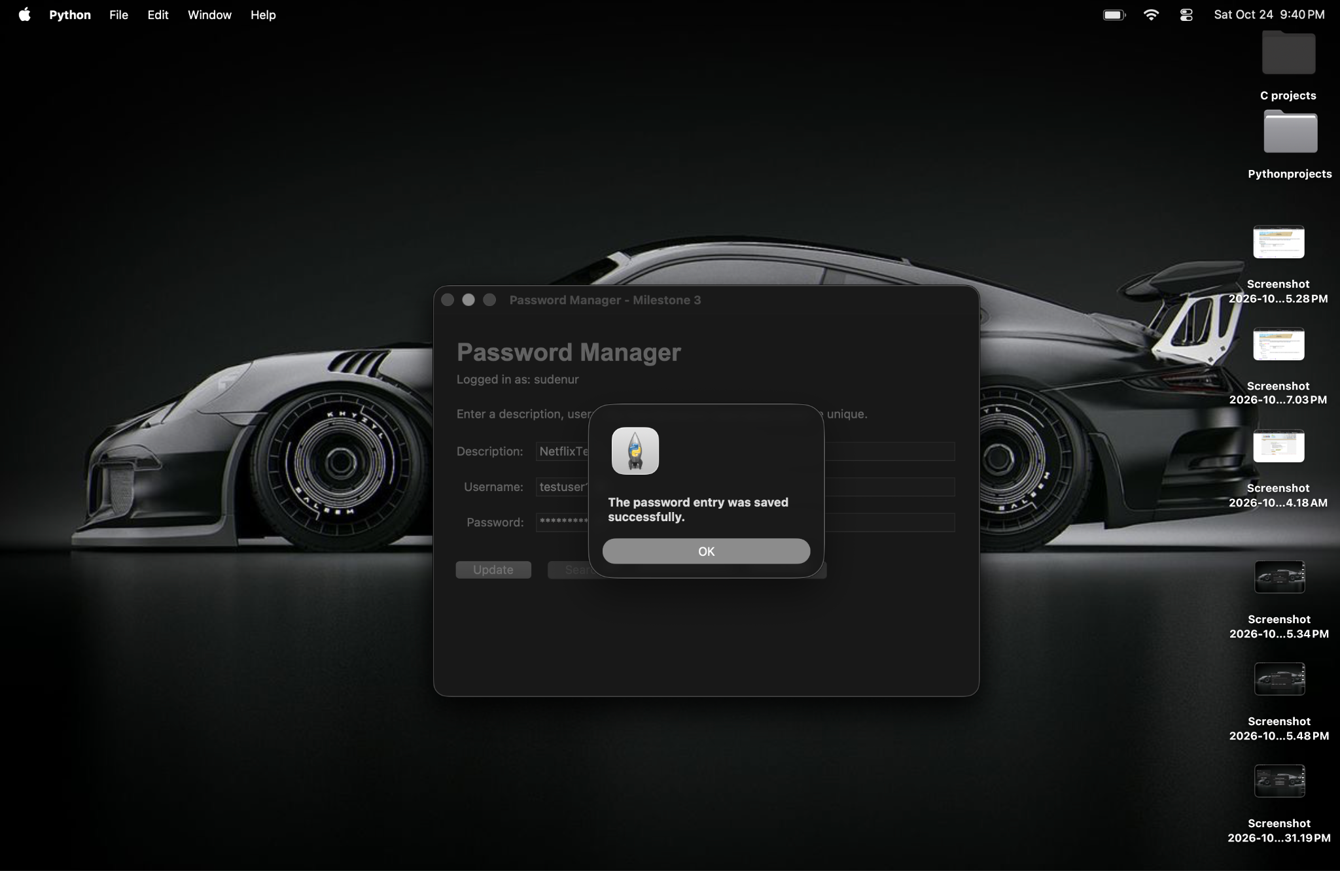
Milestone 3 screenshot evidence

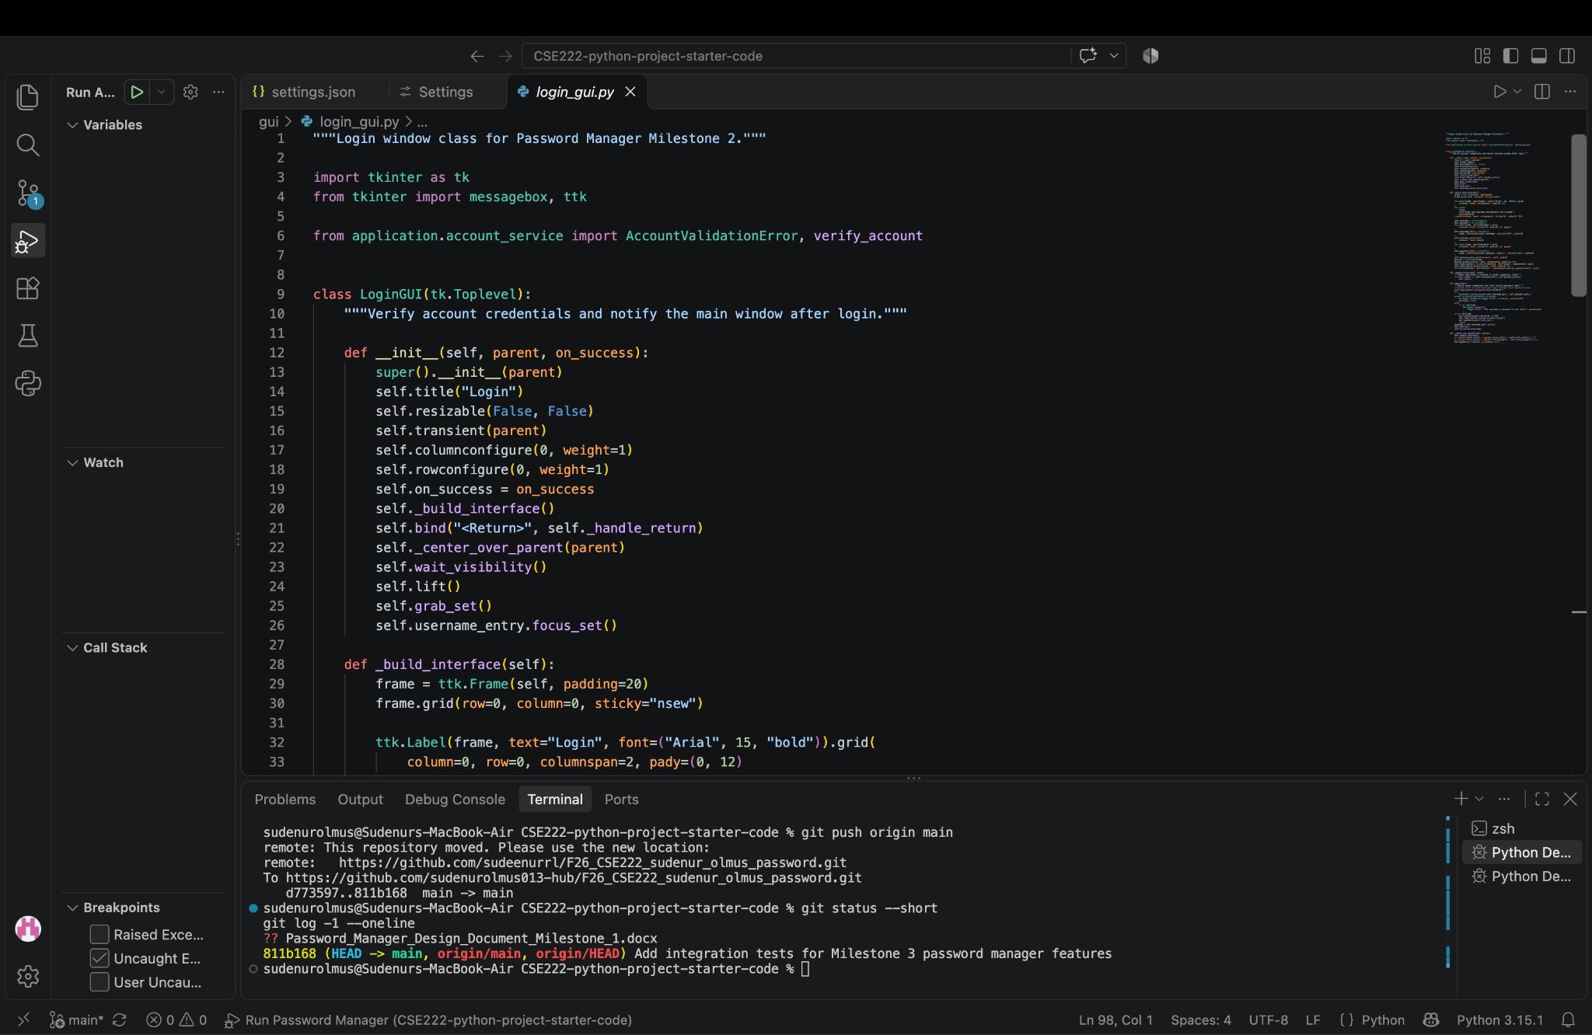
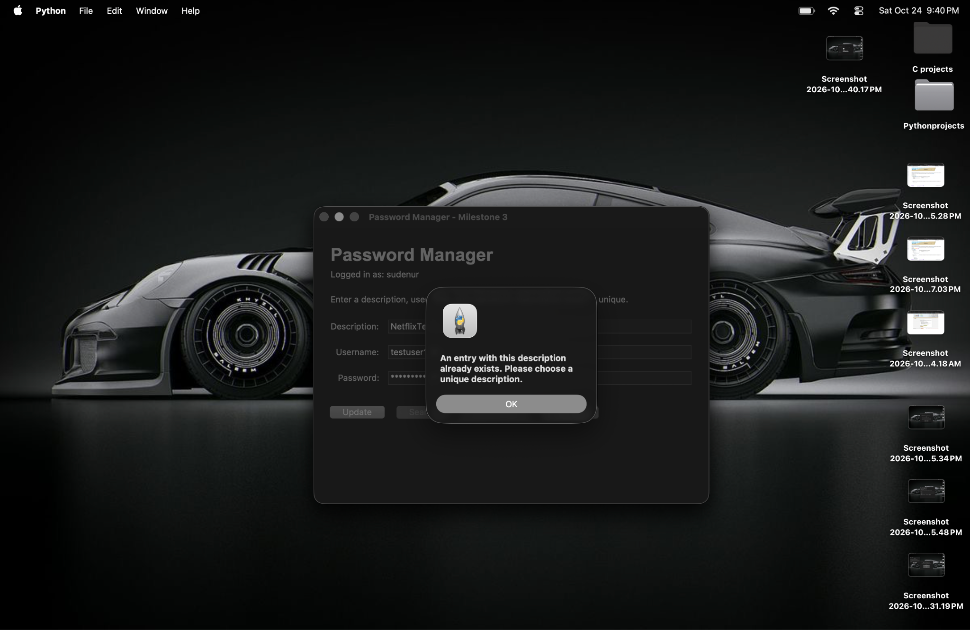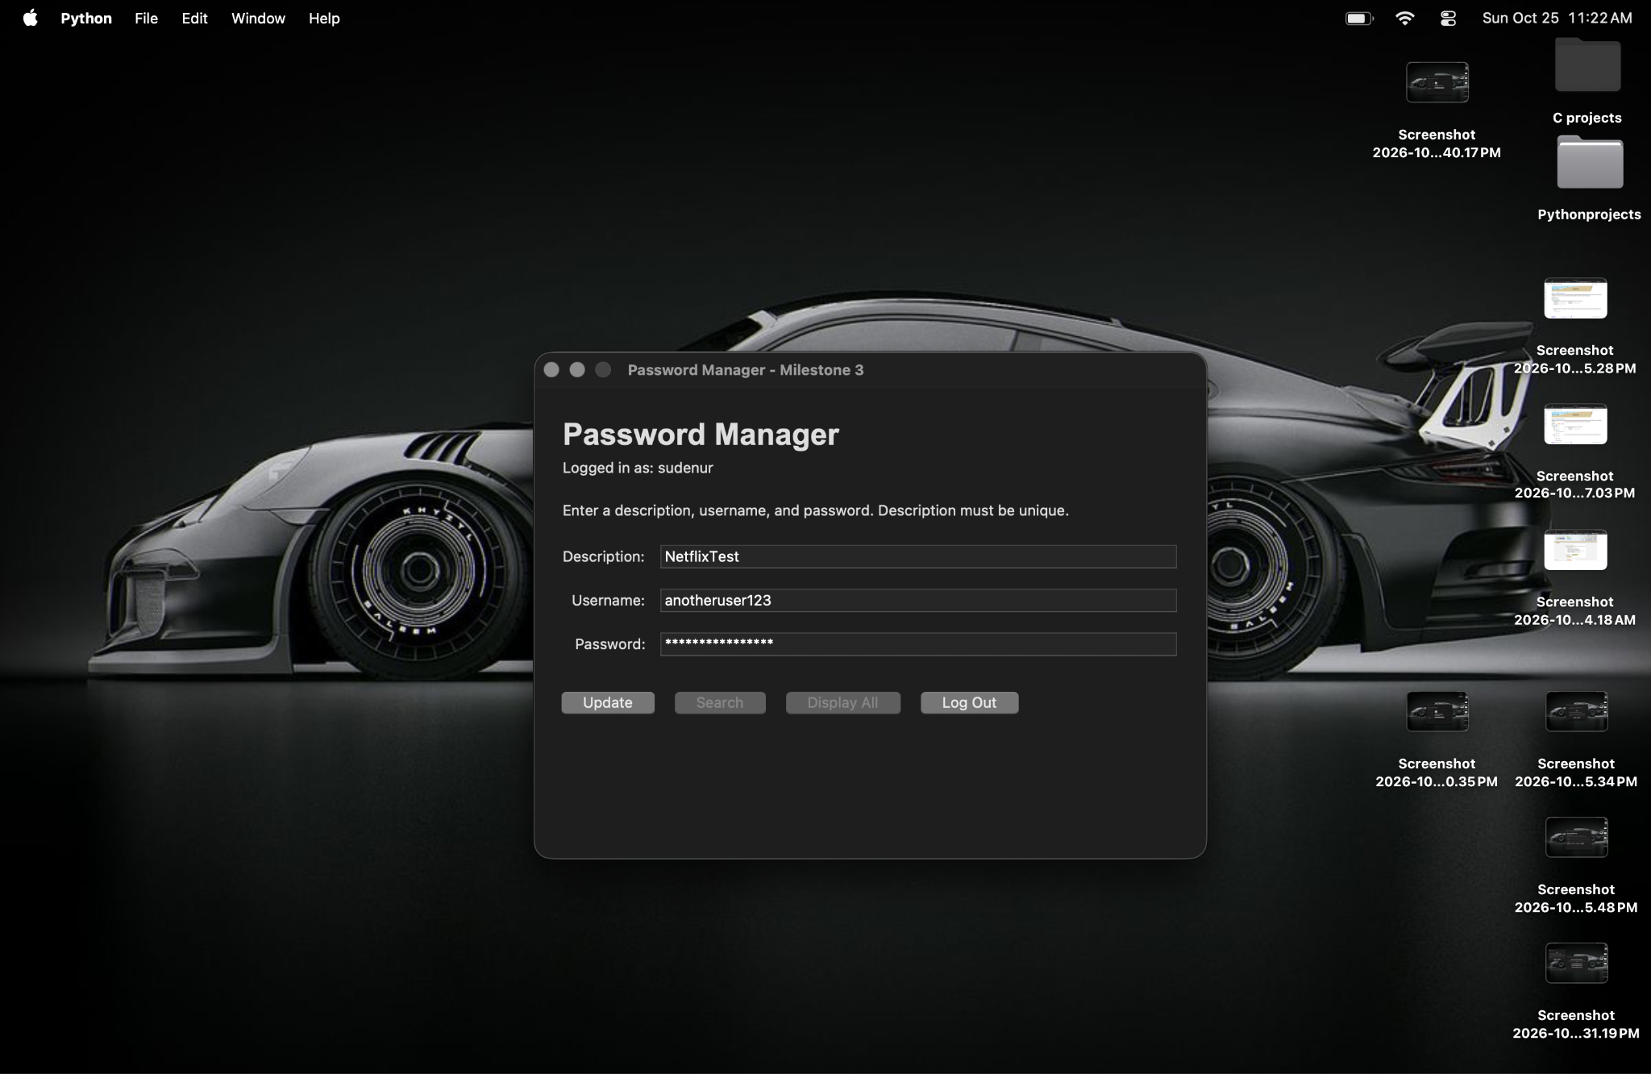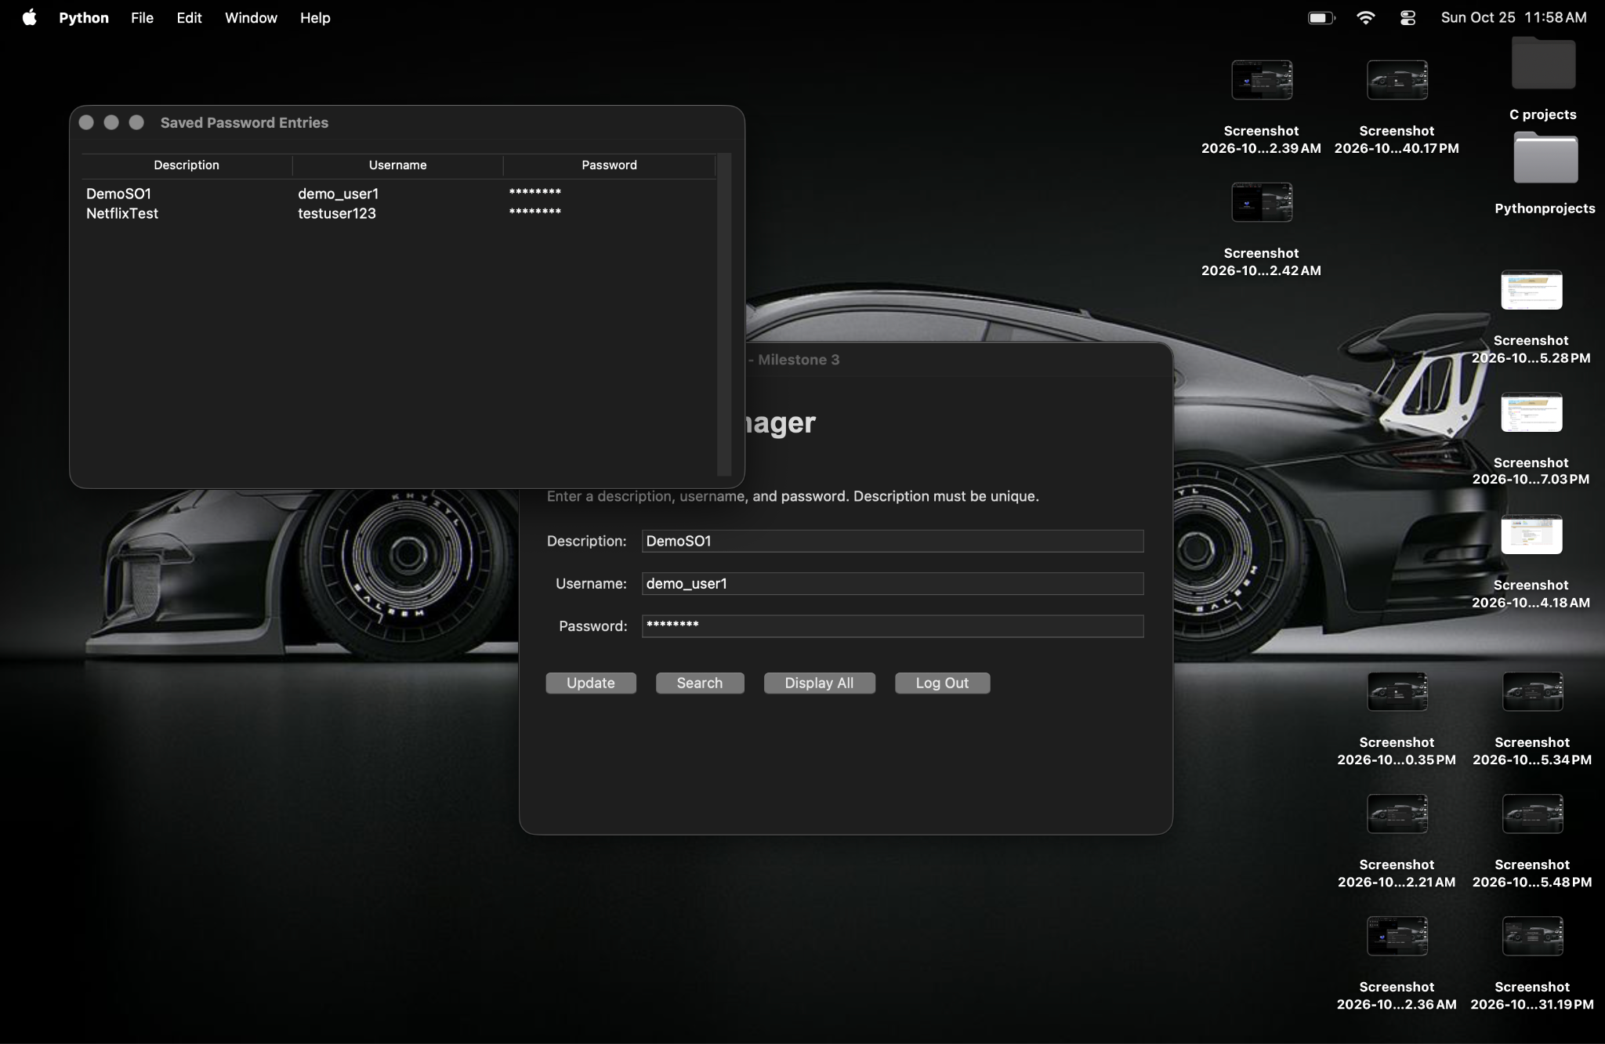
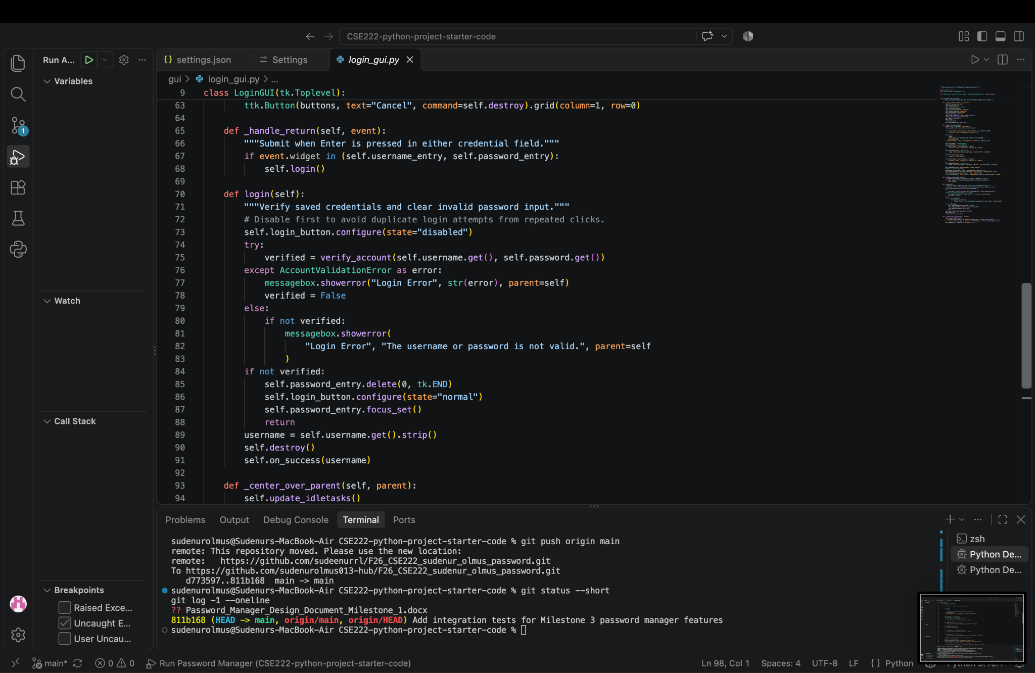
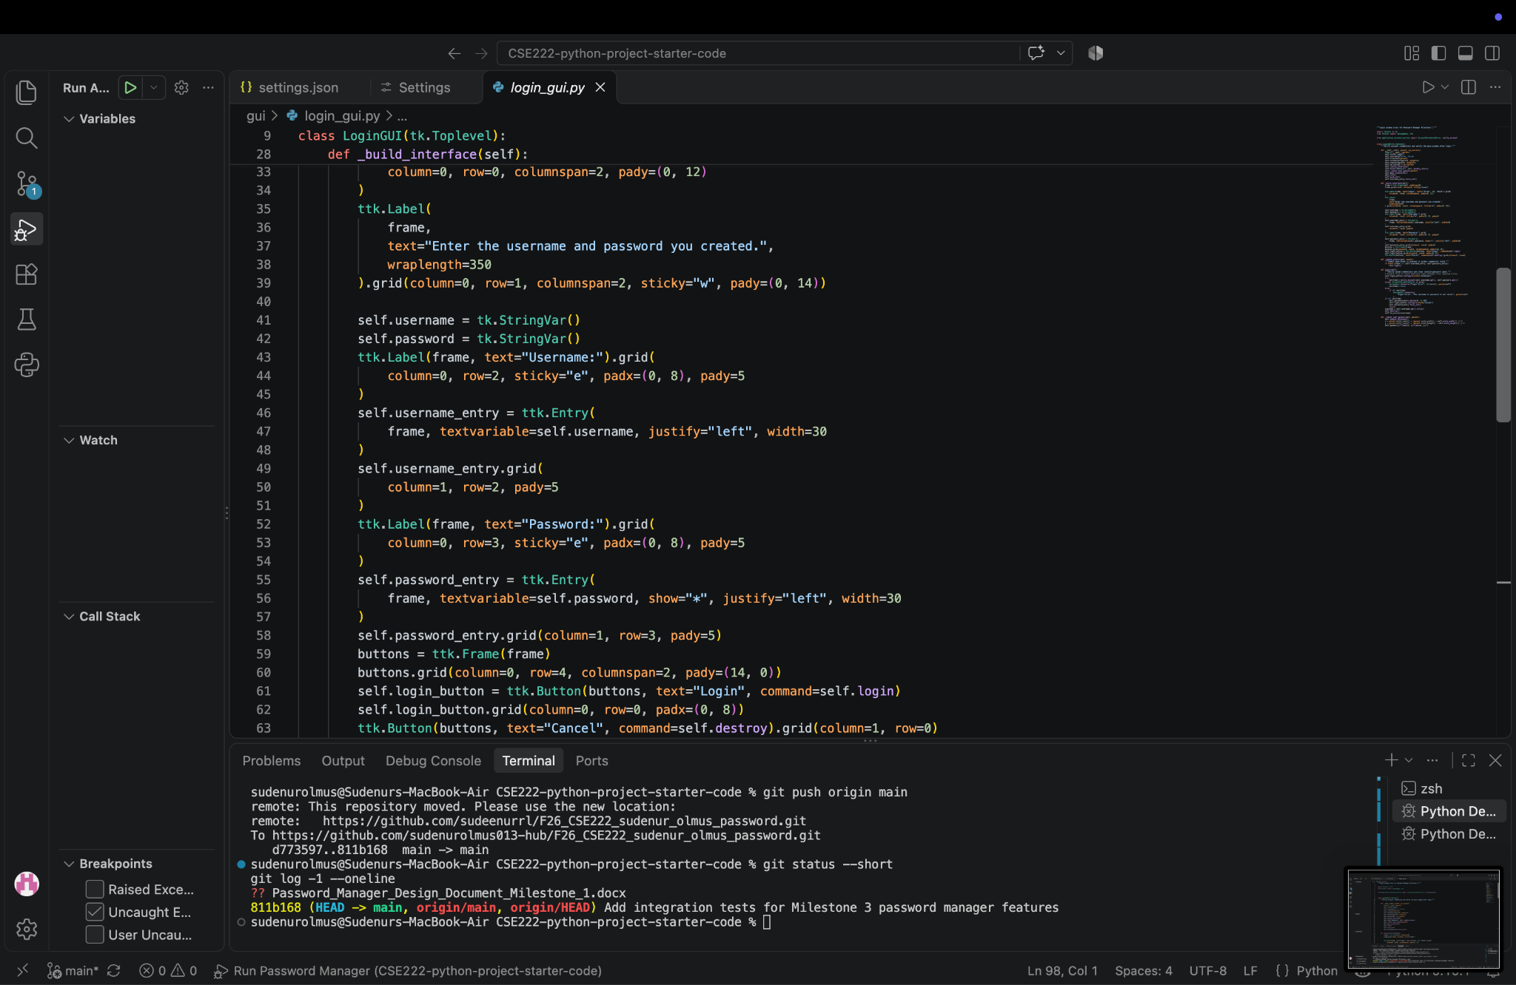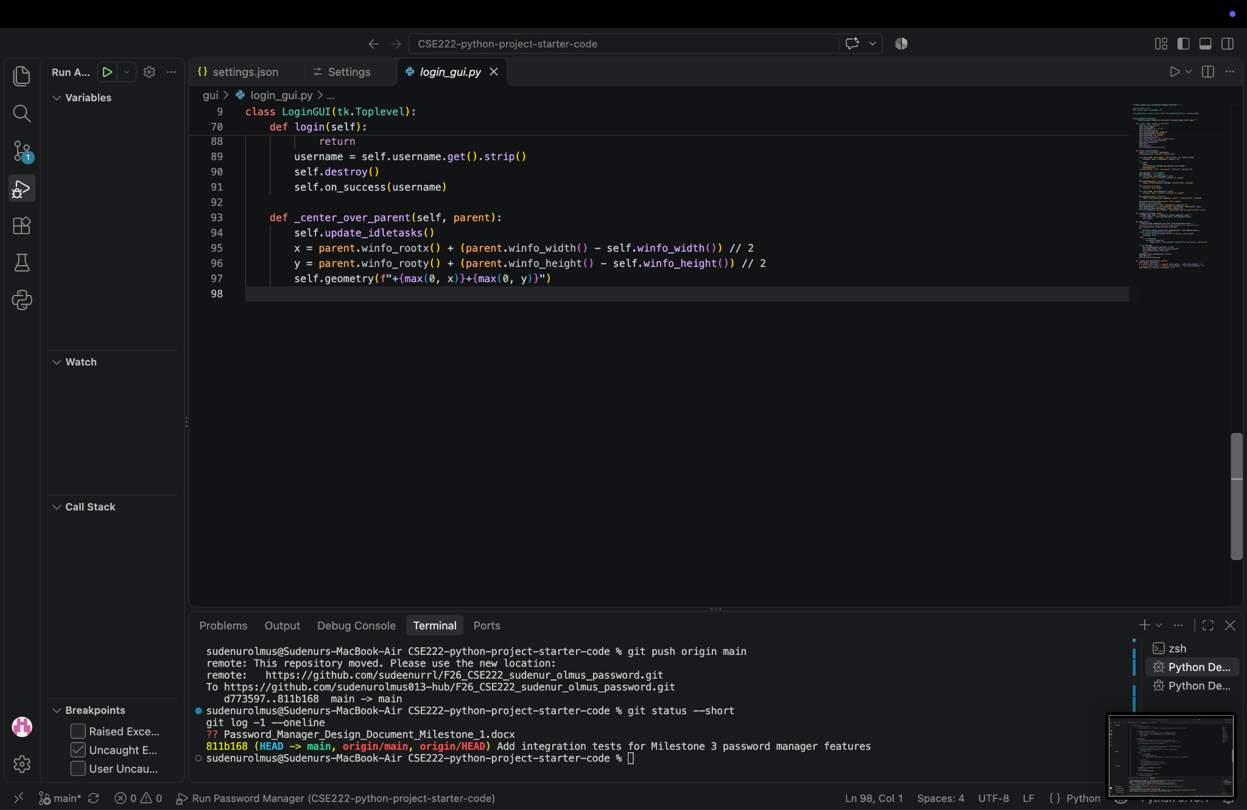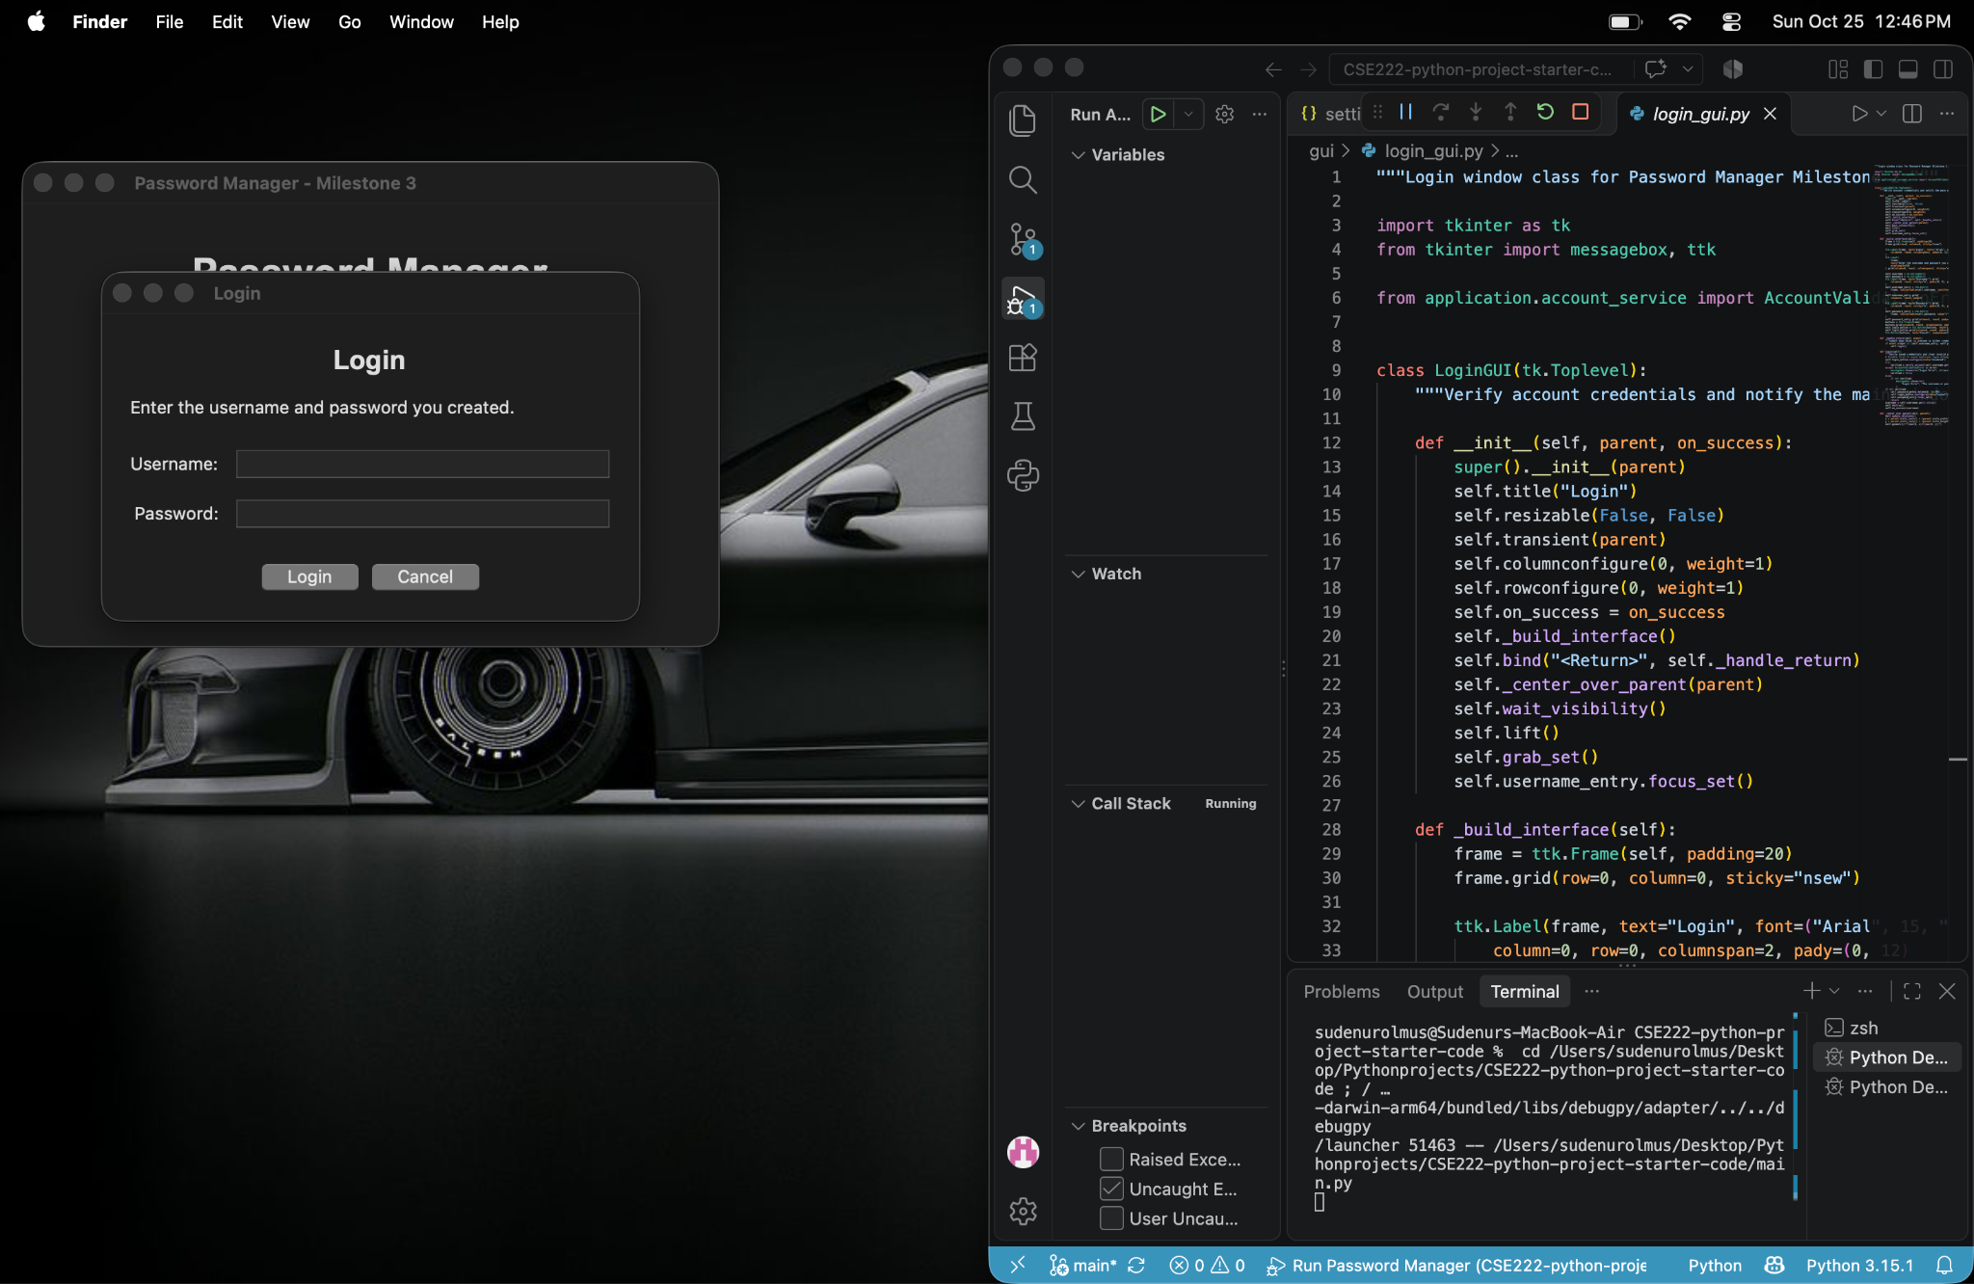

Milestone 4 Data Display Window
Planned implementation for this milestone:
- Create a scrollable display window with column headers and alphabetically sorted records.
- Refresh the display immediately when a password record is added or removed.
Add step-by-step evidence, error-handling details, and real screenshots when this milestone is implemented.

Milestone 5 Search Delete and Encryption
Planned implementation for this milestone:
- Create a separate search window that locates a record by description and reports a missing result clearly.
- Confirm deletion before removing a record and refresh an open display window.
- Encrypt password-entry data before saving it to disk and document the final peer review.
Add step-by-step evidence, error-handling details, and real screenshots when this milestone is implemented.

Code Appendix
The following source files contain the current Milestone 2 implementation.

main.py
1 """Entry point for the CSE 222 Password Manager Milestone 1 program."""
2
3 from gui.main_window import MainWindow
4
5
6 def main():
7 """Create and start the opening Password Manager window."""
8 app = MainWindow()
9 app.mainloop()
10
11
12 if __name__ == "__main__":
13 main()

account_service.py
1 """Account validation and persistence services for the Password Manager."""
2
3 import hashlib
4 import json
5 import os
6 import re
7 import secrets
8 from pathlib import Path
9
10
11 class AccountValidationError(ValueError):
12 """Raised when account input does not meet the project requirements."""
13
14
15 DATA_DIRECTORY = Path(__file__).resolve().parent.parent / "data"
16 ACCOUNTS_FILE = DATA_DIRECTORY / "accounts.json"
17
18
19 def validate_username(username):
20 """Return a trimmed username or raise an error for missing input."""
21 cleaned_username = username.strip()
22 if not cleaned_username:
23 raise AccountValidationError("Enter a username.")
24 return cleaned_username
25
26
27 def validate_password(password):
28 """Validate the password rules required for Milestone 2."""
29 if len(password) < 9:
30 raise AccountValidationError("Password must contain at least 9 characters.")
31 if not re.search(r"[A-Z]", password):
32 raise AccountValidationError("Password must include an uppercase letter.")
33 if not re.search(r"[a-z]", password):
34 raise AccountValidationError("Password must include a lowercase letter.")
35 if not re.search(r"\d", password):
36 raise AccountValidationError("Password must include a digit.")
37 return password
38
39
40 def _read_accounts():
41 """Read saved accounts; an absent file simply means no accounts exist yet."""
42 if not ACCOUNTS_FILE.exists():
43 return {}
44 try:
45 with ACCOUNTS_FILE.open("r", encoding="utf-8") as account_file:
46 accounts = json.load(account_file)
47 except (OSError, json.JSONDecodeError) as error:
48 raise AccountValidationError("Saved account data could not be read.") from error
49 if not isinstance(accounts, dict):
50 raise AccountValidationError("Saved account data has an invalid format.")
51 return accounts
52
53
54 def _save_accounts(accounts):
55 """Write account data through a temporary file to avoid partial saves."""
56 DATA_DIRECTORY.mkdir(exist_ok=True)
57 temporary_file = ACCOUNTS_FILE.with_suffix(".tmp")
58 try:
59 with temporary_file.open("w", encoding="utf-8") as account_file:
60 json.dump(accounts, account_file, indent=2)
61 os.replace(temporary_file, ACCOUNTS_FILE)
62 except OSError as error:
63 raise AccountValidationError("Account data could not be saved.") from error
64
65
66 def _hash_password(password, salt):
67 """Return a salted password hash instead of storing the raw account password."""
68 return hashlib.pbkdf2_hmac(
69 "sha256", password.encode("utf-8"), bytes.fromhex(salt), 150_000
70 ).hex()
71
72
73 def create_account(username, password):
74 """Validate and persist a new account with a unique username."""
75 cleaned_username = validate_username(username)
76 validate_password(password)
77 accounts = _read_accounts()
78 account_key = cleaned_username.casefold()
79 if account_key in accounts:
80 raise AccountValidationError("That username is already in use.")
81
82 salt = secrets.token_bytes(16).hex()
83 accounts[account_key] = {
84 "username": cleaned_username,
85 "salt": salt,
86 "password_hash": _hash_password(password, salt),
87 }
88 _save_accounts(accounts)
89
90
91 def verify_account(username, password):
92 """Return True only when the saved account credentials match."""
93 try:
94 cleaned_username = validate_username(username)
95 except AccountValidationError:
96 return False
97
98 account = _read_accounts().get(cleaned_username.casefold())
99 if account is None:
100 return False
101 supplied_hash = _hash_password(password, account["salt"])
102 return secrets.compare_digest(account["password_hash"], supplied_hash)

main_window.py
1 """Opening and post-login interfaces for Password Manager Milestone 2."""
2
3 import tkinter as tk
4 from tkinter import ttk
5
6 from gui.account_gui import AccountGUI
7 from gui.login_gui import LoginGUI
8
9
10 class MainWindow(tk.Tk):
11 """Display the opening screen and switch to the main interface after login."""
12
13 def __init__(self):
14 super().__init__()
15 self.title("Password Manager - Milestone 2")
16 self.geometry("520x330")
17 self.resizable(False, False)
18 self._center_window()
19 self.show_start_screen()
20
21 def _clear_window(self):
22 """Remove the visible view before displaying the next application screen."""
23 for widget in self.winfo_children():
24 widget.destroy()
25
26 def show_start_screen(self):
27 """Display Create Account, Login, and Cancel controls."""
28 self._clear_window()
29 frame = ttk.Frame(self, padding=32)
30 frame.pack(expand=True, fill="both")
31
32 ttk.Label(
33 frame,
34 text="Password Manager",
35 font=("Arial", 22, "bold")
36 ).pack(pady=(0, 8))
37
38 ttk.Label(
39 frame,
40 text="Create an account or log in to begin. Select Cancel to close the program.",
41 justify="center",
42 wraplength=400
43 ).pack(pady=(0, 22))
44
45 # Each button creates an instance of a class in a separate GUI module.
46 ttk.Button(frame, text="Create Account", width=24,
47 command=self.open_account_creation).pack(pady=5)
48 ttk.Button(frame, text="Login", width=24,
49 command=self.open_login).pack(pady=5)
50 ttk.Button(frame, text="Cancel", width=24,
51 command=self.destroy).pack(pady=5)
52
53 def open_account_creation(self):
54 """Open the separate Account Creation window class."""
55 AccountGUI(self)
56
57 def open_login(self):
58 """Open the separate Login window class."""
59 LoginGUI(self, self.show_main_interface)
60
61 def show_main_interface(self, username):
62 """Replace the opening screen after a successful account login."""
63 self._clear_window()
64 frame = ttk.Frame(self, padding=24)
65 frame.pack(expand=True, fill="both")
66
67 ttk.Label(
68 frame, text="Password Manager", font=("Arial", 20, "bold")
69 ).grid(column=0, row=0, columnspan=3, sticky="w")
70 ttk.Label(frame, text=f"Logged in as: {username}").grid(
71 column=0, row=1, columnspan=3, sticky="w", pady=(2, 18)
72 )
73 ttk.Label(
74 frame,
75 text="Enter a description, username, and password. Description must be unique.",
76 wraplength=520,
77 ).grid(column=0, row=2, columnspan=3, sticky="w", pady=(0, 12))
78
79 self.description = tk.StringVar()
80 self.entry_username = tk.StringVar()
81 self.entry_password = tk.StringVar()
82 self._add_main_entry(frame, "Description:", self.description, 3)
83 self._add_main_entry(frame, "Username:", self.entry_username, 4)
84 self._add_main_entry(frame, "Password:", self.entry_password, 5, show="*")
85
86 controls = ttk.Frame(frame)
87 controls.grid(column=0, row=6, columnspan=3, sticky="w", pady=(18, 0))
88 self.update_button = ttk.Button(
89 controls, text="Update", command=self._show_future_operation, state="disabled"
90 )
91 self.update_button.grid(column=0, row=0, padx=(0, 8))
92 ttk.Button(controls, text="Search", state="disabled").grid(
93 column=1, row=0, padx=8
94 )
95 ttk.Button(controls, text="Display All", state="disabled").grid(
96 column=2, row=0, padx=8
97 )
98 ttk.Button(controls, text="Log Out", command=self.show_start_screen).grid(
99 column=3, row=0, padx=8
100 )
101 for variable in (self.description, self.entry_username, self.entry_password):
102 variable.trace_add("write", self._update_button_state)
103 frame.columnconfigure(1, weight=1)
104
105 def _add_main_entry(self, frame, label, variable, row, show=None):
106 """Create one consistently aligned field in the main interface."""
107 ttk.Label(frame, text=label).grid(
108 column=0, row=row, sticky="e", padx=(0, 8), pady=6
109 )
110 ttk.Entry(
111 frame, textvariable=variable, show=show, justify="right", width=42
112 ).grid(column=1, row=row, columnspan=2, sticky="ew", pady=6)
113
114 def _update_button_state(self, *_args):
115 """Allow Update only after all entry fields contain text."""
116 has_complete_entry = all(
117 value.get().strip()
118 for value in (self.description, self.entry_username, self.entry_password)
119 )
120 self.update_button.configure(state="normal" if has_complete_entry else "disabled")
121
122 def _show_future_operation(self):
123 """Explain that saving password entries begins in Milestone 3."""
124 from tkinter import messagebox
125
126 messagebox.showinfo(
127 "Milestone 2",
128 "Password-entry storage, Search, and Display All are implemented in later milestones.",
129 parent=self,
130 )
131
132 def _center_window(self):
133 """Center the first window on the desktop."""
134 self.update_idletasks()
135 x = (self.winfo_screenwidth() - self.winfo_width()) // 2
136 y = (self.winfo_screenheight() - self.winfo_height()) // 2
137 self.geometry(f"+{x}+{y}")

account_gui.py
1 """Account Creation window class for Password Manager Milestone 2."""
2
3 import tkinter as tk
4 from tkinter import messagebox, ttk
5
6 from application.account_service import AccountValidationError, create_account
7
8
9 class AccountGUI(tk.Toplevel):
10 """Create a validated account and close when the account is saved."""
11
12 def __init__(self, parent):
13 super().__init__(parent)
14 self.title("Create Account")
15 self.resizable(False, False)
16 self.transient(parent)
17 self._build_interface()
18 self._center_over_parent(parent)
19
20 def _build_interface(self):
21 frame = ttk.Frame(self, padding=20)
22 frame.grid(sticky="nsew")
23
24 ttk.Label(
25 frame,
26 text="Create a Password Manager Account",
27 font=("Arial", 15, "bold")
28 ).grid(column=0, row=0, columnspan=2, pady=(0, 12))
29
30 ttk.Label(
31 frame,
32 text=("Choose a unique username. Your password will need at least "
33 "9 characters, including an uppercase letter, lowercase "
34 "letter, and digit."),
35 wraplength=390,
36 justify="left"
37 ).grid(column=0, row=1, columnspan=2, sticky="w", pady=(0, 14))
38
39 self.username = tk.StringVar()
40 self.password = tk.StringVar()
41 self.confirm_password = tk.StringVar()
42 self._add_entry(frame, "Username:", self.username, 2)
43 self._add_entry(frame, "Password:", self.password, 3, "*")
44 self._add_entry(frame, "Confirm password:", self.confirm_password, 4, "*")
45
46 buttons = ttk.Frame(frame)
47 buttons.grid(column=0, row=5, columnspan=2, pady=(14, 0))
48 ttk.Button(buttons, text="Create Account", command=self.create_account).grid(
49 column=0, row=0, padx=(0, 8)
50 )
51 ttk.Button(buttons, text="Cancel", command=self.destroy).grid(column=1, row=0)
52 self.bind("<Return>", lambda event: self.create_account())
53
54 def _add_entry(self, frame, label, variable, row, show=None):
55 ttk.Label(frame, text=label).grid(
56 column=0, row=row, sticky="e", padx=(0, 8), pady=5
57 )
58 ttk.Entry(frame, textvariable=variable, show=show, justify="right",
59 width=33).grid(column=1, row=row, sticky="ew", pady=5)
60
61 def create_account(self):
62 """Validate the form, save the account, and report useful errors."""
63 password = self.password.get()
64 if password != self.confirm_password.get():
65 messagebox.showerror(
66 "Account Error", "The two passwords do not match.", parent=self
67 )
68 self.password.set("")
69 self.confirm_password.set("")
70 return
71 try:
72 create_account(self.username.get(), password)
73 except AccountValidationError as error:
74 messagebox.showerror("Account Error", str(error), parent=self)
75 self.password.set("")
76 self.confirm_password.set("")
77 return
78 messagebox.showinfo(
79 "Account Created", "Your account was created. You may now log in.",
80 parent=self
81 )
82 self.destroy()
83
84 def _center_over_parent(self, parent):
85 self.update_idletasks()
86 x = parent.winfo_rootx() + (parent.winfo_width() - self.winfo_width()) // 2
87 y = parent.winfo_rooty() + (parent.winfo_height() - self.winfo_height()) // 2
88 self.geometry(f"+{max(0, x)}+{max(0, y)}")

login_gui.py
1 """Login window class for Password Manager Milestone 2."""
2
3 import tkinter as tk
4 from tkinter import messagebox, ttk
5
6 from application.account_service import AccountValidationError, verify_account
7
8
9 class LoginGUI(tk.Toplevel):
10 """Verify account credentials and notify the main window after login."""
11
12 def __init__(self, parent, on_success):
13 super().__init__(parent)
14 self.title("Login")
15 self.resizable(False, False)
16 self.transient(parent)
17 self.on_success = on_success
18 self._build_interface()
19 self.bind("<Return>", lambda event: self.login())
20 self._center_over_parent(parent)
21
22 def _build_interface(self):
23 frame = ttk.Frame(self, padding=20)
24 frame.grid(sticky="nsew")
25
26 ttk.Label(frame, text="Login", font=("Arial", 15, "bold")).grid(
27 column=0, row=0, columnspan=2, pady=(0, 12)
28 )
29 ttk.Label(
30 frame,
31 text="Enter the username and password you created.",
32 wraplength=350
33 ).grid(column=0, row=1, columnspan=2, sticky="w", pady=(0, 14))
34
35 self.username = tk.StringVar()
36 self.password = tk.StringVar()
37 ttk.Label(frame, text="Username:").grid(
38 column=0, row=2, sticky="e", padx=(0, 8), pady=5
39 )
40 self.username_entry = ttk.Entry(
41 frame, textvariable=self.username, justify="right", width=30
42 )
43 self.username_entry.grid(
44 column=1, row=2, pady=5
45 )
46 ttk.Label(frame, text="Password:").grid(
47 column=0, row=3, sticky="e", padx=(0, 8), pady=5
48 )
49 self.password_entry = ttk.Entry(
50 frame, textvariable=self.password, show="*", justify="right", width=30
51 )
52 self.password_entry.grid(column=1, row=3, pady=5)
53 buttons = ttk.Frame(frame)
54 buttons.grid(column=0, row=4, columnspan=2, pady=(14, 0))
55 self.login_button = ttk.Button(buttons, text="Login", command=self.login)
56 self.login_button.grid(column=0, row=0, padx=(0, 8))
57 ttk.Button(buttons, text="Cancel", command=self.destroy).grid(column=1, row=0)
58 self.password_entry.focus_set()
59
60 def login(self):
61 """Verify saved credentials and clear invalid password input."""
62 # Disable first to avoid duplicate login attempts from repeated clicks.
63 self.login_button.configure(state="disabled")
64 try:
65 verified = verify_account(self.username.get(), self.password.get())
66 except AccountValidationError as error:
67 messagebox.showerror("Login Error", str(error), parent=self)
68 verified = False
69 if not verified:
70 messagebox.showerror(
71 "Login Error", "The username or password is not valid.", parent=self
72 )
73 self.password_entry.delete(0, tk.END)
74 self.login_button.configure(state="normal")
75 self.password_entry.focus_set()
76 return
77 username = self.username.get().strip()
78 self.destroy()
79 self.on_success(username)
80
81 def _center_over_parent(self, parent):
82 self.update_idletasks()
83 x = parent.winfo_rootx() + (parent.winfo_width() - self.winfo_width()) // 2
84 y = parent.winfo_rooty() + (parent.winfo_height() - self.winfo_height()) // 2
85 self.geometry(f"+{max(0, x)}+{max(0, y)}")

test_account_service.py
1 """Automated checks for Milestone 2 account validation and persistence."""
2
3 import tempfile
4 import unittest
5 from pathlib import Path
6
7 from application import account_service
8
9
10 class AccountServiceTests(unittest.TestCase):
11 """Keep account-service tests isolated from the project's real data folder."""
12
13 def setUp(self):
14 self.temporary_directory = tempfile.TemporaryDirectory()
15 self.original_data_directory = account_service.DATA_DIRECTORY
16 self.original_accounts_file = account_service.ACCOUNTS_FILE
17 account_service.DATA_DIRECTORY = Path(self.temporary_directory.name)
18 account_service.ACCOUNTS_FILE = account_service.DATA_DIRECTORY / "accounts.json"
19
20 def tearDown(self):
21 account_service.DATA_DIRECTORY = self.original_data_directory
22 account_service.ACCOUNTS_FILE = self.original_accounts_file
23 self.temporary_directory.cleanup()
24
25 def test_valid_account_can_be_verified(self):
26 account_service.create_account("Sudenur", "StrongPass1")
27 self.assertTrue(account_service.verify_account("sudenur", "StrongPass1"))
28
29 def test_duplicate_username_is_rejected(self):
30 account_service.create_account("Sudenur", "StrongPass1")
31 with self.assertRaises(account_service.AccountValidationError):
32 account_service.create_account("SUDENUR", "AnotherPass2")
33
34 def test_invalid_password_is_rejected(self):
35 with self.assertRaises(account_service.AccountValidationError):
36 account_service.create_account("Sudenur", "short1A")
37
38 def test_incorrect_password_does_not_verify(self):
39 account_service.create_account("Sudenur", "StrongPass1")
40 self.assertFalse(account_service.verify_account("Sudenur", "WrongPass2"))
41
42
43 if __name__ == "__main__":
44 unittest.main()

