ABSTRACT
VISIONX is a multi-domain AI-based vision and event-monitoring system designed to provide intelligent visual monitoring across three application domains: Classroom Intelligence, Smart Traffic Intelligence, and Patient Monitoring & Safety. The system uses a common computer-vision pipeline so that the same underlying perception and tracking framework can be adapted to different environments through domain-specific rules and event-detection modules.
The proposed system consists of an ESP32-S3 camera node for image capture and wireless transmission, and a laptop-based processing unit for computationally intensive AI operations. The ESP32-S3 captures video frames using an attached camera, encodes them into JPEG format, and transmits the frames over Wi-Fi to the laptop. The laptop performs image processing, AI-based object detection, multi-object tracking, trajectory analysis, scene understanding, and domain-specific event detection using technologies such as Python, OpenCV, and YOLO-based computer vision models.
In Classroom Intelligence, the system can monitor student presence, occupancy, movement, entry and exit activity, classroom zones, and abnormal activities. In Smart Traffic Intelligence, it can detect and track vehicles, estimate their movement and speed, identify speed-limit violations and wrong-way movement, and monitor congestion or potential accident situations. In Patient Monitoring & Safety, the system focuses on visual safety events such as fall detection, prolonged inactivity, wandering, restricted-area entry, and abnormal observable movement without attempting to diagnose medical or mental-health conditions.
A temporal event engine evaluates detected activities across multiple frames to reduce false alarms and classifies events according to severity levels such as Normal, Warning, and Critical. Critical events can generate alerts through an ESP32-S3-connected buzzer and GSM-based notification system. Important event evidence can be stored locally on the ESP32-S3 microSD card, while continuous video recordings are maintained on the laptop. A database stores event metadata, tracking information, timestamps, and recording references. The system can further provide a monitoring dashboard, analytics, and automatically generated daily Excel reports.
VISIONX is designed as a modular and extensible platform in which additional application domains can be incorporated without redesigning the complete AI perception pipeline. The project aims to demonstrate how edge camera hardware, wireless communication, centralized AI processing, multi-object tracking, temporal event analysis, alert generation, evidence management, and reporting can be integrated into a single practical intelligent vision system.
CHAPTER 1 — INTRODUCTION
1.1 Scope
VISIONX is proposed as a unified AI-based visual monitoring platform capable of operating in multiple application environments using a common computer-vision and event-monitoring framework. The system focuses on three selectable domains: Classroom Intelligence, Smart Traffic Intelligence, and Patient Monitoring & Safety.
The scope of VISIONX includes image acquisition through an ESP32-S3 camera node, wireless transmission of captured frames, laptop-based AI processing, object detection, multi-object tracking, trajectory analysis, scene understanding, domain-specific activity analysis, event detection, alert generation, evidence storage, continuous video recording, database management, dashboard visualization, and daily reporting.
The system is designed around a modular architecture. A common AI perception pipeline processes the incoming visual data, while individual domain modules apply specific rules according to the selected environment. This approach reduces the need to develop completely independent vision systems for each application.
The system is intended for visual monitoring and safety assistance. In particular, the patient-monitoring module is limited to observable activities and safety-related events and is not intended to diagnose diseases, mental conditions, or other medical conditions.
The proposed scope includes:
- Real-time camera-based monitoring.
- Detection and tracking of multiple objects/persons.
- Tracking IDs and movement trajectories.
- Zone, region-of-interest, and line-crossing analysis.
- Temporal validation of important events.
- Domain-specific event detection.
- Critical-event alert generation.
- Important-event evidence storage.
- Continuous video recording on the laptop.
- Database-based event and tracking records.
- Dashboard-based monitoring and analytics.
- Daily statistical analysis and Excel report generation.
- Future experimentation with automatic scene/layout understanding.
Automatic scene understanding is considered an advanced feature and will require experimental validation for different environments. Manual zone configuration or human confirmation can therefore remain available where automatic inference is unreliable.
1.2 Problem Statement
Conventional surveillance systems primarily provide video recording and basic live monitoring, but they generally require continuous human observation to identify important activities or abnormal events. This becomes difficult in environments such as classrooms, roads, and patient-care areas, where multiple people or vehicles may be present simultaneously and important events can occur unexpectedly.
Existing monitoring approaches are often designed for a single application and may require separate systems for different environments. They may also lack integrated object tracking, temporal event analysis, automated alerts, evidence management, and analytical reporting.
Therefore, there is a need for a unified and modular AI-based vision system capable of receiving camera data, detecting and tracking multiple objects, understanding their movement, identifying domain-specific events, and generating appropriate alerts and records.
The proposed VISIONX system addresses this problem by combining an ESP32-S3-based camera and wireless communication node with a laptop-based AI processing pipeline. The system applies common object detection and multi-object tracking capabilities while using separate domain-specific intelligence for classroom, traffic, and patient-safety applications. Important events are validated over multiple frames to reduce false detections, and critical events can trigger local and remote alerts.
Thus, the problem addressed by VISIONX is the development of a single extensible AI vision platform for intelligent visual monitoring, event detection, alert generation, evidence storage, continuous recording, and analytical reporting across multiple domains.

1.3 Objectives
The main objective of VISIONX is to develop a unified AI-based vision and event-monitoring system that can be adapted to multiple application domains using a common perception and tracking framework.
The specific objectives are:
- To develop an ESP32-S3-based camera node for capturing and transmitting image frames over Wi-Fi.
- To establish reliable communication between the camera node and the laptop-based AI processing system.
- To implement AI-based object detection and multi-object tracking for identifying and following people or vehicles.
- To maintain position and movement trajectories for temporal analysis of objects.
- To develop domain-specific intelligence for classroom, traffic, and patient safety monitoring.
- To detect important events such as falls, fights, accidents, speed violations, wrong-way movement, and restricted-area entry.
- To use multi-frame temporal validation to reduce false event detections.
- To generate appropriate warning and critical alerts through buzzer and GSM-based notification mechanisms.
- To maintain continuous video recordings and store important event evidence separately.
- To provide database management, dashboard visualization, analytics, and daily Excel reporting for monitoring and analysis.

1.4 Motivation
The increasing use of cameras in educational institutions, traffic environments, and healthcare facilities creates a large amount of visual information that is difficult to monitor continuously by humans alone. Important events may be missed, detected late, or require significant human effort to identify.
This motivates the development of VISIONX, which combines computer vision, object tracking, event analysis, and automated alerts into a single platform. Instead of creating separate systems for every application, VISIONX uses a common AI perception pipeline with domain-specific intelligence, making the system modular and extensible.
The project is also motivated by the availability of affordable embedded hardware such as the ESP32-S3, which can act as a compact camera and wireless communication node, while a laptop can provide the computational resources required for AI processing.
The ultimate motivation is to develop a practical system that can observe, understand, record, and respond to important visual events, while providing useful evidence and analytics for later analysis.
CHAPTER 2
LITERATURE REVIEW
Under literature survey, we collected information by exploring research related to real-time object detection and multi-object tracking, which are important components of the proposed VISIONX system. The selected papers provide a foundation for comparing different approaches used for detecting and tracking objects in video streams.
[1] Title: “You Only Look Once: Unified, Real-Time Object Detection”
Authors: Joseph Redmon, Santosh Divvala, Ross Girshick, Ali Farhadi: 2016
[Publisher: IEEE Conference on Computer Vision and Pattern Recognition (CVPR)]
This paper introduces YOLO, a real-time object detection approach that performs object detection using a single neural network. The method is designed for fast processing of images and video and provides bounding boxes and class predictions in a unified framework. This work is relevant to VISIONX because real-time object detection forms the first stage of the common AI perception pipeline.
Direct Paper: YOLO — Direct PDF

[2] Title: “Faster R-CNN: Towards Real-Time Object Detection with Region Proposal Networks”
Authors: Shaoqing Ren, Kaiming He, Ross Girshick, Jian Sun: 2015
[Publisher: Advances in Neural Information Processing Systems (NeurIPS)]
This paper proposes Faster R-CNN, an object detection framework that introduces a Region Proposal Network (RPN) for generating object proposals. The RPN shares convolutional features with the detection network, improving the efficiency of region-based object detection. The paper provides an important comparison point with single-stage detectors such as YOLO in terms of detection accuracy and computational requirements.
Direct Paper: Faster R-CNN — Direct PDF

[3] Title: “ByteTrack: Multi-Object Tracking by Associating Every Detection Box”
Authors: Yifu Zhang, Peize Sun, Yi Jiang, Dongdong Yu, Fucheng Weng, Zehuan Yuan, Ping Luo, Wenyu Liu, Xinggang Wang: 2022
[Publisher: European Conference on Computer Vision (ECCV)]
This paper presents ByteTrack, a multi-object tracking approach that associates detection boxes across video frames. Instead of using only high-confidence detections, the method also considers lower-confidence detections to improve object association and tracking continuity. This is relevant to VISIONX because maintaining consistent tracking IDs is required for trajectory analysis and temporal event detection.
Direct Paper: ByteTrack — Direct PDF

[4] Title: “BoT-SORT: Robust Associations Multi-Pedestrian Tracking”
Authors: Nir Aharon, Roy Orfaig, Ben-Zion Bobrovsky: 2022
[Publisher: arXiv]
This paper presents BoT-SORT, a multi-object tracking method designed to improve object association in crowded scenes. The approach combines motion information, appearance information, camera-motion compensation, and re-identification features to improve tracking performance. The approach is relevant to VISIONX for maintaining object identities when multiple people or vehicles are present and when temporary occlusions occur.
Direct Paper: BoT-SORT — Direct PDF
CHAPTER 3
METHODOLOGY
3.1 Block Diagram
The VISIONX methodology follows a common AI vision pipeline that can be adapted for Classroom Intelligence, Smart Traffic Intelligence, and Patient Monitoring & Safety.
ESP32-S3 Camera → Wi-Fi → Laptop Frame Receiver → Video Processing → Object Detection → Multi-Object Tracking → Trajectory Analysis → Scene Understanding → Domain Intelligence → Event Engine → Alerts / Evidence / Recording → Database → Dashboard & Reports
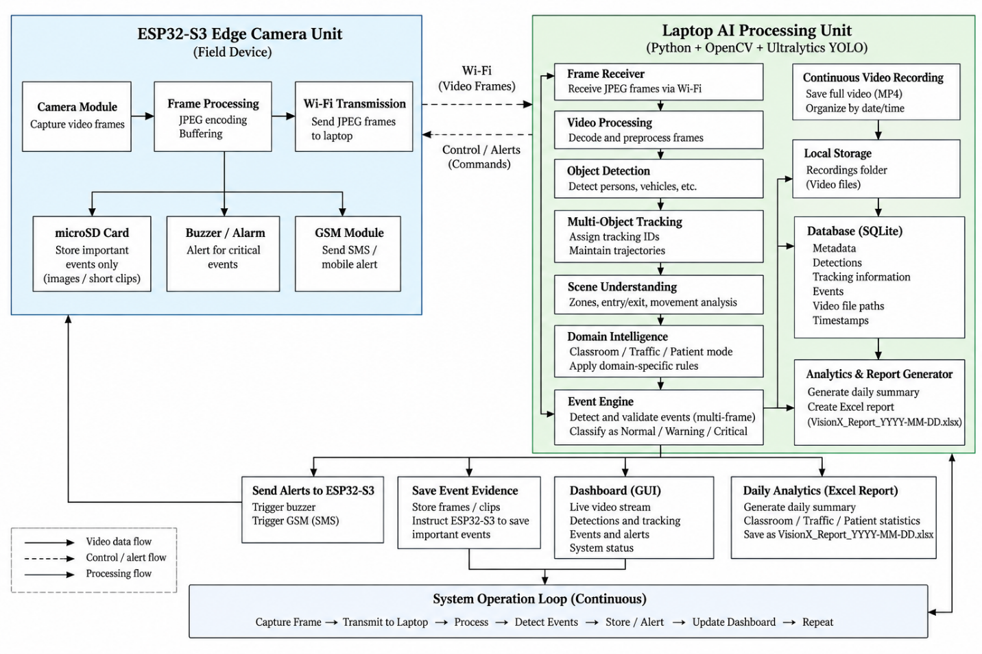
VISIONX operates as a centralized AI vision system with an ESP32-S3 edge camera node. The ESP32-S3 captures and transmits JPEG frames only when the laptop starts a monitoring session.
The overall operation is:
Laptop sends START command → ESP32-S3 captures frames → JPEG encoding → Wi-Fi transmission → Laptop receives and processes frames → Object detection → Multi-object tracking → Scene analysis → Selected domain logic → Event detection → Temporal validation → Event classification → Storage / Alert / Dashboard → Continue with next frame.
The system continuously repeats this cycle during an active monitoring session. When monitoring is stopped, the laptop sends a STOP command, after which the ESP32-S3 stops frame transmission and returns to an idle state.
For critical events, the laptop can send an alert command back to the ESP32-S3 to activate the buzzer and GSM module and to handle required event evidence. The laptop simultaneously maintains continuous video recording and database records.
This methodology allows the same core AI pipeline to support all three VISIONX domains while keeping domain-specific rules modular.
3.2 Flow Chart
The basic working flow of VISIONX is:
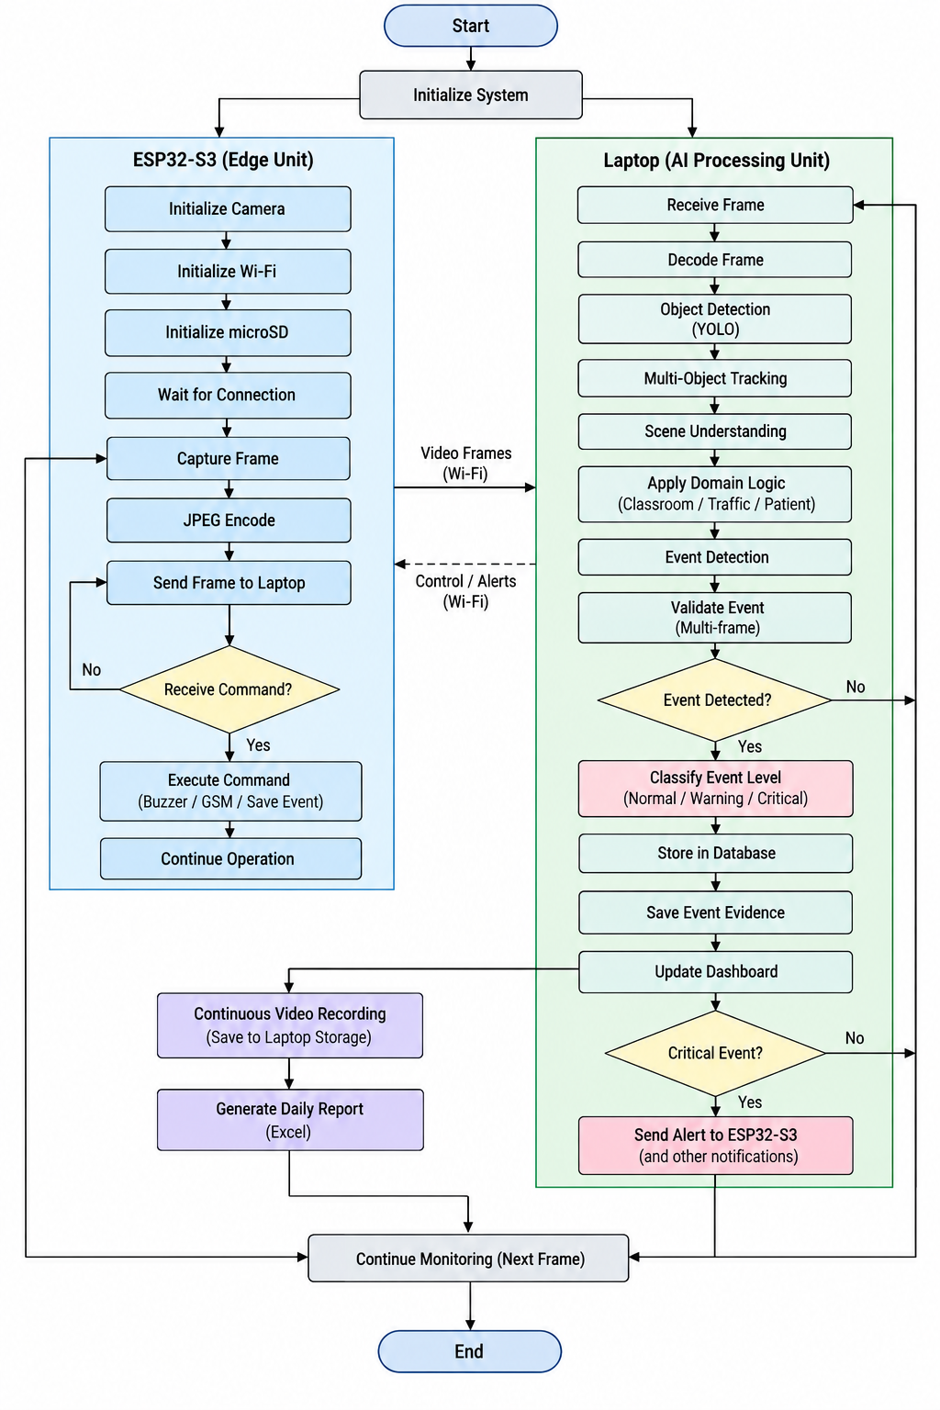
CHAPTER 4
HARDWARE AND SOFTWARE REQUIREMENTS
4.1 Hardware Requirements
Sl. No. | Hardware Component | Purpose
1 | ESP32-S3 WROOM N16R8 | Camera control, Wi-Fi communication and edge-device operations
2 | OV2640 Camera Module | Captures video frames
3 | MicroSD Card | Stores important event evidence such as selected frames and short clips
4 | GSM Module | Sends SMS/mobile notifications for critical events
5 | Buzzer/Alarm | Provides local audio indication for critical events
6 | Laptop/PC | Performs AI processing, tracking, recording, database management and reporting
7 | USB-C Data Cable | Programming and initial power/communication with ESP32-S3
8 | Wi-Fi Router/Hotspot | Provides wireless communication between ESP32-S3 and laptop
4.2 Software Requirements
Sl. No. | Software/Technology | Purpose
1 | Python | Main programming environment for laptop-side processing
2 | OpenCV | Image processing, video handling and visualization
3 | Ultralytics YOLO | AI-based object detection
4 | Multi-Object Tracking | Maintains individual tracking IDs and trajectories
5 | ESP32 Arduino / ESP-IDF Environment | ESP32-S3 firmware development
6 | SQLite | Stores events, detections, tracking data and metadata
7 | Dashboard/GUI Framework | Displays live monitoring, events and analytics
8 | Excel Generation Library | Generates daily VISIONX reports
9 | Git/GitHub | Source-code version control and project management

