1.Write a program to find the sum of two numbers entered by the user.

**code :**

**package** hellow;

**import** java.util.Scanner;

**class** Add {

**public** **int** add(**int** c, **int** d) {

**return** c + d;

}

}

**public** **class** AditionNumber {

**public** **static** **void** main(String[] args) {

Add addition = **new** Add();

Scanner sc = **new** Scanner(System.***in***);

System.***out***.println("Enter your two numbers for addition:");

**int** c = sc.nextInt();

**int** d = sc.nextInt();

System.***out***.println("Addition of numbers is: " + addition.add(c, d));

}

}

**Outpit :**

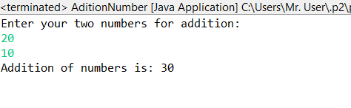

2.Write a Java program to check whether a given number is even or odd.

**Code :**

**package** sudeep;

**import** java.util.Scanner;

**public** **class** EvenODD{

**public** **static** **void** main(String[] args) {

Scanner scanner = **new** Scanner(System.***in***);

System.***out***.print("Enter a number to check if it is even or odd: ");

**int** a = scanner.nextInt();

**if** (a % 2 == 0) {

System.***out***.println(a + " is even.");

} **else** {

System.***out***.println(a + " is odd.");

}

}

}

**Output :**

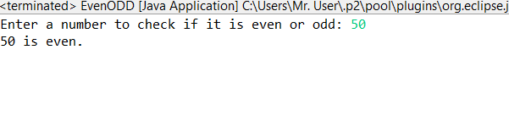

3.Write a java program to find greatest of 2 numbers.

**Code :**

**package** anudip;

**import** java.util.Scanner;

**class** NumberComparer {

**public** **int** findGreatest(**int** a, **int** b) {

**if** (a > b) {

**return** a;

} **else** {

**return** b;

}

}

}

**public** **class** GreatestNumber {

**public** **static** **void** main(String[] args) {

Scanner scanner = **new** Scanner(System.***in***);

NumberComparer comparer = **new** NumberComparer();

System.***out***.print("Enter the first number: ");

**int** number1 = scanner.nextInt();

System.***out***.print("Enter the second number: ");

**int** number2 = scanner.nextInt();

**int** greatest = comparer.findGreatest(number1, number2);

System.***out***.println("The greatest number is: " + greatest);

}

}

**Output :**

