**2D-Transformation Output**

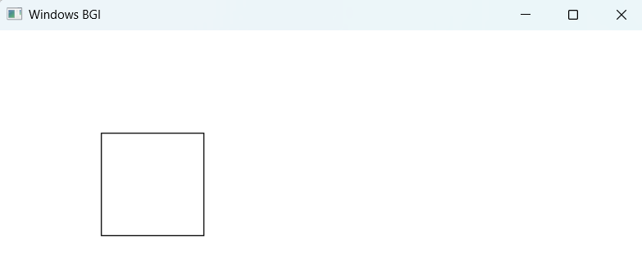**Shape Drawn:** Square with coordinates (100,100), (200,100), (200,200), (100,200), (100,100)

**Original Shape**



**Translation**

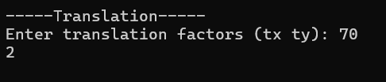

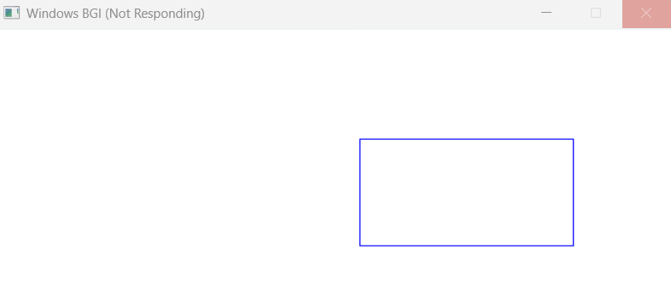

**Scaling**

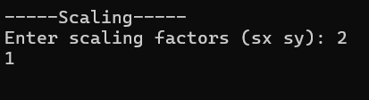

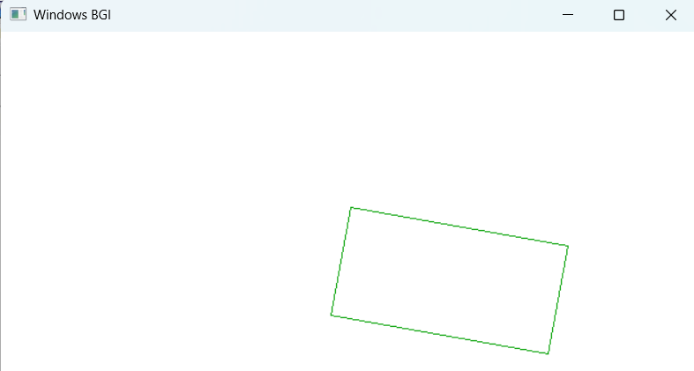

**Rotation**

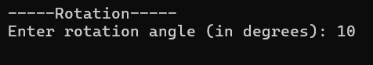

**Reflection across Y-axis:**

Original Line: Line at the left

Reflected Line: Line at the right

**Reflection across X-axis:**

Original Line: Line at the bottom

Reflected Line: Line at the top

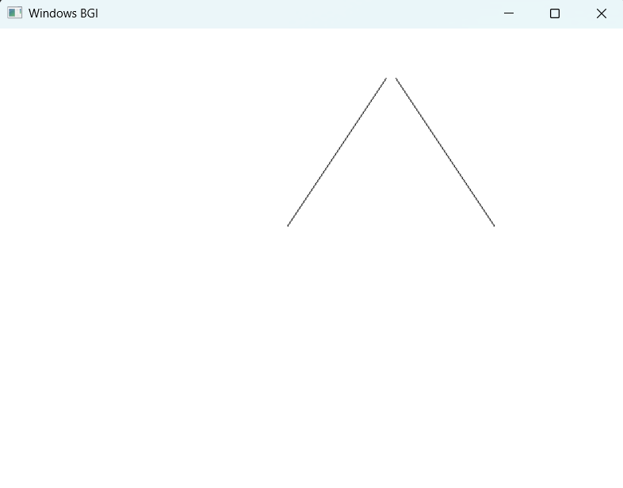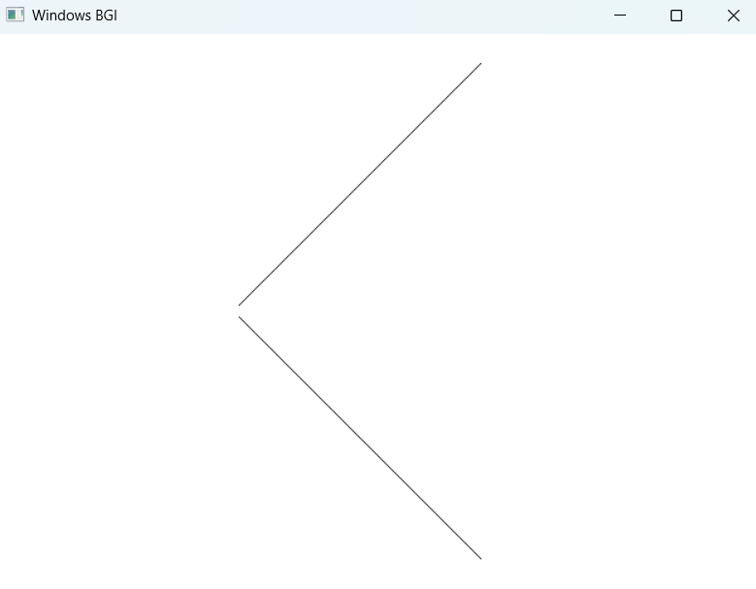

**Sudeep Subedi, 079BEI042**