**Clipping Algorithm Output**

1. 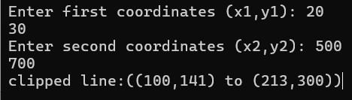**Cohen-Sutherland Algorithm**

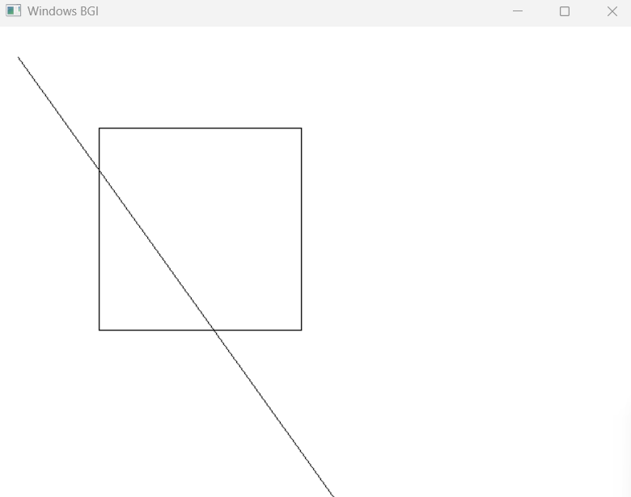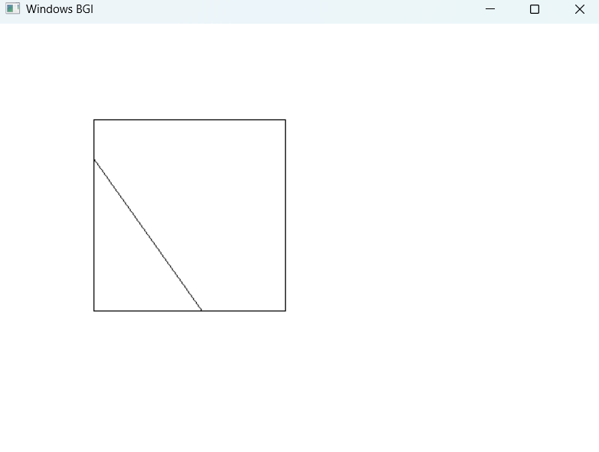

**After Clipping**

**Before Clipping**

1. 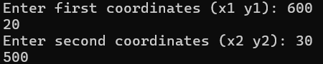**Liang-Barsky Algorithm**

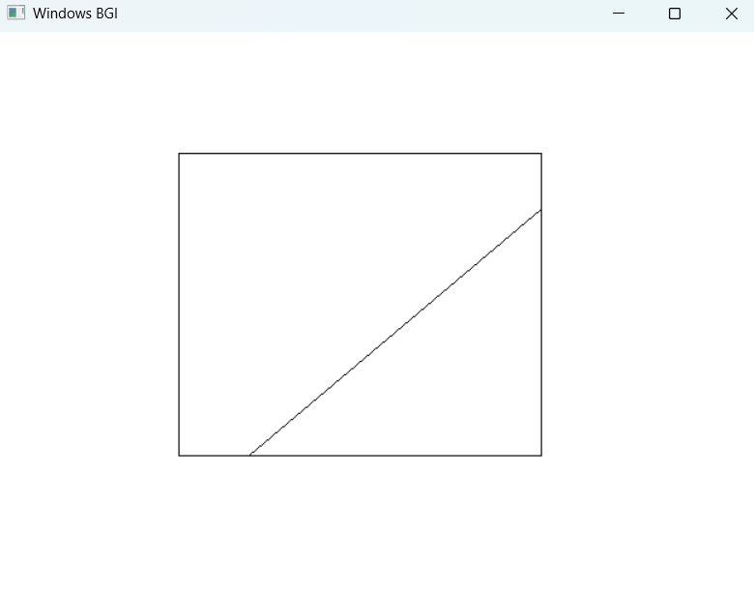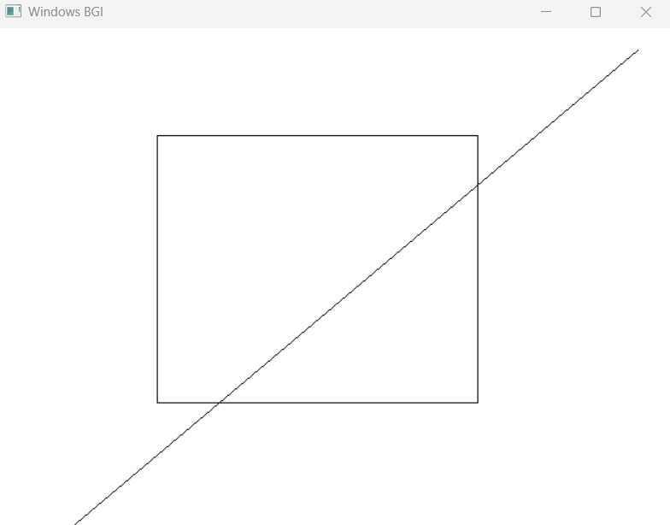

**After Clipping**

**Before Clipping**