**Bezier Curve Output**

**Three Control Point (Quadratic Bezier Curve):**

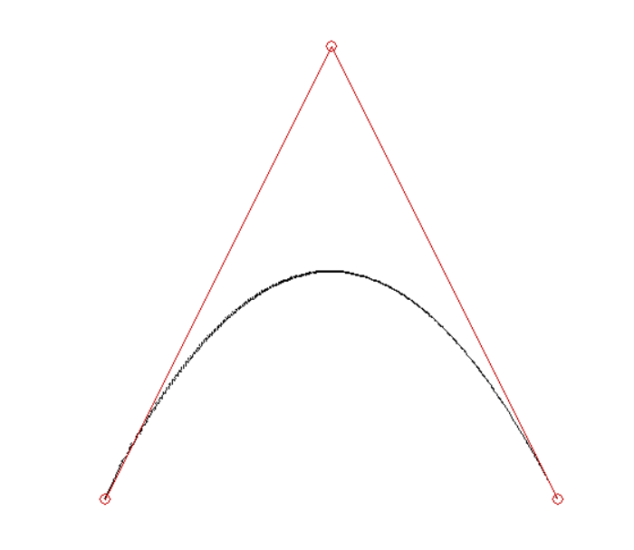

(300,100)

(500,500)

(100,500)

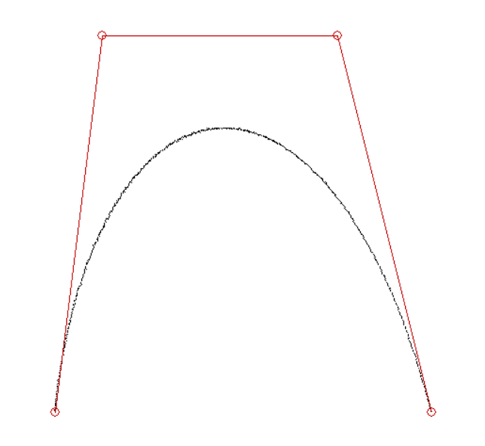**Four Control Points (Cubic Bezier Curve):**

(400,100)

(150,100)

(500,500)

(100,500)

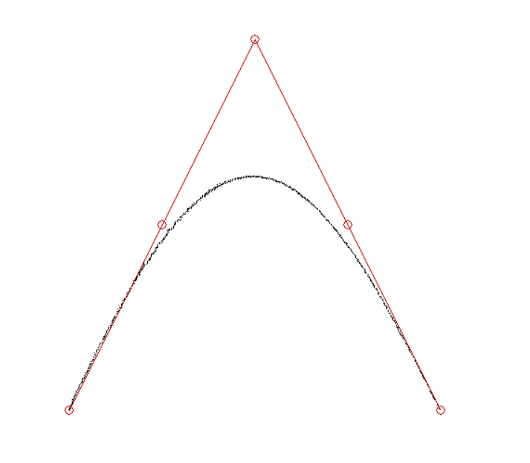**Five Control Points (Quartic Bezier Curve):**

(500,500)

(400,300)

(100,500)

(200,300)

(300,100)