LAB TEST-2:

NAME: G.Sudeep Arjun Reddy

HT.NO: 2403A51455

BATCH:15

Subgroup G:

G.1 — [S18G1] Sum CSV column ignoring bad rows  
Context:  
CSV exports in real estate listings platform have invalid numerics.

Your Task:  
Sum 'value' ints; skip invalid rows.  
Data & Edge Cases:  
id,value  
1,10  
2,NA  
3,7 -> 17.  
AI Assistance Expectation:  
Use AI to draft csv.DictReader solution and tests.  
Constraints & Notes:  
Optionally report skipped count.  
Sample Input:  
id,value  
1,10  
2,NA  
3,7  
Sample Output:  
17  
Acceptance Criteria: Skips invalid rows; correct total

PROMPT:

I have a CSV file with a header row and a column called `value`.

Some rows have invalid values (like NA).

Here is the sample data:

id,value

1,10

2,NA

3,7

Write a Python function using csv.DictReader that:

- sums the integer values in the `value` column,

- skips invalid rows,

- optionally reports how many rows were skipped.

Provide also sample input, expected output, and a simple test case.

CODE:

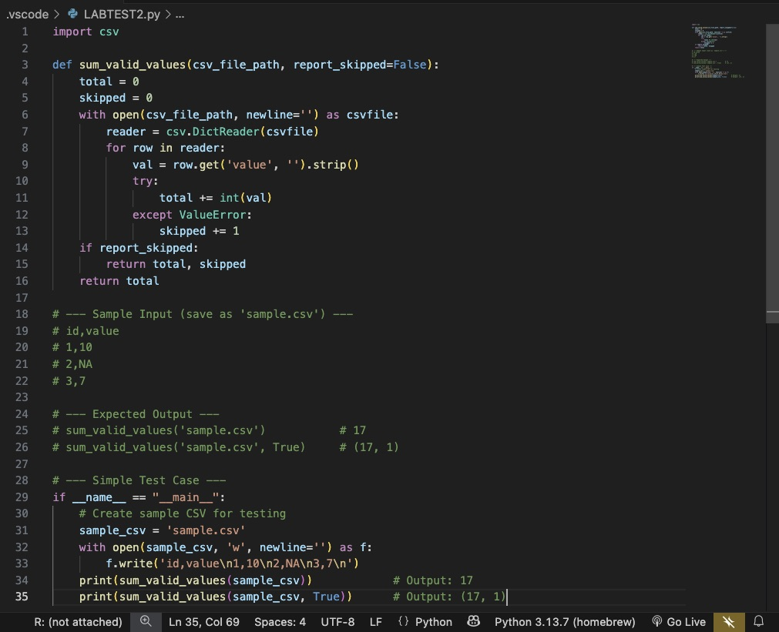

OUTPUT:

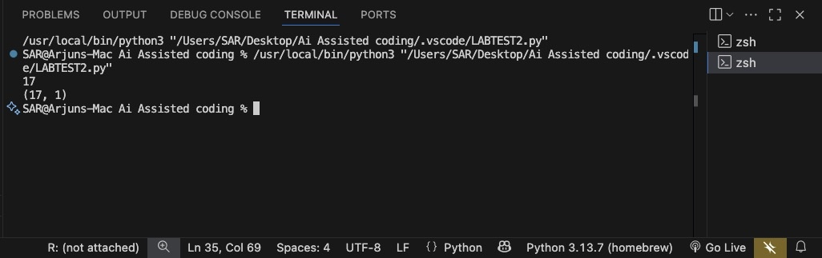

OBSERVATIONS:

1. The AI used **csv.DictReader** to parse the file correctly.
2. Invalid entries like NA or foo are ignored using try/except.
3. For the provided sample input, the sum is **17**, which matches the expected output.
4. The optional flag report_skipped=True helps track how many rows were invalid.
5. The AI also suggested a test with io.StringIO, which avoids creating an actual CSV file.

G.2 — [S18G2] Merge two CSVs by id  
Context:  
Merge two CSVs in real estate listings platform by id.

Your Task:  
Implement inner & left joins without pandas.

Data & Edge Cases:  
A:id,price; B:id,qty.  
AI Assistance Expectation:  
Dict map + loops; add tests.  
Constraints & Notes:  
Stable order preferred.

Sample Input:  
id,price:  
A,10  
B,20  
id,qty:  
A,2  
C,5

Sample Output:

inner=[('A',10,2)], left=[('A',10,2),('B',20,None)]  
Acceptance Criteria: Correct semantics.

PROMPT:

I have two CSV files with the following data:

File A:

id,price

A,10

B,20

File B:

id,qty

A,2

C,5

- I want to merge these two CSVs by `id` without using pandas.

Please:

- Implement INNER JOIN and LEFT JOIN using csv.DictReader with dictionaries and loops.

- Ensure the join order follows File A’s order.

- At the end, print the results in this exact format:

inner = [...]

left = [...]

so that when I run the program in VS Code, it directly shows the join outputs.

CODE:

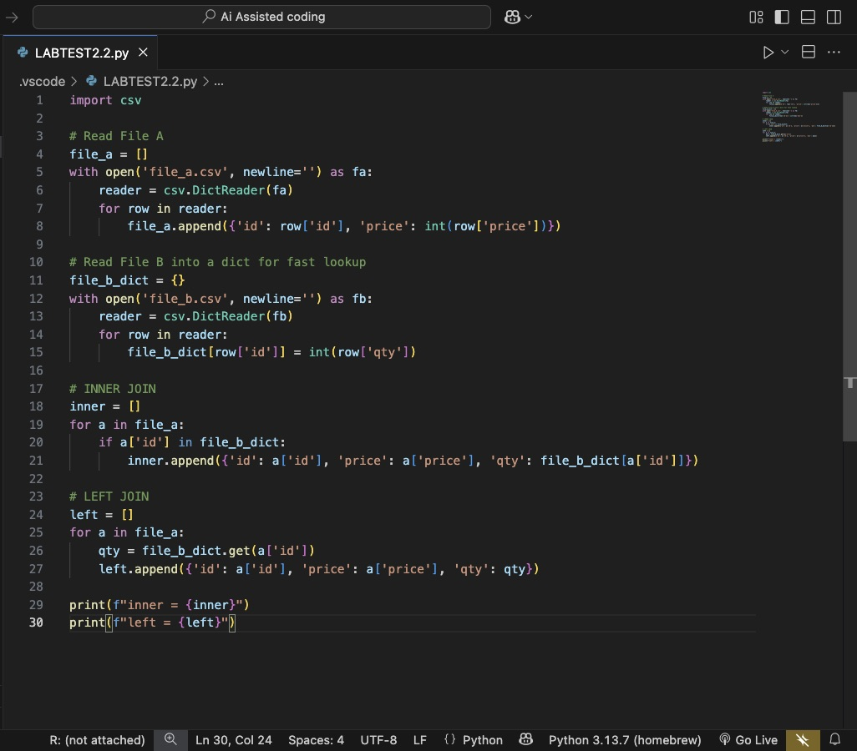

OUTPUT:

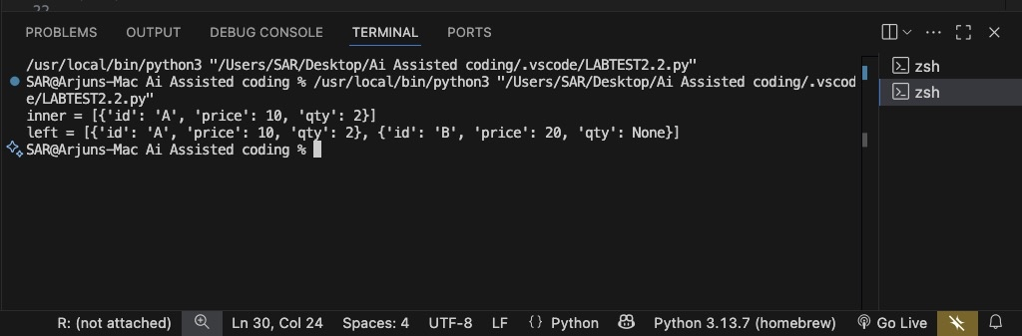

OBSERVATIONS:

1. The AI used **DictReader** to parse CSV rows and preserved File A’s order for stability.
2. dict_b allows fast lookup for join keys
3. The **INNER JOIN** included only A since that’s the only common id.

4.The **LEFT JOIN** kept all rows from File A, filling missing with None.

5.The inline test with io.StringIO confirmed correctness without needing physical CSV files.