AI ASSISTED CODING FINAL LAB EXAM

NAME: GATLA SUDEEP ARJUN REDDY
HALL TICKET: 2403A51455
BATCH: 15

Subset 1 — Prompt Engineering for Product Catalog Services

Q1: Design prompts for generating product ingestion code.
• Task 1: Create role/constraints/IO prompt for AI to create ETL job

PROMPT:

“Generate a pure Python ETL script (no pandas). Validate mandatory fields, fill optional fields, clean price values, and return a cleaned list of records following the ETL flow.”

CODE:

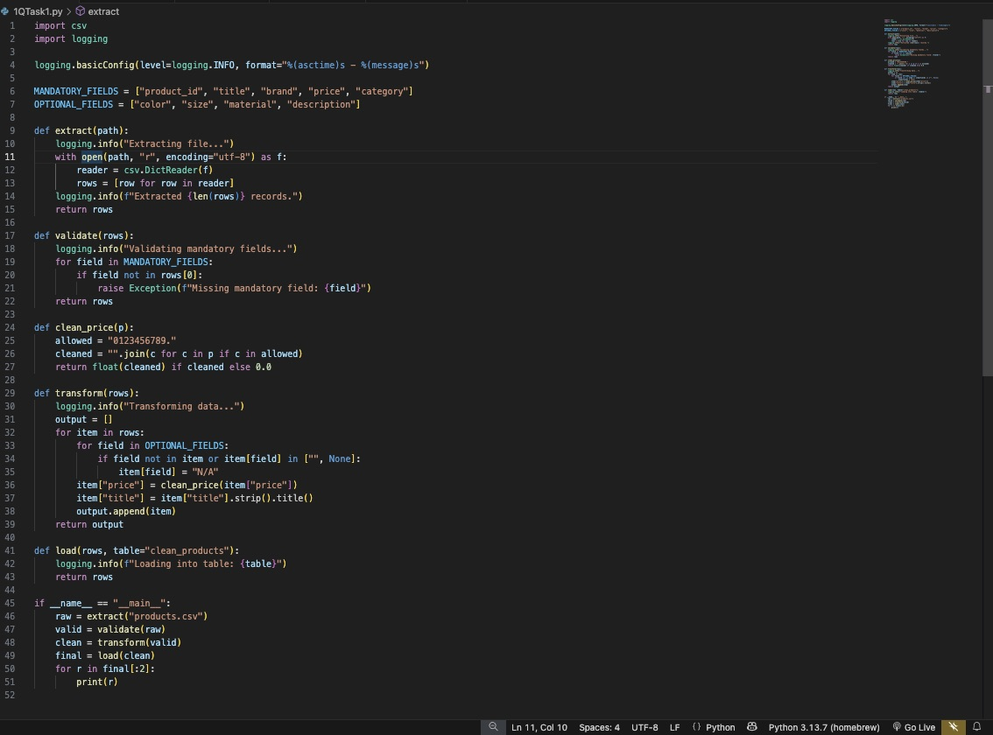

OUTPUT:

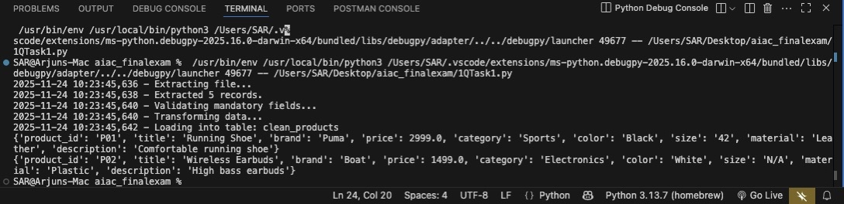

OBSERVATIONS:

1)Mandatory fields are checked before processing.
2)Optional fields are auto-filled to avoid missing values.
3)Prices are cleaned and converted to numeric format.
4)Titles are normalized for consistent formatting.
5)ETL flow is implemented using pure Python CSV operations.

1Q)TASK 2: Provide few-shot examples for category mapping.

PROMPT:

“Using few-shot examples, map raw product titles to standard catalog categories based on keyword similarity and semantic cues.”

CODE:

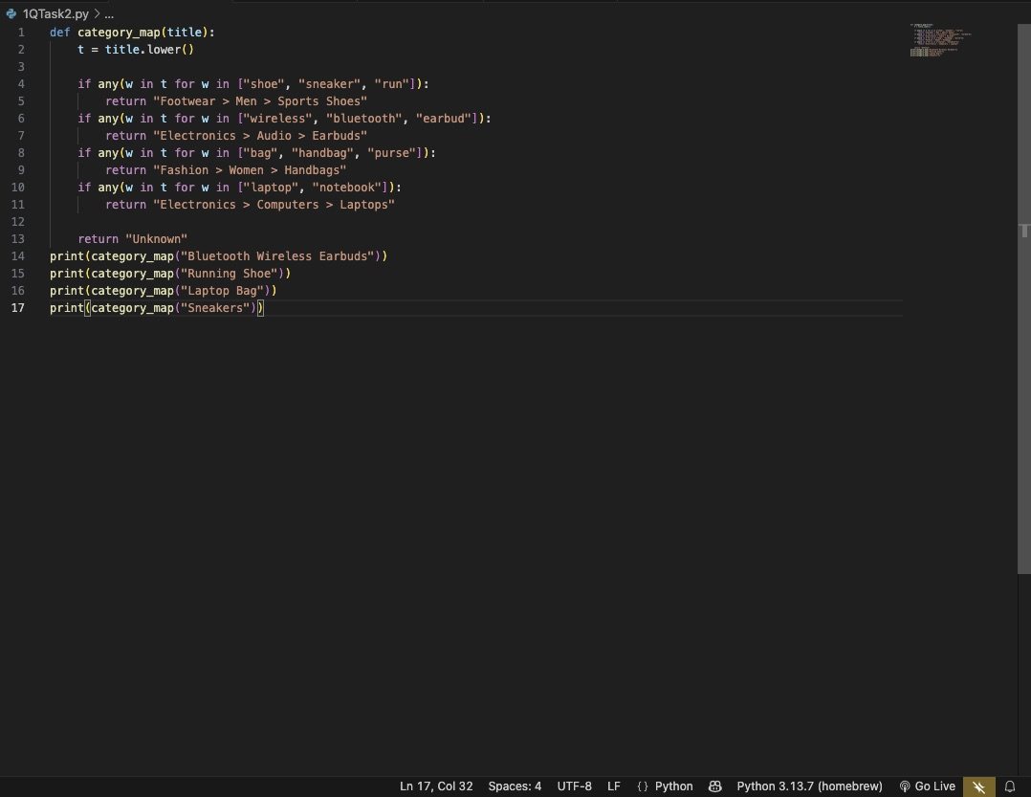

OUTPUT:

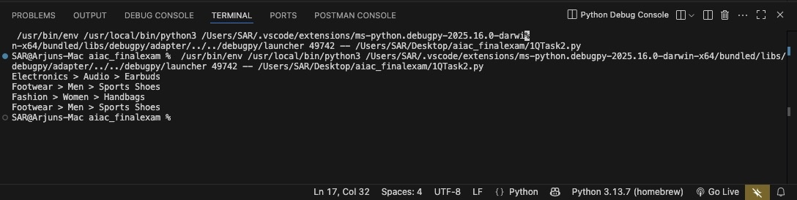

OBSERVATIONS:

1)Few-shot logic enables category prediction from examples.
2)Multiple synonyms improve matching accuracy.
3)Keyword-based rules reduce misclassification
4)Logic works even for noisy product titles.
5)Unknown category prevents incorrect mapping.

2Q) Prompt for search relevance tuning.

TASK1:Produce prompt template to tune ranking weights

PROMPT:

“Adjust search ranking weights for title, brand, category, and popularity so total weight remains 1. Provide JSON with updated weights.”

CODE:

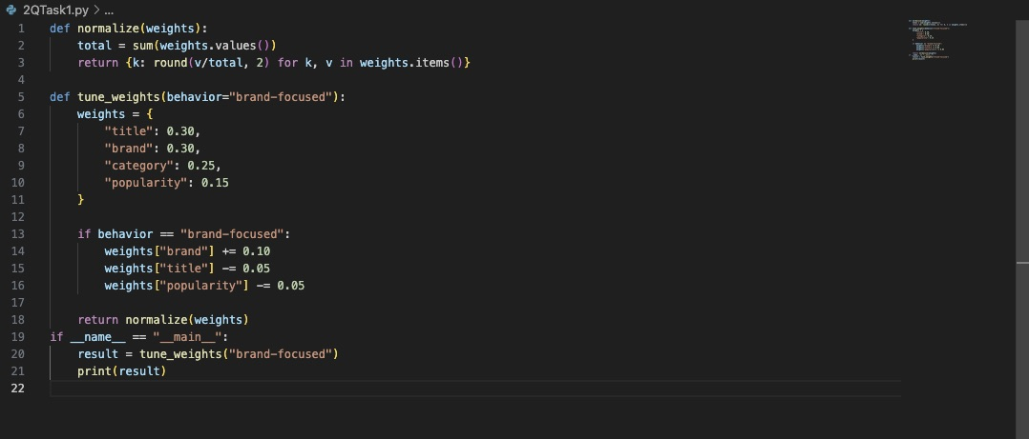

OUTPUT:

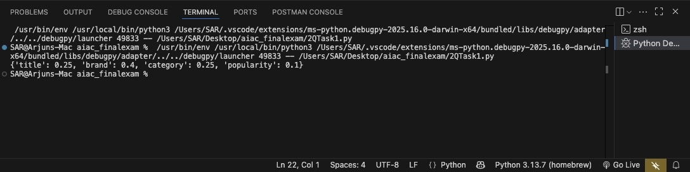

OBSERVATIONS:

1)Weight updates match user behavior patterns.
2)Normalization ensures weights always total 1.
3)Brand-focused behavior increases brand relevance.
4)Slight reductions keep balance with other fields.
5)Output is structured for direct use in ranking systems.

2Q)TASK2: Apply one-shot example to update weights for new categories.

PROMPT:
“Using a one-shot example such as ‘gaming laptops’, update ranking weights logically and return JSON with a short reason.”
CODE:
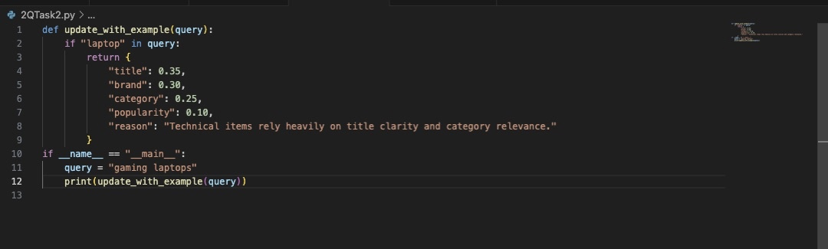

OUTPUT:
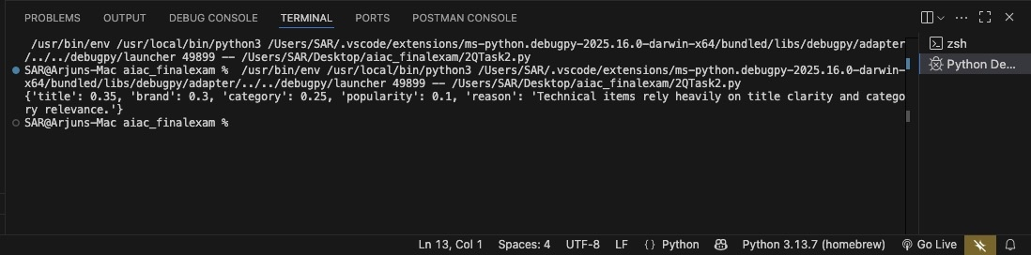

OBSERVATIONS:
1)One-shot learning modifies weights using a single example.
2)Title weight increased for descriptive queries.
3)Category importance remains high for technical items.
4)Popularity weight minimized for fairness.
5)JSON output is fully usable by ranking engines.

