# Analysis:

Analysis is the process to inspect of data and documentation in detail to understand the system for providing basis to solve problem. In this phase, first step would be to gather the necessary requirements for the system, which is the foundation for the proposed project. For the analysis phase various diagrams are used such as use case diagram and class diagram to visualize the gathered requirements. This process of visualizing the requirements is also known as system modelling.

## Analysis methodology taken:

On the basis of projects and background of the project SSADM is the methodology used for analysis. For the short delivery time and minimum requirements. The time for the delivery of the project is 104 days and modification in needs and requirements may cost extra money and time. over the period of time step by step process is done with agreement on requirements.

### DFD

## Fact finding methodology:

Facts and issues are assembled from the people and group who are meant to be involved in the process. By this method we can identify the process and problems faced. By this collection the facts have aided in making best decision and incorporate the features that can evaluate and solve the problem that are being faced in manual systems. This is also the cheapest method of collecting the facts from the large group where people are being available for the interview. The project has to be completed in short period of time though it is less time consuming and cheaper with the budget and resources available.

### Questionnaire Used:

|  |  |
| --- | --- |
| Hotel Order management System Questionnaire | |
| What is your sector of Work? | |
|
| 1. Founder |  |
| 2. Accountant/Cashier |  |
| 3. Cook |  |
| 4.Waiter |  |
| 5.Helper |  |
| How long does it take to do your task? | |
| 1. 1-4 minutes |  |
| 2. 5-8 minutes |  |
| 3. 8-10 Minutes |  |
| 4. Above 10 minutes |  |
|  |  |
| What are the areas of error? (Provide if any) | |
| 1. Billing |  |
| 1. Order taking |  |
| 1. KOT misbalance |  |
|  |  |
| What do you like most about your job? | |
|  | |
| What don't you like about your job and how can it be made better? | |
|  | |

After the tally of the responses gained from the respondent tremendous difficulties in finding the functionality of the business. Errors were found in food varieties listing and the order out of the list and calculation of bills to the particular table. The order was not managed properly with the bill made to the particular table. If the software that can reduce such issue and develop the system for the order management with features and utilities described the successful product with collaborative functions is operated out.

## Feasibility study:

Feasibility study stands for the brief study of operation of the software in the field. The need of this study section is to determine the practical performance if the designed system and features are suitable to achieve or the practical consideration of the current technique, budget and schedule plan. Organization requirement should be accomplished in the project with the feasibility study.

### Types of feasibility study done by us:

Technical feasibility:

7 laptops with i7 processors for the team of 7 designers and developers in the development, Bracket is used as the software to console PHP language of developing the system while Xampp will be used as the local apache server for testing for the deployment of the project. Likely the project seems technically feasible for the development.

Economic feasibility:

This project is developed as a part of assignment for a university. It is economically feasible to design and develop the project for instance various restaurant and hotels are established as a private marketing purposes which increases the possibility of generating the revenue.

Legal feasibility:

None of the rules and regulation can affect the part of development process of designing and developing of Hotel order management system. System could hold up the record of bills and KOT orders for least 1 year according to the company act for Audit so there is no any legal feasibility in this development process.

Schedule feasibility:

Focusing on the product assigned & team of developers and designer work together for 104 days is much enough for the development. While Waterfall model of development process is used in the process which helps in modification of requirements that helps in proper plan of the project and hence the project consists scheduled feasibility.

Social feasibility

Costumers awaiting for their order to be served has no value where table screen processes reduces costumers boring part, Orders are now taken online with description of their health purpose and Bills are served on their desk via online payment or the cash. Thus the project is socially feasible.

## Software requirement specification:

### Functional requirements

|  |  |  |  |  |
| --- | --- | --- | --- | --- |
| ID | Title | Description | Rational | Depen-dency |
| FR1 | Registration | User of the system gets registered for the first time. | New user must get registered to get logged in. |  |
| FR2 | Login | User of the system gets logged in. | User must get logged in to use the system. | FR1 |
| FR3 | Verify username and password | User name and password is verified before providing access to the system. | Whether credentials provided is valid or not is required to be validated before providing access to the system. | FR2 |
| FR4 | Order of the Costumer | Orders of the costumers are saved | Order are recorded for accounting purpose for the future. |  |
| FR5 | Update order | Cancelled orders are removed and new order is taken | Orders with details of cancellation and new orders may be useful for future. | FR4 |
| FR6 | Generate Billing Number and KOT number | Bill numbers and KOT order numbers are built by the system itself | Number of Bills and Order section is required for analyzing faults | FR4 |
| FR7 | Search Table number or costumer | Table number or costumer is searched. | Easy and fast way to bill and order | FR4 |
| FR8 | Delete Order | Table number and orders are deleted | Cancelled orders and costumer return may occur that needs to be deleted for new orders. | FR4 |
| FR9 | Pay bill | Bills are paid | Stares payment details |  |
| FR10 | Add Products | New products is added. | New products are required to be added in the system. |  |
| FR11 | Update menu | Menu details are updated. | Menu are updated here. | FR10 |
| FR12 | Delete products | Products not found are deleted. | Products unreliable to be mend are deleted here. | FR10 |

### Non-Functional requirements

|  |  |  |  |  |
| --- | --- | --- | --- | --- |
| ID | Title | Description | Rational | Depen-dency |
| NFR1 | Proper feedback and notification | Provides feedback on service performed. | Success or failure of the task is notified. |  |
| NFR2 | Elegant interface | Beautiful interface is provided. | Cumbersome interface is hard to use. |  |
| NFR3 | Responsive | Supports in all devices. | Trying to cover wide range of device users. |  |
| NFR4 | Usability | Easier to use interface is designed. | All related functions are available in single page. |  |
| NFR5 | Performance | Fast loading website. | Website loads faster and tasks being performed are also fast. |  |
| NFR6 | Security | Prevents unauthorized access and SQL injection. | Prevents system from harm. |  |

### MoSCoW Prioritization

|  |  |  |  |  |
| --- | --- | --- | --- | --- |
| ID | Title | MoSCoW | Rational | Remark |
| 1 | Registration | M | New user must get registered to get logged in. |  |
| 2 | Login | M | User must get logged in to use the system. |  |
| 3 | Verify username and password | M | Whether credentials provided is valid or not is required to be validated before providing access to the system. |  |
| 4 | Order of the Costumer | M | Order record are required to be saved for future. |  |
| 5 | Update order | M | Updating of the Orders created with error should be provided. |  |
| 6 | Generate Billing Number and KOT number | M | Number of the order is required to be generated for uniquely identify different Orders |  |
| 7 | Search Table number or costumer | M | Easy way to get Order record is necessary to be provided. |  |
| 8 | Delete Order | M | Unwanted Order is required to be deleted. |  |
| 9 | Pay bill | M | Maintains history of the payment of the fee. |  |
| 10 | Add Products | M | New products are required to be added in the system. |  |
| 11 | Update menu | M | Menu created may need to be updated. |  |
| 12 | Delete products | M | Unwanted modules are deleted here. |  |
| 18 | Proper feedback and notification | S | Success or failure of the task is notified. |  |
| 19 | Elegant interface | S | Cumbersome interface is hard to use. |  |
| 20 | Responsive | S | Trying to cover wide range of device users. |  |
| 21 | Usability | S | All related functions are available in single page. |  |
| 22 | Performance | S | Website loads faster and tasks being performed are also fast. |  |
| 23 | Security | S | Prevents system from harm. |  |

## Use Case Diagram

### For Admin User and user.

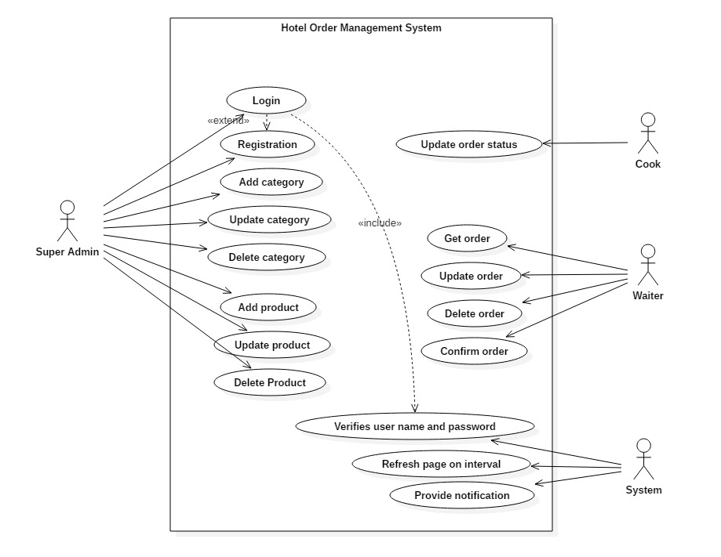

## System architecture:

We have chosen to use three tire architecture as our system architecture because user interface, business logic and database are kept and maintained on separate platforms here. Using these architectures provide us with increased performance, maintainability and flexibility. Major advantage that we will gain by using this architecture is that, each of these modules can be maintained and upgraded separately.

Three tires of this architecture are as follows:

Presentation tier:

We have planned to deploy presentation tier via web application. Via this interface users’ requests are communicated to other tires and result are displayed here. This is what the end user will see and interact with.

Application Tier:

It is a tire all the business logic associated with the school management system will be kept. This logic is written in PHP and hosted in a server. All the user request will be processed by this layer in association with database layer (Which possess the data required) and sent back to the presentation layer.

Database Tier:

This tier will handle the logic associated for managing read and write access to a database. This will also be hosted in a cloud. This is where all the student records will reside which can be accessed 24*7.

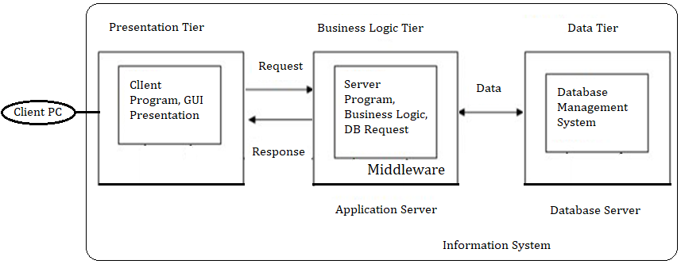

### Scenario:

#### Step 1: Identification of noun for potential list of candidate Class.

* Following nouns were identified.

|  |
| --- |
| **Noun** |
|  |

* Identified noun went through following filtration process:
  + Redundancy removed.
  + Noun with similar meaning were ignored.
  + Irrelevant noun to the project scope were removed.
  + Section part of future design are ignored.
  + Noun having high level of abstraction removed. (Like: system)

|  |  |  |  |
| --- | --- | --- | --- |
| **S.N.** | **Identification of noun** | **Is selected?** | **Justification** |
| 1. |  |  |  |
| 2. |  |  |  |
| 3. |  |  |  |
| 4. |  |  |  |
| 5. |  |  |  |
| 6. |  |  |  |
| 7. |  |  |  |
| 8. |  |  |  |
| 9. |  |  |  |
| 10. |  |  |  |
| 11. |  |  |  |
| 12. |  |  |  |
| 13. |  |  |  |
| 14. |  |  |  |

|  |  |
| --- | --- |
| **Filtered list of candidate class** | |
| **S.N.** | **Selected Class** |
| 1. |  |
| 2. |  |
| 3. |  |
| 4. |  |
| 5. |  |
| 6. |  |

#### 

#### Step 2 – Identification of verb for potential list of candidate methods.

* Following verbs were identified.

|  |
| --- |
| **Verb** |
|  |

Above verbs goes through following filtration process.

* + Redundancy removed.
  + Verb with similar meaning were ignored.
  + Irrelevant verb to the project scope were removed.
  + Section part of future design are ignored. (Designing and developing removed)
  + Verb having high level of abstraction removed.

|  |  |  |  |
| --- | --- | --- | --- |
| **S.N.** | **Identification of verb** | **Is selected?** | **Justification** |
| 1. |  |  |  |
| 2. |  |  |  |
| 3. |  |  |  |
| 4. |  |  |  |
| 5. |  |  |  |
| 6. |  |  |  |
| 7. |  |  |  |
| 8. |  |  |  |
| 9. |  |  |  |
| 10. |  |  |  |

|  |  |
| --- | --- |
| **Filtered list of candidate Methods** | |
| **S.N.** | **Selected Methods** |
| 1. |  |
| 2. |  |
| 3. |  |
| 4. |  |
| 5. |  |
| 6. |  |
| 7. |  |
| 8. |  |
| 9. |  |

### Class Diagram

