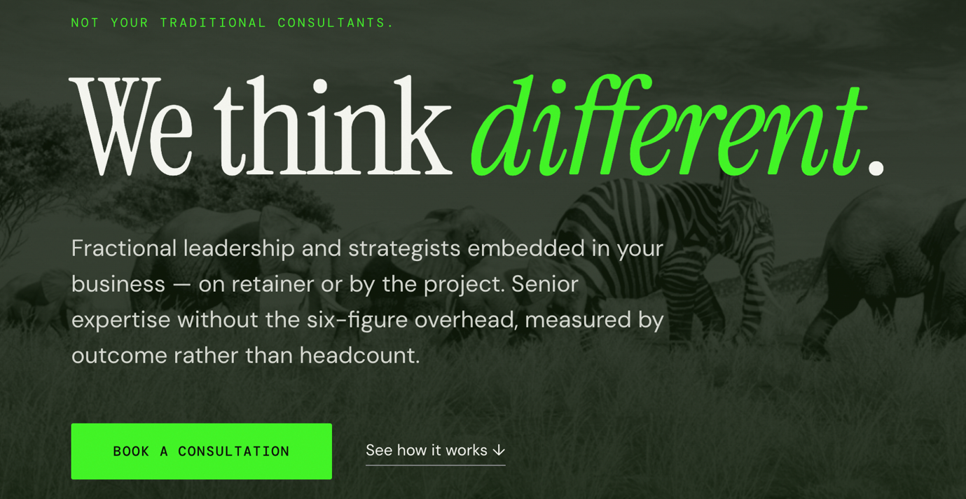

Antithesis
(Change We Think Different to) Not you traditional Consultants.

Senior leadership, embedded in your business.
Fractional executives and strategists — on retainer or by the project. The expertise of a seasoned C-suite, scoped to what you actually need.
Book a conversation · See how it works ↓
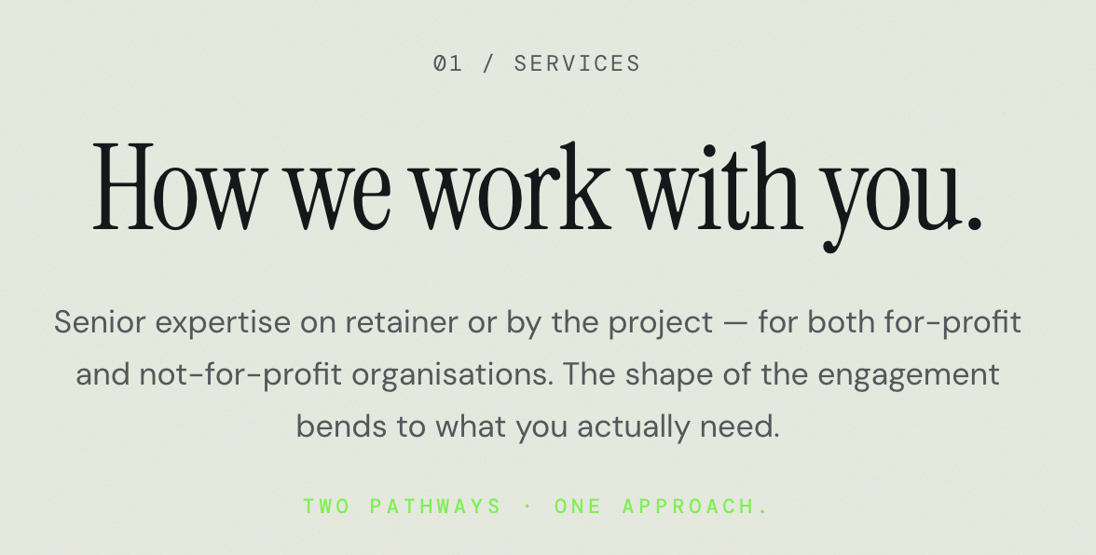

Antithesis works with for-profit and not-for-profit organisations — on retainer or scoped to a single project. Every engagement is structured around your outcomes, not a templated deliverable.

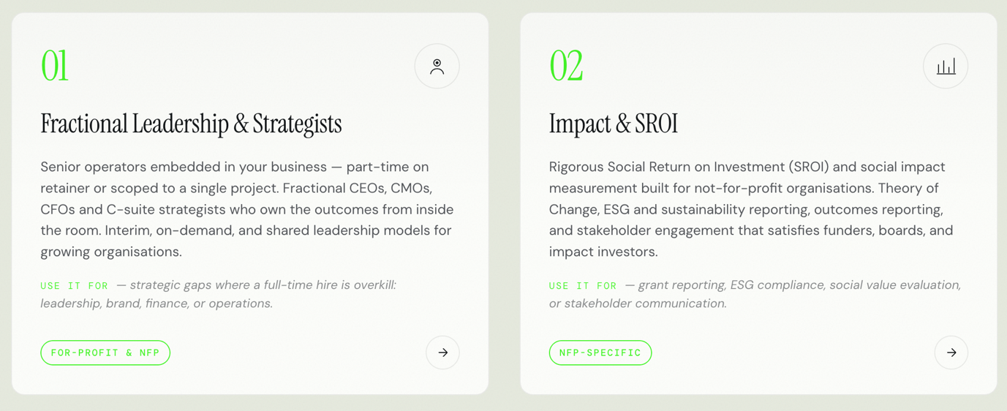

01

Fractional Leadership & Strategists
A senior operator — embedded in your business and accountable for results. Not advisory from the outside. In the room, on the decisions, building capability your team keeps.
Right for you if: A full-time hire isn't justified yet, but the strategic gap is real.
For-profit & NFP · Start the conversation →
02

Impact & SROI
Measurement frameworks that give funders the evidence they need and boards the narrative they can stand behind. SROI analysis, Theory of Change, ESG reporting, and outcomes documentation — built for the scrutiny of grant panels and impact investors alike.
Right for you if: You do meaningful work and need to prove it.
NFP-specific · Start the conversation →

The full-time hire is the wrong default.
Hire too early and you burn runway. Too late, and the gaps compound. Antithesis resolves the timing problem: senior expertise scoped to the decisions that matter, without the fixed cost of a permanent role.
The signal you need fractional leadership:
- Strategy is stalling, but a full-time hire isn't justified yet
- Your board or funders want senior accountability on a defined outcome
- You're in a critical 6–18 month window — growth, transition, or reset
Layout suggestion: The comparison table (cost/output/waste) is genuinely persuasive data. Keep it, but simplify the headers: Cost · Strategic Focus · Overhead. Remove the percentage theatre ("40% Full-time → 90% Fractional") — replace with clean callout stats below the table instead.

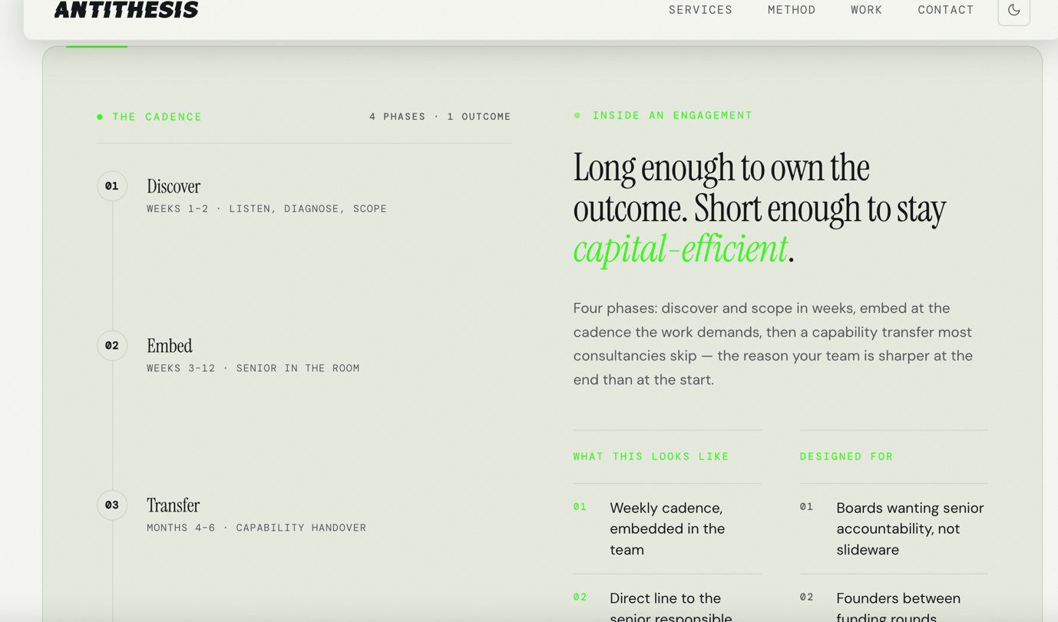

ENGAGEMENT SNAPSHOT (Embedded Section)
Optimised Copy:

Long enough to own the outcome. Brief enough to respect your budget.
Four phases — and we don't skip the one that matters most.
Phase | Timeline | What happens
Discover | Weeks 1–2 | Listen, diagnose, scope
Embed | Weeks 3–12 | Senior in the room
Transfer | Months 4–6 | Capability handover to your team
Compound | Ongoing | Light-touch retainer, on call
Most consultancies end at phase two. We consider three the real deliverable.

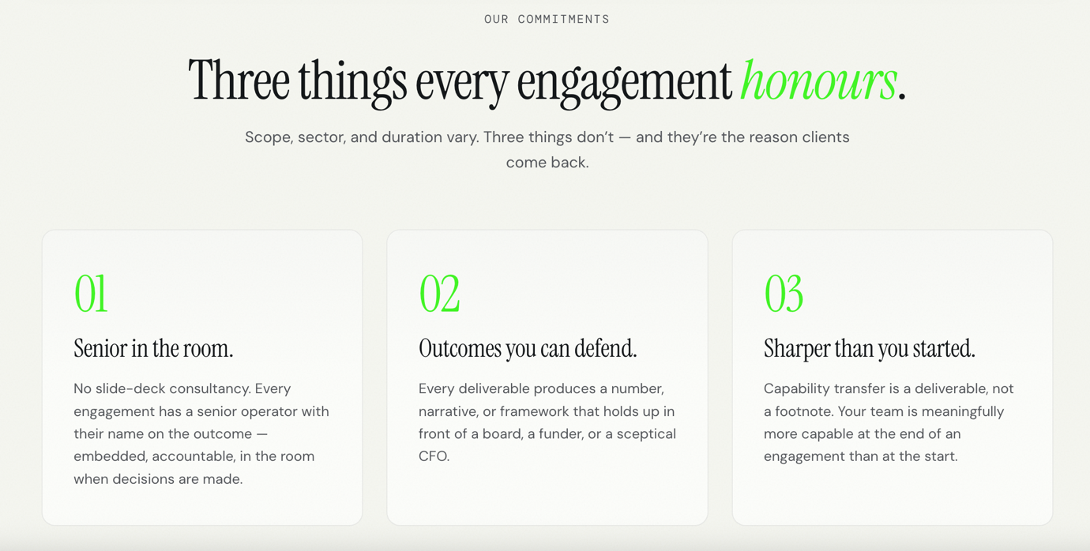

THREE COMMITMENTS
Optimised Copy:

What every Antithesis engagement delivers.
01 · Senior in the room. A senior operator with their name on the outcome — embedded, accountable, and present when decisions are made.
02 · Outcomes you can defend. Every deliverable produces a number, a narrative, or a framework that holds up in front of a board, a funder, or a sceptical CFO.
03 · A sharper team at the end. Capability transfer is a core deliverable, not a courtesy. Your team leaves the engagement more capable than when we arrived.

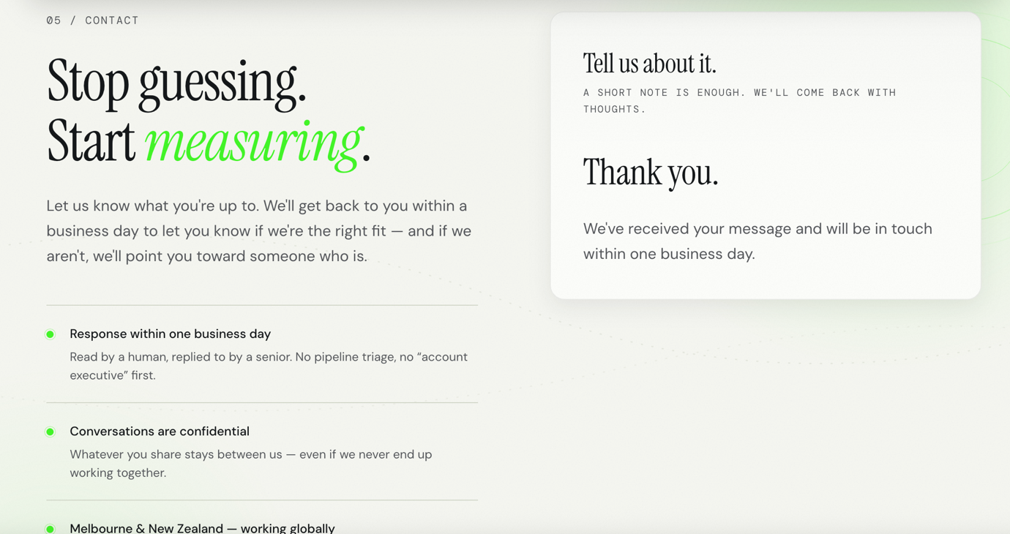

Optimised Copy:

Ready to close the gap?
Tell us what you're working on. We'll respond within one business day — and if we're not the right fit, we'll say so and point you toward someone who is.
Three trust signals below (retain as-is, update branding):
- Read and replied to by a senior. No account-executive triage.
- Everything shared stays confidential — whether we work together or not.
- Melbourne & New Zealand · Working globally · WhatsApp +64 27 233 0313

FOOTER
Original:
"© 2024 Antithesis Consulting — We think different."
Optimised Copy:

© 2024 Antithesis Consulting – Not you traditional Consultants

