1.Create a project on Azure Devops after your login

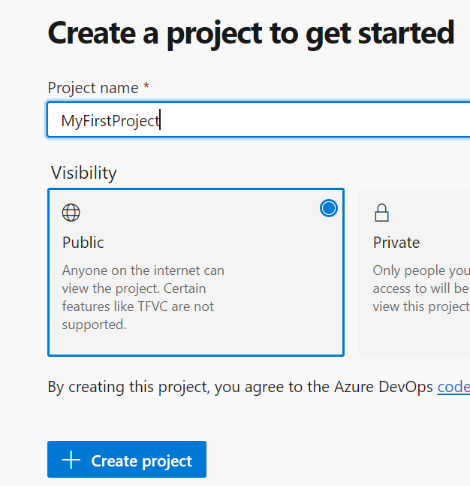

2.Clone the git or version control remote repo to Azure repos

3.Create the pipeline after configuring the service connection in the Project settings

4.Create the Yaml pipeline and add the below step as we are using webapp for .netcore cli add this after the build steps

- task: AzureWebApp@1

  inputs:

    azureSubscription: 'SP'

    appType: 'webAppLinux'

    appName: 'New-webapp'

    package: '$(System.DefaultWorkingDirectory)/\*\*/\*.zip'

5.Edit the project and make sure the below step is checked so that whenever a

Push happens to the branch the code gets triggered and published to the repository.

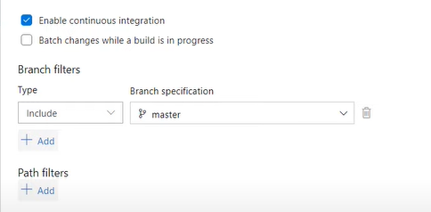

6.Now we have completed the build pipeline and now moving on to the release pipeline steps

7.Add the artifact and create the Dev stage and then link it to QA as below .The pre deployment step for QA will be if dev is triggered

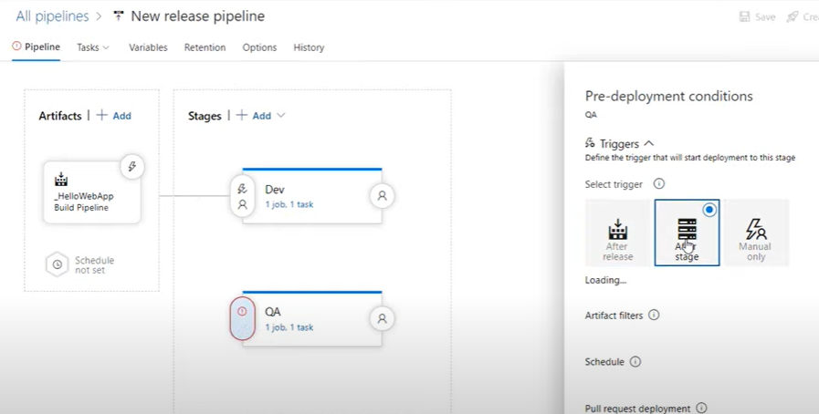

8.Create stagging slot before prod deployment stage and add the swapping slot to configure the blu green deploy for Prod

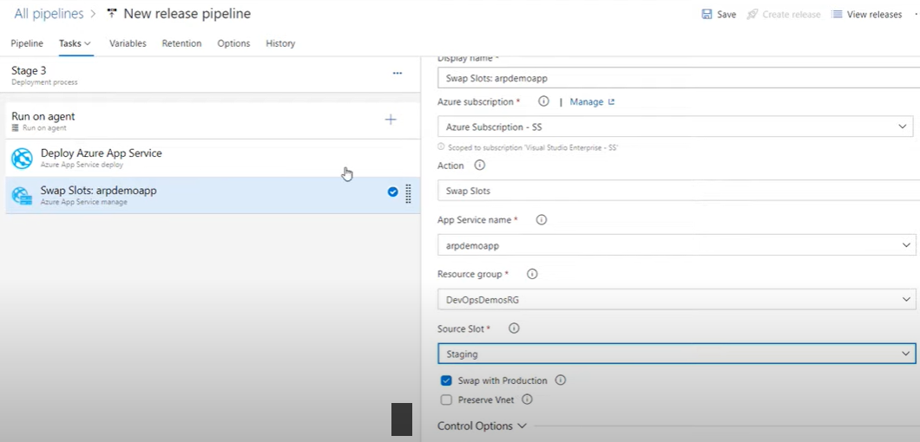

9. Add the post deployment approval at each stage

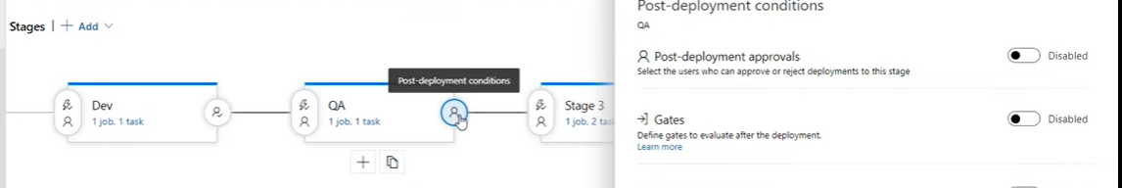

10. Add manual intervention step before the prod deploy process to enhance security

