[**VISVESVARAYA TECHNOLOGICAL UNIVERSITY**](http://www.vtu.ac.in/)

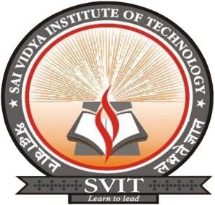

**“JNANA SANGAMA” ,BELAGAVI-590018**

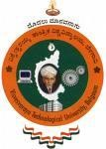

**A Mini Project Report** **On**

# S “ONLINE EXAMINATION SYSTEM”

## Submitted in the partial fulfillment of the requirement for the award of degree of

**BACHELOR OF ENGINEERING**

**IN**

**COMPUTER SCIENCE AND ENGINEERING**

**Submitted By**

**RAKESH M R B G VINAYAK HARSHITA T**

**1VA17CS040**  **1VA17CS010 1VA17CS015**

## Under the Guidance of

**Prof. Sunil G L** **Prof. Deeksha Hegde B** **Prof. Nagamahesh B S**

**Assistant Professor,** **Assistant Professor,** **Assistant Professor,**

**Dept., of IS&E** **Dept., of CS&E** **Dept., of CS&E**

**DEPARTMENT OF COMPUTER SCIENCE AND ENGINEERING**

# SAI VIDYA INSTITUTE OF TECHNOLOGY

**(Affiliated to Visvesvaraya Technological University, Belagavi | Recognized by Govt. of Karnataka |Approved**

**by AICTE, New Delhi)**

**RAJANUKUNTE, BENGALURU – 560 064**

**2018-19**

S

SAI VIDYA INSTITUTE OF TECHNOLOGY

**(**

**Affiliated to Visvesvaraya Technological University, Belagavi | Recognized by Govt.**

**o**

**f Karnataka | Approved**

**by AICTE, New Delhi)**

**Rajanukunte, Bengaluru**

**-**

**560 064**

**DEPARTMENT OF COMPUTER SCIENCE AND ENGINEERING**

CERTIFICATE

Project

Mini

that

Certified

the

work

entitled

*“*

***ONLINE EEXAMINATION***

***SYSTEM***

*”*

carried out by

**Mr.**

**RAKESH M R (1VA17CS040) Mr. B G VINAYAK (1VA17CS040)**

**HARSHITHA T (1VA17CS016) ,**

bonafide students of

**SAI VIDYA INSTITUTE OF**

**TECHNOLOGY**

, Bengaluru, in partial fulfillment for the award of Bachelor of Engineering in

Computer Science & Engineering of

**VISVESVARAYA TECHNOLOGICAL**

**UN**

**I**

**VERSITY**

,

Belagavi during the year

**2019**

**-**

**20**

**.**

It is certified that all corrections/suggestions indicated for

Internal Assessment have been incorporated in the report deposited in the departmental library.

The mini project report has been approved as it satisfies

the academic requirements in respect of

mini project work prescribed for the said Degree.

**Name of External Examiners**

**Signature**

**with**

**Date**

1.

**___________________________**

**__________________________**

2.

**___________________________**

**_____________**

**__**

**_**

**__________**

**Prof. Sunil G L**

Assistant Professor,

Dept., of IS&

E

**Prof**

***.***

**Deeksha Hegde**

**B**

Assistant Professor,

Dept., of CS&E

**Prof. K Ananthapadmanabha**

Professor & Head,

Dept., of CS&E

**Dr. H S Ramesh Babu**

Principal

