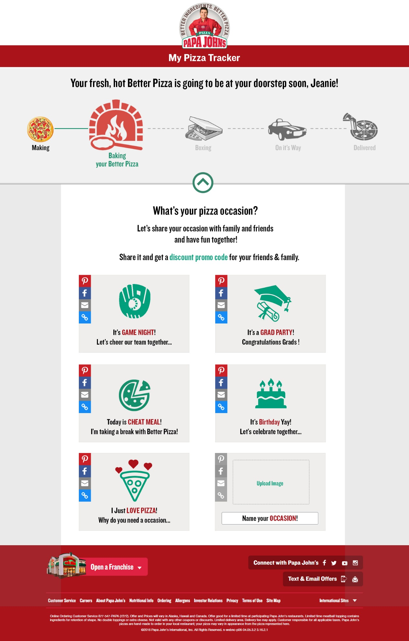

Special remarks if any

What will happen on hover, click on those boxes?

What will happen on hover, click on this arrow?

What will happen on hover, click on those icons?

sadsadsad

What will happen on hover, click on those boxes?

What will happen on hover, click on those icons?

Special remarks if any

What will happen on hover, click on this arrow?