**Project Title**

**Team Name**: Flexi-Work (Enterprise Resource Management System)

**Team Member**: Sudeep N Naik, Shreya Gupta

**Problem Statement** : A large company with thousands of employees is facing logistical issues in efficiently managing workspaces and parking slots. The existing process is manual, leading to miscommunication and resource wastage. Additionally, organizing internal events for employee engagement, such as competitions or team-building activities, becomes overwhelming without a proper system in place. A solution is needed that can automate these processes and help the company allocate resources and organize events smoothly.  
  
**1. Understanding of the Problem statement**

a. **Explanation of the Problem Context**: The company’s current system for managing workspaces, parking slots, vendor stalls in cafeteria and internal events is manual and inefficient, leading to resource misallocation, communication gaps, and logistical challenges. The intended users of this solution are the company's employees, administrators, and facility managers who are responsible for managing resources and coordinating internal events.

b. **Key Requirements Identified**:

**Workspace Allocation Automation:** A system to automate workspace booking, allowing employees to view available spaces and reserve desk.

**Parking Slot Management:** An interface for employees to book parking slots based on availability, helping prevent overbooking and ensuring a smooth allocation process.

**Event Management Support:** A system for organizing and managing internal events with features for event creation, registration, and participant tracking.

**Vendor-Stall Management**: A interface for the vendors to book the stalls and admin has a complete record of all the stalls.

**Role-based Access Control:** Different levels of access based on user roles (e.g., employee, admin, vendors, security-guard) for secure management of resources.

**2. Solution Overview**

a. **Solution Summary:** The proposed solution is a web-based application that provides automated tools for workspace, parking slot management, and event organization. It will offer a real-time interface where employees can view and reserve workspaces and parking slots, while admins have control over setting allocations and availability. The solution will incorporate an event management module to simplify the creation, tracking, and participation in company events. Additionally, Vendor stalls Booking and their details can be tracked.

b. **Objective**: The primary objective of the solution is to automate and optimize resource allocation processes, reducing miscommunication and improving efficiency. Expected benefits include:

* Improved Resource Utilization**:** Reduction in wasted or underutilized spaces by providing visibility and control over resource allocation.
* Enhanced Employee Experience**:** Easier, more efficient booking processes for employees, resulting in better overall satisfaction.
* Streamlined Event Management**:** Simplifies the organization of team-building activities and competitions, fostering a more engaging work environment.
* Time and Cost Savings**:** Reduced administrative time in handling bookings and resources, saving costs for the company.

**3. Features and Functionalities**

1. **Core Features:**

* **Workspace Management Module:**
* Interactive map or list view of available workspaces.
* Workspace booking with real-time availability checks.
* Notifications for booking confirmations, reminders, and updates.
* **Parking Slot Management Module:**
* Parking layout view showing available and booked slots.
* Real-time status updates to prevent conflicts in parking allocations.
* Notifications for booking confirmations, reminders, and updates.
* **Event Management Module:**
* Booking the venue available for the event.
* Event creation interface for administrators with options to add descriptions, dates, times, and capacity limits.
* Employee registration system for events, allowing RSVPs and tracking attendance.
* **Vendor Stall Module:**
* Detailed tracking of each vendor stall, including stall name, rent, and status (available or booked).
* Rent management functionality to track rent details for each stall.
* **Security Guard Module:**
* Interface for security guards to view and monitor parking slots and resolve any issues with bookings or unauthorized vehicles.
* Real-time communication tool to notify security staff of any urgent issues within the parking area.
* **Admin Dashboard:**
* A comprehensive dashboard for administrators to manage all resources, bookings, and vendor stalls.
* Reporting tools to provide insights on resource utilization, event engagement, and vendor space income.
* Has access to all Employee details.

b. **Additional Features:**

* **Booking Notifications and Reminders:** Automated notifications for upcoming bookings, cancellations, or any conflicts detected in the system.
* **Analytics Dashboard :** **Analytics** on resource utilization, occupancy rates.

c. **User Flows**:

* **Workspace Booking Flow:**
* User logs into the application and navigates to the Workspace module.
* User views available workspaces and selects their preferred space.
* User reserves the workspace, receiving a confirmation notification.
* Admin can view workspace availability and booking details.
* **Parking Slot Reservation Flow:**
* User navigates to the Parking module, views a layout map showing available slots, and selects a slot.
* User reserves the slot, and real-time status updates reflect the booking to avoid conflicts.
* Security guards can monitor slot usage and report or resolve issues if needed.
* **Event Management Flow:**
* Admin creates an event, adding details like date, location, and capacity, then publishes it for registration.
* Employees can view and register for events, receiving reminders and notifications before the event.
* Admins can track event registrations, monitor attendance, and close registrations once capacity is met.
* **Vendor Stall Management Flow:**
* Admin views all vendor stalls, their occupancy status, and rental details.
* Admin can assign stalls to vendors, track payment schedules, and view reports on vendor stall income.
* Vendors can access their booking details, check rental status, and view payment history.
* **Security Incident Resolution Flow:**
* Security guard accesses the parking slot monitoring interface.
* If an issue is reported (e.g., unauthorized vehicle), the guard can log and resolve the incident within the system.
* Admins receive a notification of the incident log and can follow up if necessary.

**4. Architecture Diagram**

a. System Architecture:

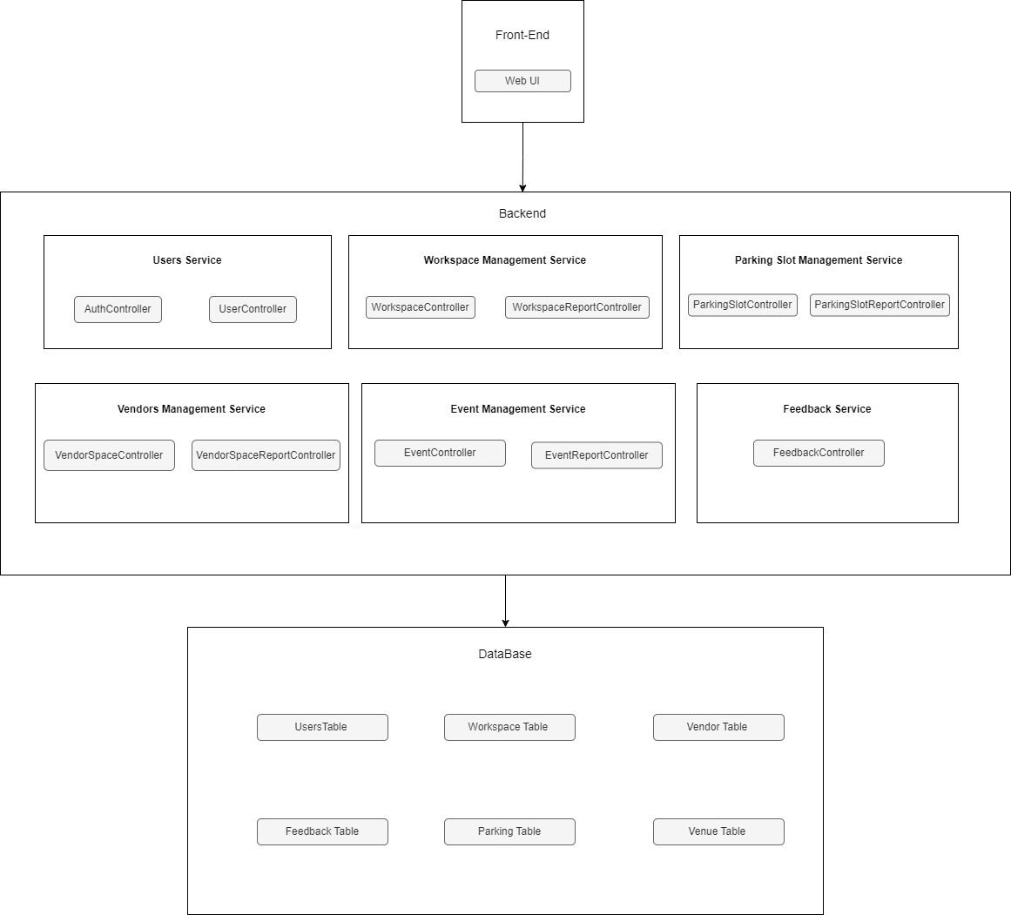

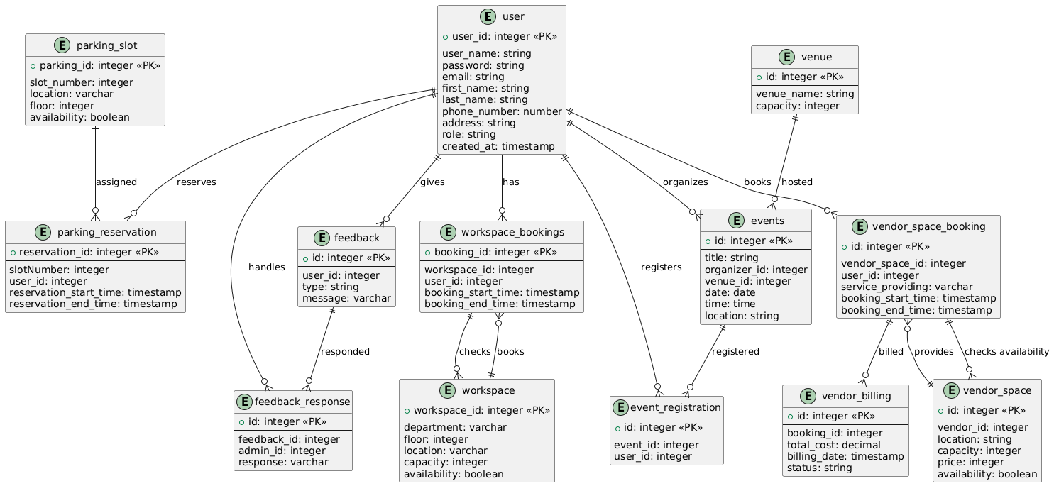

b. **Key Components:**

* **Frontend (UI):** The main interface where users interact with booking features and receive notifications.
* **Microservices (Workspace, Parking, Event, Vendor Stall, Security Guard):** Each service focuses on a distinct function to ensure modularity and scalability.
* **Notification Service:** Sends email or app notifications, integrated with external notification providers.
* **Database:** Maintains data persistence for user profiles, resource allocations, and logs.

**5. Technical Stack**

**a. Frontend:**

* **Framework:** React with TypeScript for robust type-checking.
* **UI Library:** Material UI for responsive design components.
* **API Handling:** Axios for making HTTP requests to the backend APIs.

**b. Backend:**

* **Framework:** Node.js with Express for RESTful API development.
* **Microservices Architecture:** Individual services for workspace, parking, event, and vendor stall management.
* **Authentication & Authorization:** JWT for secure token-based authentication and role-based access.

**c. Database:**

* **Main Database:** MongoDB for flexibility in storing structured and semi-structured data, ideal for user profiles and booking records.

**c. Other Technologies and Tools:**

* Nodemailer for sending mail notification.
* Cloudinary for Storing employee profile images and Vendor stall images.

**6. Prerequisites and Requirements**

**a. Technical Requirements:**

* **Hardware:** Servers with adequate CPU and memory resources for running backend services and databases (e.g., minimum of 8GB RAM, quad-core CPU).
* **Development Environment:** Local development requires Node.js, and MongoDB setup.
* **Databases:** MongoDB for main storage and Elasticsearch for logging and incident tracking.
* **Testing Tools:** Access to testing environments and tools like Postman for API testing.

**b. Data Requirements:**

* **Sample Data:** Sample datasets for workspaces, parking slots, event registrations, vendor stalls, and user profiles for initial development and testing.
* **APIs:** Access to third-party public APIs for mail notifications, Cloudinary.
* **Demo Accounts:** Accounts with role-based access (e.g., admin, user, security guard) for testing authorization and role-specific features.

**c. Access Permissions:**

* **Source Control:** Access to a Git repository where team members can collaborate on the codebase.
* **Cloud Accounts:** Admin access to cloud accounts for managing instances, databases, and scaling configurations as needed.

**d. Other Dependencies:**

* **Libraries and Plugins:**
  + **Frontend:** Material UI, Axios, and React-Router for UI components, data fetching, and navigation.
  + **Backend:** Express, JWT for authentication, Mongoose (for MongoDB), notification library (Nodemailer), Image storage (Cloudinary).
* **Versioning:** Specific versions of Node.js (LTS version), React, and MongoDB to ensure compatibility across development and production.

**7. Future Improvements**

**a. Planned Enhancements:**

* **Bidding System:** Adding bidding system for the vendor stalls.
* **Mobile App Version:** Develop a mobile app to allow easier access to booking and event management on the go.
* **Customizable Notifications:** Enable users to select their preferred notification channels (e.g., SMS, email, in-app).
* **Payment Gateway:** Implementing the payment gateway system for the vendors.

**8. Conclusion**

**a. Summary of Achievements:** The solution effectively automates workspace and parking slot management, streamlines event organization, and adds modules for vendor stall and security management. Core features, including real-time availability, role-based access, and notifications, provide a well-rounded system for addressing logistical challenges in large organizations.

**b. Value Provided:** This solution reduces administrative overhead, minimizes resource wastage, and enhances employee satisfaction by providing a user-friendly booking system. By automating and optimizing logistics, the company can reduce costs, improve communication, and create a more engaging work environment, helping to maintain a productive, organized, and employee-centered workplace.

**9. Attachments**

**Figma Design:** [**https://www.figma.com/design/uBfgHKH8EjVn8POCbahZCd/Enterprise?node-id=0-1&t=hInYhzhyM6eIgPU3-1**](https://www.figma.com/design/uBfgHKH8EjVn8POCbahZCd/Enterprise?node-id=0-1&t=hInYhzhyM6eIgPU3-1)

**Screenshots:**