**Traceability Matrix**: It is a document which ensures that every requirement has at least one test case.

Test cases are written by looking at the requirements and test cases are executed by looking at the test cases. If any requirement is missed i.e., test cases are not written for a particular requirement, then that particular feature is not tested which may have some bugs. Just to ensure that all the requirements are converted into test cases, traceability matrix is written. This is shown below,

|  |  |  |  |
| --- | --- | --- | --- |
| TRACEABILITY MATRIX | | | |
|  |  |  |  |
| Requirement Number | Test Case Name |  |  |
| 1 | … |  |  |
| 2 | … |  |  |
| 3 |  |  |  |
| 4 | … |  |  |
| 5 | … |  |  |
| 6 |  |  |  |
| 7 | … |  |  |

From the above matrix we will come to know that for the requirements 3 and 6 test cases are not written.

The Traceability Matrix is also known as RTM (Requirement Traceability Matrix) or CRM (Cross Reference Matrix).

**SOFTWARE TEST LIFE CYCLE (STLC):**

STLC is part of SDLC

Defect Life Cycle is a part of STLC

**System Study**

REQUIREMENTS

**Store it in repository**

**Test Case Approval**

**Fix Review Comments**

**Review Test Cases**

**Write test cases**

**Identify all possible test scenarios**

**Prepare test execution report (TER) and send it to customer**

**Defect Tracking**

**Test case Execution**

**Traceability Matrix**

**Write Test Cases**

**Write Test Plan**

**Retrospect Meeting**

INTERVIEW QUESTION

**Difference between Smoke Testing and Sanity Testing and Dry Run**

**Ans) Sanity Testing**

* Narrow and deep testing. Unscripted
* Take some very important features and do deep testing
* It is manually done

**Smoke Testing**

* Scripted. Shallow and wide testing
* Generally smoke test cases will be automated to save time and for quick testing.
* Take all important features and do high-level testing
* Build comes – write automation scripts and run the script. Thus, testing is done automatically.

**Dry Run Testing -** A dry run is a testing process where the effects of a possible failure are intentionally mitigated. For example, an aerospace company may conduct a "dry run" of a takeoff using a new aircraft on a runway before the first test flight.

If interviewer still expects more differences – then just tell –Can u please tell me which website i should visit to get to know the exact answer.

**Defect or Bug Life Cycle:**

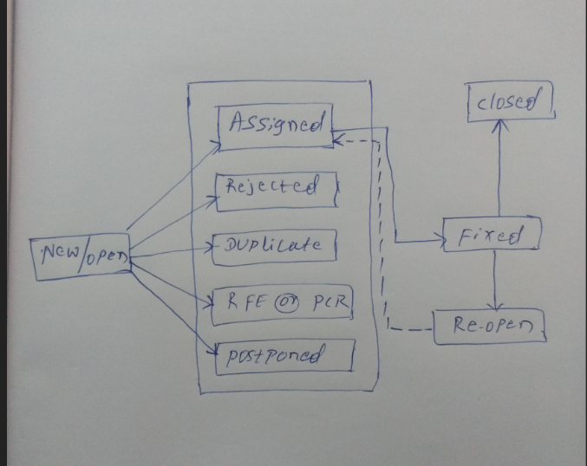

**Note:** The above all in the diagram are status of the defect.

RFE: Request for enhancement

PCR: Product Changed Request

**What is Severity of the defect:** It is how critical the defect is from business point of view is called as severity.

Severity of the defect may be,

1.Blocker/Show stopper

2.Critical

3.Major

4.Minor

**What is Priority of the defect:** It is the importance to fix the bug (OR) how soon the defect should be fixed (OR) which are the defects to be fixed first.

Priority of the defect may be,

1.High

2.Medium

3.Low

**Note:** Generally, severity is assigned by Tester / Test Lead & priority is assigned by Developer/Team Lead/Project Lead.

**What is inconsistent defect?**

The defects which are occurring at irregular intervals of time are called as inconsistent defects.

**What is Verification and Validation?**

**Verification:** Reviewing some document is called as verification or static testing.

E.g.: Requirement document

**Validation:** Giving the required inputs and checking the application is called as validation.

E.g.: Amount Field

Note: Example for verification and validation is V-MODEL