**Scanner Class:**

* Scanner class is used to read input from keyboard
* It is available in java.util package

Commonly used methods of scanner class are

1.next()

2.nextLine()

3.nextByte()

4.nextShort()

5.nextInt()

6.nextLong()

7.nextFloat()

8.nextDouble()

**Exception Handling:**

Exception is an unexpected event triggered by ‘jvm’ when some abnormal operations are performed.

**Exception hierarchy:**

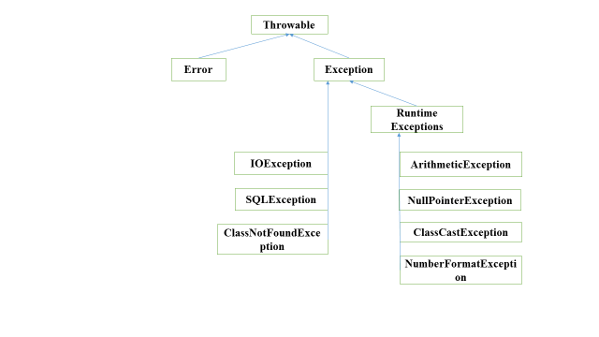

**Types of Exceptions:**

1. Un-Checked/ handled Exception (Runtime exceptions):

* These are the exceptions raised at the run-time.
* Exception types which are inherited from “RuntimeExceptions” are called as Un-checked exceptions

Ex:- ArithmeticException, NullPointerException, ClassCastException…etc.

1. Checked Exception/unhandled (Compile time Exceptions)

* These are the exceptions raised at the compile time. These exceptions need to be handled during compiling the code.
* Exception types which are directly inherited from “Exception” class are called as checked exceptions.

Ex:- IOException, SQLException, InterruptedException…etc.

**We can handle the exception using ‘try’ block ‘catch’ blocks, finally block, throw keyword and throws keyword.**

* ‘try’ block contains the code which might rise the exception.

|  |
| --- |
| try  {  //Code  } |

* ‘catch’ block will catch the exception that are thrown from ‘try’ block.

|  |
| --- |
| catch(Exception e)  {  } |

* ‘catch’ block get executed only when the respective exception is thrown from the ‘try’ block.
* ‘catch’ block will catch the exception only if they are thrown from respective ‘try’ block.
* ‘catch’ block will not catch the exceptions which are thrown from outside the ‘try’ block.

**Difference b/w final, finally and finalize:**

final:

* final is used to apply restrictions on a class, method and a variable.
* final classes cannot be inherited. final methods cannot be overridden and final variable values cannot be changed
* final is keyword

finally:

* finally block is used to place some important code.
* finally block is always gets executed whether an exception is handled or not
* finally is a block

finalize:

* finalize is used to perform cleanup processing just before object is garbage collected
* finalize is a method available in Object class.

**Difference b/w throw and throws:**

|  |  |
| --- | --- |
| throw | throws |
| Java throw keyword is used to throw an exception explicitly | Java throws keyword is used to declare an exception |
| checked exceptions cannot be propagated using throw only | checked exceptions can be propagated with throws |
| throw is followed by an instance | throws is followed by class |
| throw is used within a method | throws is used with method signature |
| you cannot throw multiple exceptions | you can declare multiple exceptions |