Webhook & Input Handling
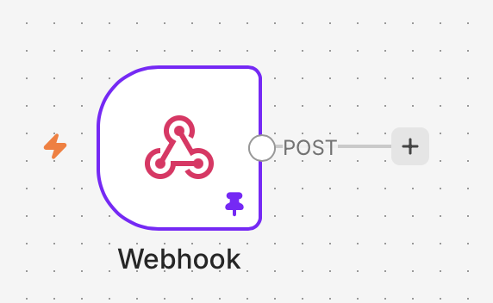
Webhook node is used for getting data from external sources. It confirms POST requests and processes user enters with their name, email and message fields.

Test Case 1:
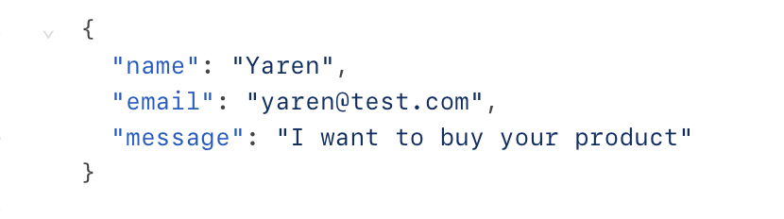

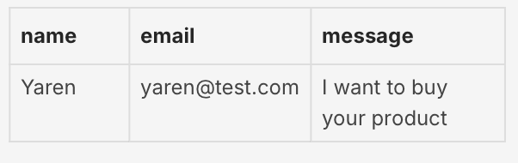
Figure 1. Output of Test Case 1 showing received user input.
Test Case 2:
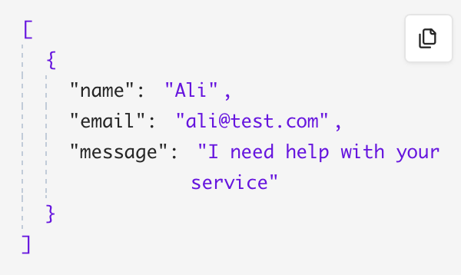
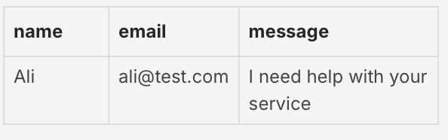
Figure 2. Webhook workflow configuration in n8n.

