SE445 HW2 Report – Lead Capture / Contact Intake

Student Name: Sude Naz Kuzay
Student ID:21244710111
Project Topic: Lead Capture / Contact Intake
GitHub Repository Link: https://github.com/sudekuzey99-source/HW2_Lead_Capture_Sude/tree/main/Desktop/HW2_Lead_Capture_Sude

Project Topic
The topic of this homework is Lead Capture / Contact Intake. The purpose of this workflow is to receive lead information from a user and store it in a CRM-like database.

Workflow Structure
The workflow follows this structure:
HTTP POST Request → Webhook Endpoint → Mock CRM API → SQLite Database
The user sends a JSON payload containing name, email, and message. The webhook endpoint receives this data and forwards it to the mock CRM API. The mock CRM API stores the lead record in the SQLite database.

How the Solution Meets the HW2 Requirements
This solution meets the HW2 requirements because it accepts an HTTP POST request with exactly three fields: name, email, and message. Each successful request creates a new record in the CRM database. The stored records can be verified through the
/api/leads endpoint.

Test Case
A test request was sent using curl with the following data:
name: Sude Naz Kuzay email: sude@gmail.com message: Final test
After the request was sent, the workflow returned a success response. The saved lead records were checked through both terminal and browser outputs.

Conclusion
The HW2 workflow successfully receives lead data, sends it to the mock CRM API, and stores it in the SQLite database without data loss or formatting errors.
Figure 1. Webhook success log
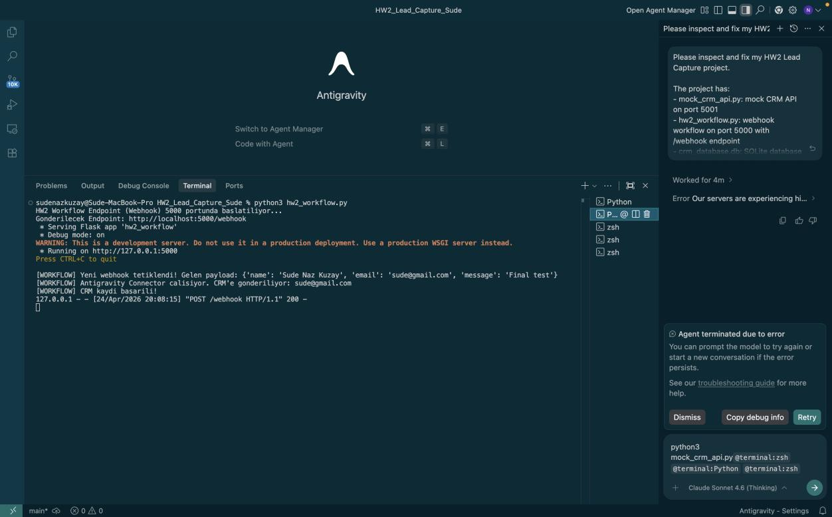

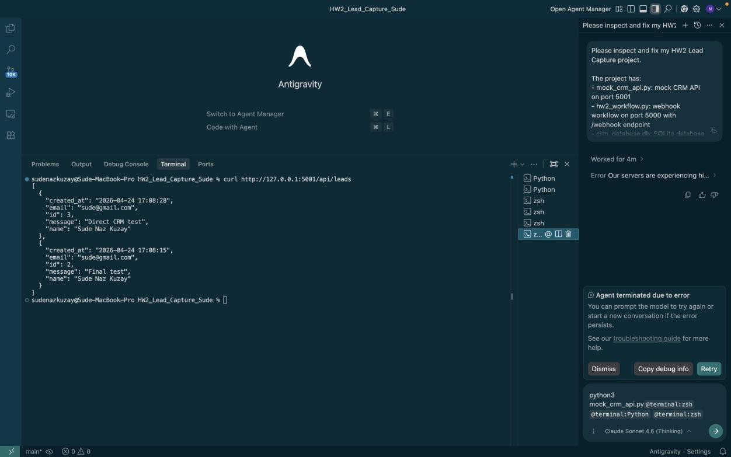
Figure 2. Terminal output showing saved leads

Figure 3. Browser output showing saved leads
