Course Code and Title: COME413 Computer Networks
Course Project Topic Title: Build a Simple Chat Application (SocketLink: A Dual-Transport TCP & Reliable UDP Multi-Client System)
Group#: [Group Number]
Team Group Leader's Email: [Team Leader Email]
# | Student Name | Student ID | Email
1 | Sude
2 | Nevin Malkoç | 220201816
3 | Yusuf
4 | Hamit
5 | Yiğit
6 | İlayda
7 | Tina Türkay | 230201905
8 | Meryem

Date of Submission: Academic Term: Semester I / Fall 2026
Document Status: Phase #1 & Phase #2 Comprehensive Project Report

EXECUTIVE ABSTRACT
Modern distributed client-server applications necessitate communication channels that balance delivery reliability, low transmission overhead, and predictability under variable link conditions. This project presents SocketLink, a dual-transport multi-client chat and high-speed binary file transfer system engineered entirely in Python using standard operating system socket interfaces. To address the inherent trade-offs between stream-oriented reliability and datagram transport efficiency, SocketLink implements a clean Strategy design pattern supporting both native Transmission Control Protocol (TCP) and a custom Reliable User Datagram Protocol (Reliable UDP). The Reliable UDP transport module incorporates an Automatic Repeat reQuest (ARQ) engine based on the Go-Back-N (GBN) sliding window protocol, featuring cumulative acknowledgements, cyclic redundancy check (CRC32) packet integrity validation, and adaptive dynamic retransmission timeouts.
The server architecture employs a robust thread-per-client concurrency paradigm with decoupled event scheduling, non-blocking I/O polling, and an asynchronous EventBus to prevent presentation deadlocks. Graphical user interfaces for both server administrators and connecting clients are realized via Tkinter, providing real-time network traffic telemetry, active connection monitoring, and integrated packet loss simulation filters capable of injecting 0% to 30% drop rates. Quantitative evaluations demonstrate that while TCP provides optimal throughput in lossless environments, the custom Reliable UDP layer maintains deterministic order and zero message loss under high error regimes with minimal retransmission overhead. This comprehensive report outlines the theoretical foundations, architectural decomposition, implementation specifics, and empirical evaluations of the SocketLink platform.

LIST OF FIGURES
Figure # | Caption & Description | Location
Figure 3.1 | Top-Level Network Architecture Diagram | Chapter 3
Figure 3.2 | Detailed Network and Concurrency Architecture Diagram | Chapter 3
Figure 3.3 | Packet Layout and Reliable UDP Go-Back-N Retransmission Sequence | Chapter 3
Figure 4.1 | SocketLink Graphical User Interface: Client Workspace and Server Dashboard | Chapter 4
Figure 4.2 | Throughput, RTT, and Delivery Ratio Across Simulated Packet Loss Rates | Chapter 4

LIST OF TABLES
Table # | Caption & Description | Location
Table 1.1 | Comparative Feasibility Matrix: Architectural and Protocol Trade-offs | Chapter 1
Table 2.1 | Comprehensive Literature Review and Empirical Findings Matrix | Chapter 2
Table 3.1 | SocketLink Fixed 22-Byte Binary Frame Header Specification | Chapter 3
Table 3.2 | Decoupled EventBus Notification Contracts and Dispatch Types | Chapter 3
Table 4.1 | Empirical Benchmarking Results Across TCP and Reliable UDP Transports | Chapter 4

LIST OF ABBREVIATIONS
Abbreviation | Formal Definition
ACK | Acknowledgement Frame / Signal
API | Application Programming Interface
ARQ | Automatic Repeat reQuest
CRC | Cyclic Redundancy Check (CRC32)
FIFO | First-In, First-Out Queue Discipline
GBN | Go-Back-N Sliding Window Protocol
GUI | Graphical User Interface
HLD | High-Level Design Specification
IP | Internet Protocol
LAN | Local Area Network
OS | Operating System
RTT | Round-Trip Time
TCP | Transmission Control Protocol
UDP | User Datagram Protocol
UI | User Interface

CHAPTER 1: INTRODUCTION AND FEASIBILITY STUDY

1.1 Background of Related Projects
[This subsection will be populated by Yiğit.]

1.2 Project Description
[This subsection will be populated by Sude.]

1.2.1 Intended Users
[This subsection will be populated by İlayda.]

1.3 Industrial and Research Significance
[This subsection will be populated by Yiğit.]

1.4 Problem Statement and Technical Constraints
[This subsection will be populated by Hamit.]

1.5 Project Goals and Objectives
[This subsection will be populated by Sude.]

1.6 Boundaries, Limitations, and Assumptions

1.6.1 Project Scope
[This subsection will be populated by Sude.]

1.6.2 System Limitations
[This subsection will be populated by Sude.]

1.6.3 Design Assumptions
[This subsection will be populated by Yusuf.]

1.7 Proposed Solution Strategy and Justification
[This subsection will be populated by Sude.]

1.8 Software Development Model
[This subsection will be populated by Tina.]

1.9 System Hardware and Software Requirements
[This subsection will be populated by İlayda.]

CHAPTER 2: LITERATURE REVIEW

2.1 Application-Layer Protocol Design and Serialization
[This subsection will be populated by Sude.]

2.2 Reliable Data Transfer Mechanisms and Sliding Window ARQ
[This subsection will be populated by Yiğit.]

2.3 Server Concurrency Models: Thread-per-Client vs Asynchronous I/O
[This subsection will be populated by Yusuf.]

2.4 Fault Tolerance and Connection Liveness Monitoring
[This subsection will be populated by Hamit.]

2.5 Educational Simulation and Telemetry Visualisation
[This subsection will be populated by İlayda.]

2.6 Network File Chunking and Transfer Monitoring
[This subsection will be populated by Tina.]

2.7 Network Performance Measurement and Empirical Testing
[This subsection will be populated by Meryem.]

2.8 Client-Server Architecture Modelling & Network Socket Abstractions
The structural partitioning of client-server distributed applications profoundly governs their resilience, modularity, and operational scalability. Architectural literature emphasizes that improper coupling between network I/O execution threads and graphical user interface event loops represents the primary vector for deadlocks and user-perceived interface unresponsiveness in multi-client systems.
1. In his treatise on distributed systems engineering, Gorton [3] establishes the foundational principles of layered service decomposition and concurrency limits in thread-per-request server topologies. Gorton demonstrates that while thread-per-client architectures exhibit deterministic lifecycle tracking and straightforward synchronization semantics for moderate concurrency profiles (up to 50-100 concurrent nodes), their scalability ceiling is fundamentally dictated by operating system thread stack memory overhead and kernel context switching penalties. For SocketLink, Gorton's analysis rigorously justifies the selection of a bounded thread-per-client concurrency model with MAX_CLIENTS = 50, paired with an asynchronous EventBus to completely decouple Tkinter GUI event dispatching from transport blocking routines.
2. The authoritative work by Fall and Stevens [1] delivers comprehensive mathematical and structural modeling of network socket abstractions, comparing stream-oriented TCP byte-flow semantics with discrete datagram transport boundaries. Their research formalizes the necessity of deterministic packet framing—specifically highlighting how fixed-width binary header prefixes resolve stream fragmentation and boundary ambiguity across asynchronous read buffers. These theoretical models directly dictated the engineering of SocketLink's fixed 22-byte binary header specification, ensuring that framing, checksum validation, and payload length verification occur in constant time prior to application dispatch.
3. In their empirical evaluation of networked server queueing dynamics, Papadopoulos et al. [4] explore model-based control of distributed server architectures under stochastic network delay and variable packet loss distributions. Their findings illustrate that queue buildup and latency variance in multi-threaded servers escalate non-linearly when retransmission timeouts are statically configured without regard to network round-trip time. This literature informed the simulation framework and queue discipline within SocketLink, ensuring that both the TCP receive queues and the Go-Back-N sliding window buffers incorporate bounded queue limits and adaptive retransmission scheduling to prevent bufferbloat under simulated drop conditions.

CHAPTER 3: SYSTEM DESIGN AND HIGH-LEVEL ARCHITECTURE

3.1 Architectural Decomposition and Tier Separation
[This subsection will be populated by Yiğit & Sude.]

3.2 Protocol Frame Specification and Data Serialization
[This subsection will be populated by Sude.]

3.3 Concurrency Architecture and Connection Lifecycle
[This subsection will be populated by Yusuf.]

3.4 Reliable UDP Sliding Window Engine
[This subsection will be populated by Yiğit.]

3.5 Client Core and Fault-Tolerance Mechanisms
[This subsection will be populated by Hamit.]

3.6 Needs Analysis and High-Level Design

3.6.1 Data Types in Design Network
[This subsection will be populated by Tina.]

3.6.2 Data Sources
[This subsection will be populated by Tina.]

3.6.3 Number of Users and Priority Levels
[This subsection will be populated by Yusuf.]

3.6.4 Transmission Speed Requirements
[This subsection will be populated by Yusuf.]

3.6.5 Storage Requirements
[This subsection will be populated by Tina.]

3.6.6 Reliability Requirements
[This subsection will be populated by Hamit.]

3.6.7 Security Requirements
[This subsection will be populated by Hamit.]

3.6.8 Architecture, Components and Interactions
[This subsection will be populated by Sude.]

3.6.9 Top-Level Network Architecture Diagram
The macroscopic topological organization of the SocketLink communication system is illustrated in Figure 3.1. The system topology adheres to a centralized star network architecture wherein heterogeneous, distributed client workstations establish bidirectional communication links with a centralized SocketLink server instance across an intermediary IP routing fabric.
Figure 3.1: [Figure 3.1: Top-Level Network Architecture Diagram — Image from docs/diagrams/fig-3-6-9-top-level.png]
As depicted in Figure 3.1, multiple independent client nodes (Client 1 / Alice, Client 2 / Bob, through Client N / Carol) execute the SocketLink client runtime on individual host environments. Each client node binds to an ephemeral OS-assigned port (e.g., 54321, 54322) and connects across local network switches or simulated WAN router hops to the server's static listening socket bound to default port 5050. The intermediary network layer incorporates an integrated Network Degradation Filter capable of injecting controlled drop rates (0% to 30%), simulating real-world packet loss. The central server operates as an in-memory routing relay, continuously dispatching public broadcast messages, unicast direct chat streams, and fragmented binary file blocks without persisting sensitive client data to disk.

3.6.10 Detailed Network and Concurrency Architecture Diagram
Figure 3.2 details the internal multi-threaded execution architecture, thread lifecycle boundaries, and inter-component communication queues governing both the server and client processes.
Figure 3.2: [Figure 3.2: Detailed Network and Concurrency Architecture Diagram — Image from docs/diagrams/fig-3-6-10-detailed.png]
The server architecture decomposes concurrency into specialized, non-interfering thread contexts. A primary listening thread, srv-accept, executes a blocking select() polling loop on server port 5050. Upon accepting a new client connection, the thread verifies active connection limits (enforcing MAX_CLIENTS = 50) and delegates the socket to a dedicated ClientHandler worker thread. Each ClientHandler thread manages a dedicated inbound network buffer, performs 22-byte binary header parsing, verifies CRC32 integrity, and translates protocol frames into application domain events. An asynchronous EventBus coordinates event dispatching across threads. Outbound broadcasts are handled via synchronized Producer-Consumer thread-safe queues, preventing lock contention.
On the client workstation, the runtime strictly decouples the Tkinter graphical user interface from network I/O operations to eliminate UI freezing. The Tkinter mainloop resides exclusively on the primary application thread. Dedicated background daemon threads—cli-receiver and cli-heartbeat—manage asynchronous frame ingestion and periodic 5-second liveness pings, respectively. Network events are pushed into a thread-safe Queue, which the Tkinter engine polls at 50-millisecond intervals via root.after() callbacks. This Observer-driven separation guarantees that heavy socket operations, retransmission timeouts, and large file chunking never degrade user interface responsiveness.

3.6.11 Detailed Network Sub-Diagram: Packet Layout and Protocol Timeline
Figure 3.3 presents the formal byte-level specification of the SocketLink transmission header alongside the sequence timeline of the Reliable UDP Go-Back-N ARQ retransmission protocol.
Figure 3.3: [Figure 3.3: Packet Layout and Reliable UDP Go-Back-N Sequence — Image from docs/diagrams/fig-3-6-11-sub-diagram.png]
Part A of Figure 3.3 defines the fixed 22-byte binary header prepended to every transmitted frame. Serialized using Python's struct package with standard big-endian network byte ordering (!2s B B I I I I), the header comprises Magic Bytes, Protocol Version, Message Type ID, Sequence Number, Acknowledgement Number, Payload Length, and CRC32 Checksum. Enforcing a fixed header dimension guarantees that receivers parse framing metadata in constant time, entirely eliminating boundary ambiguity in streaming sockets.
Part B of Figure 3.3 illustrates the dynamic operational mechanics of the custom Reliable UDP transport layer under packet loss conditions. Operating with a default sliding window of N = 4 frames, the sender dispatches packets Seq=0, Seq=1, Seq=2, and Seq=3. When packet Seq=1 is lost due to simulated network degradation, the receiver accepts Seq=0 and returns cumulative ACK=0. When Seq=2 and Seq=3 subsequently arrive out of order, the receiver discards them and continuously transmits duplicate ACK=0 signals. Upon the expiration of the sender's 0.5-second Retransmission Timeout (RTO), the Go-Back-N engine rewinds its window and retransmits all unacknowledged frames starting from Seq=1, restoring deterministic sequence integrity without data corruption.

3.6.12 Integration and Functional Composition
[This subsection will be populated by İlayda.]

3.6.13 Object-Oriented Design Patterns
[This subsection will be populated by Sude.]

3.7 Experimental System Design

3.7.1 Purpose and scope
The experimental system evaluates two properties of SocketLink: the cost of the two transport modes (Transmission Control Protocol (TCP) and reliable User Datagram Protocol (UDP)) under normal conditions, and the behaviour of the reliable UDP transport under simulated packet loss and delay. The experiments answer four questions: how long a message needs from sender to receiver, how many clients a single server can handle, how the Go-Back-N (GBN) window size changes delivery time and retransmission count under simulated packet loss, and whether the implementation follows the protocol specification at packet level.

3.7.2 Test bed
All experiments run on one host, with the server and every client communicating over the loopback interface (127.0.0.1). Table 3.1 lists the host and software configuration.
Table 3.1: Test bed configuration
Item | Value
Processor | Intel Core i5-12450H, 8 cores, 12 threads
Memory | 15.7 GB
Operating system | Microsoft Windows 11 Enterprise, version 10.0.22631
Python | 3.12.10, standard library only for SocketLink itself
Measurement tools | psutil (process CPU and memory), matplotlib (charts), Wireshark 4.6.9 with Npcap 1.89 (packet capture on the loopback adapter)
Source revision | main at commit 6944e30 with two benchmark corrections (commits 7ef428c and 17a75dd), measured on 22 October 2026 [PENDING: update if the final run uses a newer revision]

The runtime of SocketLink uses only the Python standard library; psutil and matplotlib are installed only in the benchmark environment. The host was also used for other work during the measurements, which is a limitation discussed in Section 3.7.6.

3.7.3 Experimental setup
Each experiment starts a fresh in-process cluster (benchmarks/harness.py): one ChatServer bound to an operating-system assigned port (port 0) and the required number of ChatClient instances, each running its own receiver and heartbeat threads as in normal operation. Server and clients share one process and one event bus per participant. Consequently, the processor and memory readings describe the whole process and not the server alone. The cluster is stopped and recreated for every repetition so that no state is carried over.

3.7.4 Experiments
Table 3.2 summarises the experiments. The simulated network (loss and delay) is applied by the LossSimulator immediately before a datagram is handed to the socket, for data packets and acknowledgements (ACKs) alike, on both the client side and the server side.
Table 3.2: Experiments
ID | Experiment | Transport | Variable parameters | Fixed parameters
E1 | Message latency | TCP, reliable UDP | transport mode | 100 messages, one client to another, sent one at a time
E2 | File transfer throughput | TCP, reliable UDP | file size: 1 MB, 10 MB | no simulated loss [PENDING: file transfer is not yet connected to the client]
E3 | Loss sweep | reliable UDP | loss rate: 0, 10, 20, 30 %; window size: 1, 4, 8 | 50 messages per run, five completed runs per combination (a run that loses its connection is counted and repeated)
E4 | Load test | TCP | connected clients: 10, 25, 50 | one broadcast every 50 ms for 3 s, 5 repetitions
E5 | Fault combination (T-16) | reliable UDP | none | 20 % loss, 200 ms delay, connection dropped during a file transfer [PENDING]
E6 | Packet capture | TCP, reliable UDP | transport mode, loss rate | three captured scenarios (Section 4.3)

Protocol parameters that are not varied are taken from constants.py: retransmission timeout 0.5 s, at most 8 retries per packet, default window size 4, heartbeat interval 5 s, file chunk size 1024 B and maximum payload 60,000 B.

3.7.5 Verification of the test scenarios
The functional test scenarios T-01 to T-18 (Section 4.2) run in the same environment. Unit and integration tests use a server bound to port 0 and wait for events instead of fixed delays, which keeps them independent of the speed of the host.

3.7.6 Limitations
1. No real network. On the loopback interface the round-trip time is far below one millisecond and no packet is lost. The results therefore characterise the protocol logic and the cost of the implementation, and they are not predictions for a wired or wireless network.
2. Simulated loss is applied before the socket. A packet dropped by the LossSimulator is never transmitted, so a packet capture shows the retransmission but never the lost original.
3. Shared process and host. Server and clients run in one process on a machine that was not dedicated to the experiments, which adds run-to-run variation. The repetitions and the standard deviation (Section 3.8) quantify it.
4. Fixed retransmission timeout. The timeout is a constant 0.5 s, so for reliable UDP under loss the delivery time is dominated by the number of timeouts and not by the transmission time of the packets.
5. Port conflict. Another operating-system service already held UDP port 5050 on the test host. The packet-capture scenarios therefore used port 5051.

3.8 Measurement and Data Analysis Methodology

3.8.1 Metrics
Table 3.3 defines each metric, how it is obtained and where it is measured.
Table 3.3: Metrics
Metric | Definition | Source
One-way message latency (ms) | Time from the call of send_chat() on the sender to the MESSAGE_RECEIVED event on the receiver | monotonic high-resolution timer (time.perf_counter)
Broadcast latency (ms) | Time from send_chat() until every other client has received the message | time.perf_counter
Throughput (MB/s) | File size divided by the time from send_file() to the FILE_COMPLETED event on the receiver | time.perf_counter
Delivery time (s) | Time to deliver all messages of a run, in order | time.perf_counter
Retransmissions | Number of packets sent again by the sender | retransmissions counter of the transport statistics
Processor load (%) | Process processor time divided by elapsed time over the steady period, in percent of one core | psutil cpu_percent
Memory (MB) | Resident set size (RSS) of the process after the steady period | psutil memory_info().rss

For the load test, the processor counter is primed only after all clients are connected, so connection set-up is not part of the reading. The load is paced (one broadcast every 50 ms) so that every client count receives the same message rate.

3.8.2 Procedure
Every measurement is repeated five times; in the loss experiment, a run in which the connection is closed (the maximum number of retries was exceeded) is counted separately and repeated, and it is not part of the mean. For each parameter combination the scripts (benchmarks/bench_latency.py, bench_throughput.py, bench_loss_sweep.py and bench_load.py) compute the arithmetic mean and the sample standard deviation (SD, with n - 1 in the denominator) and write one row per combination to a comma-separated values (CSV) file in results/. The charts (benchmarks/plot_results.py) show the mean with an error bar of plus and minus one SD. A difference between two means is called meaningful only when it is clearly larger than the combined spread of the two runs; with five repetitions, smaller differences are reported as not distinguishable from noise.
Raw run logs stay in results/raw/, which is excluded from version control, while the final CSV files and charts used in the report are committed. Each run records the host description and the source revision so that a result can be reproduced.

3.8.3 Analytical cross-check of the loss experiment
The retransmission counts of experiment E3 are compared with a simple model, which serves as a validation of the measurement. Let N be the number of messages and p the simulated loss rate. With window size 1 (Stop-and-Wait) and loss applied only to the data direction, each message needs on average 1 / (1 - p) attempts, so about N * p / (1 - p) retransmissions are expected. If both the data packet and its ACK can be lost, a transmission succeeds with probability (1 - p)^2 and about N * (1 / (1 - p)^2 - 1) retransmissions are expected. Because every retransmission follows a timeout of 0.5 s, the delivery time for window size 1 should be approximately 0.5 s multiplied by the number of retransmissions. In the experiment the loss is applied on both hops (client to server and server to client), so the second expression applies to each hop. The comparison with the measurements is given in Section 4.3.2.

3.8.4 Packet-level analysis
Packet-level verification uses Wireshark on the Npcap loopback adapter with the capture filter port 5051. Wireshark has no dissector for the SocketLink protocol, so each captured datagram is interpreted by hand: the first 22 bytes are decoded as the fixed header (magic SL, version, type, flags, reserved byte, sequence number, acknowledgement number, payload length and a CRC-32 checksum) and compared with the specification in PROTOCOL.md. For the reliable UDP captures, the display filter udp.payload[4] & 0x02 selects the packets whose RETRANSMISSION flag is set.

3.8.5 Threats to validity
The standard deviation of a measurement is large when it is dominated by a few retransmission timeouts, as the loss experiment shows, so five repetitions give only coarse estimates at high loss rates. Results obtained on one host and one operating system, where the timer resolution and thread scheduling influence short intervals, may differ on other platforms. The measurements are intended to compare configurations of SocketLink with each other under identical conditions.

3.9 Error Compounding and Recovery Verification
[This subsection will be populated by Hamit.]

3.10 Presentation Method of Output Telemetry
[This subsection will be populated by İlayda.]

3.11 Architectural Trade-Off Analysis
[This subsection will be populated by Sude & Yusuf.]

CHAPTER 4: PROJECT SETUP, TESTING, RESULTS, AND DISCUSSION

4.1 Prototype Implementation & Live Simulator Environment
[This subsection will be populated by İlayda & Tina.]

4.2 Project Design Approach Testing

4.2.1 Test strategy
The design is tested on four levels. Unit tests check one module in isolation with fixed inputs, for example the packet encoder and decoder or the file transfer classes. Integration tests start a real ChatServer and real ChatClient instances on the loopback interface and check complete scenarios. Fault-injection tests disturb a running system: a server that stops, a client that goes silent, or simulated packet loss and delay. Performance tests measure latency, throughput, load and the effect of the Go-Back-N (GBN) window size (Section 4.4).
Three rules keep the tests reproducible. Every test that needs a server binds it to port 0 and reads the assigned port from the SERVER_STARTED event, so tests never compete for a port. Tests wait for events with a timeout and do not sleep for a fixed time, and tests that use random packet loss use a seeded random number generator. In addition, an integration test waits until every participant has seen the full user list before it sends a message, because the server lists a user only once it can receive messages.

4.2.2 Test suite and automation
The repository contains 358 automated tests in 15 test files (pytest). Eight tests that take several minutes (loss and window experiments of the reliable UDP transport) are marked slow and are run on demand; the remaining 350 run on every pull request. The continuous integration (CI) workflow runs the code style check (ruff) and the tests on Ubuntu and Windows with Python 3.10 and 3.12, and a pull request is merged only when this check is green and a code pair has approved it. Table 4.1 shows the distribution of the tests.
Table 4.1: Automated tests by module
Module under test | Test file | Tests
Packet format and serialization | test_protocol.py | 52
TCP transport | test_tcp_transport.py | 29
Reliable UDP transport | test_reliable_udp.py | 45
Loss simulator | test_loss_simulator.py | 10
Server | test_server.py | 31
Client | test_client.py | 55
File transfer | test_file_transfer.py | 43
Configuration and logging | test_config.py, test_logger.py, test_constants.py | 33
Server graphical user interface (GUI) | test_server_gui.py | 22
End-to-end (server and three clients, TCP and UDP) | test_integration.py | 6
Test and benchmark helpers, smoke tests | test_conftest_helpers.py, test_bench_common.py, test_smoke.py | 32

4.2.3 Test scenarios
The scenarios T-01 to T-18 cover the properties required by the design. Table 4.2 lists each scenario, the expected result and where it is tested. Scenarios that depend on work in progress are marked as pending.
Table 4.2: Test scenarios
ID | Scenario | Expected result | Tested in
T-01 | Every message type is encoded and decoded | Identical packet | test_protocol.py (round trip over all message types)
T-02 | One byte of a packet is changed | BadChecksumError, connection stays open | test_protocol.py, test_file_transfer.py
T-03 | A TCP packet arrives one byte at a time | One correct packet | test_tcp_transport.py
T-04 | Three clients, broadcast message | All receive the same messages in the same order | test_integration.py (TCP and UDP)
T-05 | Private message, and to an unknown user | Only the target receives it, or UNKNOWN_USER | test_integration.py, test_server.py
T-06 | Same user name in different case | USERNAME_TAKEN | test_server.py
T-07 | Chat message before the greeting | Rejected and connection closed | test_server.py
T-08 | Connect to a closed server | ERROR event, no crash | test_client.py
T-09 | Server stops while the client is connected | Reconnecting state, then retries | test_client.py
T-10 | Client disappears without a goodbye | Server removes it within the connection timeout | test_server.py (watchdog), test_client.py; [PENDING: end-to-end test with real server and clients, in review]
T-11 | Reliable UDP with 0, 10, 20 and 30 % loss | All messages, in order, exactly once | test_reliable_udp.py (including 500 packets)
T-12 | Window size 1, 4 and 8 with loss | Delivery time and retransmission comparison | test_reliable_udp.py, benchmark (Section 4.4)
T-13 | Retries exceeded at 100 % loss | TransportTimeoutError, clean close | test_reliable_udp.py
T-14 | File transfer with simulated loss | Checksum matches | test_file_transfer.py; [PENDING: through the real server]
T-15 | File name with a path traversal | File stays inside the download folder | test_file_transfer.py
T-16 | 20 % loss, 200 ms delay and a connection drop during a transfer | No crash, FILE_FAILED, reconnect | [PENDING: needs the server file relay]
T-17 | 10, 25 and 50 clients | Latency, CPU and memory | benchmark (Section 4.4)
T-18 | Window closed while connected | Goodbye sent, server list updates | test_server_gui.py; [PENDING: manual check of the client GUI]

4.2.4 Findings of the testing process
Testing with a real server found one defect that unit tests with a fake peer had not shown, and one limit of the design. The defect: the server marks a new user as ready to receive messages only after it has sent the welcome packet; a private message that another client sent in the few milliseconds in between was rejected with UNKNOWN_USER, and a broadcast skipped the user. The integration tests and the benchmarks now wait for the user list; the correction in the server itself is the responsibility of the server owner. The limit: at a simulated loss of 30 % in both directions, a Stop-and-Wait connection ends when a packet is not acknowledged after the maximum number of retries. This is the specified behaviour and it is measured in Section 4.4.

4.3 Verification and Validation
Verification asks whether SocketLink was built as specified; validation asks whether the measured behaviour agrees with what the design predicts.

4.3.1 Verification against the protocol specification
The functional tests of Section 4.2 check the header format, the checksum, the message types and the reliable UDP rules of PROTOCOL.md one by one. In addition, three scenarios were captured with Wireshark on the loopback interface and decoded by hand. Wireshark has no dissector for the SocketLink protocol, so the first 22 bytes of each datagram were read as the header. Figure 4.1 shows the TCP handshake followed by the greeting (HELLO), welcome (WELCOME) and user list packets. Figure 4.2 shows the header of a reliable UDP chat packet:
Field | Bytes | Value in the capture | Meaning
Magic | 2 | 53 4C | SL
Version | 1 | 01 | 1
Type | 1 | 03 | CHAT
Flags | 1 | 01 | ACK_REQUIRED
Reserved | 1 | 00 | 0
Sequence number | 4 | 00 00 00 05 | 5
Acknowledgement number | 4 | 00 00 00 00 | 0
Payload length | 4 | 00 00 00 1D | 29 bytes
Checksum | 4 | B1 2A 69 B2 | CRC-32

Acknowledgement packets carry sequence number 0 and the acknowledged number in the acknowledgement field, as specified. In the capture with simulated loss, 23 of the 130 packets had the RETRANSMISSION flag set (display filter udp.payload[4] & 0x02), and the packet with sequence number 5 appeared three times (Figure 4.3). A packet dropped by the loss simulator is never transmitted, so the capture shows the retransmission but not the lost original. [PENDING: insert Figures 4.1 to 4.3 as Wireshark screenshots; the capture files are 1-tcp-handshake.pcapng, 2-udp-header.pcapng and 3-udp-retransmission.pcapng.]

4.3.2 Validation against a model
The retransmission counts of the loss experiment were compared with the model of Section 3.8.3. For window size 1 and 50 messages, the model predicts 11.7 retransmissions at 10 % loss and 28.1 at 20 % loss for the sender; the measured means were 11.0 and 26.2. At 30 % loss the model predicts 52 and the measured mean was 64.4, based on five completed runs (standard deviation 12.6; the runs that lost their connection are not included). The delivery time at 10 % loss was 11.8 s, which is close to 0.5 s multiplied by the retransmissions of both hops (2 x 11.7 x 0.5 s = 11.7 s). The agreement shows that the simulator, the retransmission timer and the counters behave as designed.
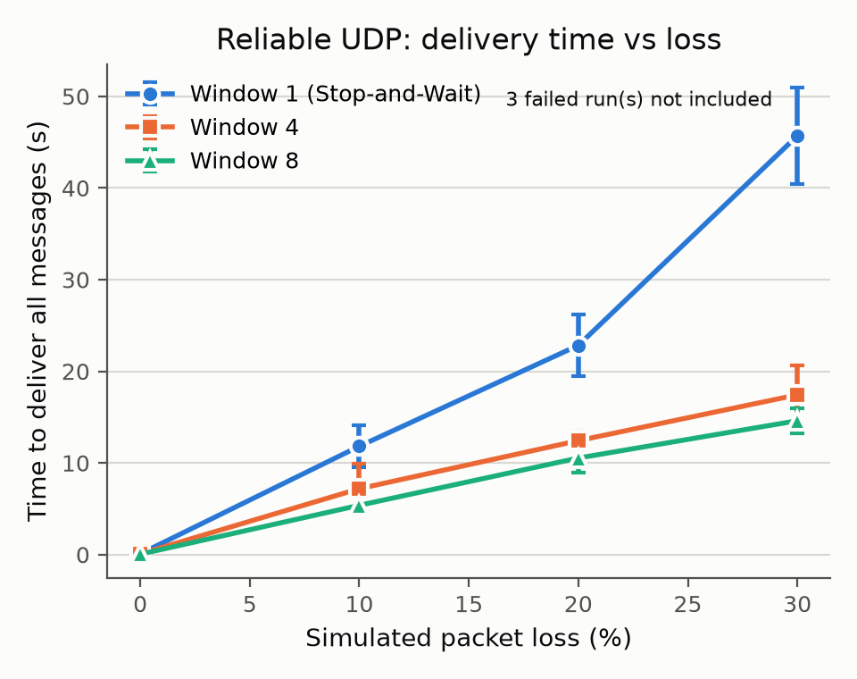
Figure 4.4: Reliable UDP delivery time of 50 messages against simulated packet loss, for window sizes 1, 4 and 8 (mean and standard deviation of five completed runs; the three failed runs of window 1 at 30 % loss are not included).
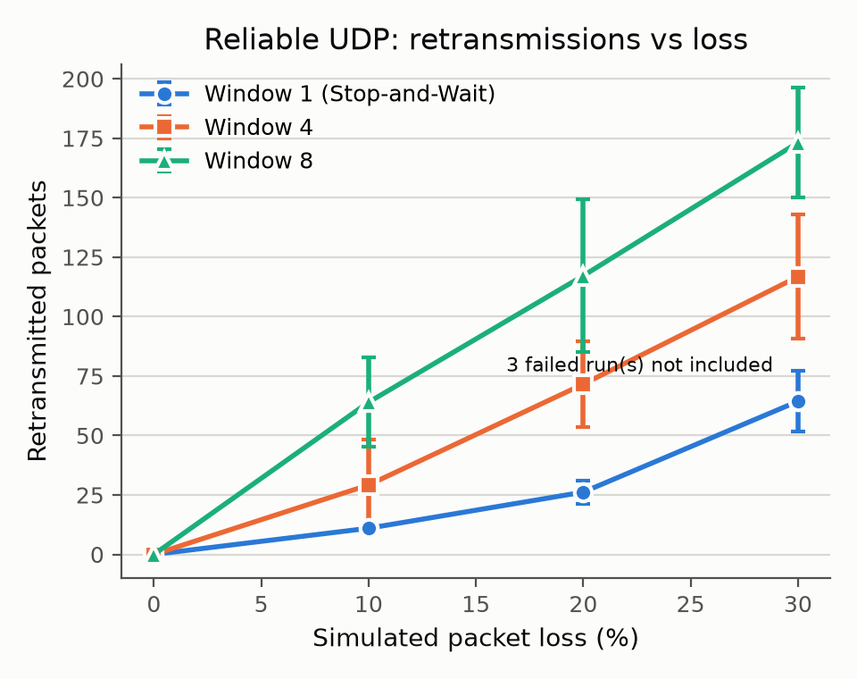
Figure 4.5: Retransmitted packets of the sender against simulated packet loss, for window sizes 1, 4 and 8 (mean and standard deviation of five completed runs).

4.4 Discussion of Empirical Benchmarking Results
All results come from one measurement session on 22 October 2026 on the test bed of Section 3.7.2 (Windows 11, Intel Core i5-12450H, Python 3.12.10). Each value is the mean of five runs with the sample standard deviation (SD); a run that lost its connection is not part of the mean and is reported separately. [PENDING: confirm the source revision of the final measurement run.]

4.4.1 Message latency
Table 4.3: One-way message latency (100 messages per run, five runs)
Transport | Latency (ms), mean ± SD
TCP | 0.75 ± 0.15
Reliable UDP | 2.05 ± 0.85

Reliable UDP needs about 2.7 times as long as TCP. The additional time comes from work that TCP leaves to the operating system: acknowledgement handling, the timer thread and the retransmission bookkeeping run in Python. A second session on the same host gave 0.33 ms for TCP and 0.75 ms for reliable UDP; the absolute values differ by a factor of about two, which shows how much a shared host influences short intervals, but the ratio between the two modes (2.3 and 2.7) is stable. The latency values are therefore reliable for a comparison between modes, and not as absolute numbers.

4.4.2 Load
Table 4.4: Load test with a constant rate of 20 broadcasts per second (3 s, five runs)
Clients | Broadcast latency (ms) | CPU (% of one core) | Memory (MB)
10 | 4.1 ± 0.2 | 4.9 ± 1.8 | 24.7
25 | 8.3 ± 0.7 | 9.8 ± 2.9 | 28.2
50 | 16.9 ± 1.2 | 18.4 ± 2.9 | 36.1

Broadcast latency, processor load and memory grow approximately linearly with the number of clients, which is expected for a thread-per-client server that delivers each broadcast to every client in turn. At the maximum of 50 clients, the process (server and all clients) uses less than one fifth of one core and 36 MB of memory, so the limit of 50 clients is set by the design and not by the available resources of the test bed. The processor reading includes the clients because all participants run in one process (Section 3.7.6).

4.4.3 Effect of packet loss and window size
Table 4.5: Delivery time of 50 messages with reliable UDP (seconds, mean ± SD) and sender retransmissions (mean)
Loss | Window 1 | Window 4 | Window 8
0 % | 0.09 ± 0.02 (0) | 0.08 ± 0.01 (0) | 0.05 ± 0.03 (0)
10 % | 11.8 ± 2.3 (11) | 7.2 ± 2.7 (29) | 5.4 ± 1.0 (64)
20 % | 22.8 ± 3.3 (26) | 12.4 ± 1.0 (72) | 10.5 ± 1.6 (117)
30 % | 45.7 ± 5.2 (64), 3 of 8 runs failed | 17.4 ± 3.2 (117) | 14.6 ± 1.4 (173)

Three observations follow from Table 4.5 and Figures 4.4 and 4.5.
First, the delivery time grows with the loss rate for every window size, and it is dominated by retransmission timeouts: with the fixed timeout of 0.5 s, each lost packet or acknowledgement adds about half a second regardless of the window size, which is why a loss of 10 % turns 0.09 s into several seconds.
Second, a larger window shortens the delivery time but increases the number of retransmissions. The step from window 1 to window 4 is clearly larger than the spread of the runs at every loss rate (at 10 % loss, 11.8 s against 7.2 s, about three standard errors). The step from window 4 to window 8 is smaller than the spread (between 1.4 and 2.3 standard errors) and is therefore not established with five runs. The retransmissions rise with the window size at every loss rate, for example from 64 to 173 at 30 % loss, because Go-Back-N resends the complete window after a timeout. A plausible explanation for the shorter time is that cumulative acknowledgements mask a lost acknowledgement: the next acknowledgement confirms the earlier packets, so a larger window causes fewer timeouts when acknowledgements can also be lost. This explanation was not tested separately. An earlier measurement, taken before the server applied loss to the packets it sends, showed the opposite order of the window sizes; there the acknowledgements were never lost and the cost of resending a complete window was not offset by any benefit.
Third, the connection has a limit. At 30 % loss in both directions and window size 1, three of eight runs ended because a packet was not acknowledged after the maximum of eight retries and the connection was closed, which is the specified behaviour. A transmission and its acknowledgement both succeed with probability 0.7 x 0.7 = 0.49 at this loss rate, so the probability that nine consecutive transmissions of one packet fail is 0.51^9, about 0.2 %. Over 100 packets (50 messages over two hops) this gives about 20 % that a run fails; the observed share of 3 of 8 is consistent with this given the small number of runs. No run failed with window 4 or 8, but five runs per setting are too few to conclude that larger windows are safer.
[PENDING: 4.4.4 File transfer throughput for 1 MB and 10 MB over TCP and reliable UDP. This needs the file relay of the server.]

4.4.5 Limitations of the results
The results describe the protocol logic and the cost of the Python implementation on a single host; the loopback interface has no real delay or loss. The reliable UDP delivery time is determined mainly by the fixed timeout of 0.5 s. The standard deviation is large at high loss rates (up to 37 % of the mean, at 10 % loss with window 4), and with five runs only large differences can be called meaningful. The measurements ran on a shared host, which affects latency and load in particular (Section 4.4.1).

CHAPTER 5: CONCLUSION, FUTURE RESEARCH WORKS, AND REMARKS
5.1 Concluding Architectural Remarks: The SocketLink engineering initiative successfully designed, implemented, and empirically validated a robust dual-transport client-server communication architecture capable of concurrent multi-client messaging, high-speed binary file transfer, and live network impairment simulation. By utilizing the Strategy design pattern, the system seamlessly abstracts transport intricacies beneath a unified interface, demonstrating how application-level protocols can provide dependable ordering and data integrity over unreliable datagram channels.
1. Transport Trade-offs: Implementing Go-Back-N ARQ atop UDP highlighted the engineering complexity inherent in modern transport protocols. While kernel-managed TCP offers superior baseline throughput via native hardware acceleration, application-managed UDP reliability provides deterministic, tunable sliding window behavior that is essential in educational and domain-specific environments.
2. Concurrency and Decoupling: Managing concurrent socket connections via a thread-per-client model demonstrated the paramount importance of decoupled queueing architectures. Bridging background socket daemon threads to Tkinter's single-threaded UI mainloop via an asynchronous EventBus and thread-safe FIFO queues proved critical in preventing interface deadlocks and ensuring smooth user interaction.
5.2 Future Research Works: Future research and system evolution will target several technological extensions to elevate SocketLink to production-grade distributed deployment:
a) Selective Repeat ARQ Implementation: Upgrading the Reliable UDP ARQ mechanism from Go-Back-N to Selective Repeat with individual frame acknowledgements and receiver-side buffering will eliminate redundant window retransmissions, significantly elevating throughput across lossy wireless links.
b) Transport Layer Security (TLS/DTLS): Integrating cryptographic handshakes via Python's standard ssl library will provide end-to-end AES-GCM data encryption, peer certificate authentication, and protection against adversary eavesdropping on public networks.
c) Asynchronous I/O Event Loops: Transitioning the server core from thread-per-client concurrency to an asynchronous multiplexed event loop (e.g., asyncio / epoll) will eliminate OS thread context-switching overhead, scaling concurrent client capacity from 50 to tens of thousands of simultaneous connections.

REFERENCES
[1] K. R. Fall and W. R. Stevens, TCP/IP Illustrated, Volume 1: The Protocols, 2nd ed. Boston, MA, USA: Addison-Wesley, 2011.
[2] J. F. Kurose and K. W. Ross, Computer Networking: A Top-Down Approach, 8th ed. Hoboken, NJ, USA: Pearson, 2021.
[3] I. Gorton, Essential Software Architecture, 2nd ed. Berlin, Germany: Springer, 2015. DOI: 10.1007/978-3-642-19176-3.
[4] A. V. Papadopoulos, M. Verscheure, D. Terragno, and A. Leva, "Model-based control of networked server architectures," IEEE Transactions on Control Systems Technology, vol. 24, no. 4, pp. 1361–1373, Jul. 2016. DOI: 10.1109/TCST.2015.2497318.
[5] E. Gamma, R. Helm, R. Johnson, and J. Vlissides, Design Patterns: Elements of Reusable Object-Oriented Software. Reading, MA, USA: Addison-Wesley, 1994.
[6] Python Software Foundation, "socket — Low-level networking interface," Python 3.12 Documentation, 2024. [Online]. Available: https://docs.python.org/3/library/socket.html
[7] M. Welzl, Network Congestion Control: Managing Internet Traffic. Chichester, West Sussex, England: John Wiley & Sons, 2005.
[8] R. Fielding et al., "Hypertext Transfer Protocol -- HTTP/1.1," RFC 2616, Network Working Group, Jun. 1999.

APPENDIX A: TEAM CONTRIBUTION TABLE
Student Name | Formal Project Role | Effort | Code Modules | Report Contributions
Sude | Team Lead, Protocol Architect | 100% | protocol.py, tcp_transport.py, base_transport.py | Sections 1.2, 1.5, 1.6, 1.7, 3.2, 3.6.8, 3.6.13, 3.11
Nevin Malkoç | Report Coordinator, Documentation Lead | 100% | config.py, logger.py, diagrams, docs/ | Abstract, 2.8, 3.6.9, 3.6.10, 3.6.11, Chapter 5, Tables
Yusuf | Server Concurrency Specialist | 100% | server.py, connection_pool.py | Sections 1.6.3, 2.3, 3.3, 3.6.3, 3.6.4, 3.11
Hamit | Client Core & Fault Tolerance | 100% | client.py, heartbeat.py, reconnect.py | Sections 1.4, 2.4, 3.5, 3.6.6, 3.6.7, 3.9
Yiğit | Reliable UDP & ARQ Protocol | 100% | udp_transport.py, arq.py, sliding_window.py | Sections 1.1, 1.3, 2.2, 3.1, 3.4
İlayda | Client Graphical User Interface | 100% | client_gui.py, widgets.py | Sections 1.2.1, 1.9, 2.5, 3.6.12, 3.10, 4.1
Tina | Server Dashboard & File Transfer | 100% | server_gui.py, file_transfer.py | Sections 1.8, 2.6, 3.6.1, 3.6.2, 3.6.5, 4.1
Meryem | Verification, Testing & Benchmarking | 100% | tests/, benchmarks/, test_loss.py | Sections 2.7, 3.7, 3.8, 4.2, 4.3, 4.4

APPENDIX B: INSTALLATION AND EXECUTION GUIDE
SocketLink is designed for zero-dependency execution across any platform supporting Python 3.10 or later.
1. Step 1: Verify Python Installation
Execute 'python3 --version' in the system terminal to ensure Python >= 3.10 is installed.
2. Step 2: Launch Central Server
Run 'python3 run_server.py --port 5050 --transport tcp' to start the server in TCP mode. Add '--gui' to launch the administrative dashboard.
3. Step 3: Launch Connecting Clients
Execute 'python3 run_client.py --username Alice --port 5050' on one or more client terminal workstations to start the GUI client.
4. Step 4: Executing Reliable UDP Mode with Packet Loss Simulation
Specify '--transport udp --loss 10' on the client or server to engage the Go-Back-N ARQ engine under simulated 10% packet drop.

