Ethereum Wallet Behaviour Segmentation
Final academic synthesis report
Executive Summary
This project studies Ethereum externally owned account behaviour as a layered structure. After removing contract addresses, we compare static K4/K5/K6 behavioural taxonomies, select K5 as the main interpretable role layer, and extend the analysis with temporal signal features and transaction-network validation.
The strongest result is not that one clustering method explains everything. Static aggregate roles, wavelength-style temporal rhythms, time-domain activity states, and network position provide related but distinct views of wallet behaviour.
Research Question
Can Ethereum EOA wallet behaviour be represented as a layered structure combining aggregate roles, temporal activity rhythms, activity-state dynamics, and transaction-network position?
Method Overview
- Removed contract addresses and focused on externally owned accounts.
- Compared K4, K5, and K6 static wallet taxonomies.
- Used K5 as the main interpretable behavioural role layer.
- Built daily 2022 wallet signals for an edge-aware sample of 10,000 wallets.
- Extracted frequency-domain and time-domain features.
- Validated labels with shuffled-label transaction-network null tests and temporal transition tests.
Core Result: Temporal Signals Add A Separate Layer
Temporal signal clusters only partly reproduce the static K4/K5/K6 roles. K5 has the strongest correspondence, but the agreement is still low to moderate.
taxonomy | signal_cluster_type | ari | nmi
k4_cluster | wavelength_cluster | 0.0814 | 0.1628
k4_cluster | time_domain_cluster | 0.1148 | 0.3247
k5_cluster | wavelength_cluster | 0.1027 | 0.1662
k5_cluster | time_domain_cluster | 0.1777 | 0.3250
k6_cluster | wavelength_cluster | 0.0851 | 0.1645
k6_cluster | time_domain_cluster | 0.1220 | 0.3048
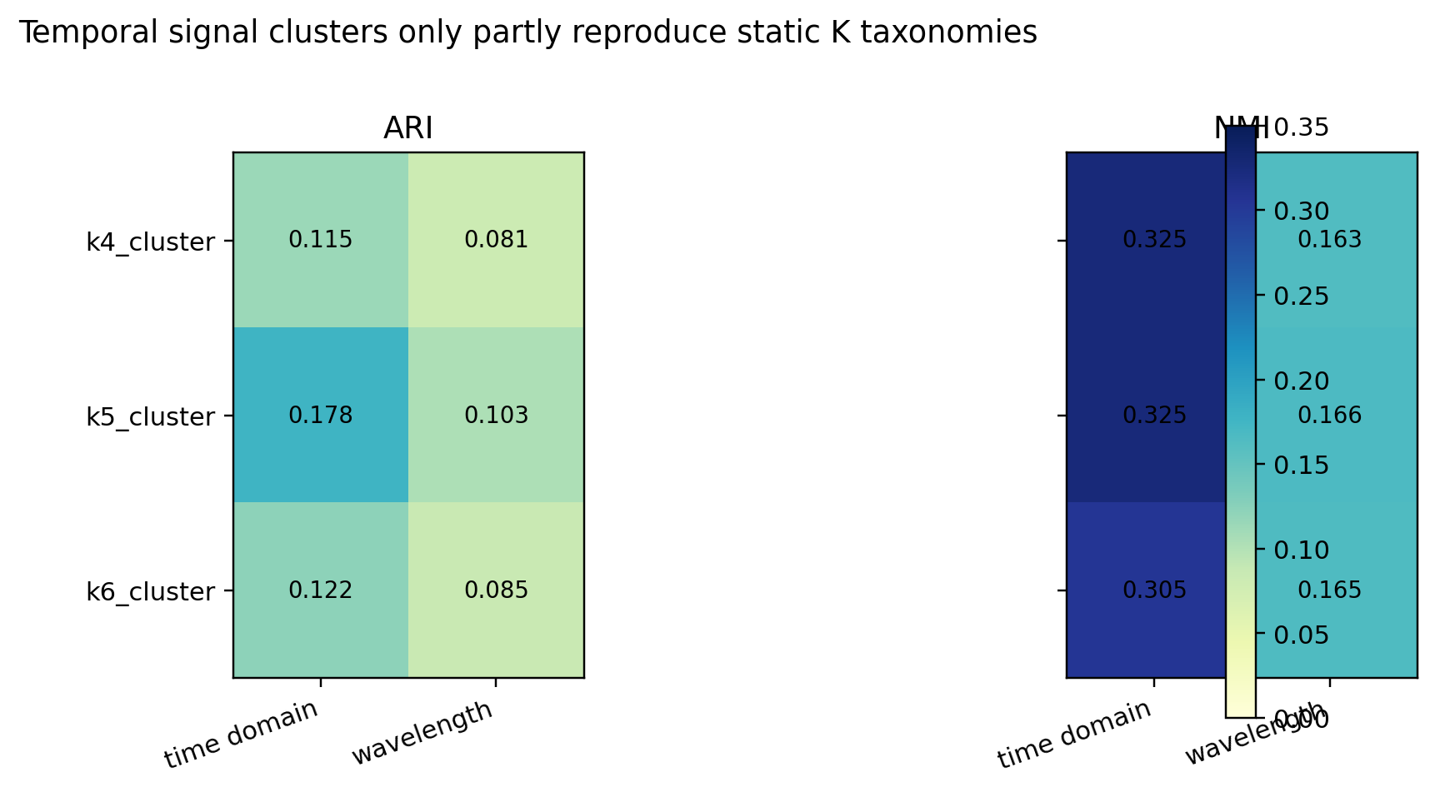
Signal Cluster Validation
Both signal representations show positive silhouette scores and are stronger than shuffled-label null models. Their seed stability is moderate, so they should be presented as exploratory temporal states rather than fixed wallet identities.
label_type | observed_silhouette | null_mean_silhouette | p_value_upper | seed_stability_mean_ari | seed_stability_mean_nmi
wavelength_cluster | 0.2065 | -0.0160 | 0.0099 | 0.6556 | 0.6962
time_domain_cluster | 0.2582 | -0.0352 | 0.0099 | 0.5168 | 0.6246
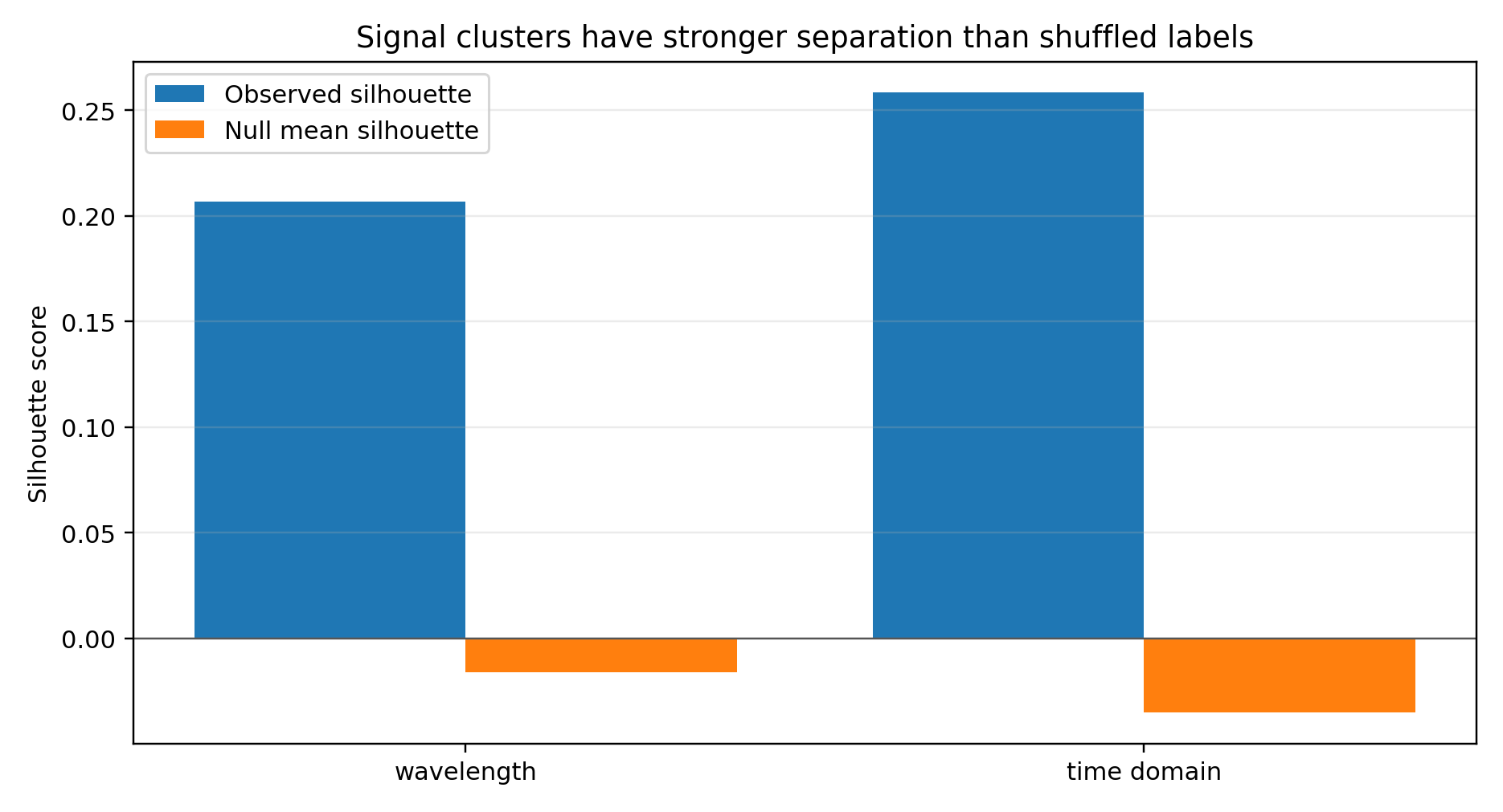
Network-Science Validation
K4, K5, and K6 all show strong same-label transaction concentration relative to shuffled labels. Wavelength clusters also show network alignment. Time-domain clusters do not exceed the null model in the 10,000-wallet edge-aware test.
label_type | edge_count | observed_same_cluster_ratio | null_mean | p_value_upper
k4_cluster | 46771 | 0.7627 | 0.2894 | 0.0099
k5_cluster | 46771 | 0.6197 | 0.2035 | 0.0099
k6_cluster | 46771 | 0.5387 | 0.1916 | 0.0099
wavelength_cluster | 46771 | 0.3143 | 0.2301 | 0.0099
time_domain_cluster | 46771 | 0.3932 | 0.4276 | 0.7723
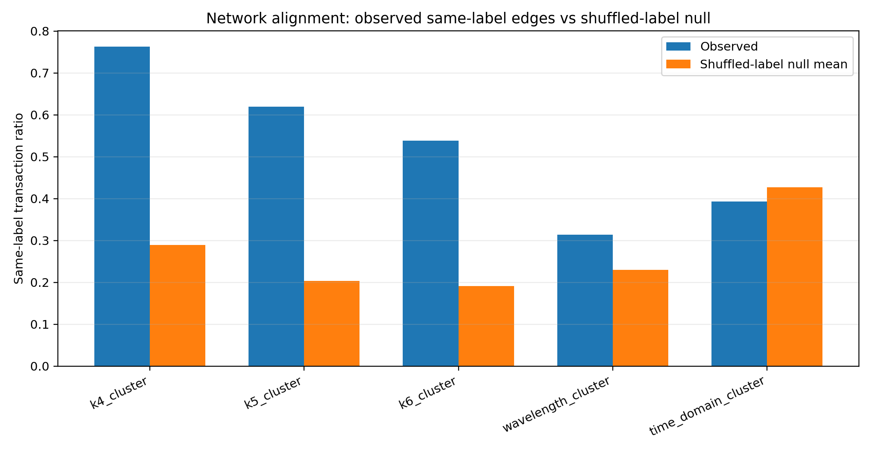
Temporal Stability And Two-Step Return
Across monthly triples, wallets that left their original K5 state often returned two months later more frequently than expected under the null model.
month_t | month_t1 | month_t2 | observed_two_step_return_rate | null_mean | p_value_upper
202201.0000 | 202202.0000 | 202203.0000 | 0.3408 | 0.2837 | 0.0020
202202.0000 | 202203.0000 | 202204.0000 | 0.3598 | 0.3123 | 0.0020
202203.0000 | 202204.0000 | 202205.0000 | 0.3405 | 0.3023 | 0.0020
202204.0000 | 202205.0000 | 202206.0000 | 0.3634 | 0.3152 | 0.0020
202205.0000 | 202206.0000 | 202207.0000 | 0.3428 | 0.2931 | 0.0020
202206.0000 | 202207.0000 | 202208.0000 | 0.3505 | 0.3096 | 0.0020
202207.0000 | 202208.0000 | 202209.0000 | 0.2995 | 0.2931 | 0.0020
202208.0000 | 202209.0000 | 202210.0000 | 0.3769 | 0.3119 | 0.0020
202209.0000 | 202210.0000 | 202211.0000 | 0.3259 | 0.2941 | 0.0020
202210.0000 | 202211.0000 | 202212.0000 | 0.3211 | 0.2987 | 0.0020
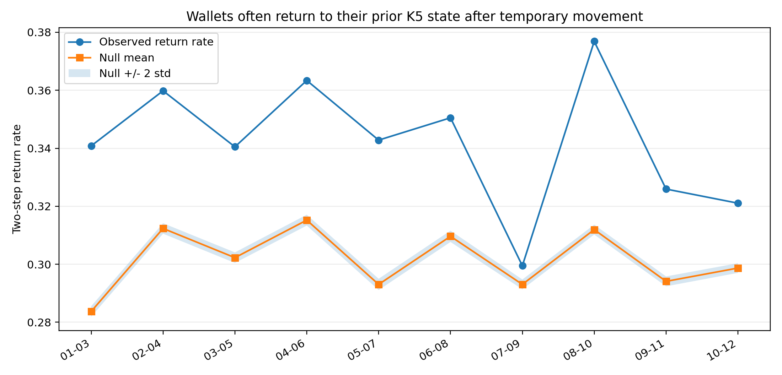
Academic Contribution
The project contributes a reproducible validation framework for wallet behaviour segmentation. It connects static EOA wallet roles, temporal signal analysis, transaction-network null tests, and temporal stability checks into a single empirical workflow.
Limitations
- Labels describe behavioural states, not verified real-world identities.
- Event-adjacent checks are contextual and should not be framed as causal evidence.
- The edge-aware signal analysis is sample-based, not full-population signal assignment.
- Time-domain states are structured in feature space but not strongly network-assortative in the 10k test.

