LDAB  


IDCH  
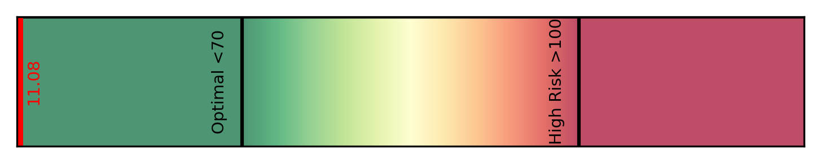

VLPN  


LDTG  
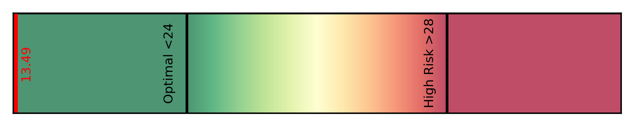

LDPN  
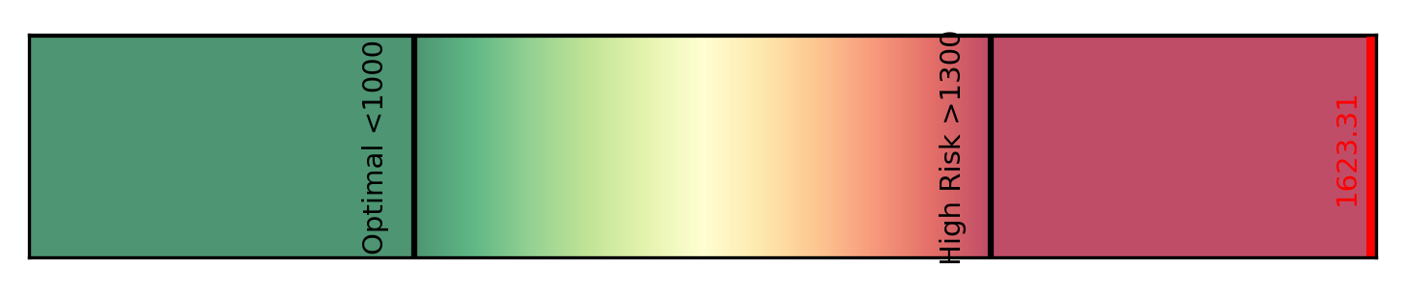

TBPN  


ABA1  


IDTG  


IDAB  


VLTG  


LDHD  


VLAB  
