ldl-serbest kolestrol / ldl-kolestrol  
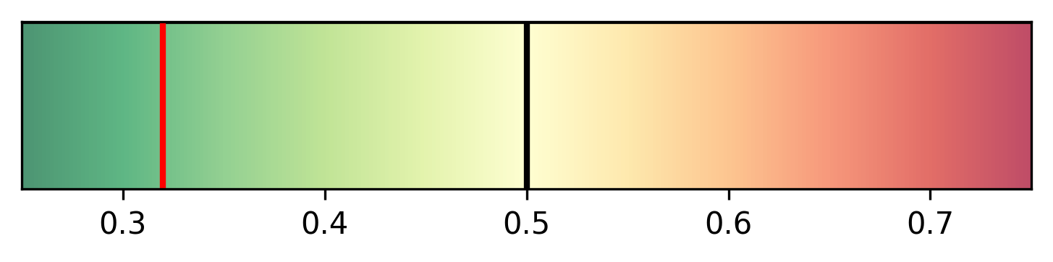

hdl-serbest kolestrol / hdl-kolestrol  
