RESPONSIVE IMAGE SLIDER LIBRARY
A Vanilla JavaScript Implementation

Sudip Pangali
MIT College
Course: Web Development
Instructor: ____________________
October 13, 2026

Introduction
An image slider is a user-interface component that presents a sequence of visual items within a shared viewing area. It helps a page display multiple images without requiring users to scroll through a long list. This project implements a responsive image slider using standard HTML, CSS, and vanilla JavaScript rather than a third-party carousel library.
The main objectives were to create previous and next controls, generate a dot for each slide, support direct navigation, animate the slide track horizontally, and allow navigation to wrap around at both boundaries. The interface also adapts to smaller viewports and includes keyboard controls, accessible labels, and reduced-motion styling.

Requirements and Design
The page is divided into three main layers. HTML provides semantic structure for the slider viewport, track, slide figures, buttons, status text, and indicator container. CSS controls the clipped viewport, horizontal flex track, image scaling, control placement, and transitions. JavaScript manages the active index, creates dots from the slide count, and responds to user input. This separation makes the component easier to read, test, and maintain.
The viewport uses overflow: hidden so slides outside the viewing area remain clipped. Each slide occupies 100% of the track viewport, and the track moves using transform: translateX(). CSS transforms are appropriate for visual movement, while the transition property defines how the browser interpolates between positions (Mozilla, n.d.).

Tools and Technologies
HTML5, CSS3, modern JavaScript (ES6+), a current web browser, and Git/GitHub for version control and publication.

Implementation Details

HTML Structure
The index.html file defines a main page, introduction, and slider section. The slider contains a viewport and a track. Each slide is a figure with an image and caption. Previous and next buttons are positioned inside the viewport, while a separate container is reserved for dots. The status element uses aria-live="polite" so assistive technology can announce the current image count after navigation.
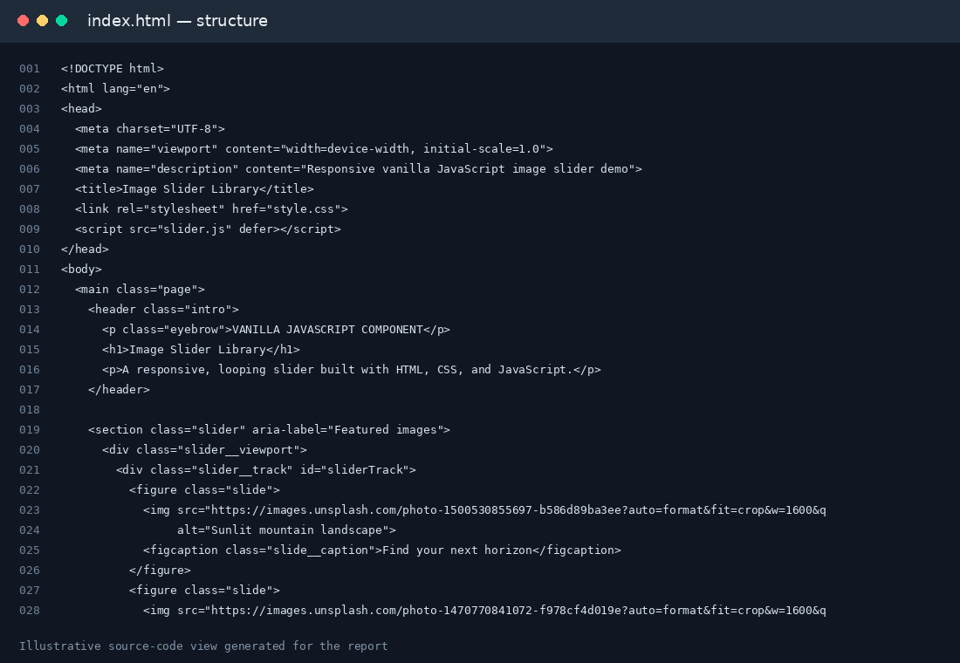
Figure 1. Source-code view of the HTML structure (illustrative excerpt).

CSS Layout and Motion
The style.css file sets the viewport to a fluid width and uses aspect-ratio to establish a stable shape. On smaller screens, a media query changes the viewport ratio and adjusts spacing. Images fill each slide with width: 100%, height: 100%, and object-fit: cover, preserving a clean crop without stretching. The track is a flex row; its transform is updated to move one slide-width at a time. The will-change hint indicates that transform is expected to change, although actual rendering performance depends on the browser and device.
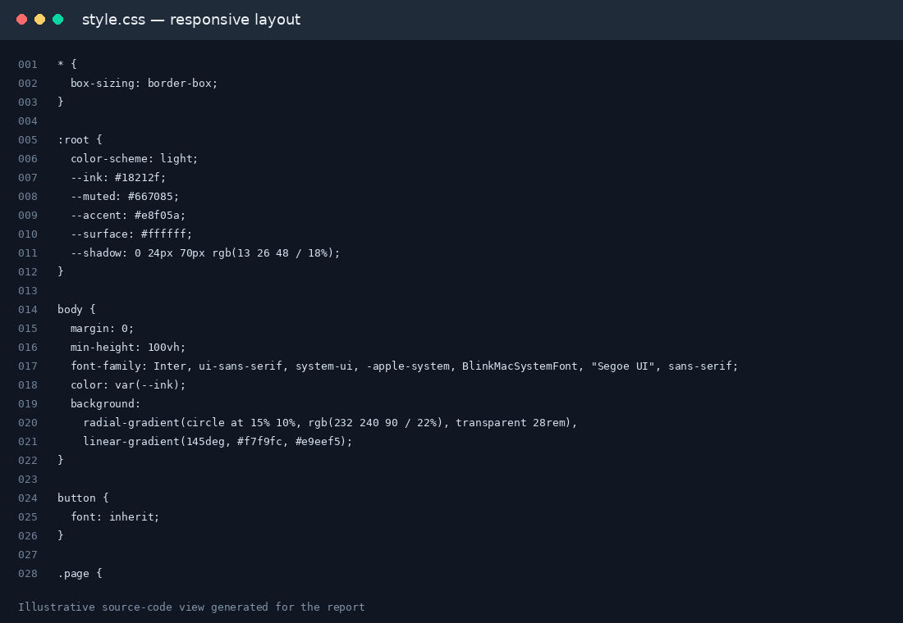
Figure 2. Source-code view of responsive CSS and slider presentation (illustrative excerpt).

JavaScript Behavior
The slider.js file defines an ImageSlider class. The constructor collects the required DOM nodes, stores the slide elements, generates the dots, registers event listeners, sets the initial position, and observes container resizing. The buildDots() method creates one button for every slide, so the number of indicators stays aligned with the supplied content.
The next() and previous() methods calculate indexes using modular arithmetic. For example, (index + 1) % slideCount returns to index zero after the final slide. The update() method positions the track with translateX(-index × 100%). For boundary navigation, animateBoundaryWrap() temporarily inserts a clone of the destination boundary slide, animates in the requested direction, then removes the clone and restores the track to the real slide position. This makes the wraparound feel continuous.
DOM methods and event listeners are used to change interface state in response to user actions. The Document Object Model represents the page as a tree of objects that scripts can inspect and modify (World Wide Web Consortium [W3C], n.d.). The implementation also updates aria-current on the active dot and the live status message after navigation.
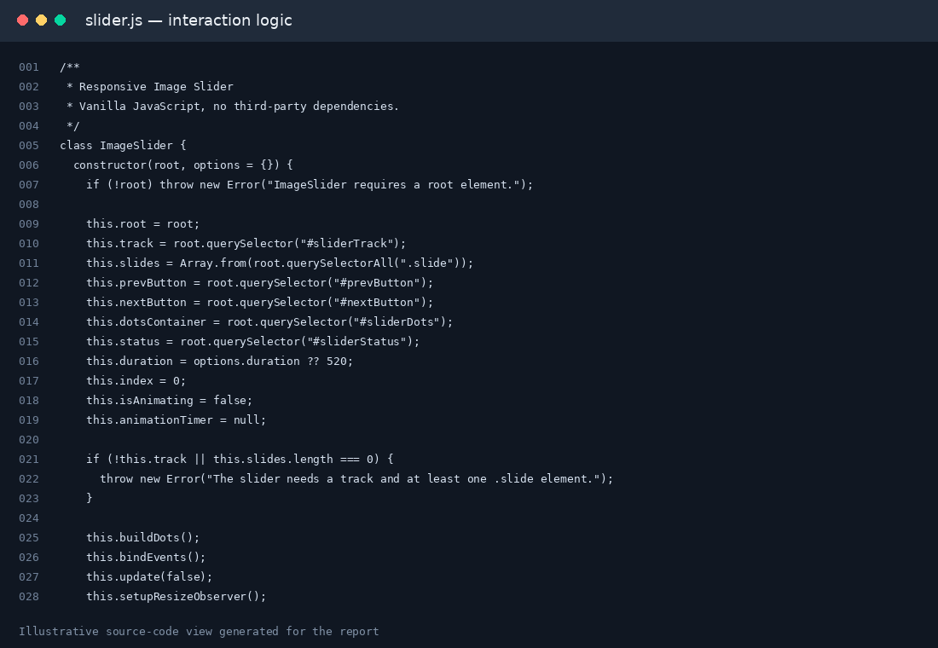
Figure 3. Source-code view of the JavaScript slider class (illustrative excerpt).

Results and Testing
The finished demonstration presents four sample image slides in a responsive viewport. The previous and next arrows sit at the left and right edges of the viewing window. The active indicator is elongated and changes color; the other dots remain neutral. Clicking a dot navigates directly to its corresponding slide. The image counter updates to show the current position.
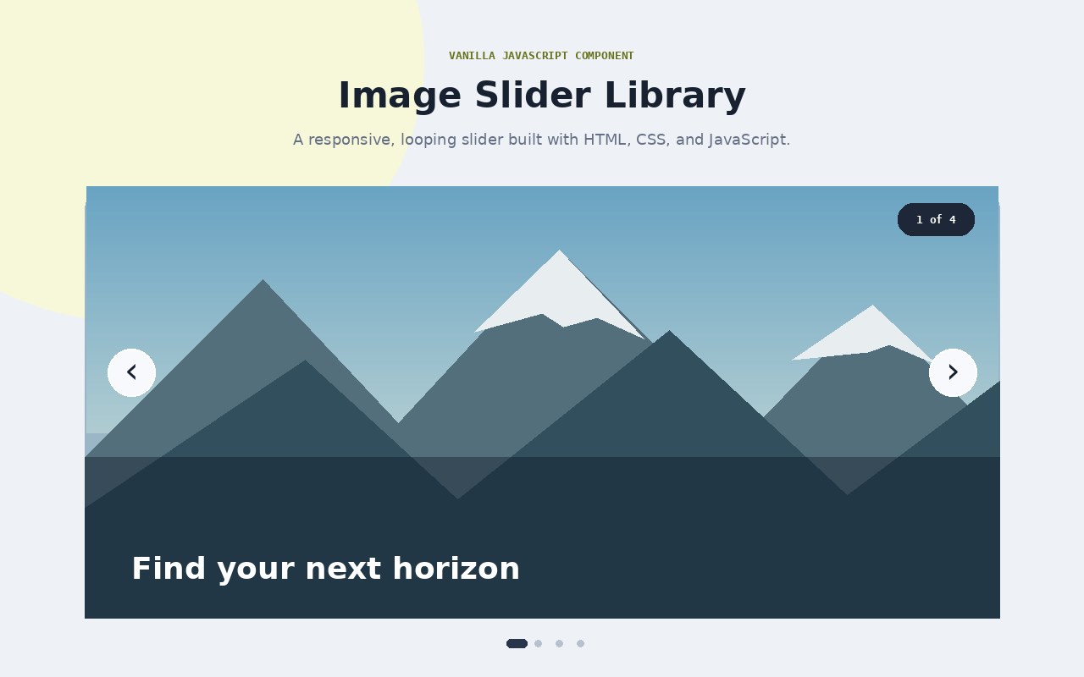
Figure 4. Representative application-output view. The report image is a designed illustration of the intended UI.

Test Checklist
- Initial load: first slide is active and the first dot is selected.
- Next/Previous: track moves horizontally and the active indicator changes.
- Direct navigation: each dot selects its matching slide.
- Forward wrap: Next on the final slide moves toward the first slide.
- Backward wrap: Previous on the first slide moves toward the final slide.
- Responsive layout: viewport and controls resize at narrow widths.
- Accessibility: controls have labels, status is announced, and keyboard arrows work.
- Reduced motion: transitions are shortened when the user requests reduced motion.
The test checklist describes the intended manual verification procedure. Because the supplied report includes illustrative screenshots rather than browser-captured evidence, the project should be opened in a browser and these checks should be performed before submission. The external Unsplash image URLs require an internet connection.

Conclusion
This project demonstrates how a reusable image slider can be built from core web technologies. The implementation separates structure, presentation, and behavior; calculates slide positions from the active index; creates indicators dynamically; and handles boundary wrapping with temporary slide clones. Responsive CSS, semantic controls, keyboard navigation, and reduced-motion support improve the usability of the component.
A future version could add touch-swipe gestures, autoplay with pause-on-hover, configurable transition timing, image preloading, TypeScript types, and automated tests. Before publication, the developer should validate behavior in multiple browsers, replace the sample images if licensing or offline availability is a concern, and push the complete folder to a public GitHub repository.

References
Mozilla. (n.d.). Using CSS transitions. MDN Web Docs. https://developer.mozilla.org/en-US/docs/Web/CSS/CSS_transitions/Using_CSS_transitions
World Wide Web Consortium. (n.d.). Document Object Model (DOM). https://www.w3.org/DOM/

