**Integrated Sustainability solutions with AI (Provided by An qi) - (Runtime Duration 40 seconds)**

The integrated sustainability solutions with AI employ three models: Data Pre-processing model, Forecasting model, and Simulation model.

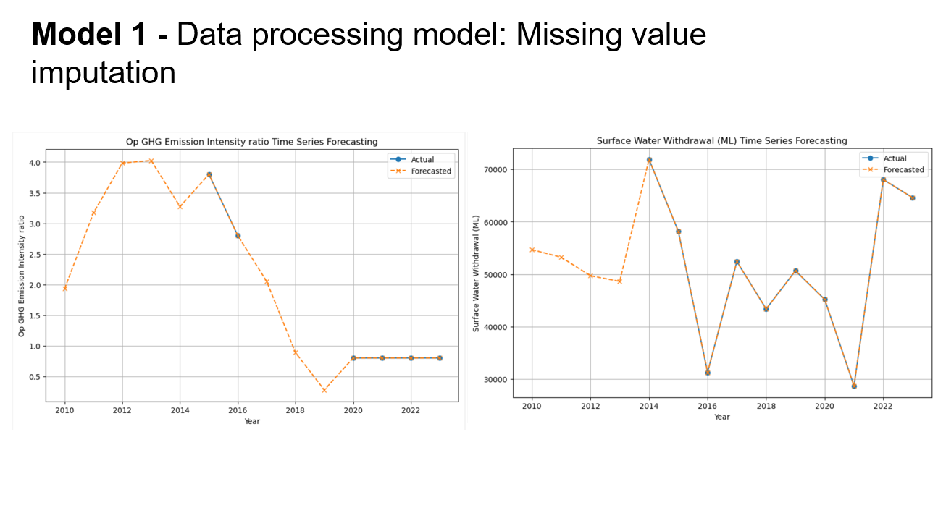

When dealing with real-world datasets, the presence of missing data often requires methods for handling them. Data Pre-processing model uses advanced techniques like machine learning xgboost algorithm to fill missing data, ensuring robust datasets for analysis.

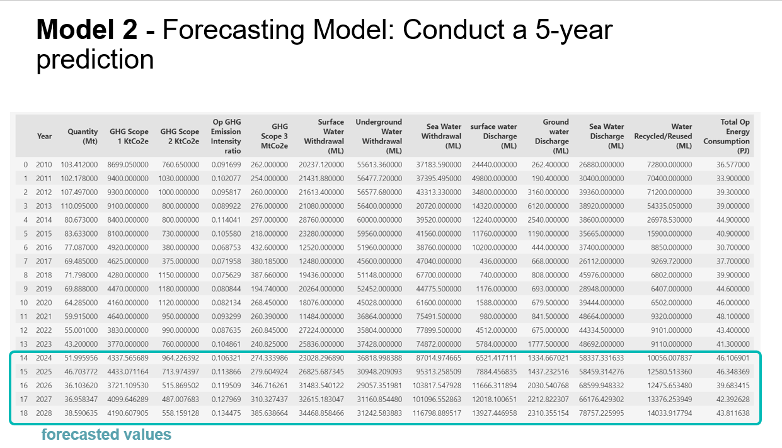

Building upon our processed datasets, the forecasting model employs vector autoregression algorithm, optimizing parameters to forecast trends over five years accurately.

The Simulation model comprises a Causality Analysis and Backward Prediction. Causality Analysis identifies crucial relationships among variables for emission management. Backward Prediction aids production planning by anticipating potential emission scenarios.

These Integrated models serve as vital tools, utilizing data analysis to guide strategic decisions and action plans for emission management and production optimization.