MovieFlix / Movie Recommendation App - ER Diagrams
Database Design Documentation

1. Implementation ER Diagram (Actual Project Database)
This ER diagram represents the actual database schema implemented in the Movie Recommendation App project (movie_recommender database).
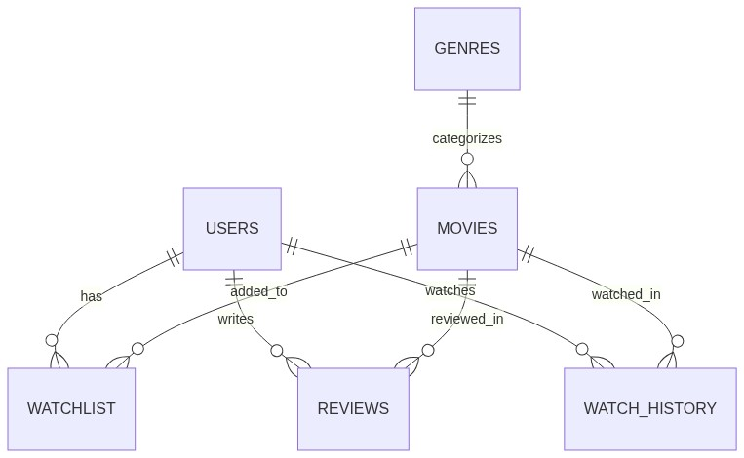

1.1 Entity Definitions

USERS
Column | Type | Key | Description
id | INT | PK | Auto-increment primary key
fullname | VARCHAR(100) |  | User full name
email | VARCHAR(100) | UK | Unique email address
password | VARCHAR(255) |  | Hashed password (bcrypt)
created_at | TIMESTAMP |  | Account creation timestamp

GENRES
Column | Type | Key | Description
id | INT | PK | Auto-increment primary key
genre_name | VARCHAR(50) | UK | Genre name (Action, Comedy, etc.)

MOVIES
Column | Type | Key | Description
id | INT | PK | Auto-increment primary key
title | VARCHAR(255) |  | Movie title
description | TEXT |  | Movie synopsis/description
genre_id | INT | FK | References GENRES.id
release_year | YEAR |  | Year of release
duration | INT |  | Duration in minutes
rating | DECIMAL(3,1) |  | Average rating (e.g., 8.5)
poster_url | VARCHAR(500) |  | Poster image URL
trailer_url | VARCHAR(500) |  | Trailer video URL
created_at | TIMESTAMP |  | Record creation timestamp

WATCHLIST
Column | Type | Key | Description
id | INT | PK | Auto-increment primary key
user_id | INT | FK | References USERS.id (ON DELETE CASCADE)
movie_id | VARCHAR(30) |  | TMDB movie ID (external reference)
movie_title | VARCHAR(255) |  | Cached movie title
poster | VARCHAR(500) |  | Cached poster path
created_at | TIMESTAMP |  | When added to watchlist

REVIEWS
Column | Type | Key | Description
user_id | INT | FK, PK | References USERS.id (composite PK)
movie_id | VARCHAR(30) | FK, PK | TMDB movie ID (composite PK)
movie_title | VARCHAR(255) |  | Cached movie title
rating | DECIMAL(2,1) |  | User rating (1-10)
review | TEXT |  | Review text content
created_at | TIMESTAMP |  | Review creation timestamp

WATCH_HISTORY
Column | Type | Key | Description
user_id | INT | FK, PK | References USERS.id (composite PK)
movie_id | VARCHAR(30) | FK, PK | TMDB movie ID (composite PK)
title | VARCHAR(255) |  | Cached movie title
poster | VARCHAR(500) |  | Cached poster path
watched_at | TIMESTAMP |  | Last watched timestamp (auto-updated)

1.2 Relationships
Parent Entity | Card. | Child Entity | Card. | Description
USERS | 1 | WATCHLIST | M | A user can have many watchlist entries
USERS | 1 | REVIEWS | M | A user can write many reviews
USERS | 1 | WATCH_HISTORY | M | A user can have many watch history entries
GENRES | 1 | MOVIES | M | A genre can categorize many movies
MOVIES | 1 | WATCHLIST | M | A movie can be in many watchlists
MOVIES | 1 | REVIEWS | M | A movie can have many reviews
MOVIES | 1 | WATCH_HISTORY | M | A movie can be watched by many users

2. Document ER Diagram (MovieFlix Review-II Report Specification)
This ER diagram represents the database design as specified in the project review document (Section 12: ER Diagram). It uses TMDB movie IDs as external references rather than local movie storage.
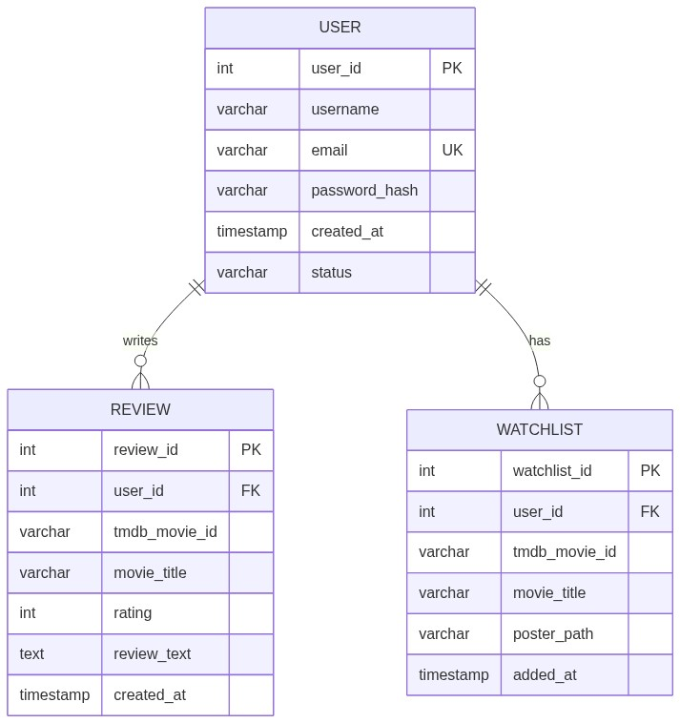

2.1 Entity Definitions

USER
Column | Type | Key | Description
user_id | INT | PK | Auto-increment primary key
username | VARCHAR |  | Unique username
email | VARCHAR | UK | Unique email address
password_hash | VARCHAR |  | Securely hashed password
created_at | TIMESTAMP |  | Account creation timestamp
status | VARCHAR |  | Account status (active/inactive)

REVIEW
Column | Type | Key | Description
review_id | INT | PK | Auto-increment primary key
user_id | INT | FK | References USER.user_id
tmdb_movie_id | VARCHAR |  | TMDB external movie ID
movie_title | VARCHAR |  | Cached movie title for display
rating | INT |  | Rating 1-10
review_text | TEXT |  | Review content
created_at | TIMESTAMP |  | Review creation timestamp

WATCHLIST
Column | Type | Key | Description
watchlist_id | INT | PK | Auto-increment primary key
user_id | INT | FK | References USER.user_id
tmdb_movie_id | VARCHAR |  | TMDB external movie ID
movie_title | VARCHAR |  | Cached movie title
poster_path | VARCHAR |  | TMDB poster path
added_at | TIMESTAMP |  | When added to watchlist

2.2 Relationships
Parent Entity | Card. | Child Entity | Card. | Description
USER | 1 | REVIEW | M | A user can write many reviews
USER | 1 | WATCHLIST | M | A user can have many watchlist entries

3. Comparison: Implementation vs Document
Aspect | Document Specification | Actual Implementation
Movie Storage | External only (TMDB API) | Local MOVIES table + TMDB cache
Genres | Not specified | Dedicated GENRES table with FK
Watch History | Not specified | WATCH_HISTORY table with auto-update
Review PK | review_id (surrogate) | Composite (user_id, movie_id)
Watchlist PK | watchlist_id (surrogate) | id (surrogate)
Movie Reference | tmdb_movie_id (VARCHAR) | movie_id (VARCHAR) + local MOVIES.id
Cascading Deletes | Not specified | WATCHLIST.user_id ON DELETE CASCADE
Rating Precision | INT (1-10) | DECIMAL(2,1) for reviews, DECIMAL(3,1) for movies

3.1 Key Differences
- The implementation includes a local MOVIES table and GENRES table for richer local data storage and filtering capabilities.
- WATCH_HISTORY table tracks user viewing activity with automatic timestamp updates on re-watch.
- The document design relies entirely on TMDB API for movie metadata; the implementation caches key data locally.
- Composite primary keys in REVIEWS and WATCH_HISTORY prevent duplicate entries per user-movie pair.
- The implementation uses ON DELETE CASCADE on watchlist for referential integrity.

