Quality Intelligence Platform
Application Description & Technology Profile for VAPT

1. Application Overview
The Quality Intelligence Platform is an AI-powered, multi-plant, multi-project web application for Mahindra manufacturing and quality teams. It is not limited to a single plant or vehicle programme. It allows quality, warranty and manufacturing engineers to query traceability and warranty data in natural language, analyse trends visually, search 200+ quality guideline PDFs, and generate AI-assisted PFMEA (Process Failure Mode & Effects Analysis).

2. Functional Modules
Module | Purpose
Quality Chatbot (GraphRAG) | Natural-language Q&A over traceability, warranty, PPCM and e-SQA data using cooperating agents: Cypher agent (Neo4j), analyst agent (SQL and charts) and standards/guidelines agent (semantic search with PDF citations). Responses are streamed.
Part Sense Visualizer (PartLabeler) | Upload of warranty data (Excel/CSV) mapped to vehicle components; dashboards by month, quarter, model and MIS. Planned sources: warranty, offline RPT, GNOVAC, RFI, e-SQA.
PFMEA Advisor | Upload of PFMEA Excel; LLM pipeline normalises, scores severity/occurrence/detection (RPN/AP), reviews rows and writes suggestions to a downloadable workbook.
Z-Stage | Plant layout planner with 3D view: stations, connections, line-to-model mappings, car models, input records and audit exports.
Admin Panel | User and role management, prompt management, feedback.
Authentication | Signup, login, password reset; roles: admin and user.

3. Technology Stack
Component | Technology / Version
Backend | Python 3.11, FastAPI, Uvicorn; LangChain / LangGraph for AI orchestration
Frontend | React 19, react-scripts 5 (Create React App), Node 20 (alpine) build; Recharts, Three.js, react-pdf, Axios
Relational database | PostgreSQL 17 (postgres:17-alpine)
Graph database | Neo4j 2025.12.1 with APOC plugin
Vector database (embeddings) | OpenSearch 2.11.0, k-NN with FAISS engine; index: qlense_assistant_index
Embedding model | Azure OpenAI text-embedding-ada-002
LLM provider | Azure OpenAI
Web server / reverse proxy | Nginx (nginx:alpine), HTTPS with TLS 1.2 / 1.3
Document ingestion | Docling + OCR (RapidOCR / EasyOCR), HybridChunker
Deployment | Docker Compose on Ubuntu VM (app, Postgres, Neo4j, OpenSearch, Nginx)

4. Architecture Summary
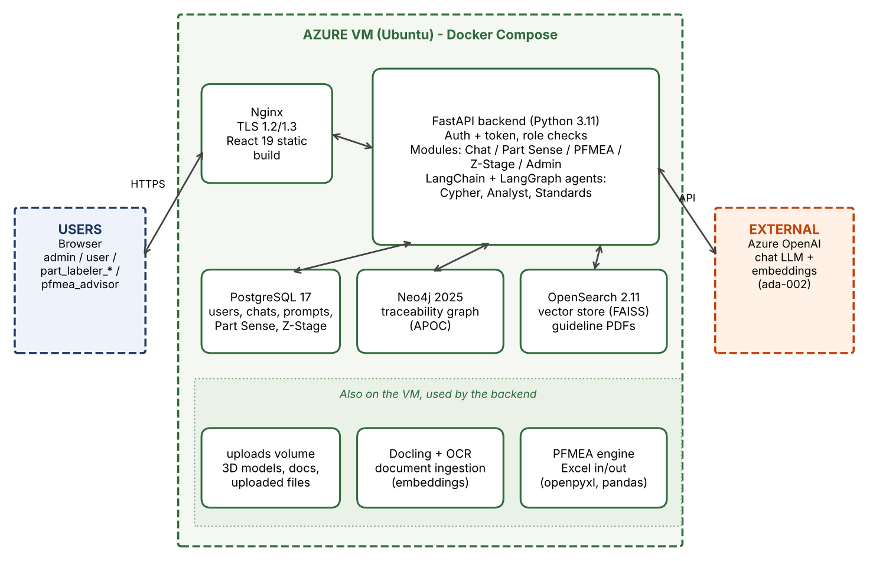
- Users reach Nginx over HTTPS (443; 80 also listens). Nginx serves the React static build and proxies API calls to the FastAPI backend (port 5000).
- FastAPI exposes about 100 REST routes (43 GET, 30 POST, 14 PUT, 17 DELETE) plus streaming (SSE) and WebSocket support.
- The frontend holds no database or vector store; all data access goes through the backend.
- Chat flow: User question > React UI > FastAPI > agent > Neo4j / PostgreSQL / OpenSearch > response streamed back.
- Guideline PDFs are parsed, chunked, embedded and stored in OpenSearch; the standards agent retrieves top-k chunks (default 5, max 10) with citations.

5. User Roles and Access Profiles
Seven roles are defined. Access is decided by the role stored on the user record (users.role); the modules shown on the landing page and the routes allowed depend on it.
Role | Accessible modules | Notes / suggested test profile
admin | All modules + Admin Panel | Full access; can create users, change roles, manage prompts. Test user: vapt_admin
user | Part Sense Field, Qlense Guidelines | Default role for every new signup; an admin then assigns the working role. Test user: vapt_user
part_labeler | Part Sense Field + Plant, Qlense Guidelines | Test user: vapt_part_labeler
part_labeler_field | Part Sense Field, Qlense Guidelines | Test user: vapt_pl_field
part_labeler_plant | Part Sense Plant, Z-Stage, Qlense Guidelines, PFMEA | Test user: vapt_pl_plant
part_labeler_ev | Part Sense EV, Z-Stage, Qlense Guidelines | Test user: vapt_pl_ev
pfmea_advisor | PFMEA APEX Advisor, Part Sense Plant | Test user: vapt_pfmea
Test credentials will be shared with the VAPT team separately over a secure channel and must be disabled after the engagement. Suggested checks: horizontal and vertical privilege escalation between the roles above, direct API calls to modules a role cannot see in the UI, and admin endpoints called with a non-admin identity.

6. Attack Surface (Scoping)
Area | Details
External entry points | HTTPS via Nginx; /api auth routes; admin routes; chat endpoints; static /documents/ PDFs
File uploads | PartLabeler (Excel/CSV), PFMEA (xlsx), Z-Stage input records and 3D models; Nginx limit 300 MB
Ports published in docker-compose | PostgreSQL 5432, Neo4j 7474 / 7687, OpenSearch 9200 (to be firewalled from outside the host)
User roles | Anonymous plus seven authenticated roles (see section 5)
AI-specific | LLM-generated Cypher / SQL queries (prompt injection risk); query validator in place

7. Known Observations for Review
The following were identified from code and configuration review and should be validated or remediated:
- Passwords: salted PBKDF2-SHA256 hashing is implemented and read-compatible with the legacy format; it is switched on (PASSWORD_HASH_UPGRADE) in a second phase after the access-control changes are proven in UAT.
- Admin routes still accept a client-supplied requester_id parameter, but the admin router now also requires an admin token.
- Session secret: if SESSION_SECRET is not configured, a random per-installation secret is generated and stored in the database (no public default is used).
- Content-Security-Policy allows unsafe-inline and unsafe-eval; /documents/ returns Access-Control-Allow-Origin: *.
- Database ports are published on the host; Postgres uses md5 host auth; Neo4j APOC procedures are unrestricted.
- OpenSearch defaults to no SSL and no certificate verification.
- Debug defaults: SERVER_RELOAD=True and log level debug; CORS defaults to localhost origins.
- Role enforcement: PartLabeler, PFMEA, Z-Stage and Admin APIs now require a signed bearer token and check the user's current role server-side (HTTP 401 / 403). The conversation/chat APIs and WebSocket do not yet require a token.
- Admins can set a new password for any user from the Admin Panel (forgotten-password case); admin token required, minimum 8 characters.
- Login and password reset lock a username for 15 minutes after 5 failed attempts (HTTP 429); counters are in-memory per process.
- Access tokens are passed as an access_token query parameter for GET downloads (files, 3D models); this can appear in server logs.
- Signup is open to anyone and new accounts get the minimal user role; chat/WebSocket APIs do not yet require a token.
- File upload handling should be tested for type/size validation, CSV/Excel formula injection and path traversal.

