Z-Stage: Architecture and Resource Sizing
Input for the GPU server request

1. Summary
Z-Stage is the 3D plant-layout planner. It is currently hosted on an Azure VM that has no GPU. Users who have a GPU in their own PC see smooth performance; users without one see lag.
Why: the 3D scene (Three.js / WebGL) is drawn inside each user's browser, using that user's own graphics hardware. The server only stores data and sends files. A GPU on the server would therefore not speed up the current design by itself.

2. Architecture
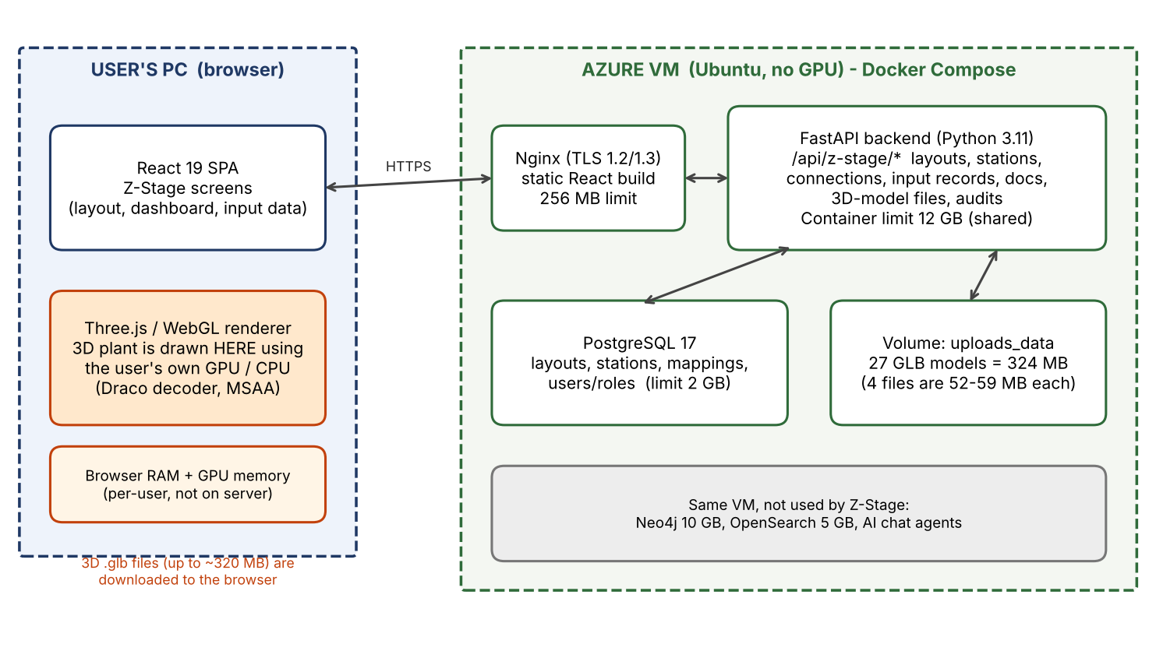

3. Components and Resources
Component | Technology | Resources / sizing
Frontend (in user's browser) | React 19, Three.js 0.168 (WebGL), Draco decoder, MSAA anti-aliasing, pixel ratio capped at 1.5 (1.0 on low-end PCs) | Uses the user's PC RAM and GPU memory. Not measured yet: see section 5.
Reverse proxy | Nginx (alpine), TLS 1.2 / 1.3 | Container limit 256 MB RAM, 0.5 CPU
Backend | Python 3.11, FastAPI, /api/z-stage/* | Container limit 12 GB RAM / 3 CPU (shared with chat, PFMEA and PDF ingestion). Z-Stage itself only does CRUD and file serving, so it is lightweight.
Database | PostgreSQL 17 | Container limit 2 GB RAM, 1 CPU (shared)
File storage | Docker volume uploads_data | 3D models: 27 GLB files, 324 MB total. Four files are 52 to 59 MB each (layout6_Under_Break_Line, white_suv_3d_model, layout6_Trim_Line, thar_4x4_recolored). The rest are 5 to 8 MB or smaller.
Other services on the same VM | Neo4j 10 GB, OpenSearch 5 GB | Not used by Z-Stage, but they share the VM's 32 GB RAM / 8 cores.

4. What a GPU server would and would not fix
- A normal GPU VM would NOT fix user lag. Rendering happens in the browser, so slow PCs stay slow.
- To use a server GPU, the 3D view would have to be rendered on the server and streamed to the user as video (pixel streaming / remote rendering, for example an Azure NV-series VM). This works on any PC but needs a large redesign, a GPU VM per few concurrent users, and good network bandwidth.
- Cheaper first steps that help users without a GPU: shrink the four 52 to 59 MB models (mesh simplification, Draco / meshopt compression, texture downsizing); load models on demand by station; use lower-detail models when zoomed out (LOD); offer a Low Quality mode (no anti-aliasing, lower pixel ratio).

5. Numbers still to be measured
These can only be measured on the running system and have not been measured yet:
Metric | How to measure
Backend RAM / CPU while Z-Stage is in use | On the VM: docker stats traceability-app (and the postgres container) while several users open Z-Stage
Browser RAM and GPU memory per user | Chrome: Shift+Esc (Task Manager) for memory; DevTools > Performance and the Rendering > FPS meter for frame rate; chrome://gpu for GPU details
Download size per session | Chrome DevTools > Network, filter .glb, check total transferred
Number of concurrent users | From the team: expected peak users on Z-Stage
Minimum client spec that is smooth | Test on one no-GPU and one GPU PC and record FPS

6. Information to give the GPU-server team
- Z-Stage backend needs no GPU. Total Z-Stage server footprint is small: well under 1 GB RAM above the shared containers, and about 324 MB of stored models.
- If remote rendering is wanted: share the expected concurrent users and the 3D model sizes above so they can size a GPU VM.

