-- EDA: Use the layoff database

USE layoff_db;

-- Display all records from layoff_staging2

SELECT * FROM layoff_staging2;

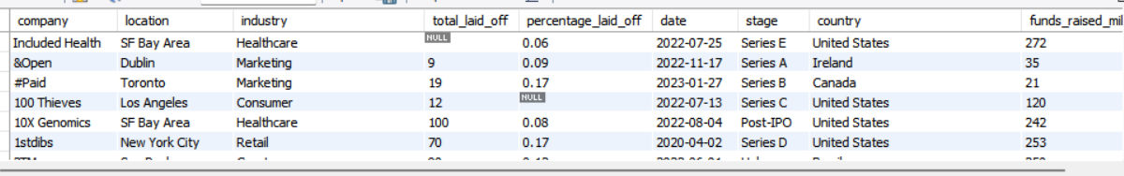

-- Find the maximum values from total_laid_off and percentage_laid_off

SELECT

MAX(total_laid_off) AS max_total_laid_off,

MAX(percentage_laid_off) AS max_percentage_laid_off

FROM layoff_staging2;



-- Subquery to get details where percentage_laid_off is maximum

SELECT *

FROM layoff_staging2

WHERE percentage_laid_off = (

SELECT MAX(percentage_laid_off)

FROM layoff_staging2

);

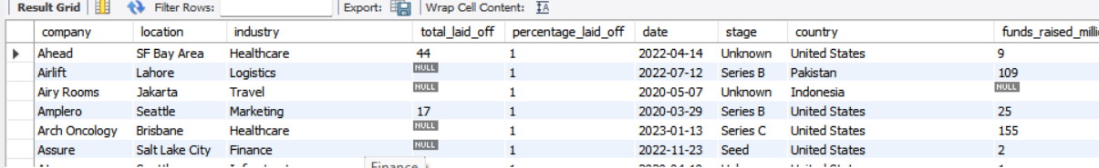

-- Get layoff details where percentage_laid_off is 100%, ordered by funds raised

SELECT *

FROM layoff_staging2

WHERE percentage_laid_off = 1

ORDER BY funds_raised_millions DESC;

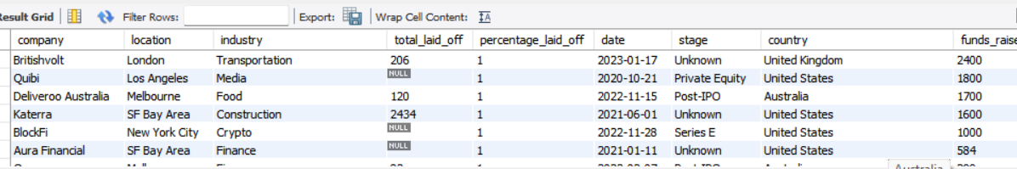

-- Display all records again

SELECT * FROM layoff_staging2;

-- Find the date range of the records

SELECT

MIN(`date`) AS start_date,

MAX(`date`) AS end_date

FROM layoff_staging2;

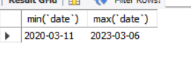

-- Company-wise total layoffs, ordered by total layoffs

SELECT

company,

SUM(total_laid_off) AS total_laid_off

FROM layoff_staging2

GROUP BY company

ORDER BY total_laid_off DESC;

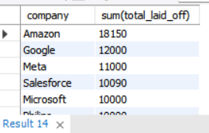

-- Industry-wise total layoffs, ordered by total layoffs

SELECT

industry,

SUM(total_laid_off) AS total_laid_off

FROM layoff_staging2

GROUP BY industry

ORDER BY total_laid_off DESC;

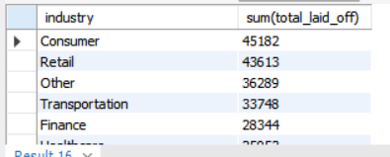

-- Country-wise total layoffs, ordered by total layoffs

SELECT

country,

SUM(total_laid_off) AS total_laid_off

FROM layoff_staging2

GROUP BY country

ORDER BY total_laid_off DESC;

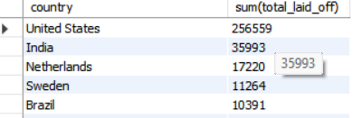

-- Year-wise total layoffs, ordered by total layoffs

SELECT

YEAR(`date`) AS year,

SUM(total_laid_off) AS total_laid_off

FROM layoff_staging2

GROUP BY year

ORDER BY total_laid_off DESC;

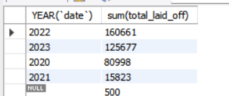

-- Stage-wise total layoffs, ordered by total layoffs

SELECT

stage,

SUM(total_laid_off) AS total_laid_off

FROM layoff_staging2

GROUP BY stage

ORDER BY total_laid_off DESC;

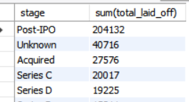

-- Company-wise average percentage layoffs, ordered by average percentage

SELECT

company,

AVG(percentage_laid_off) AS avg_percentage_laid_off

FROM layoff_staging2

GROUP BY company

ORDER BY avg_percentage_laid_off DESC;

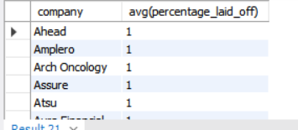

-- Stored procedure to get rolling sum of total_laid_off by date for a specific company

DELIMITER $$

CREATE PROCEDURE company_layoff(IN com TEXT)

BEGIN

WITH cte_rolling AS (

SELECT

company,

`date`,

total_laid_off,

SUM(total_laid_off) OVER (PARTITION BY company ORDER BY `date`) AS rolling_sum

FROM layoff_staging2

)

SELECT

company,

`date`,

total_laid_off,

rolling_sum

FROM cte_rolling

WHERE company = com;

END $$

DELIMITER ;

-- Call the stored procedure for Amazon

CALL company_layoff('Amazon');

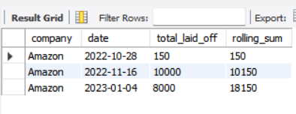

-- CTE to find month-wise rolling sum of total_laid_off

WITH cte_rolling_sum AS (

SELECT

SUBSTRING(`date`, 1, 7) AS `Month`,

SUM(total_laid_off) AS total_laidoff

FROM layoff_staging2

WHERE SUBSTRING(`date`, 1, 7) IS NOT NULL

GROUP BY `Month`

ORDER BY `Month`

)

SELECT

`Month`,

total_laidoff,

SUM(total_laidoff) OVER (ORDER BY `Month`) AS roll_sum

FROM cte_rolling_sum;

