PL/SQL Programming

Exercise 1: Control Structures

Scenario 1: The bank wants to apply a discount to loan interest rates for customers above 60 years old.
  - Question: Write a PL/SQL block that loops through all customers, checks their age, and if they are above 60, apply a 1% discount to their current loan interest rates.
Scenario 2: A customer can be promoted to VIP status based on their balance.
  - Question: Write a PL/SQL block that iterates through all customers and sets a flag IsVIP to TRUE for those with a balance over $10,000.
Scenario 3: The bank wants to send reminders to customers whose loans are due within the next 30 days.
  - Question: Write a PL/SQL block that fetches all loans due in the next 30 days and prints a reminder message for each customer.

Create table Customer

CREATE TABLE CUSTOMERS (
CUSTOMERID NUMBER PRIMARY KEY,
NAME VARCHAR2(100),
DOB DATE,
BALANCE NUMBER,
LASTMODIFIED DATE
);

Create table Loans

CREATE TABLE LOANS (
LOANID NUMBER PRIMARY KEY,
CUSTOMERID NUMBER,
LOANAMOUNT NUMBER,
INTERESTRATE NUMBER,
STARTDATE DATE,
ENDDATE DATE,
FOREIGN KEY ( CUSTOMERID )
REFERENCES CUSTOMERS ( CUSTOMERID )
);

Insert into Customers val1

INSERT INTO CUSTOMERS (CUSTOMERID, NAME, DOB, BALANCE, LASTMODIFIED)
VALUES (1, 'John Doe', TO_DATE('1985-05-15', 'YYYY-MM-DD'), 1000, SYSDATE);

Insert into Customers val2

INSERT INTO CUSTOMERS (CUSTOMERID, NAME, DOB, BALANCE, LASTMODIFIED)
VALUES (2, 'Jane Smith', TO_DATE('1990-07-20', 'YYYY-MM-DD'), 1500, SYSDATE);

Insert into Loans val1

INSERT INTO LOANS (LOANID, CUSTOMERID, LOANAMOUNT, INTERESTRATE, STARTDATE, ENDDATE)
VALUES (1, 1, 5000, 5, SYSDATE, ADD_MONTHS(SYSDATE, 60));

Scenario 1 : Control Structures – Loan Discount For 60+ :

DECLARE
CURSOR cur_customer IS
SELECT customerid, EXTRACT(YEAR FROM SYSDATE) - EXTRACT(YEAR FROM dob) AS age
FROM customers;
v_id customers.customerid%TYPE;
v_age NUMBER;
BEGIN
OPEN cur_customer;
LOOP
FETCH cur_customer INTO v_id, v_age;
EXIT WHEN cur_customer%NOTFOUND;

IF v_age > 60 THEN
UPDATE loans
SET interestrate = interestrate - 1
WHERE customerid = v_id;
ELSE
DBMS_OUTPUT.PUT_LINE('Customer ID: ' || v_id || ' | Age: ' || v_age);
DBMS_OUTPUT.PUT_LINE('Customer not eligible for interest discount');
END IF;
END LOOP;
CLOSE cur_customer;
COMMIT;
END;
/

Output:

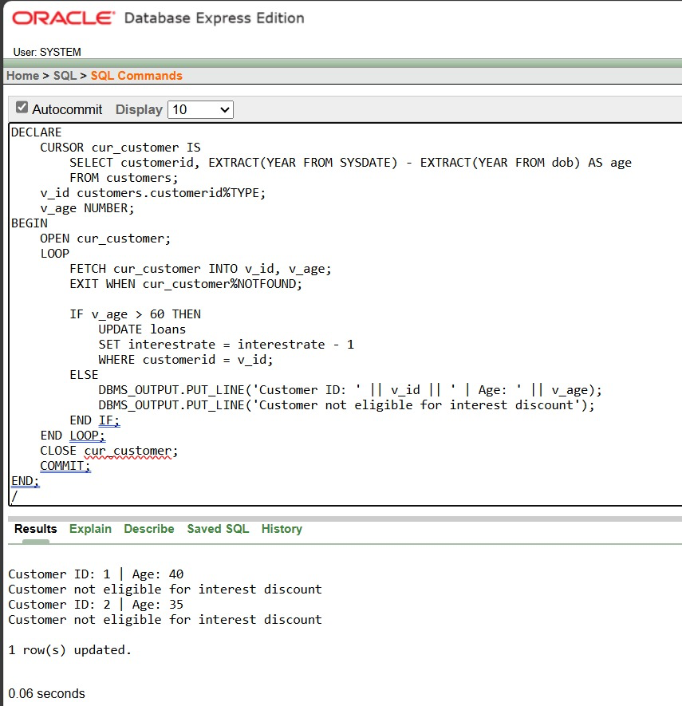

Scenario 2 : Mark VIP Customers

ALTER TABLE customers ADD isvip VARCHAR2(10);

BEGIN
FOR user_rec IN (
SELECT customerid, balance FROM customers
) LOOP
IF user_rec.balance > 10000 THEN
UPDATE customers
SET isvip = 'TRUE'
WHERE customerid = user_rec.customerid;
ELSE
UPDATE customers
SET isvip = 'FALSE'
WHERE customerid = user_rec.customerid;
END IF;
END LOOP;
COMMIT;
END;
/

Output :

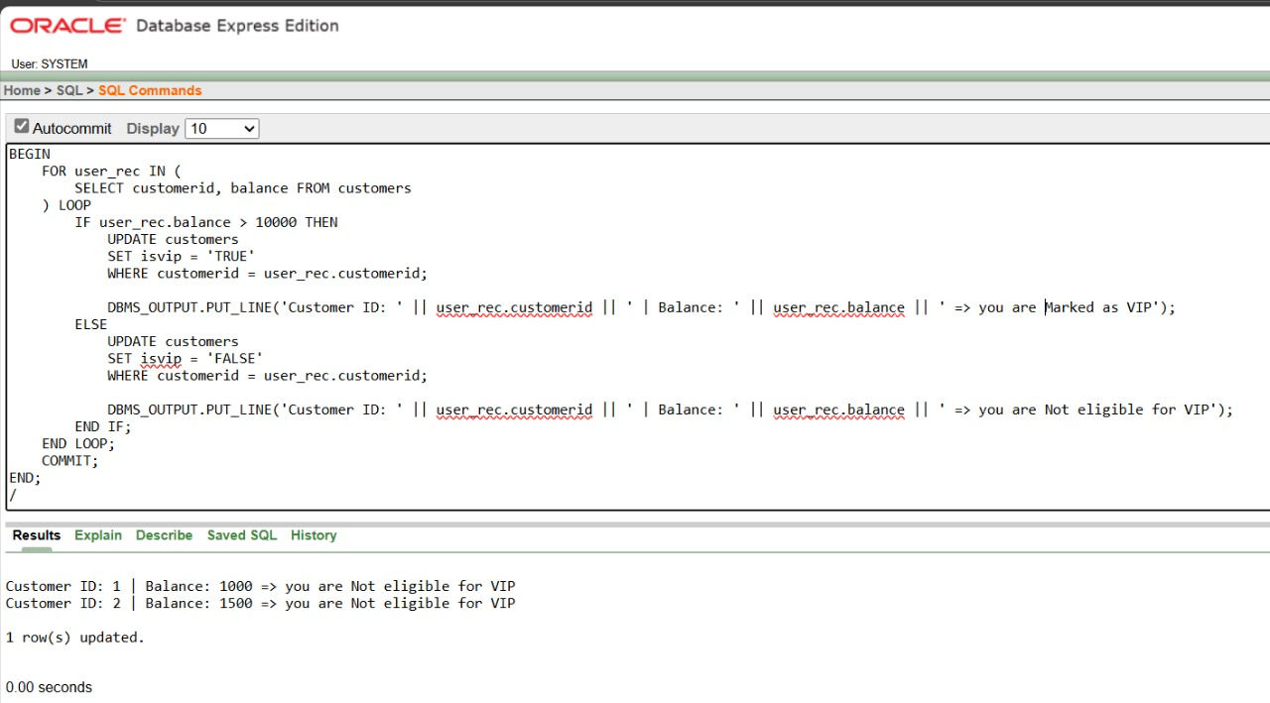

Scenario 3 : Loan Due To Be Reminded

SET SERVEROUTPUT ON;

DECLARE
CURSOR cur_loans IS
SELECT l.loanid, l.customerid, c.name, l.enddate
FROM loans l
JOIN customers c ON c.customerid = l.customerid
WHERE l.enddate BETWEEN SYSDATE AND SYSDATE + 30;

v_loanid loans.loanid%TYPE;
v_custid loans.customerid%TYPE;
v_name customers.name%TYPE;
v_due loans.enddate%TYPE;
found BOOLEAN := FALSE;

BEGIN
OPEN cur_loans;
LOOP
FETCH cur_loans INTO v_loanid, v_custid, v_name, v_due;
EXIT WHEN cur_loans%NOTFOUND;

found := TRUE;
DBMS_OUTPUT.PUT_LINE(
'Reminder: Loan ' || v_loanid ||
' for ' || v_name ||
' (ID: ' || v_custid ||
') is due on ' || TO_CHAR(v_due, 'DD-Mon-YYYY')
);
END LOOP;
CLOSE cur_loans;

IF NOT found THEN
DBMS_OUTPUT.PUT_LINE('No loans are nearing due date in next 30 days.');
END IF;
END;
/

Output :

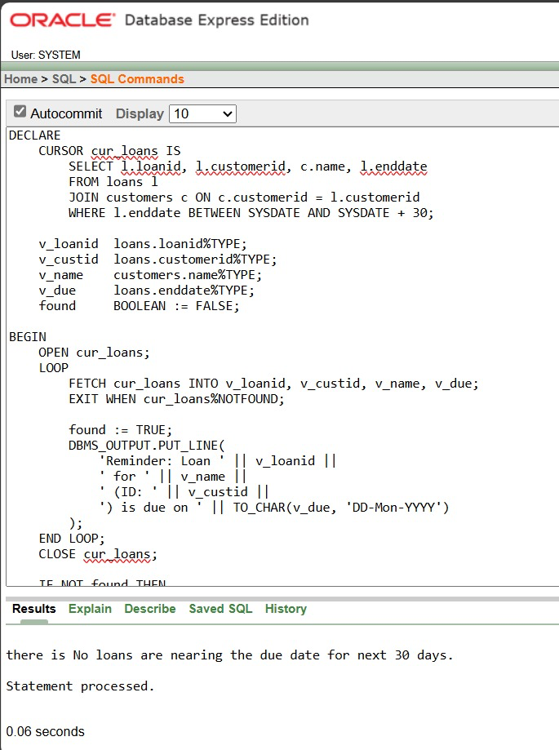

Exercise 3: Stored Procedures

Scenario 1: The bank needs to process monthly interest for all savings accounts.
  - Question: Write a stored procedure ProcessMonthlyInterest that calculates and updates the balance of all savings accounts by applying an interest rate of 1% to the current balance.

Scenario 2: The bank wants to implement a bonus scheme for employees based on their performance.
  - Question: Write a stored procedure UpdateEmployeeBonus that updates the salary of employees in a given department by adding a bonus percentage passed as a parameter.

Scenario 3: Customers should be able to transfer funds between their accounts.
  - Question: Write a stored procedure TransferFunds that transfers a specified amount from one account to another, checking that the source account has sufficient balance before making the transfer.

Create table Accounts
CREATE TABLE ACCOUNTS (
ACCOUNTID NUMBER PRIMARY KEY,
CUSTOMERID NUMBER,
ACCOUNTTYPE VARCHAR2(20),
BALANCE NUMBER
);

Create table Employees
CREATE TABLE EMPLOYEES (
EMPLOYEEID NUMBER PRIMARY KEY,
NAME VARCHAR2(100),
DEPARTMENT VARCHAR2(50),
SALARY NUMBER
);

Insert into Accounts val1
INSERT INTO ACCOUNTS VALUES (1, 1, 'SAVINGS', 10000);
INSERT INTO ACCOUNTS VALUES (2, 2, 'SAVINGS', 15000);
INSERT INTO ACCOUNTS VALUES (3, 1, 'CURRENT', 5000);

Insert into Employees val1
INSERT INTO EMPLOYEES VALUES (1, 'John', 'IT', 50000);
INSERT INTO EMPLOYEES VALUES (2, 'Jane', 'IT', 60000);
INSERT INTO EMPLOYEES VALUES (3, 'Smith', 'HR', 45000);

Scenario 1 : Stored Procedure – Process Monthly Interest

CREATE OR REPLACE PROCEDURE ProcessMonthlyInterest
IS
BEGIN
UPDATE ACCOUNTS
SET BALANCE = BALANCE + (BALANCE * 0.01)
WHERE ACCOUNTTYPE = 'SAVINGS';
COMMIT;
DBMS_OUTPUT.PUT_LINE('Monthly interest applied successfully.');
END;
/
Output :
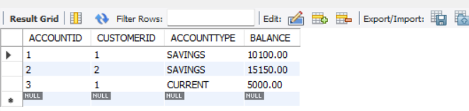

Scenario 2 : Stored Procedure – Update Employee Bonus

CREATE OR REPLACE PROCEDURE UpdateEmployeeBonus
(
p_department IN VARCHAR2,
p_bonus_percent IN NUMBER
)
IS
BEGIN
UPDATE EMPLOYEES
SET SALARY = SALARY + (SALARY * p_bonus_percent / 100)
WHERE DEPARTMENT = p_department;
COMMIT;
DBMS_OUTPUT.PUT_LINE('Bonus updated successfully.');
END;
/
Output :

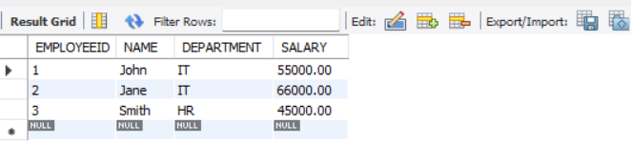

Scenario 3 : Stored Procedure – Transfer Funds

CREATE OR REPLACE PROCEDURE TransferFunds
(
p_from_account IN NUMBER,
p_to_account IN NUMBER,
p_amount IN NUMBER
)
IS
v_balance NUMBER;
BEGIN
SELECT BALANCE INTO v_balance
FROM ACCOUNTS
WHERE ACCOUNTID = p_from_account;
IF v_balance >= p_amount THEN
UPDATE ACCOUNTS
SET BALANCE = BALANCE - p_amount
WHERE ACCOUNTID = p_from_account;
UPDATE ACCOUNTS
SET BALANCE = BALANCE + p_amount
WHERE ACCOUNTID = p_to_account;
COMMIT;
DBMS_OUTPUT.PUT_LINE('Funds transferred successfully.');
ELSE
DBMS_OUTPUT.PUT_LINE('Insufficient balance.');
END IF;
END;
/
Output :
