IOT BASED

SMART CAMPUS WASTE MANAGEMENT SYSTEM

**Project Created by:**

SUDESHWARI V

RAJALAKSHMY D

THIREKHA V

VANAJAKUMARI M

**Project Reviewed By:**

Mrs. G. SELVAPRIYA, Asst. prof /CSE

**Project Created Date:**  31/May/2024

Contents

Executive Summary 3

Project Objective: 4

Scope: 4

Methodology 5

Artifacts used 6

Technical coverage: 8

Circuit Diagram: 9

Blynk Web Console: 10

Results 11

Benefits and Applications: 11

Conclusion 11

**Executive Summary:**

A smart campus waste management system leverages advanced technologies to optimize the collection, segregation, and disposal of waste on educational campuses. **Sensor and IOT Devices** : Sensors are installed in waste bins to monitor fill levels in real-time. These sensors communicate data to a central management system. **Data Analytics**: The collected data is analyzed to identify patterns in waste generation, enabling predictive analytics for waste collection scheduling and resource allocation. **Environmental Impact**: Improved waste management practices contribute to a cleaner campus environment, reducing pollution and promoting sustainability. **Cost Efficiency**: By optimizing collection routes and reducing manual labor, the system lowers operational costs and improves resource utilization.

# **Project Objective:**

# This project based on smart campus waste management system. A smart campus for waste management involves integrating technology and sustainable practices to efficiently manage waste, reduce environmental impact. The objectives for a smart waste management are **Efficient waste collection and disposal, Waste Reduction and recycling, Sustainability and environmental education, Resource optimization, Innovation and continuous improvement, Community Engagement.** By focusing on these objectives, a smart campus can effectively manage the waste, enhance the sustainability, and serve as a model for communities.

# **SCOPE:**

The focus of this project is the development the functional in smart campus waste management system. The offers numerous benefits and has a wide scope in improving efficiency, sustainability and cleanliness. The key aspects of its scope.

**1.Real-time Monitoring and Management:**

Sensors and IOT devices can monitor base levels in bins, allowing for the real-time tracking and data collection. Automated alerts can notify maintenance staff when bins are nearly full, optimizing collection and reducing overflow issues.

**2.Cost reduction and Resource Optimization:**

Optimized collection routes and schedules can be reduce fuel consumption and lobar costs. Maintenance of waste management equipment can extend the lifespan of assets and reduce downtime.

**3.Environmental Impact:**

Reduced overflow and littering can lead to a cleaner and more hygienic campus environment. Lower house gas emission from optimized waste collection routes and reduce landfill usage.

**4.Enhanced Recycling and sustainability:**

Smart systems can help in segregating waste more efficiently, improving recycling rates. Educational campaigns and feedback mechanisms can be integrated to encourage better waste disposal habits among students and staff.

**Methodology :**

The project on a "Smart Campus Waste Management System" using an ESP32 microcontroller. It includes ultrasonic and DHT sensors to monitor the waste bin's fullness, temperature, and humidity. The system sends data to the Blynk app, alerts when the bin is full, and displays information on an LCD. The project uses various libraries, defines pin configurations, and includes a detailed setup and loop code for sensor reading and communication.

# **Artifacts used**

The following artifacts were utilized throughout the project:

* **Blynk Library:** Arduino library for interfacing with the Blynk platform and sending/receiving data.
* **Wokwi online simulator tool:** Used for testing and debugging Arduino code.

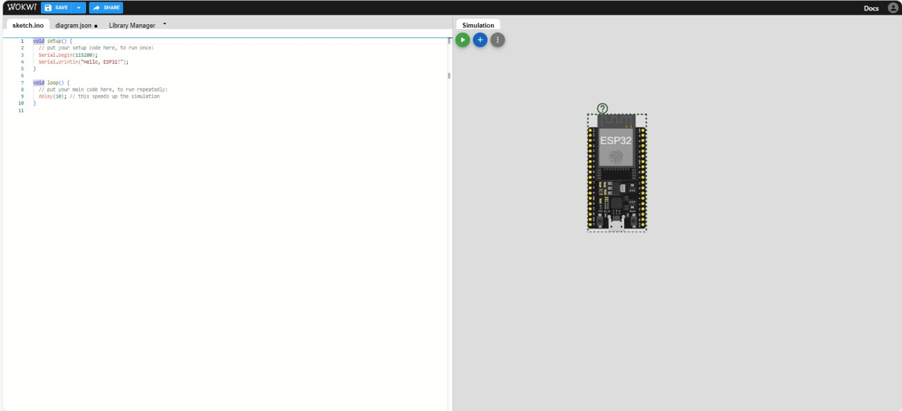

* **Blynk IoT Platform:** Web console and mobile app for IoT device control and data visualization.

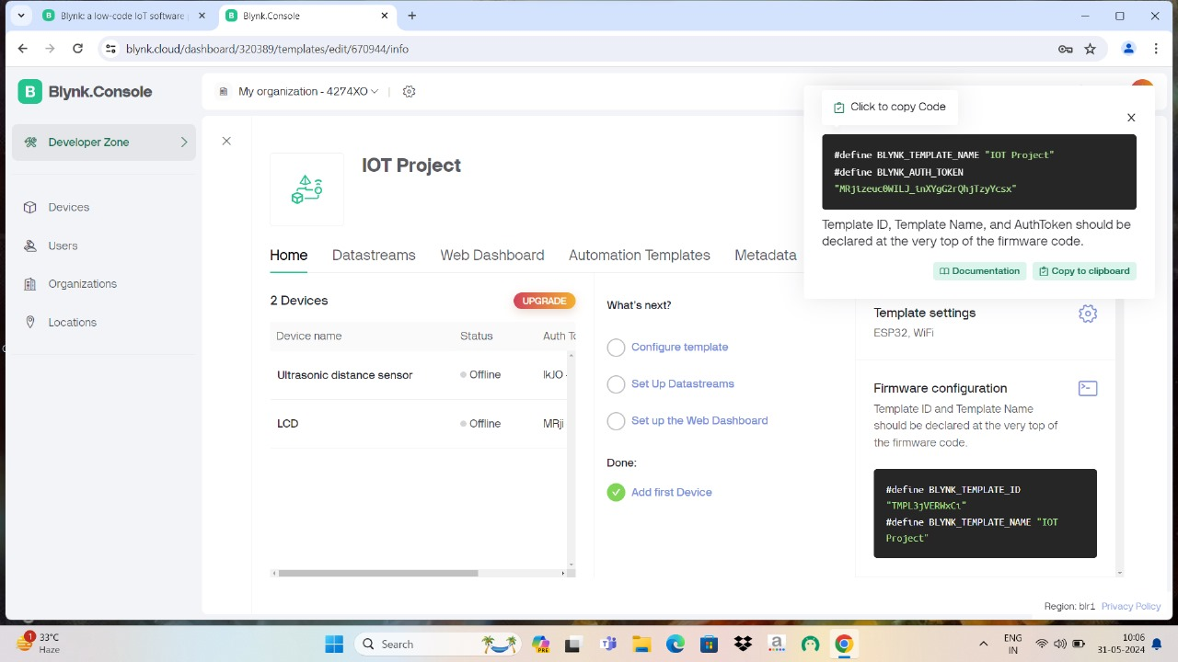

* **ESP8266 or ESP32 Wi-Fi Module:** Hardware platform for enabling Wi-Fi connectivity and IoT capabilities.

a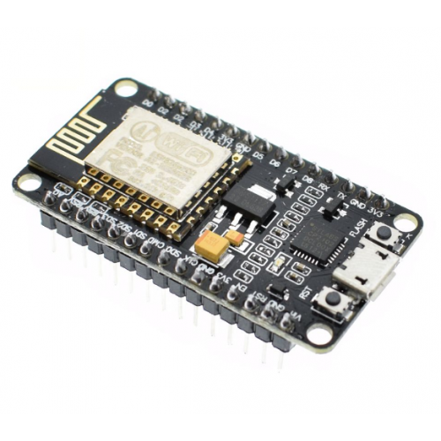

# **Technical coverage:**

# The "Smart Campus Waste Management System" project on Wokwi involves using an ESP32 microcontroller to manage waste bins. It includes:

# **Ultrasonic Sensor:** Measures waste bin levels.

# **DHT22 Sensor:** Monitors temperature and humidity.

# **LCD Display:** Shows real-time data.

# **LEDs and Speaker:** Provide alerts when the bin is full.

# **Blynk Integration:** Sends data to a remote dashboard.

# The system triggers alerts and displays sensor data, enabling efficient waste management.

cc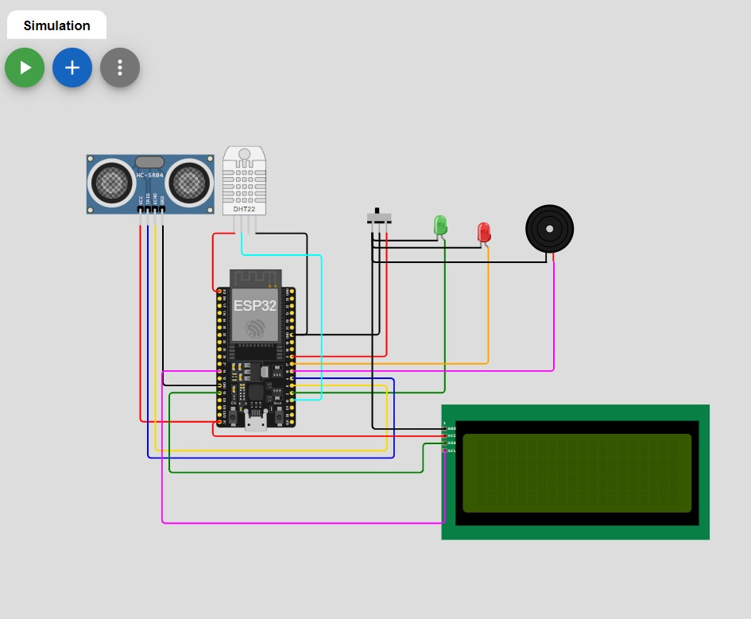

## Blynk Web Console:

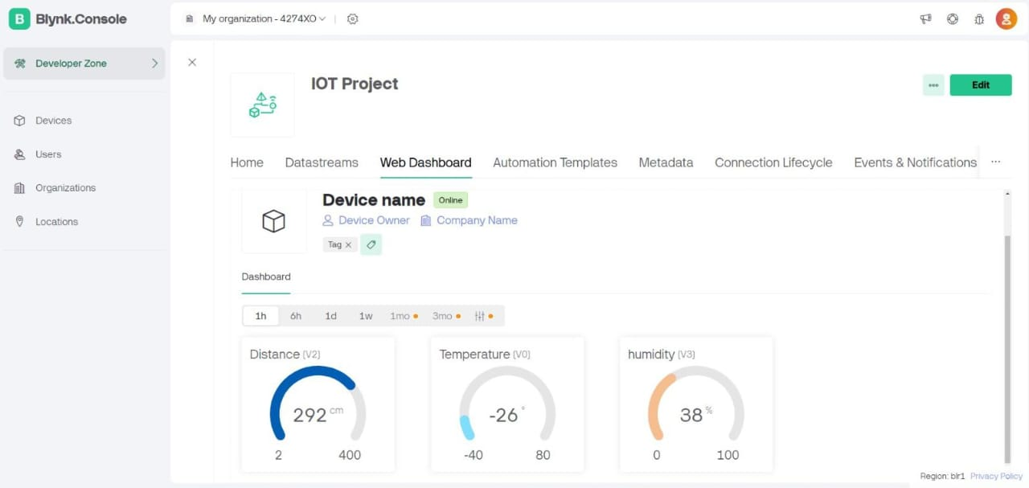

# **Results**

The project is a "Smart Campus Waste Management System" using an ESP32 microcontroller. It integrates various components such as an ultrasonic sensor, a DHT22 sensor, LEDs, a speaker, and an LCD display. The system measures waste bin levels, temperature, and humidity, sending data to Blynk for remote monitoring. The project includes code for triggering alerts when the bin is full and displaying sensor data on the LCD.

# **Benefits and Applications:**

**Benefits:**

* **Enhanced Efficiency:** Optimized, reducing the frequency of unnecessary pickups and ensuring bins are emptied before they overflow.
* **Cost Saving:** Optimized collection routes and schedules lead to reduced fuel and labor cost, as well as lower maintenance expenses for waste collection vehicles.

**Applications:**

* Waste management teams to optimize collection routes and reduce unnecessary pickups.
* AI vision can automate processes from waste collection to disposal.
* It gives top priority to waste prevention, followed by re-use, recycling, recovery, and finally disposal.

# 

# **Conclusion :**

# The Smart Campus Waste Management System demonstrates how IoT technologies can be leveraged to solve traditional waste management challenges. By providing real-time data and analytics, the system ensures timely and efficient waste collection, contributing to a cleaner and more sustainable campus  environment.