Assignment-4

1. What exactly is []?

-This is a empty list which contains no items.

2. In a list of values stored in a variable called spam, how would you assign the value ’hello’ as the third value?(Assume[2,4,6,8,10] are in spam.)

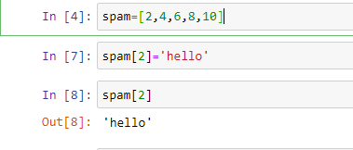

Let’s pretend the spam includes the list [‘a’,’b’,’c’,’d’] for next three queries.

3. What is the value of spam[int(int(‘3’or 2)/11)]

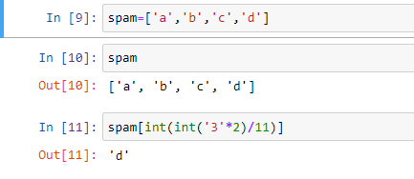

4. What is the value of spam[-1]? 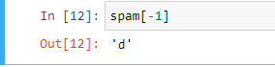

5.What is the value of spam[:2]?

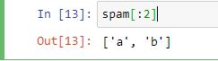

Let’s pretend bacon has the list[3.14,’cat’,11,’cat’,True] for the next three questions.

6.What is the value of bacon.index(‘cat’)?

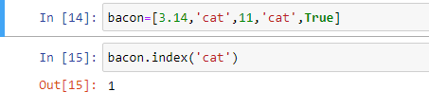

7.How does bacon.append(99)change the look of the list value in bacon?

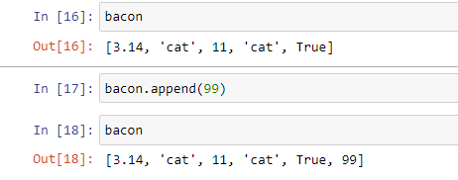

8.How does bacon.remove(‘cat’)change the look of the list in bacon?

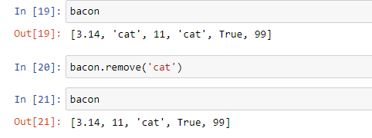

9.What are the list concatenation and list replication operators?

The operator for list concatenation is +.

The operator for list replication is \*.

10.What is difference between the list methods append()and insert()?

-Difference between list append()and list insert() methods is that append() will only add values to the end of a list, insert() can add value anywhere in the list.

11.What are the two methods for removing items from a list?

-The ’del’ statement and list remove() method are the two ways to remove items from a list.

12.Describe how list values and string values are identical.

-Both list and strings have indexes and slices,can be used in loops and can be concatenated or replicated.

13.What’s the difference between tuples and lists?

-Lists are mutable while tuples are immutable.

-Lists are represented by[] while tuples are represented by().

14.How do you type a tuple value that only contains the integer 42?

- (42,)

15.How do you get a list value’s tuple form?

How do you get a tuple value’s list form?

-Using tuple() and list() functions .

