ADSA

Q1. Define Algorithm and Explain Algorithm Analysis
Answer:
1. Algorithm
An algorithm is a finite sequence of well-defined, unambiguous steps used to solve a problem or perform a computation. Each step must be clear, executable, and must terminate in a finite time.
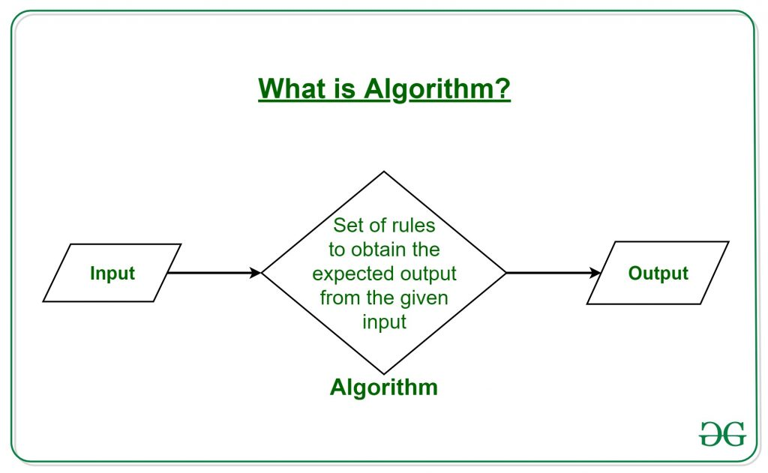

2. Characteristics of an Algorithm
An algorithm must satisfy the following properties:
- Input
  - Accepts zero or more inputs
- Output
  - Produces at least one output
- Definiteness
  - Each step is clearly and precisely defined
- Finiteness
  - Terminates after a finite number of steps
- Effectiveness
  - Steps are simple, feasible, and executable

3. Example of an Algorithm
Algorithm to find the largest of three numbers:
START
1. Read num1, num2, num3
2. If num1 > num2 and num1 > num3 → largest = num1
3. Else if num2 > num3 → largest = num2
4. Else → largest = num3
5. Print largest
END
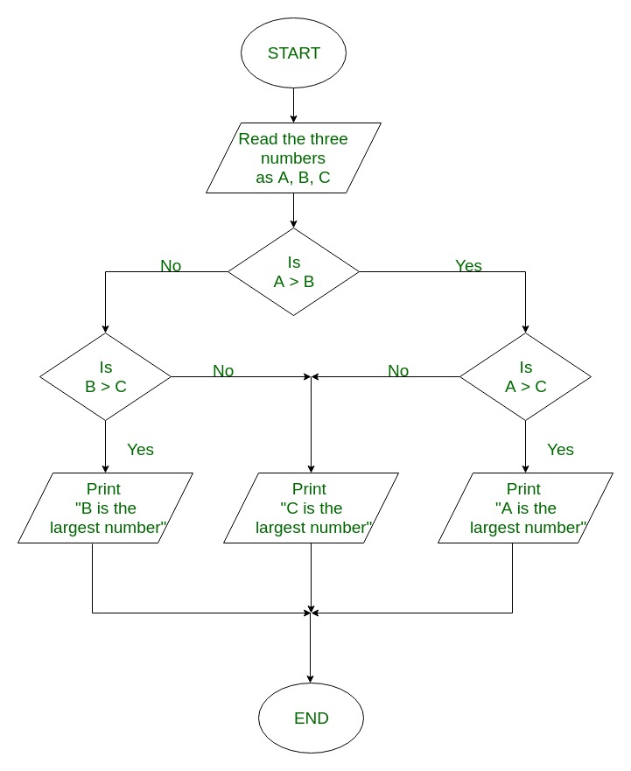
Time Complexity (TC): O(1)
- Constant number of comparisons
Space Complexity (SC): O(1)
- Uses fixed number of variables

4. Algorithm Analysis
Algorithm analysis is the process of evaluating the efficiency of an algorithm in terms of time and space requirements, usually before implementation.

5. Importance of Algorithm Analysis
Algorithm analysis helps to:
- Compare different algorithms
- Select the most efficient algorithm
- Predict performance for large inputs
- Optimize resource usage (time and memory)

6. Types of Algorithm Analysis
6. Types of Analysis
- Priori Analysis:
Theoretical (before implementation)
- Posterior Analysis:
Practical (after implementation)
6.1 Time Complexity
Time complexity measures the execution time of an algorithm as a function of input size $n$.
Cases:
- Best Case (Ω) – Minimum time
- Worst Case (O) – Maximum time
- Average Case (Θ) – Expected time
Examples:
- Linear Search → O(n)
- Binary Search → O(log n)

6.2 Space Complexity
Space complexity measures the memory usage of an algorithm.
Includes:
- Input Space – Memory for input data
- Auxiliary Space – Extra memory used
Example:
- Merge Sort uses more space compared to Bubble Sort

7. Conclusion
An algorithm provides a systematic approach to solving problems, while algorithm analysis ensures that the solution is efficient in terms of time and space, leading to better performance and optimal resource utilization.
Q2. Explain Asymptotic Notations Used for Algorithm Analysis
Answer:
1. Introduction
Asymptotic notations are mathematical tools used to represent the time complexity of an algorithm.
They describe how the execution time grows as input size $n$becomes very large, focusing on the growth rate instead of exact time.

TYPES:
2. Big-O Notation (O) – Upper Bound
- Represents the worst-case time complexity
- Shows the maximum time an algorithm can take
Definition
An algorithm with time complexity $f(n)$is said to be $O(g(n))$if there exist constants $c>0$and $n_{0}$such that:
$$0≤f(n)≤c⋅g(n),\text{for all }n≥n_{0}$$

Diagram Explanation (Based on your image)
- After $n_{0}$, the curve f(n) lies below or equal to $c⋅g(n)$
- Indicates the algorithm will not exceed this bound
Purpose
- Provides upper limit of growth
- Ensures performance does not go beyond this complexity
Example Linear Search → O(n)
3. Omega Notation (Ω) – Lower Bound
- Represents the best-case time complexity
- Shows the minimum time required
Definition
An algorithm with time complexity $f(n)$is said to be $Ω(g(n))$if:

$$0≤c⋅g(n)≤f(n),\text{for all }n≥n_{0}$$
Diagram Explanation (Based on your image)
- After $n_{0}$, the curve f(n) lies above or equal to $c⋅g(n)$
- Indicates the algorithm will take at least this much time
Purpose
- Provides minimum performance guarantee
Example
- Linear Search → Ω(1)

4. Theta Notation (Θ) – Tight Bound
- Represents the exact growth rate
- Provides both upper and lower bounds
Definition
An algorithm with time complexity $f(n)$is said to be $Θ(g(n))$if:

$$c_{1}⋅g(n)≤f(n)≤c_{2}⋅g(n),\text{for all }n≥n_{0}$$
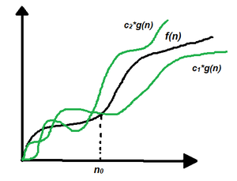

Diagram Explanation (Based on your image)
- The curve f(n) lies between two bounds:
  - Lower bound: $c_{1}g(n)$
  - Upper bound: $c_{2}g(n)$
- Shows tight (exact) complexity
Purpose
- Gives the most accurate description
Example
- Merge Sort → Θ(n log n)

5. Comparison of Common Growth Rates
Time Complexity | Name
O(1) | Constant Time
O(log n) | Logarithmic Time
O(n) | Linear Time
O(n log n) | Linearithmic Time
O(n²) | Quadratic Time
O(2ⁿ) | Exponential Time

6. Conclusion
Asymptotic notations help in analyzing and comparing algorithms by describing their time complexity using upper, lower, and tight bounds, without considering constant factors. This helps in selecting the most efficient algorithm.

- Label axes:
  - X-axis → n
  - Y-axis → Time
o
Q3. What do you mean by Hashing? Discuss the Need of Hashing
Answer:

1. Definition of Hashing
Hashing is a technique used to map a large amount of data (keys) into a fixed-size value called a hash value (or hash code) using a hash function.
The hash value is used as an index to store and retrieve data efficiently in a hash table.

2. Mechanism of Hashing
The working of hashing involves the following steps:
- A key (such as a number or string) is given as input
- A hash function computes a numeric value
- This value is used as an index in a hash table
- Data is stored or accessed using this index

3. Diagram (Components of Hashing)
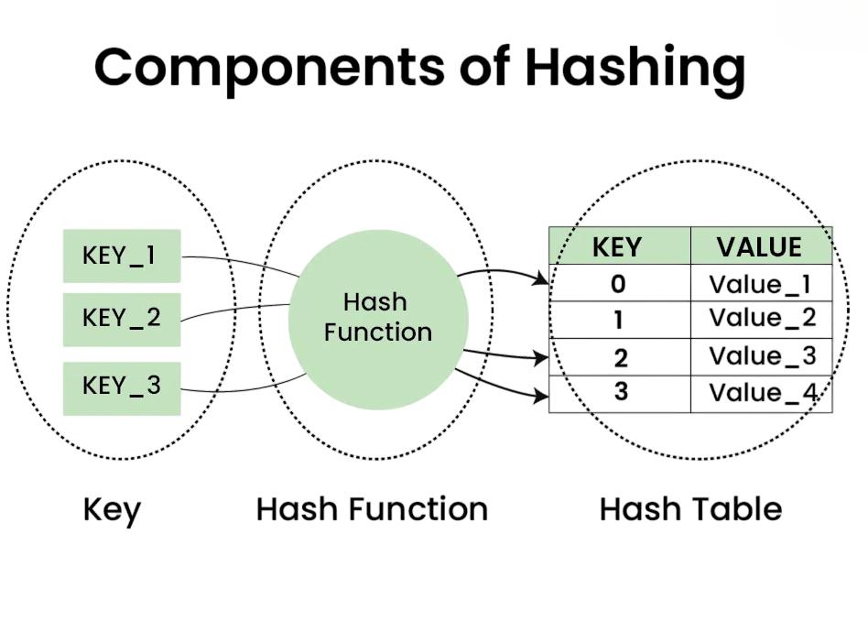
Explanation of Diagram
- Key: Input data (e.g., KEY_1, KEY_2)
- Hash Function: Converts key into index value
- Hash Table: Stores values at computed indices
Each key is mapped to a specific location, enabling fast data retrieval.

4. Goal of Hashing
The main objective of hashing is to achieve constant time complexity O(1) for:
- Searching
- Insertion
- Deletion

Need of Hashing
Hashing is an important technique used in data structures to improve the efficiency of data storage and retrieval. The need for hashing arises due to the following reasons:

1. Fast Data Access
- In linear search, the time complexity is O(n) as each element must be checked.
- In binary search, the time complexity is O(log n), but it requires sorted data.
- Hashing allows direct access to data using a hash function, resulting in O(1) time complexity (average case).
- This makes hashing significantly faster for large datasets.

2. Efficient Data Mapping
- Arrays support only integer indices.
- Hashing enables the use of non-integer keys such as strings or objects.
- A hash function converts such keys into valid indices.
Example:
Hash("Apple") → 5
The value is stored at index 5 in the hash table.

3. Handling Large Data Efficiently
- In real-world applications, Consider a database with millions of users, but only a few thousand are active.
- Creating an array with millions of slots wastes memory
- Hashing maps a large range of possible keys into a smaller, manageable table size.
Thus, hashing provides efficient memory usage.

4. Improved Memory Utilization
- Eliminates the need for large, sparsely used arrays.
- Stores only the required data.
- Reduces memory wastage and improves space efficiency.

5. Security and Data Integrity
Hashing plays a key role in security-related applications:
- Data Integrity: If the data changes, its hash value also changes. This helps detect file tampering.
- Password Storage: Systems store hashed passwords instead of actual passwords, enhancing security even if data is exposed.

6. Faster Searching in Databases
- Hashing is widely used in database indexing.
- It avoids scanning the entire dataset.
- Enables quick and efficient retrieval of records.

Conclusion
Hashing is essential for achieving fast data access, efficient memory usage, handling large datasets, and ensuring data security in modern computing systems.

Q4. Explain the Different Hash Functions Used to Implement a Dictionary
Answer:

1. Introduction
A Dictionary (Map) stores data in key–value pairs.
To achieve O(1) time complexity for searching, insertion, and deletion, we use hash functions.
A hash function is a function that converts a key into an index in a hash table.

2. Types of Hash Functions

1. Division Method (Modulo Method)
Formula:
h(k) = k mod m
Working:
- Divide key by table size
- Take remainder as index
Example:
k = 25, m = 10
h(25) = 5
Extra Points:
- m should be a prime number & It should not be close to a power of 2 to reduce collisions
- Very simple and fast

2. Multiplication Method
Formula:
$$h(k)=⌊M⋅(k⋅A mod 1)⌋$$
Working:
- Multiply the key k by a constant A where $0<A<1$.
- Extract the fractional part.
- Multiply it by the table size M.
- Take the floor value.
Example:
k = 10, A = 0.5, M = 10
Index = 0
Extra Points:
- Works well even if M is power of 2
- Better distribution than division
- Knuth recommends using the Golden Ratio
$A≈0.618$.

3. Mid-Square Method
Working:
- Square the key
- Take middle digits
Example:
k = 12 → 12² = 144 → index = 4
Extra Points:
- Uses all digits of key
- Reduces clustering

4. Folding Method
Working:
- Split key into equal parts
- Add them
Example:
k = 1234 → 12 + 34 = 46
Extra Points:
- Useful for long keys
- Simple method

5. Digit Analysis Method
This method is used when the set of keys is known in advance (static hashing).
Working:
- Analyze the keys to identify digits that vary the most.
- Use only those digits to form the hash index.
Example:
Student IDs:
- 2023001
- 2023002
- 2023005
The first four digits are the same.
So, only the last three digits are used for hashing.

3. Characteristics of Good Hash Function
- Uniformity – distributes keys evenly
- Deterministic – same key gives same index
- Efficiency – fast computation

4. Conclusion
Different hash functions such as division, multiplication, mid-square, folding, and universal hashing are used to convert keys into indices.
A good hash function ensures uniform distribution, fewer collisions, and efficient dictionary operations.

Q5. Explain the Different Collision Resolution Strategies for Hashing. State Advantages and Disadvantages
Answer:
1. Introduction
A collision in hashing occurs when two or more keys are mapped to the same index in a hash table.
Since only one element can occupy a slot, collision resolution techniques are required.
These techniques are classified into:
- Open Hashing (Separate Chaining)
- Closed Hashing (Open Addressing)

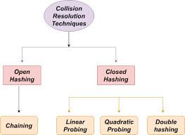

2. Collision Resolution Techniques
2.1 Separate Chaining (Open Hashing)
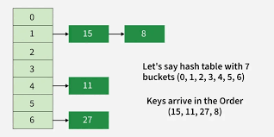
Working:
- Each index stores a linked list
- All keys mapping to same index are stored in that list

Example:
h(k) = k mod 5
Keys: 12, 17 → both at index 2 → stored as: 12 → 17

Advantages and Disadvantages
Advantages | Disadvantages
Simple to implement | Requires extra memory
No limit on number of elements | Search time increases if chain is long
Easy deletion | Not cache-friendly

2.2 Linear Probing (Open Addressing)
Working:
- If slot is occupied, check next slot sequentially
Formula:
$$h(k,i)=(h^{}(k)+i)mod M$$
Example:
12 → index 2
17 → collision → placed at index 3
Advantages and Disadvantages
Advantages | Disadvantages
Simple and easy | Causes primary clustering
No extra memory | Performance decreases as table fills

2.3 Quadratic Probing
Working:
Use square increments (i²) to find next slot , slots are searched at quadratic distances.
Formula:
h(k, i) = (h(k) + i²) mod m
Example:
17 → collision at 2 → next index = 3
Advantages and Disadvantages
Advantages | Disadvantages
Reduces primary clustering | Secondary clustering occurs
Better distribution | May fail if table is not properly sized

2.4 Double Hashing
Working:
- Use second hash function for step size
Formula:
h(k, i) = (h₁(k) + i · h₂(k)) mod m
Example:
h₁(k)=k mod 5, h₂(k)=1+(k mod 3)
Key 17 → new position using h₂
Advantages and Disadvantages
Advantages | Disadvantages
Minimizes clustering | More complex
Best distribution | Requires two hash functions

3. Conclusion
Collision resolution techniques such as separate chaining, linear probing, quadratic probing, and double hashing are essential for efficient hashing.
They help in handling collisions, improving performance, and ensuring efficient data access

EXTRA(unit-1)

Q. What do you mean by Performance Analysis? Give algorithm for matrix multiplication and find time complexity using Step–Count Method
Answer:
1. Performance Analysis
Performance analysis is the process of evaluating an algorithm based on the time and space resources it requires during execution
It includes:
- Time Complexity → time taken
- Space Complexity → memory required
It is calculated using the step-count (frequency count) method, where each statement is counted based on how many times it executes.

2. Algorithm 1: Sum of Elements in an Array
Let A be an array of size $n$

Algorithm
sum = 0
for(i = 0; i < n; i++)
sum = sum + A[i]
return sum
Step Count
Statement | Frequency
sum = 0 | 1
i = 0 | 1
i < n | n + 1
sum = sum + A[i] | n
return | 1
Total
$$T(n)=2n+3$$
Time Complexity
$$O(n)$$
Space Complexity
$$S(n)=n+3⇒O(n)$$

3. Algorithm 2: Matrix Addition
Let A and B be $n×n$matrices
Algorithm
for(i = 0; i < n; i++)
for(j = 0; j < n; j++)
C[i][j] = A[i][j] + B[i][j]
Step Count
Statement | Frequency
i loop | n + 1
j loop | n(n + 1)
C[i][j] = A[i][j] + B[i][j] | n²
Total
$$T(n)=2n^{2}+2n+1$$
Time Complexity
$$O(n^{2})$$
Space Complexity
$$S(n)=3n^{2}+3⇒O(n^{2})$$

4. Algorithm 3: Matrix Multiplication
Let A and B be $n×n$matrices
Algorithm
for(i = 0; i < n; i++)
for(j = 0; j < n; j++)
{
C[i][j] = 0
for(k = 0; k < n; k++)
C[i][j] = C[i][j] + A[i][k] * B[k][j]
}
Step Count
Statement | Frequency
i loop | n + 1
j loop | n(n + 1)
k loop | n²(n + 1)
multiplication + addition | n³
Total
$$T(n)=2n^{3}+3n^{2}+2n+1$$
Time Complexity
$$O(n^{3})$$
Space Complexity
$$S(n)=3n^{2}+4⇒O(n^{2})$$
5. Conclusion
- Sum of array → O(n)
- Matrix addition → O(n²)
- Matrix multiplication → O(n³)
Thus, time complexity increases with number of nested loops.

Q. Dynamic Hashing (Extendible Hashing)
1. Definition
Dynamic Hashing is a hashing technique in which the size of the hash table is dynamically adjusted based on the number of records.
It reduces collisions, overflow, and memory wastage, thereby improving performance.

2. Need for Dynamic Hashing
In static hashing:
- The table size is fixed
- Overflow occurs when data grows
- Performance degrades due to collisions
Dynamic hashing overcomes these limitations by:
- Expanding the table when data increases
- Shrinking the table when data decreases
- Maintaining efficient search and insertion

3. Types of Dynamic Hashing
- Extendible Hashing
- Linear Hashing

4. Extendible Hashing
Concept
Extendible hashing uses a directory of pointers to buckets.
The hash function generates a binary value, and prefix bits (MSB/LSB) are used to determine the bucket location.

Key Terminology
- Global Depth (GD):
Number of bits used to index the directory
$$\text{Directory Size}=2^{GD}$$
- Local Depth (LD):
Number of bits used by an individual bucket
$$LD≤GD$$

5. Structure Diagram
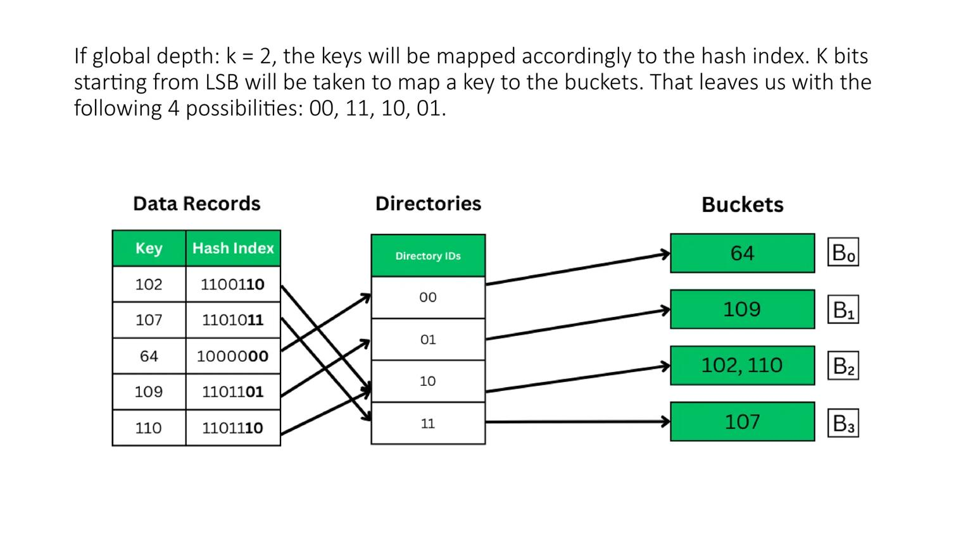
6. Working Procedure
- Apply hash function to the key
- Convert the key into binary form
- Use GD bits to locate directory index
- Insert the record into the corresponding bucket
Handling Overflow
- If LD < GD:
Only bucket splitting is performed
- If LD = GD:
Bucket splitting + directory expansion (doubling) is performed
GD is incremented by 1
- After splitting, rehashing of elements is done
7. Linear Hashing
Concept
- Does not use a directory
- Buckets are split gradually
Working
- On overflow:
  - Split one bucket at a time
  - Redistribute elements
8. Advantages
- Minimizes collisions and overflow
- Efficient memory utilization
- Dynamic resizing
- Faster search and insertion

9. Disadvantages
- More complex than static hashing
- Requires additional memory for directory
- Overhead due to splitting and rehashing
10. Conclusion
Dynamic hashing, particularly extendible hashing, provides an efficient and flexible mechanism for handling dynamic datasets by adapting the structure according to data size, ensuring better performance than static hashing.

✅ Key Exam Statement
In extendible hashing, Local Depth is always less than or equal to Global Depth (LD ≤ GD).
If LD = GD, directory expansion is required.

UNIT-2
Q1. Discuss Rotations in AVL Tree with Suitable Examples
Answer:
1. Introduction
An AVL Tree is a self-balancing Binary Search Tree in which the difference between heights of left and right subtrees (Balance Factor) is at most ±1.
When this condition is violated after insertion or deletion, rotations are performed to restore balance.

2. Balance Factor
$$\text{Balance Factor}=\text{Height of Left Subtree}-\text{Height of Right Subtree}$$
- BF = -1, 0, 1 → Balanced
- BF > 1 or BF < -1 → Unbalanced

3. Types of Rotations
There are 4 types of rotations:
- LL Rotation (Single Right Rotation)
- RR Rotation (Single Left Rotation)
- LR Rotation (Left-Right Rotation)
- RL Rotation (Right-Left Rotation)

3.1 .LL Rotation (Left-Left Case)
Condition:
- Insertion happens in the left subtree of the left child
- Balance factor becomes +2
Example: Insert: 30, 20, 10
Before Rotation:
30
/
20
/
10
After Rotation (Right Rotation):
20
/ \
10 30
Fix:
Perform Right Rotation

3.2 RR Rotation (Right-Right Case)
Condition:
- Insertion happens in the right subtree of the right child
- Balance factor becomes −2
Example:
Insert: 10, 20, 30
Before Rotation:
10
\
20
\
30
After Rotation (Left Rotation):
20
/ \
10 30
Fix:
Perform Left Rotation

3.3 LR Rotation (Left-Right Case)
Condition:
- Insertion in right subtree of left child
- Balance factor becomes +2
Example:
Insert: 30, 10, 20

Before Rotation:
30
/
10
\
20
Steps:
- Left rotation on 10
- Right rotation on 30
After Rotation:
20
/ \
10 30

3.4 RL Rotation (Right-Left Case)
Condition:
- Insertion in right subtree of left child
- Balance factor becomes +2
Example:
Insert: 10, 30, 20
Before Rotation:
10
\
30
/
20
Steps:
- Right rotation on 30
- Left rotation on 10
After Rotation:
20
/ \
10 30

4. Summary Table
Rotation | Condition | Operation
LL | Left of left | Right Rotation
RR | Right of right | Left Rotation
LR | Right of left | Left + Right
RL | Left of right | Right + Left
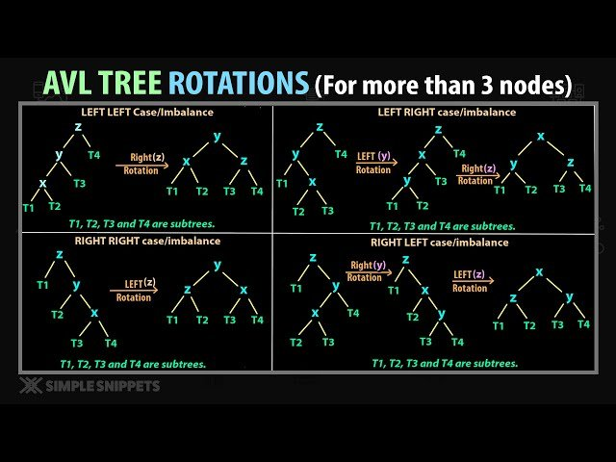
5. Time Complexity (TC)
- Search → $O(log⁡n)$
- Insertion → $O(log⁡n)$
- Deletion → $O(log⁡n)$
- Rotation → $O(1)$

6. Space Complexity (SC)
- Tree storage → $O(n)$
- Recursion stack → $O(log⁡n)$

7. Conclusion
Rotations in AVL trees help maintain balance and height efficiency, ensuring operations like search, insertion, and deletion are performed in O(log n) time.

Q2. Explain the process for insertion and deletion of an element in a B-Tree with example
Answer:
1. Introduction
A B-Tree is a self-balancing multi-way search tree in which each node contains multiple keys and children.
It maintains sorted data and allows efficient insertion, deletion, and searching.
Properties (order m):
- Maximum keys = m − 1
- Minimum keys = ⌈m/2⌉ − 1
- All leaves are at the same level
- Maximum children = m

2. Insertion in B-Tree
Process:
- Start from root
- Traverse to appropriate leaf node
- Insert key in sorted order
If node is full:
- Split the node
- Move middle key to parent
- Continue upward if needed

Example (Order = 3)
Insert: 10, 20, 30, 40
Step 1:
[10]

Step 2:
[10 20]

Step 3 (Overflow → Split):
[10 20 30]
[20]
/ \
[10] [30]

Step 4:
[20]
/ \
[10] [30 40]

3. Deletion in B-Tree
Process:
- Locate the key
- If key is in leaf → delete directly
- If key is in internal node:
  - Replace with predecessor or successor
- If node has minimum keys:
  - Borrow from sibling OR
  - Merge nodes

Example (Delete 40)
Before Deletion:
[20]
/ \
[10] [30 40]
After Deletion:
[20]
/ \
[10] [30]
Underflow Case (Important)
If a node has fewer than minimum keys:
- Borrow from sibling
- If not possible → Merge with sibling

4. Time Complexity (TC)
- Search → $O(log⁡n)$
- Insertion → $O(log⁡n)$
- Deletion → $O(log⁡n)$

5. Space Complexity (SC)
- Storage → $O(n)$
- Height → $O(log⁡n)$
6. Conclusion
B-Trees maintain balanced height, ensuring efficient operations.
They are widely used in databases and file systems for fast data access.

Q3. Construct the AVL Tree for the elements: 25, 12, 17, 30, 15, 14, 37, 27, 40, 29, 28
Answer:

1. Definition
An AVL Tree is a self-balancing Binary Search Tree in which the balance factor (BF) of every node is:
$$BF=Height(left)-Height(right)$$
and must satisfy:
$$-1≤BF≤+1$$
If imbalance occurs, rotations (LL, RR, LR, RL) are performed to restore balance.

2. Construction of AVL Tree
Insert elements one by one and balance after each insertion.

Step 1: Insert 25
25

Step 2: Insert 12
25
/
12

Step 3: Insert 17 → (LR Rotation)
Before:
25
/
12
\
17
After:
17
/ \
12 25

Step 4: Insert 30
17
/ \
12 25
\
30

Step 5: Insert 15
17
/ \
12 25
\ \
15 30

Step 6: Insert 14 → (LR Rotation)

17  / \  12 25  \ \  15 30  /  14 | After balancing:  17  / \  14 25  / \ \  12 15 30

Step 7: Insert 37 → (RR Rotation)
17  / \  14 25  / \ \  12 15 30  \  37 | 17  / \  14 30  / \ / \  12 15 25 37

Step 8: Insert 27
17
/ \
14 30
/ \ / \
12 15 25 37
\
27

Step 9: Insert 40
17
/ \
14 30
/ \ / \
12 15 25 37
\ \
27 40

Step 10: Insert 29 → (RL Rotation)
17  / \  14 30  / \ / \  12 15 25 37  \ \  27 40  \  29 | 17  / \  14 30  / \ / \  12 15 27 37  / \ \  25 29 40

Step 11: Insert 28
Final AVL Tree
17
/ \
14 30
/ \ / \
12 15 27 37
/ \ \
25 29 40
/
28

3. Time Complexity (TC)
- Each insertion → $O(log⁡n)$
- Total construction → $O(nlog⁡n)$
4. Space Complexity (SC)
- Tree storage → $O(n)$
- Recursion stack → $O(log⁡n)$

5. Conclusion
AVL Tree maintains balance using rotations, ensuring efficient operations with logarithmic height.

Q4. Construct a Min Heap and Discuss Time Complexity

1. Definition
A Min Heap is a complete binary tree in which the value of each node is less than or equal to its children.
Thus, the minimum element is always at the root.

2. Properties of Min Heap
1. Heap Order Property
$$\text{Parent}≤\text{Children}$$
Ensures smallest element is at the root
2. Complete Binary Tree Property
- All levels are completely filled except possibly the last
- Last level is filled from left to right
3. Root Property
- Root node contains the minimum element
4. Height of Heap
$$O(log⁡n)$$
5. Array Representation
For a node at index $i$:
- Left child = $2i+1$
- Right child = $2i+2$
- Parent = $\left\lfloor (i-1)/2\right\rfloor$

3. Construction of Min Heap (Step-by-Step)
Given Elements
$$1, 3, 5, 4, 6, 13, 10, 9, 8, 15, 17$$
Method
- Insert elements one-by-one
- Apply Heapify Up when required

Steps
Step 1: Insert 1
[1]
Step 2: Insert 3 → No swap
1
/
3
Step 3: Insert 5 → No swap
1
/ \
3 5
Step 4: Insert 4 → No swap
1
/ \
3 5
/
4
Step 5: Insert 6 → No swap
1
/ \
3 5
/ \
4 6
Step 6: Insert 13 → No swap
1
/ \
3 5
/ \ /
4 6 13
Step 7: Insert 10 → No swap
1
/ \
3 5
/ \ / \
4 6 13 10

Step 8: Insert 9 → No swap
1
/ \
3 5
/ \ / \
4 6 13 10
/
9
Step 9: Insert 8 → No swap
1
/ \
3 5
/ \ / \
4 6 13 10
/ \
9 8
Step 10: Insert 15 → No swap
1
/ \
3 5
/ \ / \
4 6 13 10
/ \ /
9 8 15
Step 11: Insert 17 → No swap

4. Final Min Heap
1
/ \
3 5
/ \ / \
4 6 13 10
/ \ / \
9 8 15 17

5. Time Complexity
- Insertion (each):
$$O(log⁡n)$$
- Building heap (n elements using insertion):
$$O(nlog⁡n)$$
- Optimized heap construction (bottom-up):
$$O(n)$$
- Deletion (min): $O(log⁡n)$
- Access minimum: $O(1)$

6. Space Complexity
$$O(n)$$

7. Conclusion
Min Heap ensures that the smallest element is always at the root, making it efficient for priority queues, scheduling, and graph algorithms.

✅ Key Exam Statement
A Min Heap is constructed using insertion and heapify-up operations, maintaining the property that every parent node is less than or equal to its children.

Q5. Illustrate Operations in Max Heap with Example
1. Definition
A Max Heap is a complete binary tree in which:
- Every node is greater than or equal to its children
- The maximum element is present at the root

2. Properties of Max Heap
1. Heap Order Property
$$\text{Parent}≥\text{Children}$$

2. Complete Binary Tree Property
- All levels are completely filled except possibly the last
- The last level is filled from left to right

3. Root Property
- The root node contains the maximum element

4. Height of Heap
$$O(log⁡n)$$

5. Array Representation
For a node at index $i$:
- Left child = $2i+1$
- Right child = $2i+2$
- Parent = $\left\lfloor (i-1)/2\right\rfloor$

3. Heapify Operation
Definition
Heapify is the process of restoring the heap property after insertion or deletion by adjusting node positions.

Types of Heapify
1. Heapify Up (Bottom-Up)
- Used during insertion
- Compare node with parent
- Swap if child > parent
- Continue until heap property is satisfied

2. Heapify Down (Top-Down)
- Used during deletion (extract max)
- Replace root with last element
- Compare with children
- Swap with larger child
- Continue until heap property is restored

4. Time Complexity
- Insertion → $O(log⁡n)$
- Deletion (Max) → $O(log⁡n)$
- Heapify → $O(log⁡n)$
- Access maximum → $O(1)$

Max Heap Construction (Step-by-Step)
1. Given Elements
1, 3, 5, 4, 6, 13, 10, 9, 8, 15, 17
2. Method Used
Max Heap is constructed using:
- Insertion (one-by-one)
- Heapify Up (Bottom-Up approach)

3. Step-by-Step Construction
Step 1: Insert 1
[1]

Step 2: Insert 3
- Insert at leaf
- 3 > 1 → swap
3
/
1

Step 3: Insert 5
- 5 > 3 → swap
5
/ \
1 3

Step 4: Insert 4
- 4 > 1 → swap
5
/ \
4 3
/
1

Step 5: Insert 6
- 6 > 4 → swap
- 6 > 5 → swap
6
/ \
5 3
/ \
1 4

Step 6: Insert 13
- 13 > 3 → swap
- 13 > 6 → swap \
13
/ \
5 6
/ \ /
1 4 3

Step 7: Insert 10
- 10 > 6 → swap
13
/ \
5 10
/ \ / \
1 4 3 6

Step 8: Insert 9
- 9 > 1 → swap
- 9 > 5 → swap
13
/ \
9 10
/ \ / \
5 4 3 6
/
1

Step 9: Insert 8
- 8 > 5 → swap
13
/ \
9 10
/ \ / \
8 4 3 6
/ \
1 5

Step 10: Insert 15
- 15 > 4 → swap
- 15 > 9 → swap
- 15 > 13 → swap
15
/ \
13 10
/ \ / \
8 9 3 6
/ \ /
1 5 4

Step 11: Insert 17
- 17 > 3 → swap
- 17 > 10 → swap
- 17 > 15 → swap

4. Final Max Heap
17
/ \
13 15
/ \ / \
8 9 10 6
/ \ / \
1 5 4 3

5. Space Complexity
$$O(n)$$

6. Conclusion
Max Heap is an efficient data structure that maintains the largest element at the root.
It is widely used in priority queues, scheduling, and heap sort algorithms.

EXTRA:
Q. Explain Deletion Operation in AVL Tree by deleting three nodes with example

1. Definition
An AVL Tree is a self-balancing Binary Search Tree in which the balance factor (BF) of every node is:
$$BF=\text{Height(Left)}-\text{Height(Right)}$$
It must satisfy:
$$-1≤BF≤+1$$
If imbalance occurs after deletion, rotations are performed to restore balance.

2. Deletion in AVL Tree (Steps)
- Delete node using BST deletion rules
- If node has two children:
  - Replace with Inorder Successor (smallest in right subtree)
  - OR Inorder Predecessor (largest in left subtree)
- Update heights
- Calculate balance factor
- Apply rotations if required

3. Example (Delete Three Nodes)
Initial AVL Tree
50
/ \
30 70
/ \ / \
20 40 60 80

Step 1: Delete 80
50
/ \
30 70
/ \ /
20 40 60
✔ Tree remains balanced → No rotation

Step 2: Delete 70
50
/
30
/ \
20 40
\
60
👉 $BF(50)=+2$→ Unbalanced
👉 LR Case
Apply LR Rotation:
- Left rotation on 30
- Right rotation on 50
40
/ \
30 50
/ \
20 60

Step 3: Delete 50
40
/ \
30 60
/
20
✔ Tree remains balanced → No rotation

4. Final AVL Tree
40
/ \
30 60
/
20

5. Time Complexity (TC)
- Search → $O(log⁡n)$
- Deletion → $O(log⁡n)$
- Rotation → $O(1)$

6. Space Complexity (SC)
- Tree storage → $O(n)$
- Recursion stack → $O(log⁡n)$

7. Conclusion
Deletion in AVL Tree is performed using BST deletion followed by rebalancing using rotations, ensuring efficient operations with logarithmic height.

