Home Page:
• Displays events using backend API data.
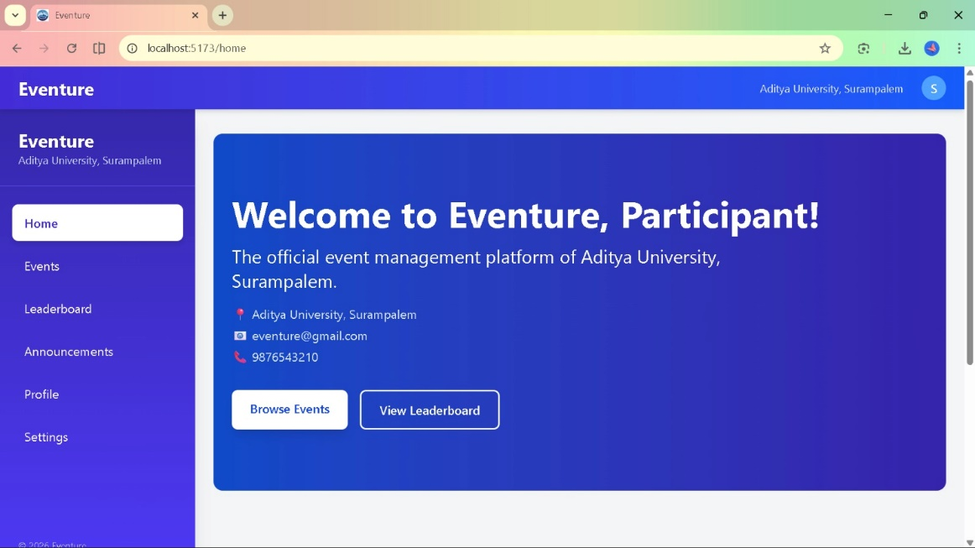

User Registration Page:
• Creates new user and stores encrypted data in MongoDB.
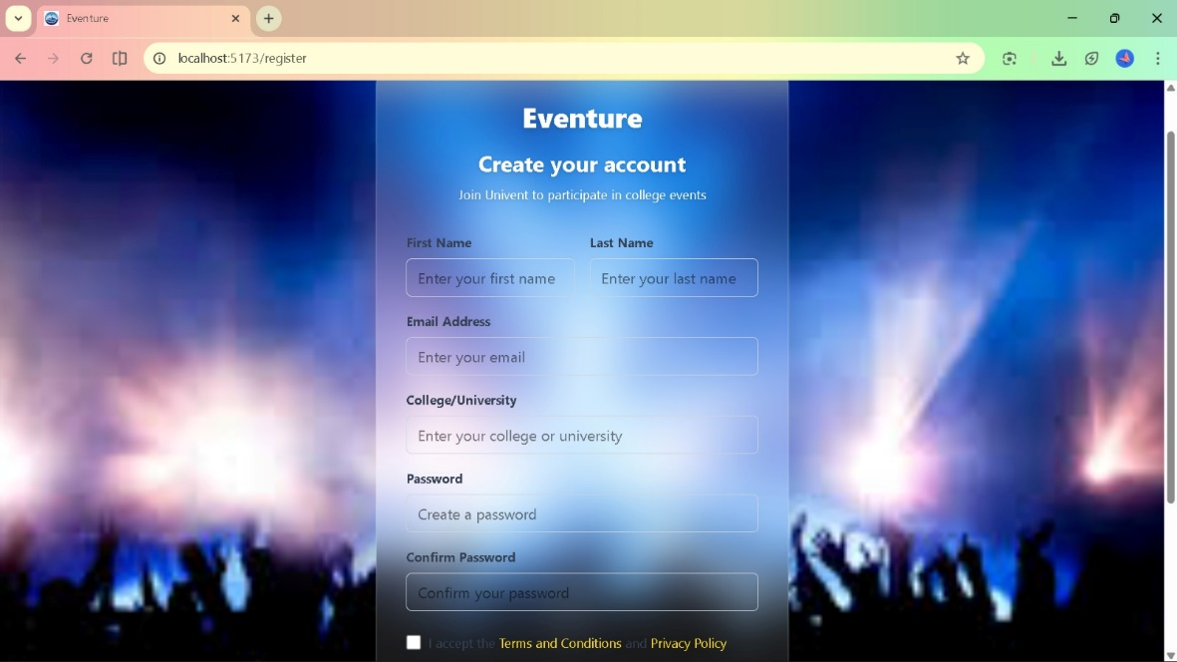
User Login Page:
• Authenticates user and generates JWT token.
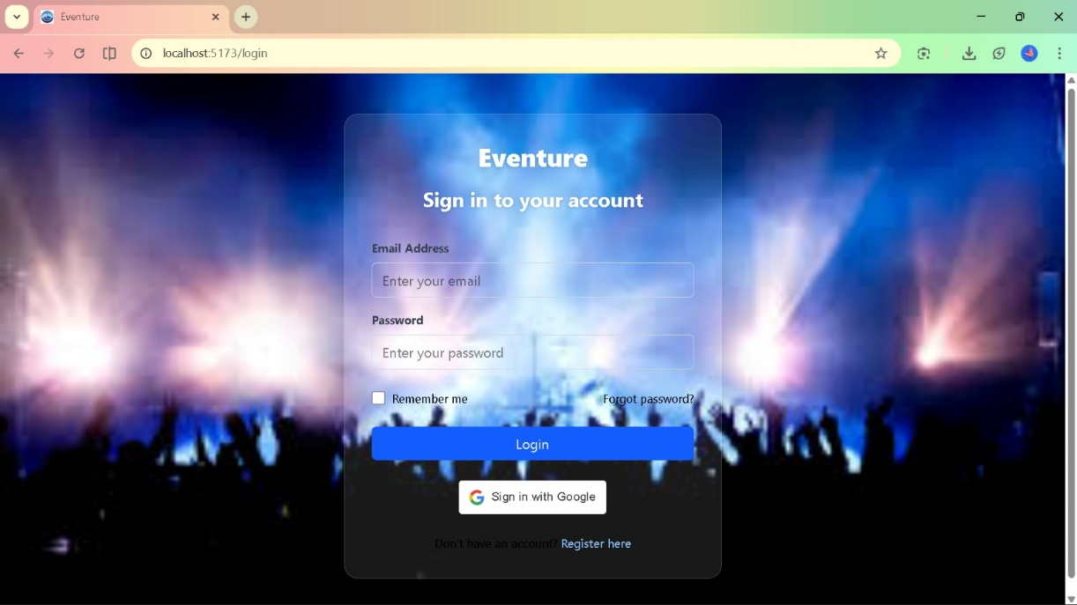

Event Listing Page:
• Fetches and renders events from database.
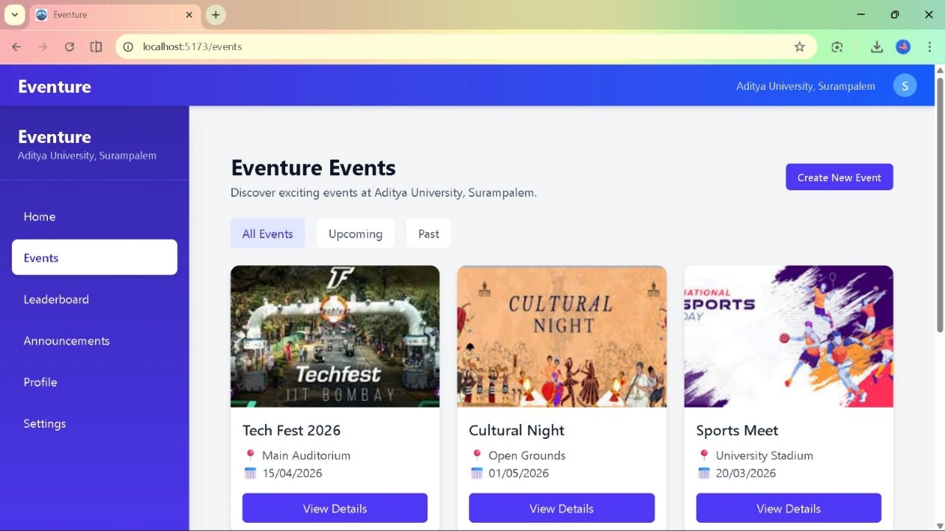

Event Details listing:
• Shows selected event data using event ID.
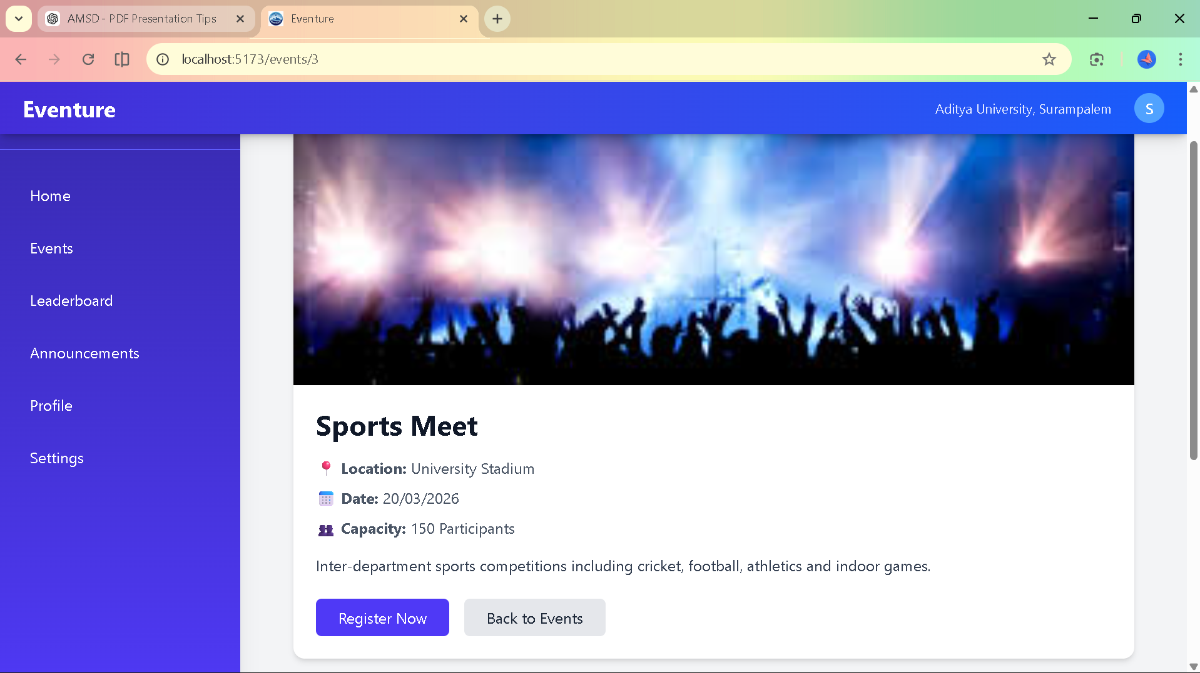

Leaderboard Listing:
• Displays sorted ranking data from backend.
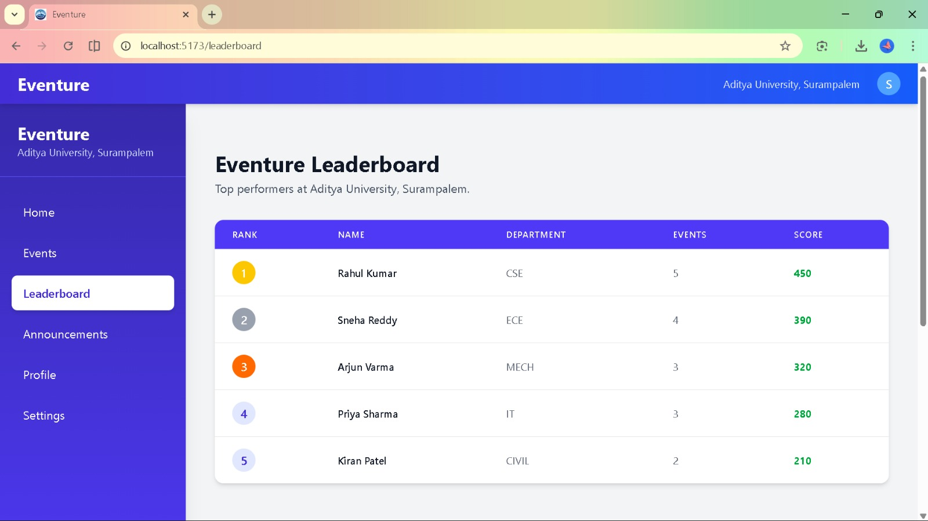

Announcements Notification Page:
• Retrieves admin announcements dynamically.
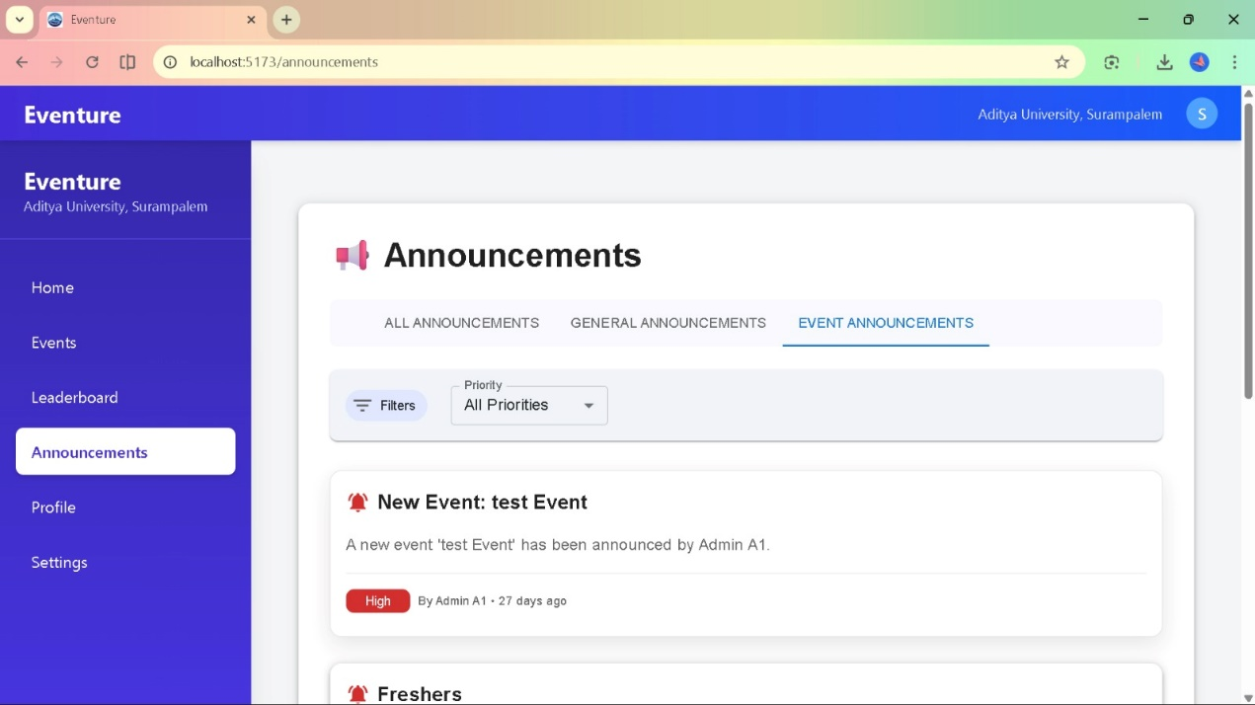

User Account Information:
• Displays authenticated user profile data.
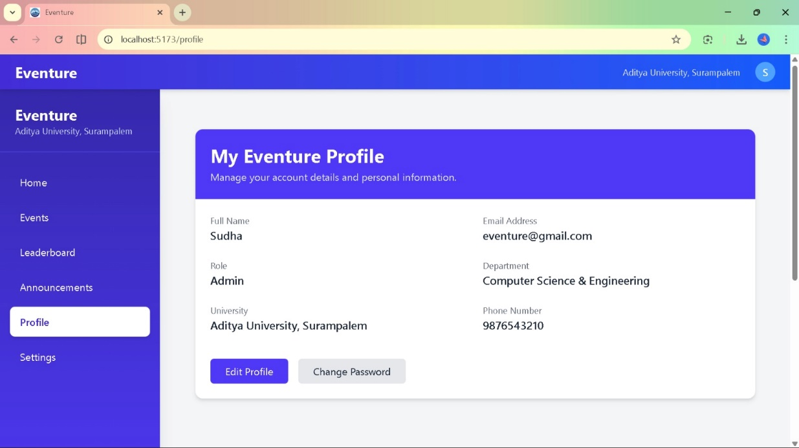

User Settings:
• Updates user data via PUT API request.
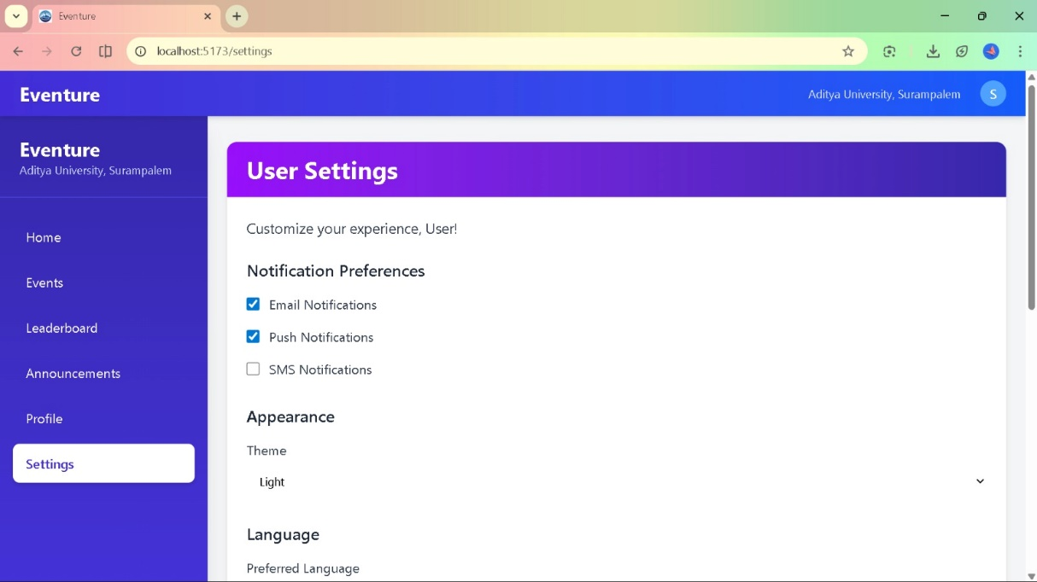

Setting Updation and Footer page:
• Confirms data persistence and maintains navigation layout.
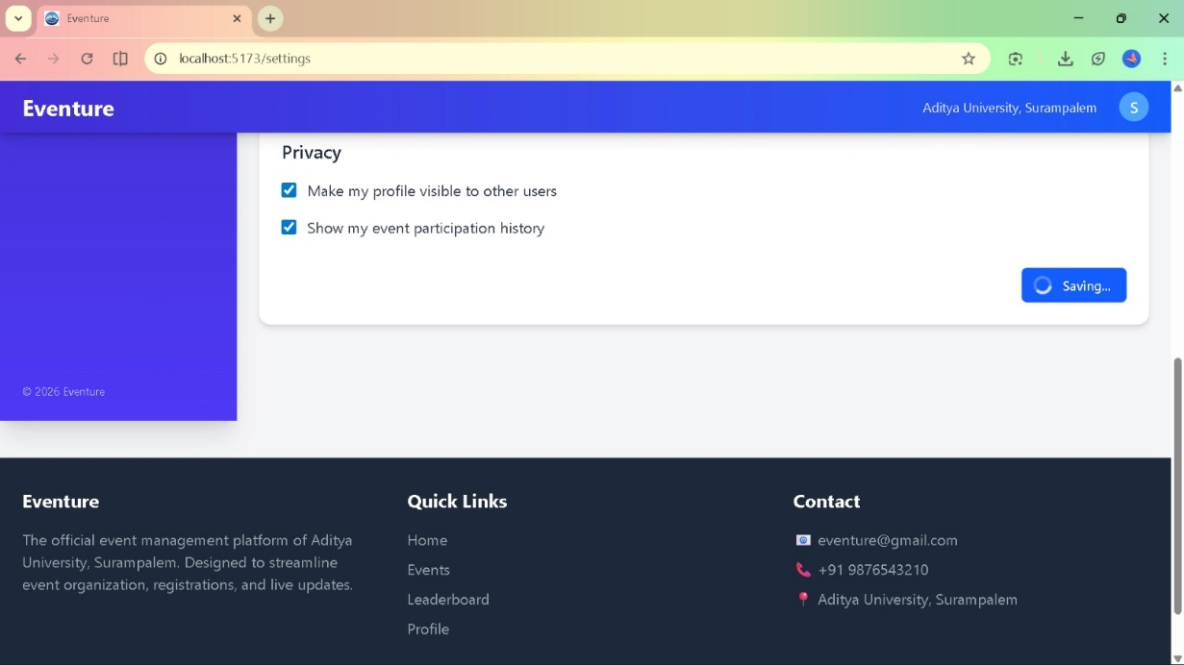

Presented by Team – 3
Shanumuka Priya K(24B11CS183)
S. S. Lakshmi Mani Hasini K (24B11CS206)
Balaraju K (24B11CS217)
Sudha Rani K(24B11CS226)

