HOMEWORK – II

Name: Sudha Sree, Yerramsetty

Goals:
- Organizational goals:
Goal 1: Improve brand reputation and customer trust through socially responsible innovation:
  - Measure: Brand trust score and media sentiment.
  - Data: Customer surveys, social media sentiment analysis, and media coverage frequency.
  - Operationalization: Calculate the average trust score from post-launch surveys (scale 1–5) and track positive/negative mentions about the dashcam brand in social media and online news articles before and after the feature’s release.
Goal 2: Ensure regulatory and ethical compliance with privacy and data protection standards:
  - Measure: Compliance rate with national and international data protection laws.
  - Data: Results from internal privacy audits and third-party compliance reports.
  - Operationalization: Evaluate whether the system passes all required compliance checks; compute compliance rate as the percentage of standards met or exceeded across all jurisdictions.
- System goals:
Goal 1: Low end-to-end latency for sighting reports:
- Measure: Median time from missing-child report publication to first matched sighting delivered to authorities.
- Data: Timestamped logs of (a) report publication time in the backend, (b) time of dashcam footage ingestion or local match detection, and (c) time the system forwards a match to authorities.
- Operationalization: For each successful match, compute delivery time = match forward time - report publication time. Report median and 95th percentile latency over a rolling 7-day window; verify median latency <= 30 minutes (example SLA).
Goal 2: High detection recall (minimize false negatives) for sightings that would meaningfully help authorities:
- Measure: Recall (sightings correctly identified/total true sightings present in footage) for images/video segments judged relevant.
- Data: A labeled evaluation corpus collected from controlled field trials and logged, validated real-world matches confirmed by authorities (with human verification).
- Operationalization: Compute recall across that corpus. Report both overall recall and recall stratified by conditions (day/night, occlusion, camera model). Target: recall >= 0.9 in daytime, >= 0.7 in the night (example thresholds).
Goal 3: High precision of forwarded matches (minimize false positives passed to authorities):
- Measure: Precision = true positive matches / (true positive matches + false positive matches) among matches that the system forwards.
- Data: Ground-truth labels from human verification of forwarded matches (logs of matches, whether authority confirmed or later rejected).
- Operationalization: For a reporting period, compute precision and track trends; set an operational threshold (e.g., precision >= 0.85) and generate alerts if precision drops below threshold.
- User goals:
Goal 1: Users (dashcam owners/drivers) should trust that the system accurately detects potential sightings of missing children:
  - Measure: User trust and satisfaction with alert accuracy.
  - Data: Collected via post-event in-app surveys, user interviews, and logs showing the proportion of true-positive alerts vs. false alarms users received.
  - Operationalization: Send short satisfaction surveys (e.g., Likert scale 1–5) after each verified detection event or monthly summary. Quantify trust as the average score of user-perceived reliability; target >= 4.0/5.0. Correlate this with the precision metric from the model (e.g., >= 85% verified true positives).
Goal 2: Users should feel that their privacy is protected, and that their normal driving experience is not disrupted by the system’s operation:
  - Measure: User perception of privacy protection and interference.
  - Data: Anonymous user feedback forms, privacy complaint logs, and telemetry of device processing (e.g., percentage of video processed locally vs. uploaded).
  - Operationalization: Periodically collect user ratings on perceived privacy (1–5 scale) and interference (frequency of noticeable alerts, CPU/battery usage). Compute privacy satisfaction = average privacy rating and interference index = number of alerts or interruptions / driving hours. Set targets for privacy satisfaction to be >= 4.5, and for interference index to be <= 0.05 alerts/hour.
- Model goals:
Goal 1: The face/person recognition model should identify children correctly in dashcam footage under varying conditions (lighting, motion, angle, and occlusion):
  - Measure: Overall model accuracy (precision, recall, F1-score).
  - Data: A labeled dataset containing real-world dashcam-like footage with known identities, including diverse environmental conditions (day/night, rain, shadows, partial visibility).
  - Operationalization: Compute precision = TP / (TP + FP), recall = TP / (TP + FN), and F1-score = 2 * (precision * recall) / (precision + recall). Use cross-validation on a representative test set that mimics dashcam conditions. Target F1 >= 0.85 and recall >= 0.90 (since missing a child sighting is costlier than a false alarm).
Goal 2: The model should maintain consistent performance and robustness across diverse and challenging environmental conditions such as poor lighting, weather effects, or motion blur:
  - Measure: Performance drop between ideal and challenging conditions.
  - Data: Two test datasets — one captured under ideal conditions (clear daylight, front-facing) and another under degraded conditions (night, rain, motion blur, partial occlusion).
  - Operationalization: Compute ΔPerformance = Ideal Accuracy - Challenging Accuracy. A smaller Δ indicates higher robustness. Target ΔPerformance <= 10%.

Relations between the goals:
- Strong ethical compliance and reliable performance build brand trust and user satisfaction, which in turn strengthen the company’s market position. Similarly, maintaining cost efficiency and scalable infrastructure allows the organization to expand globally while continuing to innovate responsibly.
- Improved model precision (fewer false positives) and transparent feedback mechanisms increase user trust and engagement, supporting organizational goals of adoption and reputation.
- Achieving high local processing rates (edge inference) and secure communication protocols supports this goal. It ties directly to system goals around privacy, low operating cost, and low latency.
- Higher recognition accuracy directly reduces false negatives, improving system reliability and user trust, which in turn supports organizational reputation and public goodwill.
- Improved robustness ensures the model functions well in real-world driving contexts, contributing to lower false negative rates, faster detections, and higher user satisfaction, supporting system goals around latency and reliability.

Environment and Machine:
- Environmental Entities: These are entities in the world that the system interacts with or depends on:
- Children reported missing – The primary objects of detection.
- Vehicles equipped with dashcams – Sources of video footage.
- Users (drivers/owners) – People who operate the dashcams and may consent to sharing data.
- Authorities/non-profit organizations – Coordinate searches and report missing children.
- Physical environment – Lighting, weather, traffic, occlusion, and other conditions affecting visibility.
- Network and communication channels – USB, Bluetooth, WiFi hotspots that allow data transfer.
- Machine Components: These are components that the system (AI or non-AI) provides or relies on to interact with the environment:
- AI-based person recognition module – Performs image recognition to identify children in dashcam footage.
- Data transfer module – Handles secure uploading/downloading of footage or alert data via USB, Bluetooth, or WiFi.
- Local processing unit – Dashcam CPU/GPU that processes video for detection locally (edge inference).
- Storage subsystem – Stores video recordings locally until processed or transferred.
- Alert/notification system – Sends potential matches or alerts to users or authorities.
- Monitoring module – Observes system performance, logs events, and provides metric values for evaluation.

Requirement Decomposition:
- Requirement (REQ): "The system should detect and report sightings of missing children in dashcam footage within 5 minutes of capturing and uploading the relevant video segment under normal driving conditions." This requirement focuses on system goal: low latency and timely reporting to authorities, supporting user trust and system utility.
- Environmental Assumptions (ASM): These are assumptions about the environment necessary to meet the REQ:
  - The dashcam has sufficient lighting and a reasonably clear view of the environment to detect faces.
  - Vehicles equipped with dashcams are moving at speeds where images are not overly blurred.
  - Users regularly connect dashcams to devices or networks for uploading data.
  - Children reported missing are present within camera view at some point during the dashcam recording.
  - Network connections or transfer mechanisms function within reasonable delays (WiFi/Bluetooth/USB).
- Machine Specifications (SPEC): These are responsibilities of the system components to satisfy the REQ in conjunction with the ASM:
- The AI module shall analyze each video frame for potential matches against the missing children database in real time or near real time.
- The local processing unit should process video frames fast enough to detect relevant sightings within the 5-minute latency target.
- The data transfer module shall securely upload alerts and matched images to authorities or the coordinating system.
- The alert/notification system shall generate notifications of potential matches immediately after detection.
- The monitoring module shall log detection times, processing latency, and any errors for future auditing.

Risk analysis:
Top Event/Requirement Violation: Detection and reporting of a missing child is delayed beyond 5 minutes of video capture.
We decompose the fault into logical branches leading to the top event. The top Event occurs if either:
(A) Detection is delayed
(B) Reporting is delayed
Detection Delay: Detection is delayed if:
(A1) AI model fails to process frames fast enough (performance bottleneck)
(A2) AI model accuracy too low → multiple false positives cause system slowdown
(A3) Dashcam’s local processing unit has insufficient computational power
(A4) Environmental conditions (e.g., low light, motion blur) reduce frame usability
Reporting Delay: Reporting is delayed if:
(B1) Network unavailability or slow connectivity (e.g., no WiFi or Bluetooth connection)
(B2) Data transfer failure due to corrupted files or software crash
(B3) User hasn’t authorized or configured data sharing (user setting prevents upload)
(B4) Alert/notification module failure (crash, timeout, or queue backlog)

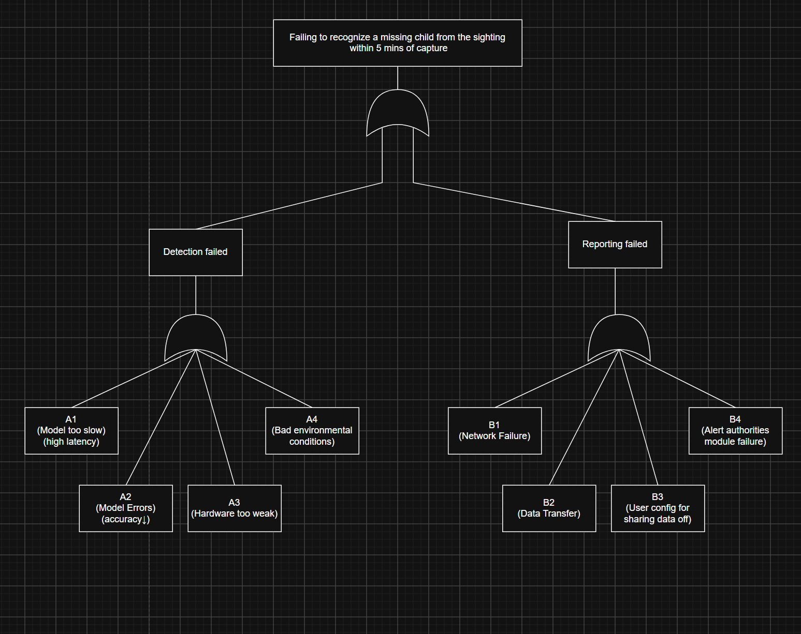
Minimal cut sets are the smallest combinations of basic events that can independently cause the top event. From the fault tree, each basic event alone can cause the top event because all internal gates are OR gates. Therefore, Minimal Cut Sets = {A1}, {A2}, {A3}, {A4}, {B1}, {B2}, {B3}, {B4}. This means that any single failure among these can lead to violation of the latency requirement.

Mitigation Strategies:
Mitigation Strategy 1 (M1): Edge-Cloud Hybrid Processing:
- Description: Allow dashcams to perform lightweight on-device recognition (pre-filtering) but periodically upload video snippets to a nearby edge server (e.g., in gas stations or drive-throughs) for faster and more powerful reprocessing. This approach reduces local computation load, increases accuracy under poor hardware or environmental conditions, and shortens latency even with limited connectivity.
- Addresses: A1, A2, A4, partially B1.

Mitigation Strategy 2 (M2): Adaptive Offline Buffer & Retry Queue:
- Description: Implement a local queue that caches detection results when the network is down (B1, B2) and automatically retries transmission when connectivity resumes. Include user prompts/reminders to enable upload if B3 occurs. This method ensures data is not lost, delays are minimized after recovery, and user intervention is reduced.
- Addresses: B1, B2, B3, B4

Mitigation Strategy 3 (M3): Model Monitoring and Auto-Update:
- Description: Periodically benchmark inference speed and update model weights optimized for each hardware tier. This approach keeps inference within latency constraints and maintains balance between accuracy and performance.
- Addresses: A1, A2, A3

Updated Fault Tree Analysis (FTA): Drive link to CS516_HW2.drawio (https://app.diagrams.net/#G1vZX0mT0V7cRilq_d56YuUgse0-ib1nzk#%7B%22pageId%22%3A%22_9xEwUIfo1mTu_IwfFHd%22%7D)
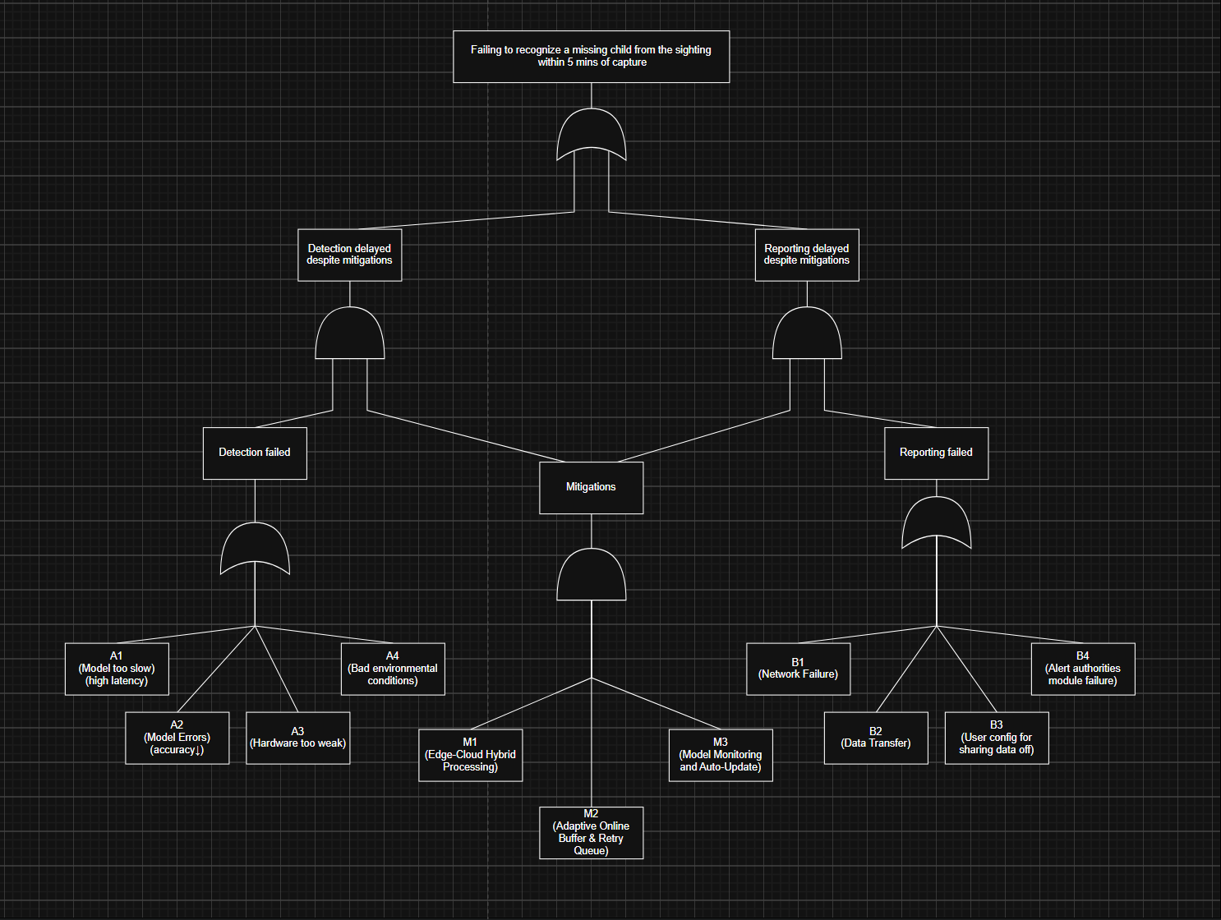

Minimal Cut Sets (updated): Earlier, every basic event alone was a minimal cut set (single points of failure). With mitigations present, the minimal cut sets become larger — the system requires combinations to fail. Updated minimal cut sets that lead to TE (smallest combinations under the updated tree): {A1, M1_fail, M2_fail, M3_fail}, {A2, M1_fail, M2_fail, M3_fail}, {A3, M1_fail, M2_fail, M3_fail}, {A4, M1_fail, M2_fail, M3_fail}, {B1, M1_fail, M2_fail, M3_fail}, {B2, M1_fail, M2_fail, M3_fail}, {B3, M1_fail, M2_fail, M3_fail}, {B4, M1_fail, M2_fail, M3_fail}.

