## **DELIVERABLES**

Python Test automation scripts

<https://drive.google.com/file/d/1UXgObaCxPG7Wxl0SNJrcqDVzUsE5N4xr/view?usp=sharing>

SVL Test automation results

<https://drive.google.com/file/d/1HGS1b3UfPSqoyBtf4ZvertkXi2CE4huc/view?usp=sharing>

Test Cost, Coverage & Complexity

<https://docs.google.com/presentation/d/1Ul2lI_mkIViBe1s882UYKjchjhzqVpKd/edit?usp=sharing&ouid=115962920318554834100&rtpof=true&sd=true>

Live Demo

<https://drive.google.com/file/d/1ZTUNdqQNVeq3dJaLZCalo2cIriRbmYTN/view?usp=sharing>

## **AV PROJECT - HOW TO GET STARTED**

**Reach out to us for help:** [mails.to.sudha.arul@gmail.com](mailto:mails.to.sudha.arul@gmail.com), [richardngo04@gmail.com](mailto:richardngo04@gmail.com), [pritdineshbhai.lakhani@sjsu.edu](mailto:pritdineshbhai.lakhani@sjsu.edu)

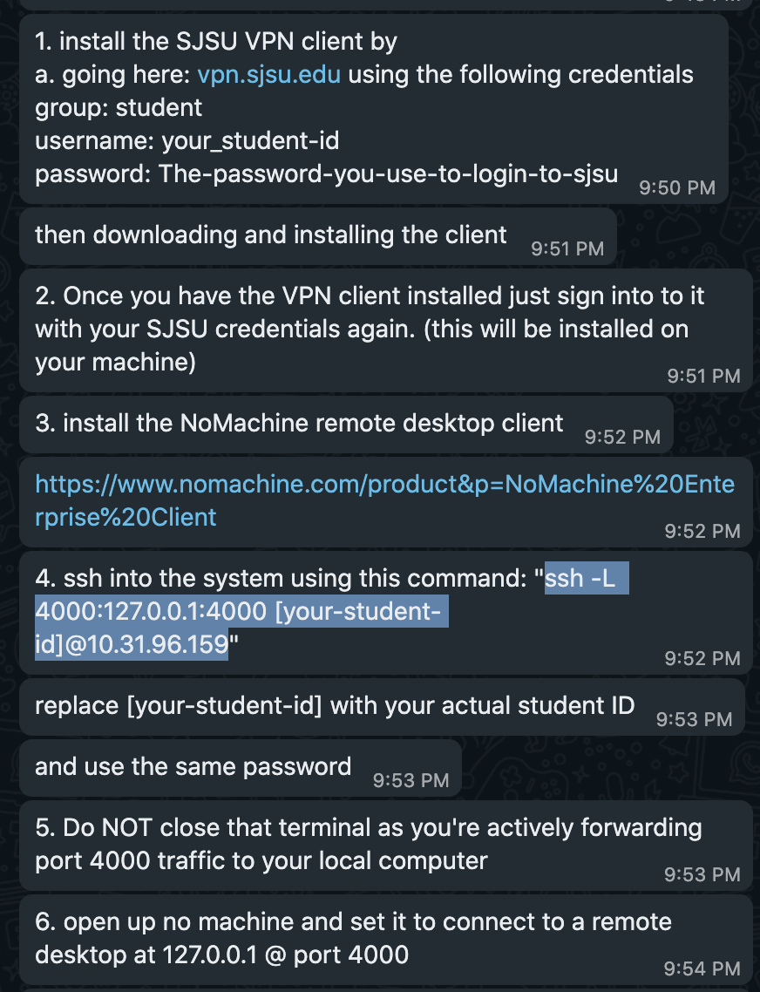

## **SVL Simulator**

Create Python API using the svl simulator. Refer the below link for setting up the same,

<https://www.svlsimulator.com/docs/python-api/python-api/>

Reference Git Repo:<https://github.com/lgsvl/PythonAPI>

## **APOLLO 6.0 Setup**

[**https://www.svlsimulator.com/docs/system-under-test/apollo-master-instructions/#cloning-the-repository**](https://www.svlsimulator.com/docs/system-under-test/apollo-master-instructions/#cloning-the-repository)

**Docker setup**

[**https://docs.docker.com/engine/install/ubuntu/**](https://docs.docker.com/engine/install/ubuntu/)

sudo apt-get install docker-ce=5:19.03.9~3-0~ubuntu-focal docker-ce-cli=5:19.03.9~3-0~ubuntu-focal containerd.io

**Cloning Apollo**

git clone<https://github.com/ApolloAuto/apollo>

**git checkout tags/v6.0.0**

./docker/scripts/dev_start.sh

./docker/scripts/dev_into.sh

./apollo.sh build_opt_gpu

**Failed at this point**

Issue bazel version error

**Solution references**

<https://githubhot.com/repo/ApolloAuto/apollo/issues/14374>

<https://stackoverflow.com/questions/17535428/how-to-edit-save-a-file-through-ubuntu-terminal>

**Commands executed**

**REFER THE SOLUTION LINK ABOVE TO MAKE MODIFICATIONS TO THE BELOW BUILD FILES TO BUILD APOLLO 6.0 SUCCESSFULLY.**

014749488@coe-cmpe-206-05:~/287_project/apollo$ cd apollo/.cache/bazel/540135163923dd7d5820f3ee4b306b32/external/rules_proto/proto/private/

bash: cd: apollo/.cache/bazel/540135163923dd7d5820f3ee4b306b32/external/rules_proto/proto/private/: No such file or directory

014749488@coe-cmpe-206-05:~/287_project/apollo$ cd .cache/bazel/540135163923dd7d5820f3ee4b306b32/external/rules_proto/proto/private/

014749488@coe-cmpe-206-05:~/287_project/apollo/.cache/bazel/540135163923dd7d5820f3ee4b306b32/external/rules_proto/proto/private$ ls

BUILD **dependencies.bzl native.bzl**

014749488@coe-cmpe-206-05:~/287_project/apollo/.cache/bazel/540135163923dd7d5820f3ee4b306b32/external/rules_proto/proto/private$ **sudo vi dependencies.bzl**

[sudo] password for 014749488:

014749488@coe-cmpe-206-05:~/287_project/apollo/.cache/bazel/540135163923dd7d5820f3ee4b306b32/external/rules_proto/proto/private$ **vi repositories.bzl**

Ubunut : insert => i ; save : esc :wq

re-executing

**./apollo.sh build_opt_gpu**

**Build-in-progress**

**History of commands**

1 nvidia-smi

2 git clone https://github.com/ApolloAuto/apollo

3 ./docker/scripts/dev_start.sh

4 ls

5 cd apollo

6 ls

7 ./docker/scripts/dev_start.sh

8 sudo ./docker/scripts/dev_start.sh

9 ./docker/scripts/dev_into.sh

10 sudo ./docker/scripts/dev_into.sh

11 cd

12 docker pull lgsvl/apollo-5.0

13 sudo docker pull lgsvl/apollo-5.0

14 sudo git clone --recurse-submodules https://github.com/lgsvl/apollo-5.0.git

15 sudo docker/scripts/dev_start.sh

16 ls

17 cd apollo-5.0

18 sudo docker/scripts/dev_start.sh

19 sudo docker/scripts/dev_into.sh

20 cd

21 ls

22 cd Templates

23 ls

24 cd

25 cd apollo-5.0

26 ls

27 cd lgsvl_pkgs/

28 ls

29 cd

30 cd apollo

31 ls

32 cd

33 cd apollo-5.0/

34 la

35 ls

36 clear

37 ls

38 cd script

39 cd scripts

40 ls

41 sudo docker/scripts/dev_into.sh

42 cd

43 cd apollo-5.0/

44 sudo docker/scripts/dev_into.sh

45 exit

46 exit

47 logout

48 docker start 68953d3bd57a3715a1a2af382c6c94066554bc1d2abfb0d3e132bbc71b957ec9

49 sudo docker start 68953d3bd57a3715a1a2af382c6c94066554bc1d2abfb0d3e132bbc71b957ec9

50 cd 287_project/

51 git clone https://github.com/ApolloAuto/apollo

52 cd apollo/

53 git checkout tags/v6.0.0

54 ./docker/scripts/dev_start.sh

55 ls

56 cd scripts

57 ls

58 dev_start.sh

59 cd

60 cd 287_project/apollo/

61 ls

62 cd docker

63 ls

64 cd scripts

65 ls

66 dev_start.sh

67 cd

68 cd 287_project/apollo/

69 ./docker/scripts/dev_start.sh

70 sudo ./docker/scripts/dev_start.sh

71 ./docker/scripts/dev_into.sh

72 sudo ./docker/scripts/dev_into.sh

73 nvidia-smi

74 cd 287_project/

75 ls

76 git clone https://github.com/ApolloAuto/apollo

77 sudo ./docker/scripts/dev_start.sh

78 cd apollo/

79 sudo ./docker/scripts/dev_start.sh

80 LS

81 CD

82 cd

83 cd 287_project/

84 ls

85 clear

86 git clone https://github.com/ApolloAuto/apollo

87 cd apollo/

88 git checkout tags/v6.0.0

89 cd

90 nvidia-smi

91 sudo ./docker/scripts/dev_start.sh

92 cd 287_project/apollo/

93 sudo ./docker/scripts/dev_start.sh

94 sudo apt-get update

95 sudo apt-get install docker-ce docker-ce-cli containerd.io

96 apt-cache madison docker-ce

97 1. sudo apt-get install docker-ce= 5:19.03.9~3-0~ubuntu-focal docker-ce-cli=5:19.03.9~3-0~ubuntu-focalcontainerd.io

98 sudo apt-get install docker-ce= 5:19.03.9~3-0~ubuntu-focal docker-ce-cli=5:19.03.9containerd.io

99 sudo apt-get install docker-ce=5:19.03.9~3-0~ubuntu-focal docker-ce-cli=5:19.03.9~3-0~ubuntu-focal containerd.io

100 sudo docker run hello-world

101 cd 287_project/

102 ls

103 git clone https://github.com/ApolloAuto/apollo

104 sudo reboot

105 clear

106 sudo reboot

107 cd

108 cd 287_project/apollo/

109 ls -a

110 cd .cache

111 cd bazel

112 cd 540135163923dd7d5820f3ee4b306b32/external/io_bazel_rules_go/go/private/

113 ls

114 cat repositories.bzl

115 vi repositories.bzl

116 cd apollo/.cache/bazel/540135163923dd7d5820f3ee4b306b32/external/io_bazel_rules_go/go/private/repositories.bzl

117 cd .cache/bazel/540135163923dd7d5820f3ee4b306b32/external/io_bazel_rules_go/go/private/repositories.bzl

118 cd .cache/bazel/540135163923dd7d5820f3ee4b306b32/external/io_bazel_rules_go/go/private

119 vi repositories.bzl

120 cd .cache/bazel/540135163923dd7d5820f3ee4b306b32/external/io_bazel_rules_go/go/private

121 vi repositories.bzl

122 cd .cache/bazel/540135163923dd7d5820f3ee4b306b32/external/io_bazel_rules_go/go/private

123 sudo vi repositories.bzl

124 vi repositories.bzl

125 cd 287_project/

126 git clone https://github.com/ApolloAuto/apollo

127 git checkout tags/v6.0.0

128 cd apollo

129 git checkout tags/v6.0.0

130 sudo ./docker/scripts/dev_start.sh

131 sudo ./docker/scripts/dev_into.sh

132 cd apollo/.cache/bazel/540135163923dd7d5820f3ee4b306b32/external/rules_proto/proto/private/

133 cd .cache/bazel/540135163923dd7d5820f3ee4b306b32/external/rules_proto/proto/private/

134 ls

135 sudo vi dependencies.bzl

136 pwd

137 ls

138 cd 014749488

139 cd 014749488@SJSUAD/

140 ls

141 cd 287_project/

142 ls

143 cd apollo/

144 ls

145 cd scripts/

146 ls

147 ls dev*

148 ls de*

149 cd ..

150 cd docker/

151 cd scripts/

152 ls

153 history

## **HOW TO RUN - high-level**

1. Start the SVL SIMULATOR (*.exe), connect to svl simulator cluster.
2. Access the Python API test solution(Create one time) on the svl simulator cloud <=, requires login.
3. Start Apollo 6.0 Dreamviewer <= Docker installation above.
4. Execute python scripts (follow demo video) <= final-scripts.

**Startup Protocol**

On new Terminal run (let’s call this Terminal A)

1. sudo ~/287_project/apollo/docker/scripts/dev_start.sh (this will start the docker container)

once the container starts up, open up a new tab/terminal and run (this will be called Terminal B)

2. sudo ~/287_project/apollo/docker/scripts/dev_into.sh

This will log you into the docker container

3. /apollo/scripts/bootstrap_lgsvl.sh

this will start the apollo simulator, wait until the command prompt returns control to you.

4. Run:

/apollo/scripts/bridge.sh

To start the bridge connection.

5. Leave both terminals up and simply open up the SVL simulator to finish the setup.

**Shutdown protocol.**

1. In Terminal B press “Ctrl +C” to end the bridge.sh script
2. In the same terminal run “/apollo/scripts/bootstrap_lgsvl.sh stop” to stop the apollo simulator
3. You may now close Terminal B
4. In Terminal A, run “sudo ~/287_project/apollo/docker/scripts/dev_start.sh stop” to stop the docker containers.