CAPSTONE PROJECT 1
SecureNova AI Identity Security
Threat Model | Evidence Submission
Architecture • Threat Analysis • Risk Assessment • MITRE ATLAS Mapping

1 | Data Flow Diagram
SecureNova AI Identity Security proposed architecture showing identity components, data flows and trust boundaries.
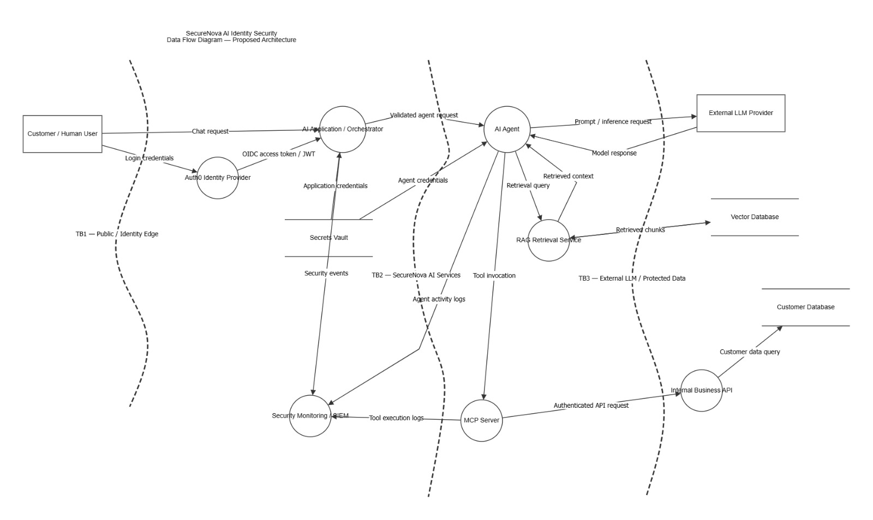

2 | STRIDE Threat Assessment — OWASP Threat Dragon
OWASP Threat Dragon threat panel showing threats associated with the AI Agent-to-MCP Server tool invocation flow.
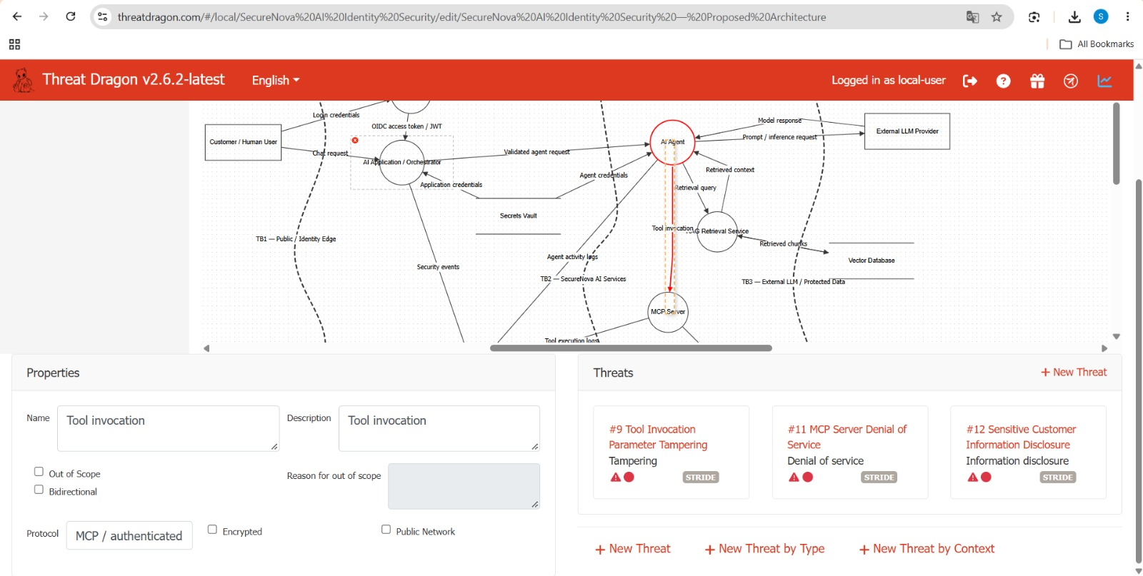

3 | Attack Tree — LLM API Key Exfiltration
Attack tree showing the goal of exfiltrating an LLM API key and the application-exposure and agent-abuse attack paths.
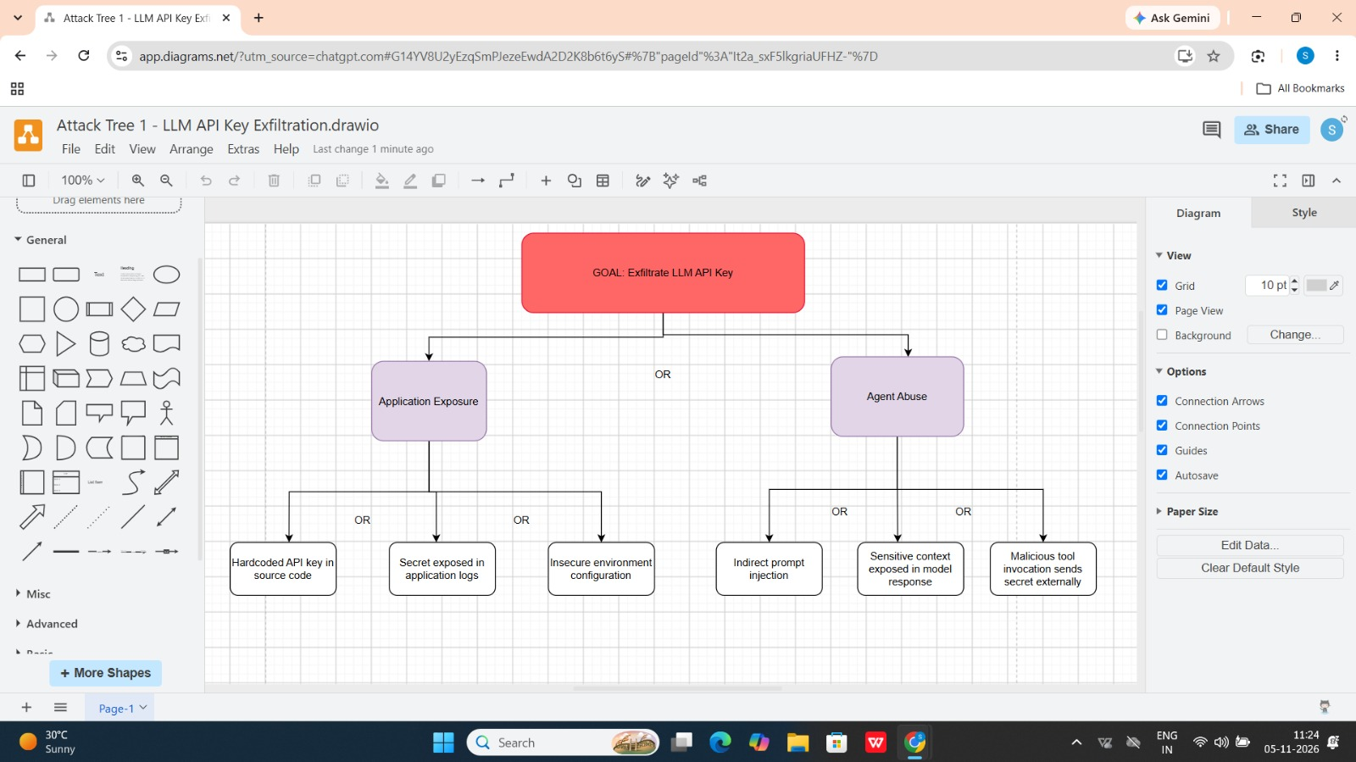

4 | Attack Tree — Agent Identity Spoofing
Attack tree showing credential-theft and verification-weakness paths that could be used to spoof an AI agent identity.
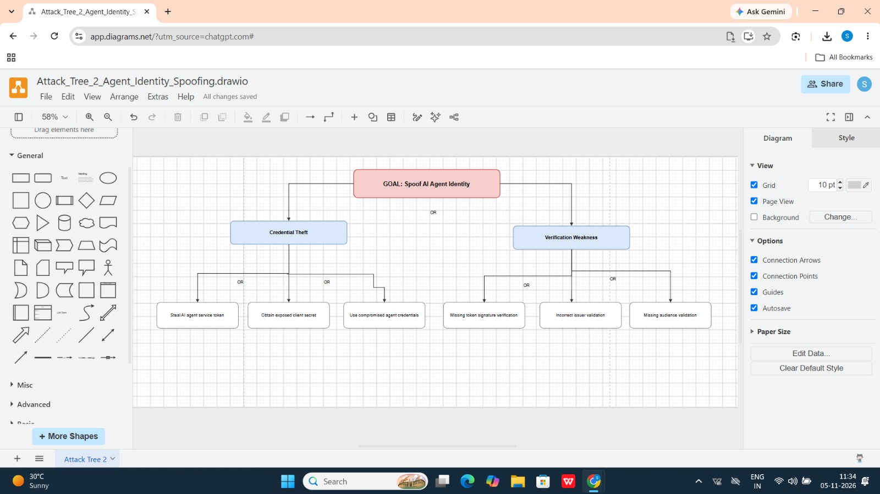

5 | Attack Tree — RAG Chunk Poisoning
Attack tree showing malicious-document and vector-store-tampering paths that could poison the RAG knowledge base.
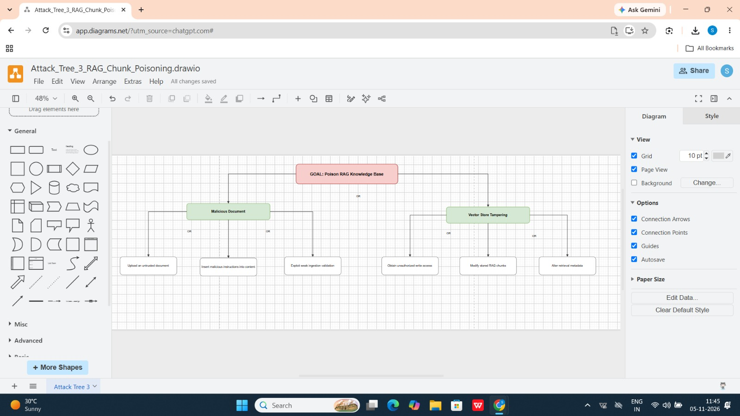

6 | STRIDE Threat Matrix — Part 1
STRIDE matrix entries for the initial architecture components.
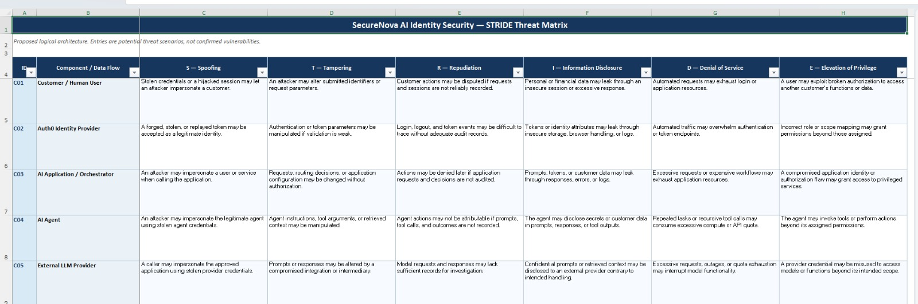

6 | STRIDE Threat Matrix — Part 2
STRIDE matrix entries covering additional architecture components and data flows.
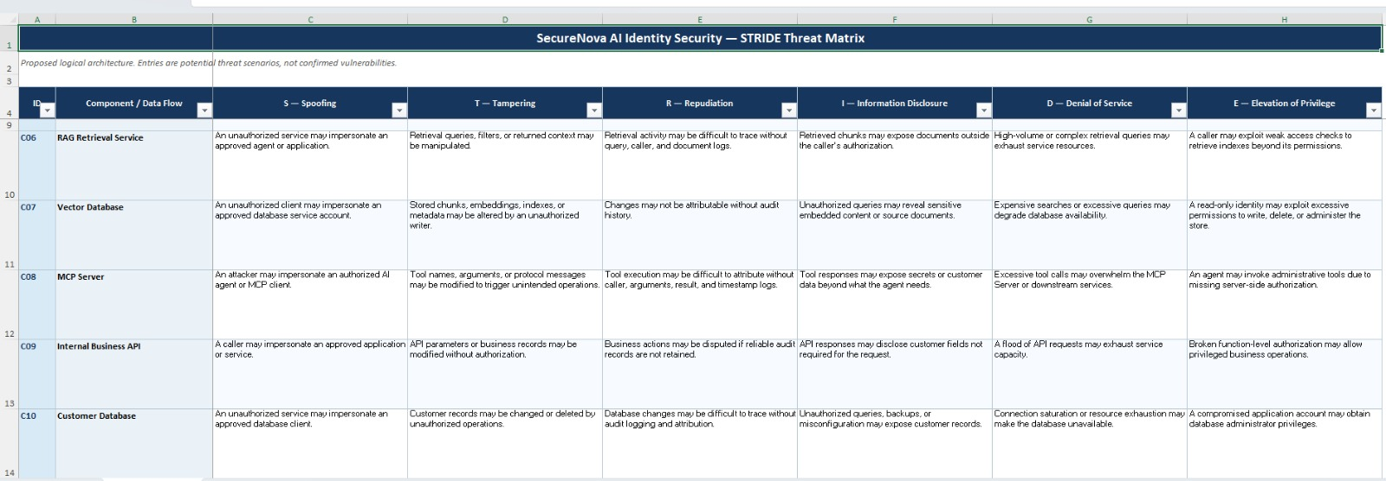

6 | STRIDE Threat Matrix — Part 3
STRIDE matrix entries covering the remaining components and data flows.
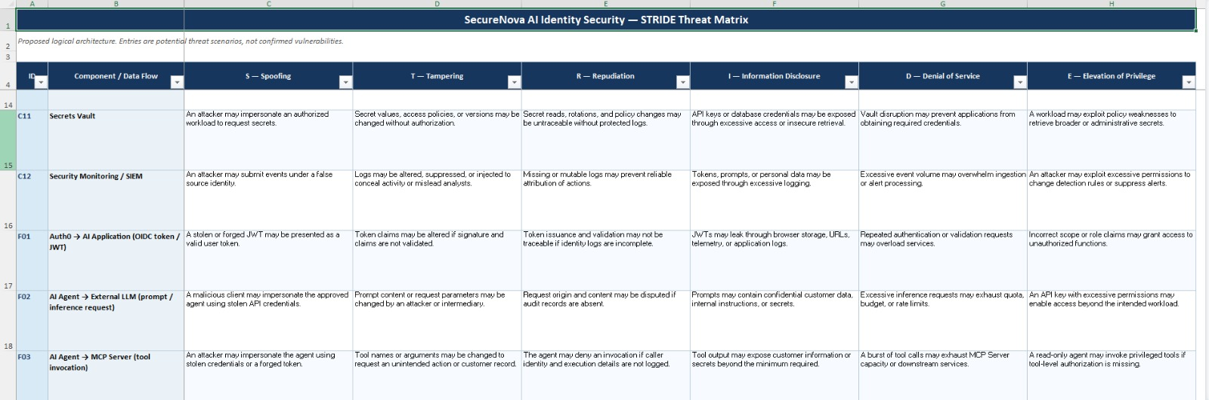

7 | Risk Register — Part 1
Risk register showing the highest-ranked risks, their likelihood, impact, risk scores, severity and recommended mitigations.
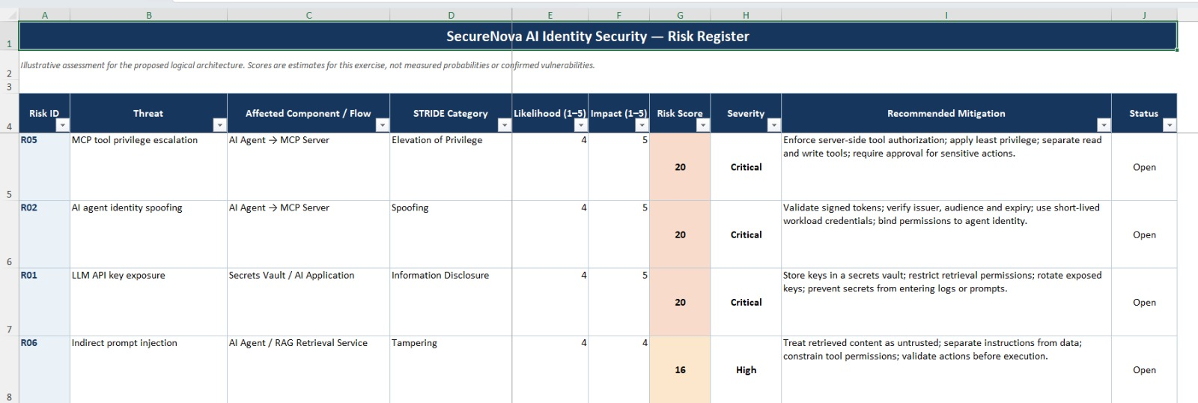

7 | Risk Register — Part 2
Continuation of the risk register showing the next ranked threats and their risk assessments.
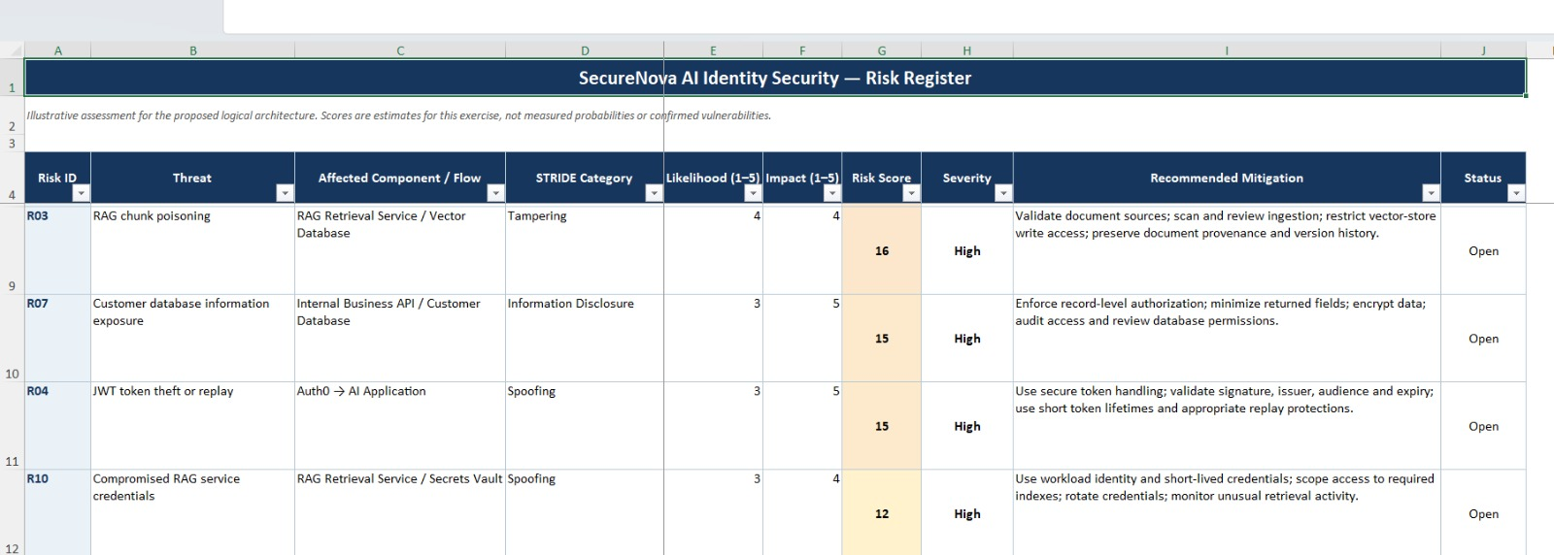

7 | Risk Register — Part 3
Final risk register entries, completing the list of ten assessed threats.
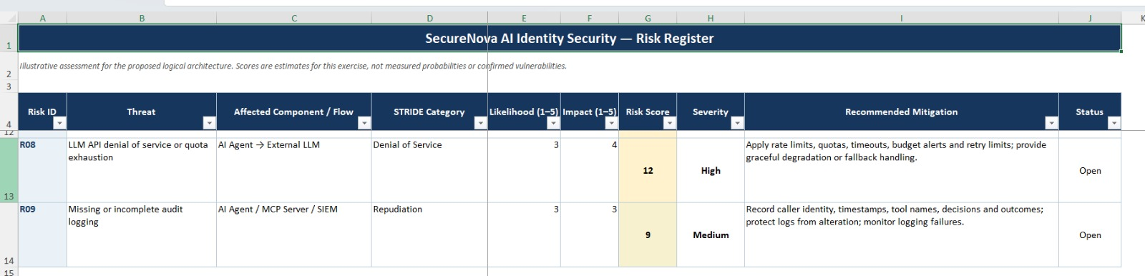

8 | MITRE ATLAS Technique Mapping
Official MITRE ATLAS technique page for AML.T0070 — RAG Poisoning, mapped to Attack Tree 3.
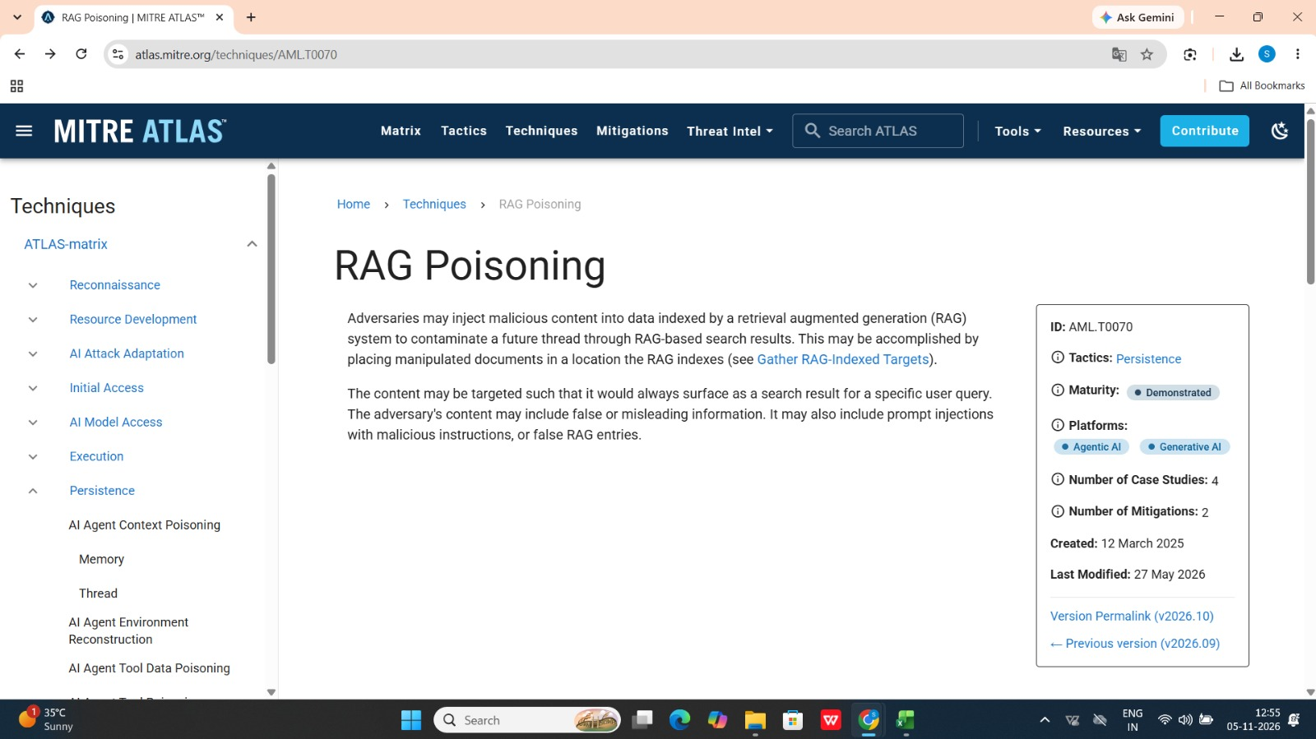

CAPSTONE PROJECT 1
THREAT MODEL
SECURENOVA AI IDENTITY SECURITY

SUBMISSION COMPLETE
Architecture • Threat Identification • Attack Trees
STRIDE Analysis • Risk Assessment • MITRE ATLAS Mapping
ACCENTURE | CAPSTONE SUBMISSION

