CAPSTONE PROJECT 2

Build and Secure the
Auth0-Backed AI Application
SecureNova AI Identity Security
Implementation evidence and screenshot-by-screenshot explanations
Accenture | Capstone Submission

Project Overview
This document records the Auth0 implementation for the SecureNova AI application. It covers application registration, API scopes, OAuth 2.0 Authorization Code with PKCE, JWT verification, Universal Login branding, TOTP multi-factor authentication, Auth0 Actions, attack protection, short-lived M2M tokens, and Single Sign-On.
Each evidence screenshot has its own short explanation describing the visible configuration or result.

Implementation Summary
Auth0 applications | SecureNova AI Chat (Regular Web Application) and SecureNova AI Agent (Machine-to-Machine).
API | SecureNova AI API; identifier: https://securenova-ai-api.
Custom scopes | read:ai-data and write:admin.
JWT | RS256 signing; the application verifies the JWT signature and relevant claims.
MFA | TOTP challenge shown during authentication.
Post-login Action | Adds https://securenova.ai/agent_id with value agent-001 to the ID token.
Token expiry test | 60-second M2M token; /chat returned 200 OK, then expired-token replay returned 401 Unauthorized.
SSO | Second Regular Web Application authenticated through Auth0.

1. Auth0 Tenant and Application Registration
The Auth0 Applications dashboard is used to register and manage the applications that participate in the SecureNova AI authentication setup.
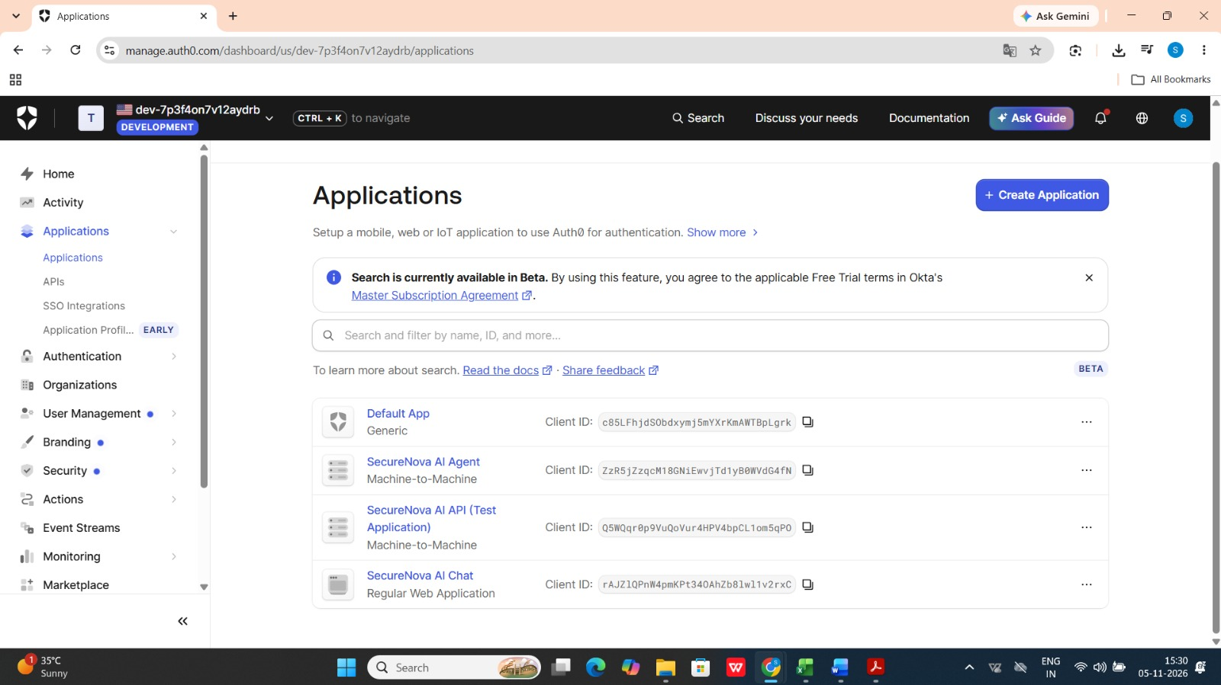
Figure 1: The Applications page lists the SecureNova AI Agent as a Machine-to-Machine application and SecureNova AI Chat as a Regular Web Application. This establishes the two main Auth0 clients used in the implementation.

2. SecureNova AI API and Custom Permissions
The custom API defines the permissions that can be requested by clients when accessing protected AI resources.
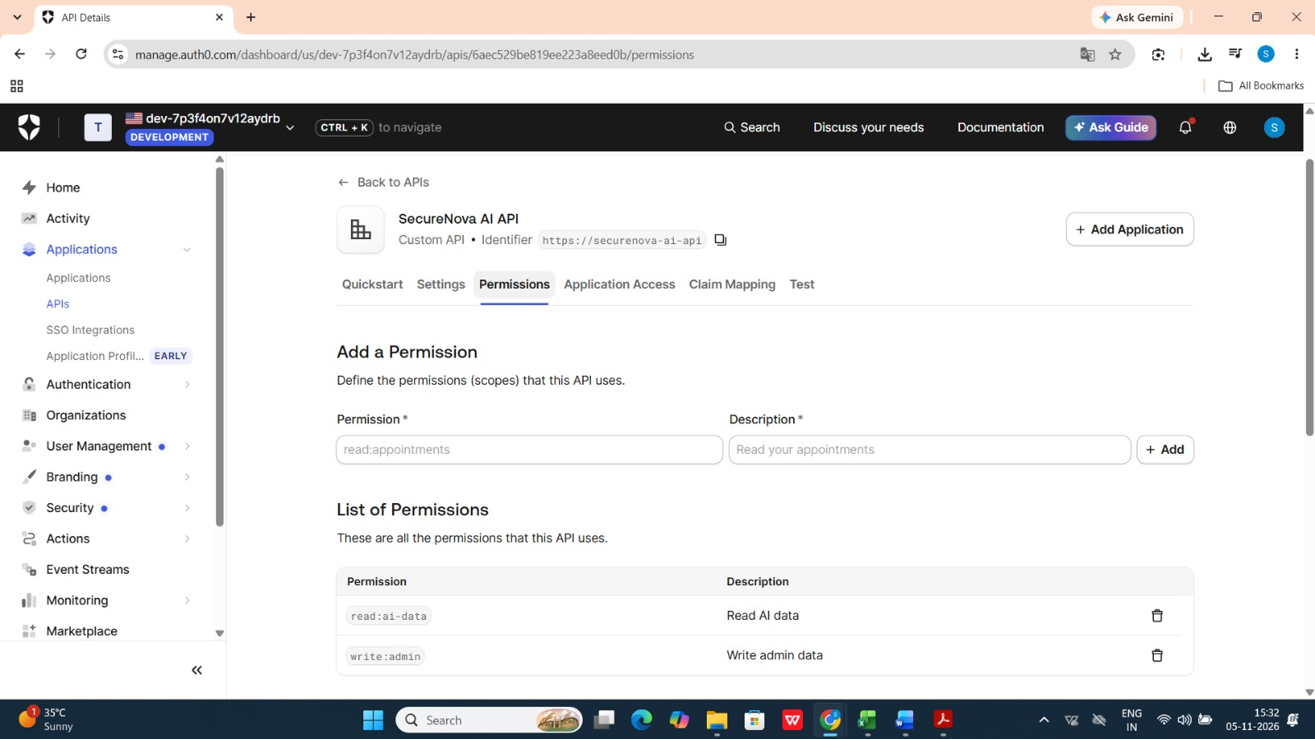
Figure 2: The API Permissions page shows the custom scopes read:ai-data and write:admin, together with their descriptions. These permissions are used to distinguish ordinary AI-data access from administrative access.

3. OAuth 2.0 Authorization Code Flow with PKCE and JWT Verification
The web application uses the Authorization Code flow with PKCE. The callback validates the returned JWT, while the debugger provides a view of the decoded token claims.
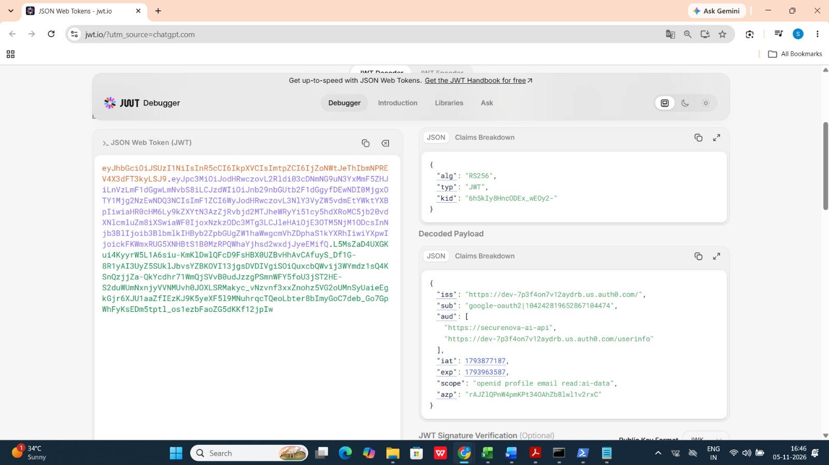
Figure 3: The jwt.io debugger displays the decoded JWT header and payload, including RS256, the issuer, API audience, expiry, and granted scopes. The token text is shown as captured in the original evidence.
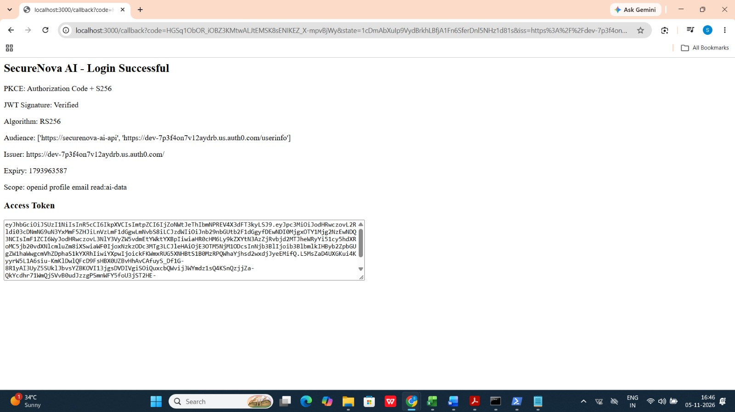
Figure 4: The local SecureNova AI login result confirms Authorization Code with PKCE using S256, successful JWT signature verification, RS256, audience, issuer, expiry, and the read:ai-data scope.
4. Auth0 Universal Login Branding
The Universal Login theme is customized and then checked on the rendered login page.
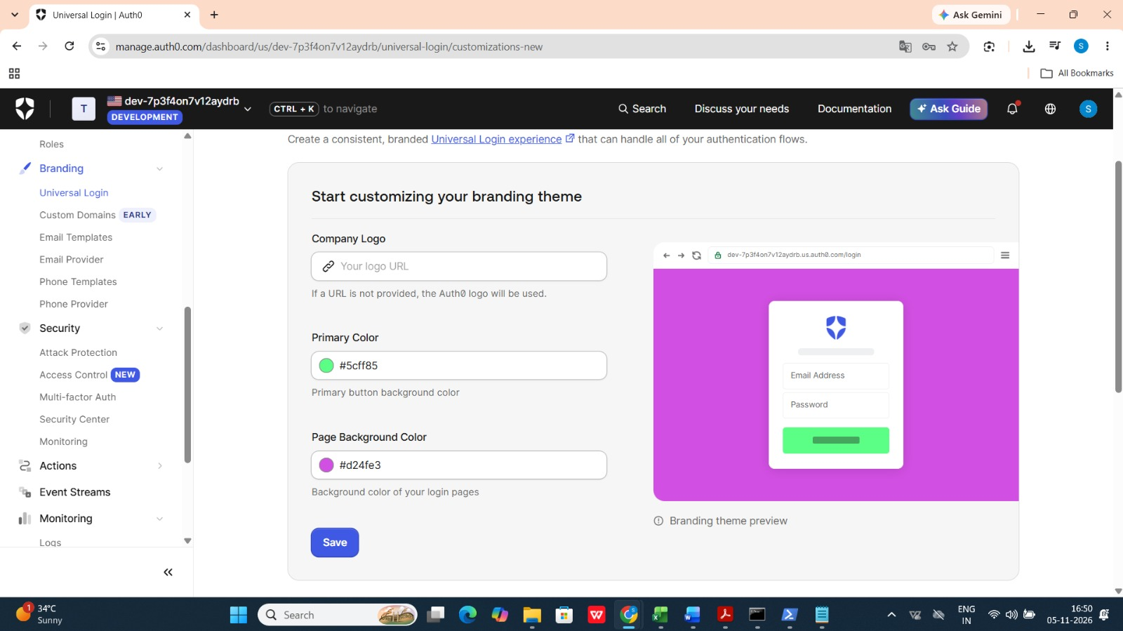
Figure 6: The Universal Login customization page shows the selected primary colour (#5cff85) and page background colour (#d24fe3), along with the branding preview.
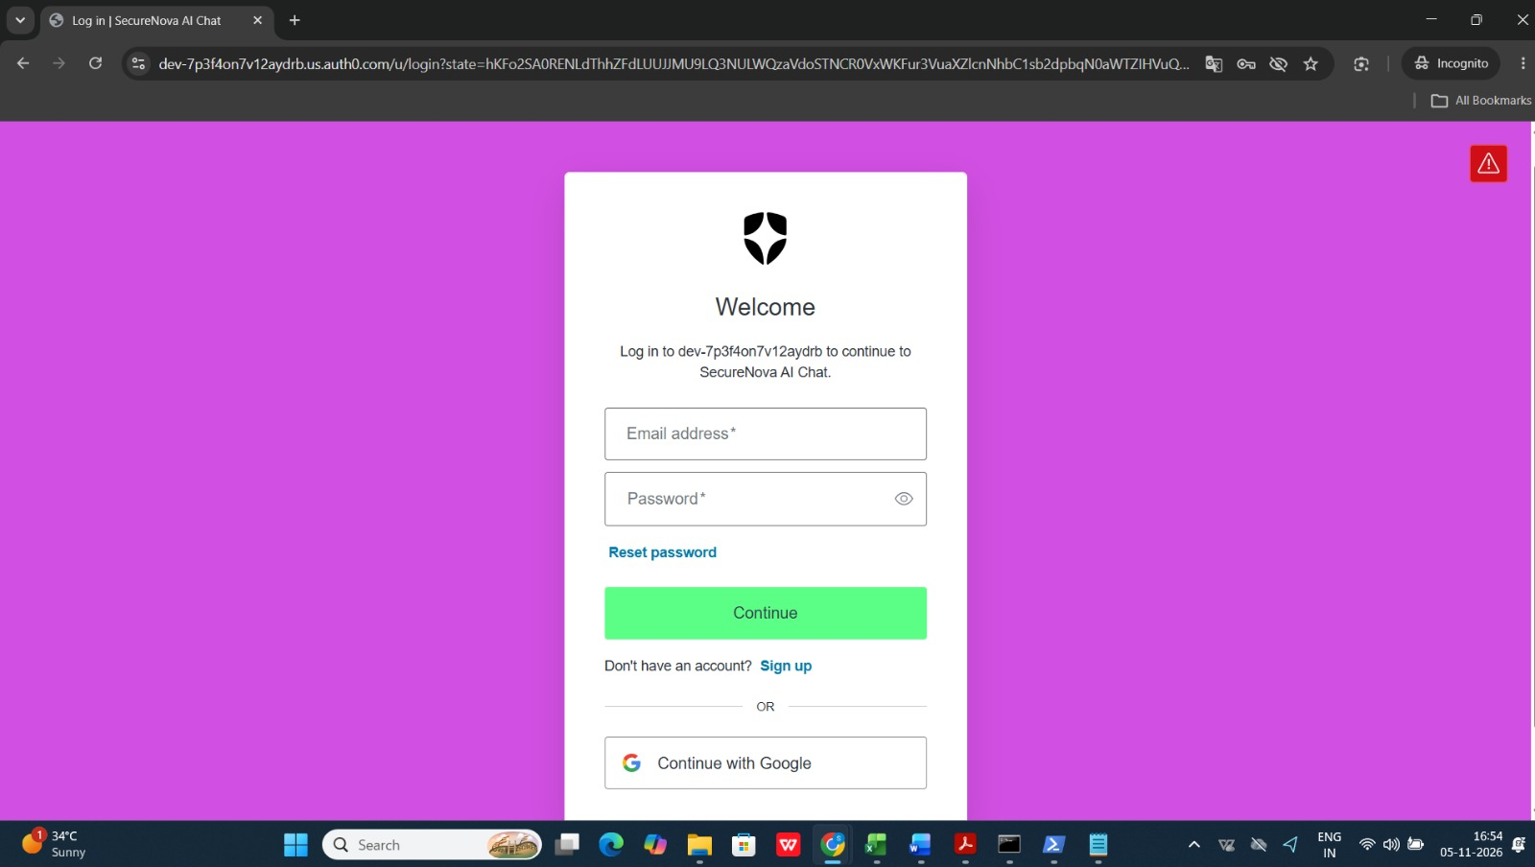
Figure 7: The branded Universal Login page displays the customized purple background and green Continue button. This shows that the theme is reflected in the actual login experience.

5. Multi-Factor Authentication with TOTP
The sign-in flow requires an authenticator-generated one-time password as an additional verification step.
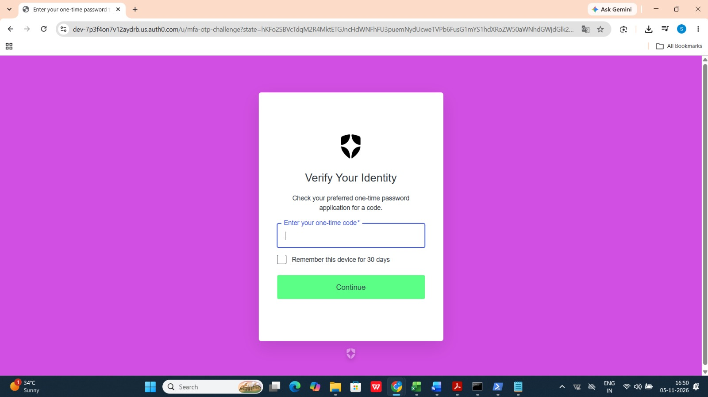
Figure 5: The Auth0 one-time-password challenge asks the user to enter a code from an authenticator application. This demonstrates the TOTP MFA challenge in the sign-in flow.
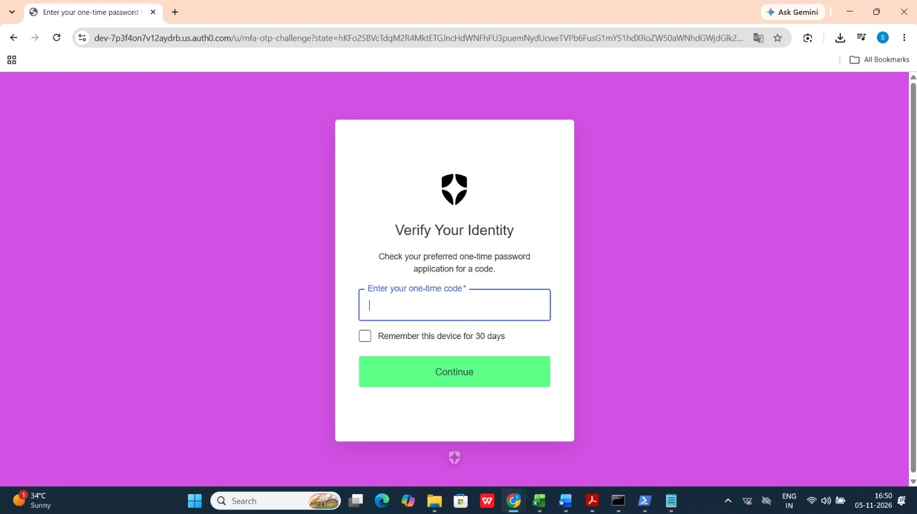
Figure 8: A second view of the one-time-password challenge shows the MFA prompt after the user reaches the verification stage of authentication.

6. Post-Login Action and Custom Agent ID Claim
A Post Login Action adds a custom claim to the ID token. The Action is attached to the Login trigger, and the issued ID token is checked in the application and decoded for confirmation.
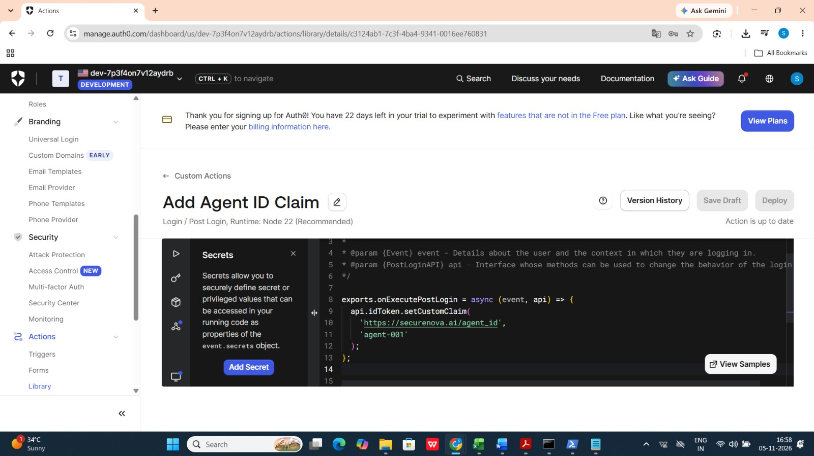
Figure 9: The Auth0 Action editor displays the Add Agent ID Claim Post Login Action and its code, which adds the namespaced agent_id claim with the value agent-001.
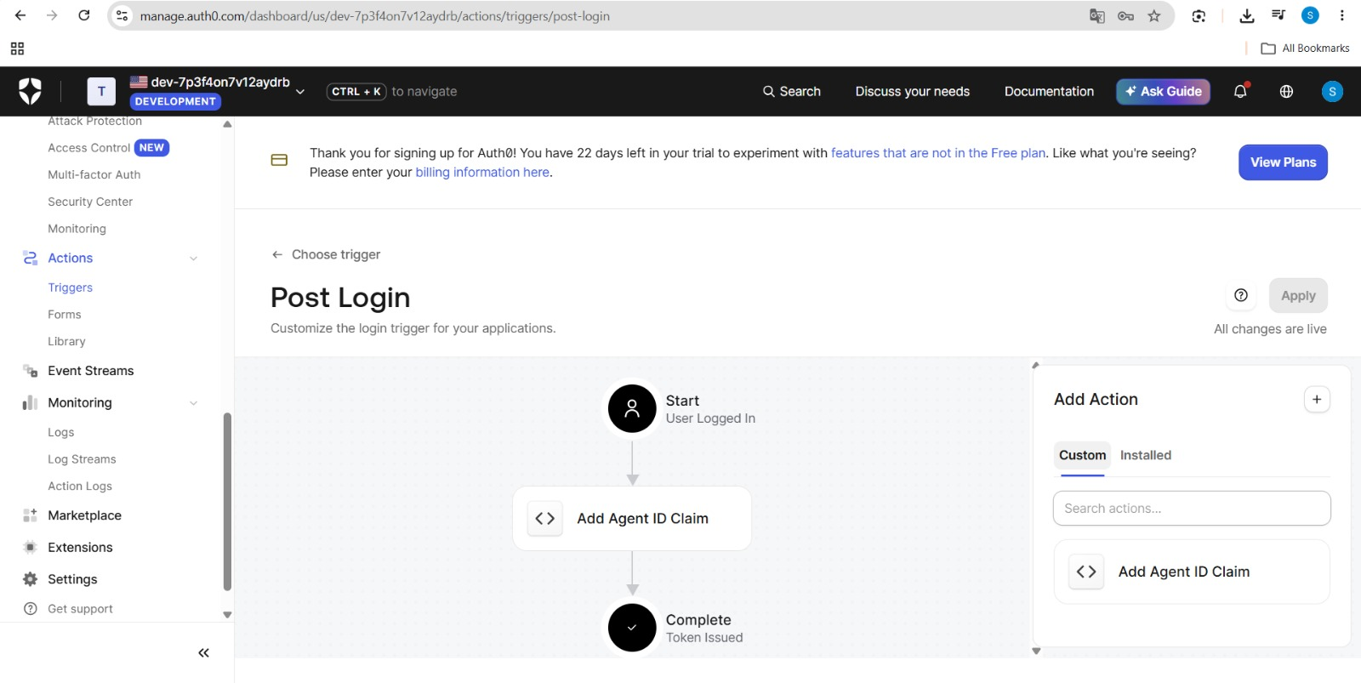
Figure 10: The Post Login trigger flow shows Add Agent ID Claim placed between the Start and Complete nodes, confirming that the Action is attached to the login flow.
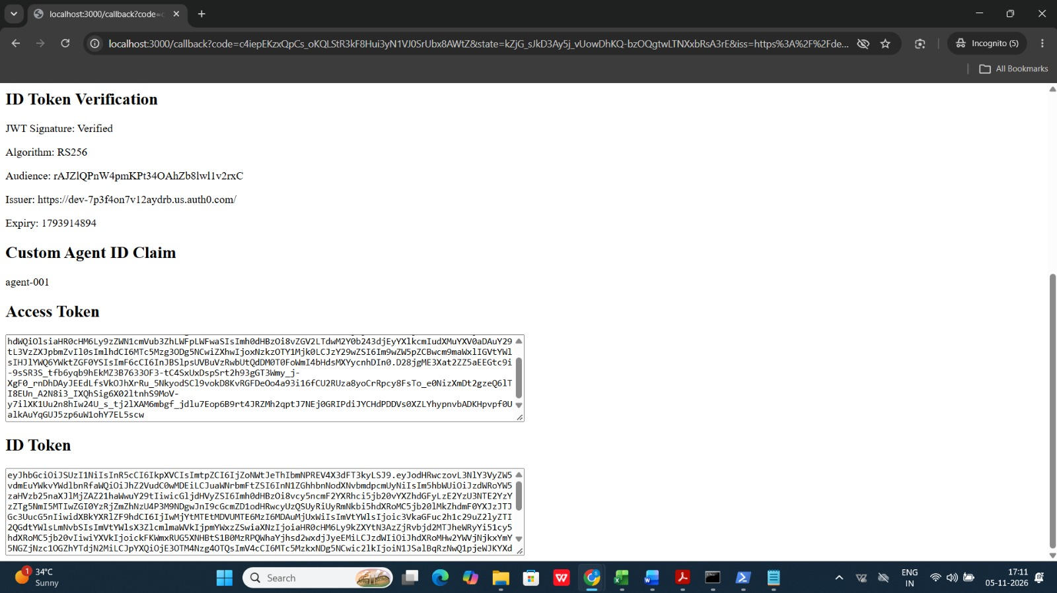
Figure 11: The application’s ID Token Verification page reports a verified RS256 signature and displays the custom Agent ID claim value agent-001.
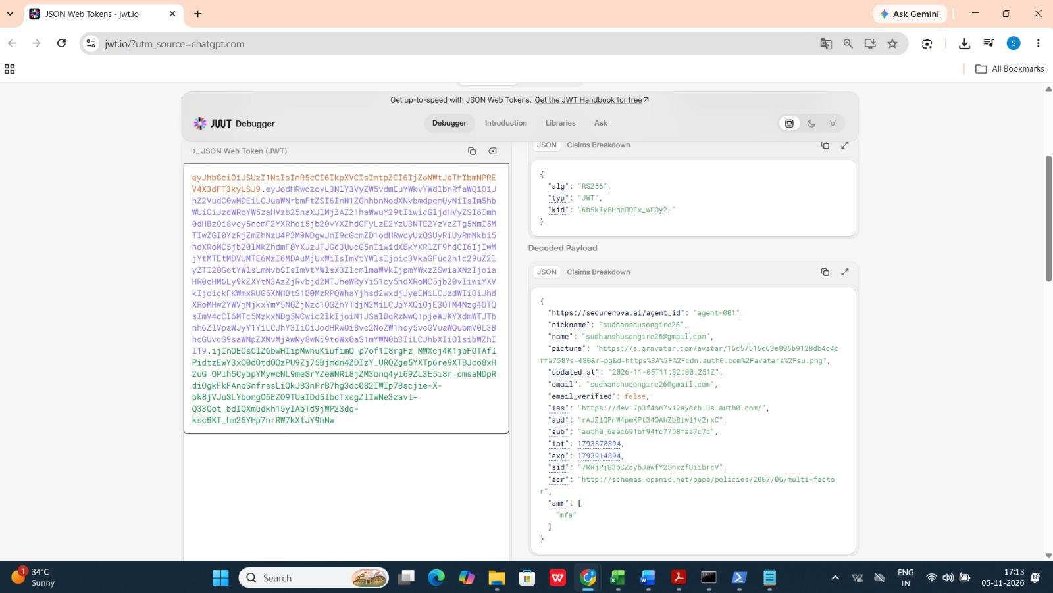
Figure 12: The decoded ID-token payload in jwt.io shows the namespaced claim https://securenova.ai/agent_id with the value agent-001, providing decoded-token evidence of the Action output.

7. Auth0 Attack Protection
Auth0 attack protection features are enabled to help mitigate repeated login attempts and suspicious traffic from individual IP addresses.
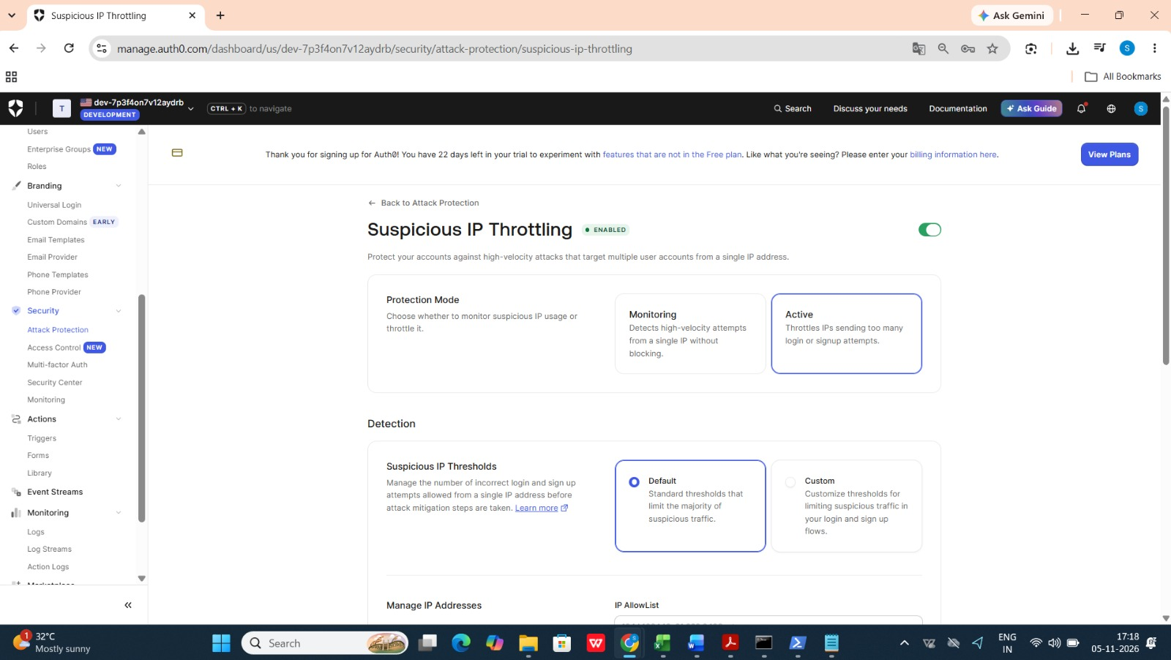
Figure 13: The Suspicious IP Throttling settings page shows the feature enabled and the protection mode set to Active. Active mode throttles IP addresses generating excessive login or sign-up attempts.
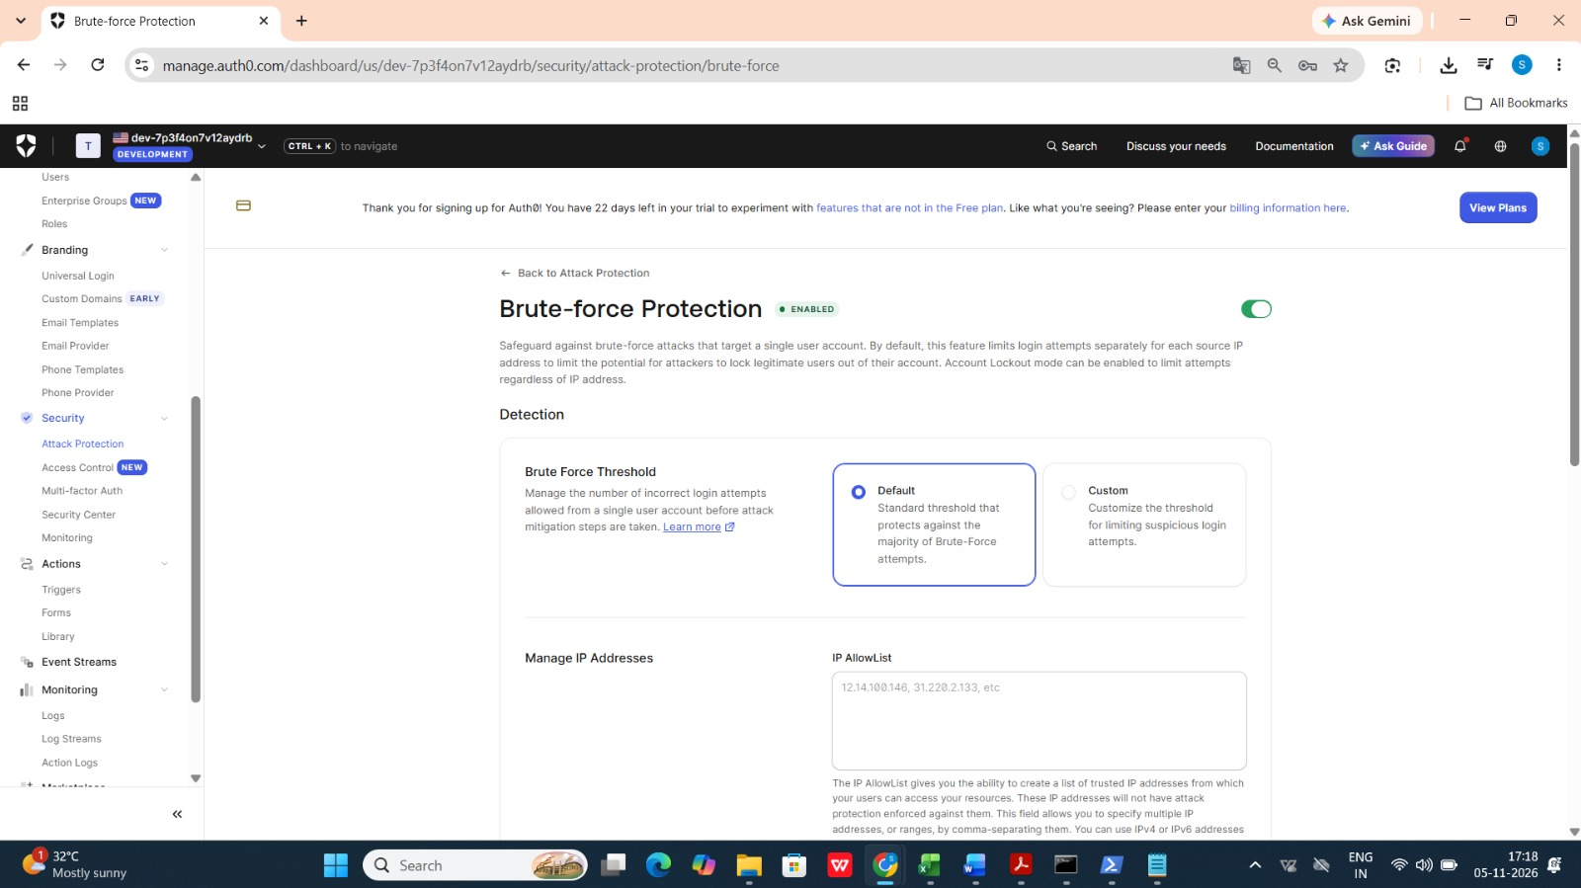
Figure 14: The Brute-force Protection settings page shows the feature enabled. This demonstrates that Auth0 brute-force protection is switched on for the tenant.

8. Short-Lived M2M Token and Expired-Token Replay
A Python test obtains a short-lived M2M token, calls the /chat endpoint while the token is valid, waits beyond the token lifetime, and replays the same token to confirm that the API rejects it.
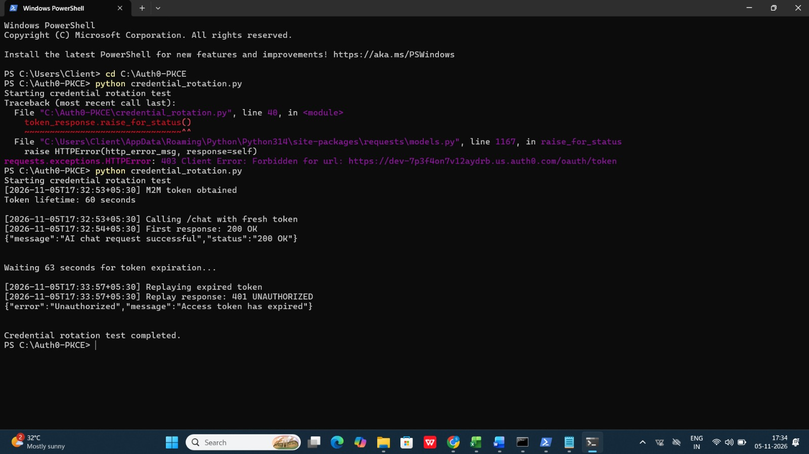
Figure 15: The terminal output shows the M2M token lifetime as 60 seconds, the first /chat request returning 200 OK, and replay of the expired token returning 401 UNAUTHORIZED after waiting 63 seconds.

9. Single Sign-On Across Web Applications
A second Regular Web Application is used to demonstrate authentication through the existing Auth0 session.
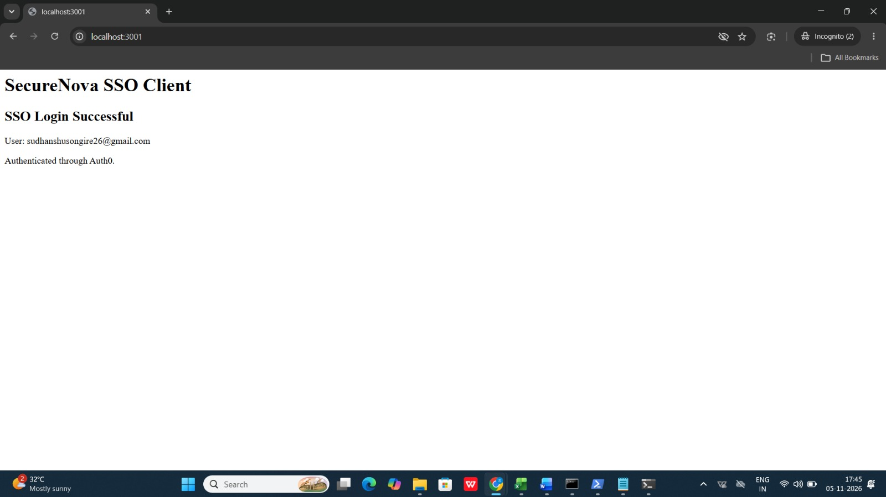
Figure 16: The SecureNova SSO Client page displays SSO Login Successful and confirms that the second web application authenticated through Auth0.

SUBMISSION COMPLETE
Capstone Project 2 — Auth0 Implementation
Accenture | Capstone Submission

