# **React With Java**

truthi-brave, dhrusti- foreseeing,mathi- talent, dhaksyam - ability a

>> Create a Java class which store the data members receive from React frontend – java object. (1)

>> Create a java class which process the object from above class. (2)

>> Calling the above class at frontend using **rpc** established in project (3)

<https://nextjs.org/learn/dashboard-app>

Maven is a Java build automation tool, and npm is a Node. js package manager and build automation tool. Both tools are intended to automate the process of developing, testing, and deploying software, and they both include a plethora of built-in functionality for common build tasks.

sudo apt install zip

zip -r source_folder.zip source_folder/*

**Spring**

In layman’s terms, it’s an application framework that helps you build Java applications with all bells and whistles really fast.

**Spring Boot**

Spring Boot is a solution for creating stand-alone, production-grade Spring-based Applications that you can "just run" with very little configuration. In simple terms, it can help you get started in building a REST API server in less than 30 minutes.

Example:

User need to create volume group, creating java class which stores the user input, and using this object data another class which responsible to invoke the CLI by calling API call to CLI creates the volume group based on input given by user

1. class CreateVolumeGroupInput - with private data members
2. class CreateVolumeGroupTask – at volumes package
3. launch (task:await rpc.volumes.createVolumeGroup( new CreateVolumeGroupInput(name, size, type), 123) );

**REST API:**

* They follow a client-server model where one software program sends a request and the other responds with some data.
* REST APIs commonly use the HTTP protocol to send requests & receive responses.

# **Java Script ES6**

Refer the best module – [ES6 by JS](https://www.javascripttutorial.net/es6/)

To run js on cmd use command Node <file.js>

### **Basics**

* [let](https://www.javascripttutorial.net/es6/javascript-let/) – declare block-scoped variables using the let keyword. With in {} braces scoped.
* [const](https://www.javascripttutorial.net/es6/javascript-let/) – declare block-scoped variables using the const keyword. But the value can’t be changed but returns new variable with value.
* var – declare global-scoped when declare outside of the function or block {}, can be used though out the class anywhere.

typesof(var) -can returns the type of an element. Instanceof

Arrow functions const fun = (…args)=>{}; here this couldn’t work.

const a = [1,2,3,4];

.map is used to return the value in object/array >> console.log(array.map(ar => ar+1));//[2,3,4,5,]

.filter is used to return the filtered object values >> console.log(a.filter(ar => (ar/2 ===1)));//2

Const date = new Date();

date.getFullYear(); date.getDay(); date.getMonth()+1;

let current date = `${date}-${month}-${year}` //String literals

Tip01: The advantage of using static functions or properties in a class is that:

* They can be used to create functions/properties which need not be present in the instances. This helps to maintain some isolation in the codebase.
* They reduce code redundancy in some cases.

**Tip02**: to iterate though the array need to use “of” like, for I of array. To iterate through the object need to use “in” for I in object.

in > iterates through key in object, where “of ” > iterates through the value of array.

let language = "JavaScript";  
  
let text = "";  
for (let x of language) {  
text += x;  
}

for(let c in  charObj){

        if(charObj[c]%2 ==1){

            odd++;

        }

    }

If nominator is less than the denominator then it the mod result is nominator only.

onEvent(“id”, “event”, function());

### **Class and Objects**

Classes were introduced in [ECMAScript 2015](https://262.ecma-international.org/6.0/) (ES6) to provide a cleaner way to follow object-oriented programming patterns. Class is blueprint of an object.

Classes are developed on behalf of constructor functions. In this type of implementation its hard to add functions. Like need to use Pen.prototype.showprice = ()=>

function Pen(name, color, price) {

this.name = name;

this.color = color;

this.price = price;

}

const pen1 = new Pen("Marker", "Blue", "$3");

console.log(pen1);

We can re-create the above example with the help of the class keyword. Have a look at the below code:

class Pen {

constructor(name, color, price){

this.name = name;

this.color = color;

this.price = price;

}

showPrice(){

console.log(`Price of ${this.name} is ${this.price}`);

}

}

const pen1 = new Pen("Marker", "Blue", "$3");

pen1.showPrice();

Implement JavaScript inheritance using **extends** and **super – here mostly can use static types.**

Objects: Objects in everyday life have properties and “method” actions. Take, for instance, a fan. It's an object with humidity.

Creating an object without class:

const person = {

‘name’:'kamal',

age:30,

friends:[

'Shola','Ade','Ibraheem'

],

greet:function(){

alert('Hello World')

}

}

Console.log(Person.name);

For key properties– dot - must a variable or key

To Access a property > person.age;

To Delete a property> delete person.age;

To Modify a property or adding property(if new)> person.age = 30;

For without key properties– it is achievable by square brackets: To Access a property > person[‘name’] and person[“age”]; -> must string

function getAge(obj) {

*//console.log(obj.name);*

  return obj["age"];

}

*//bracket notation is used to retrive using string not variable*

**Reasons for Separate Syntax:**

**When creating class with methods, the class methods don’t follow any function keyword, because to differentiate the normal/regular function to class function.**

**And also class methods implicitly inherits the context of class instance, by this keyword**

There are a few reasons why JavaScript uses a different syntax for class methods:

* **Clarity:** Separating class methods from regular functions makes the code structure clearer, especially when dealing with complex classes with many methods.
* **Context:** Class methods inherently have access to the class instance (object) through the this keyword, which isn't the case with regular functions. The simpler syntax reflects this difference in context.
* **Conciseness:** Omitting the function keyword makes the code more concise and easier to read, particularly for methods that are likely to be used frequently within the class.

Object Spread Operator

The object spread operator is a popular and powerful syntax in JavaScript. The spread operator takes all the key-value pairs of an object and copies the key name and value into a new object.

Object Destructuring

Object destructuring is an important feature in JavaScript that allows you to pull out values from an object and assign them to individual variables.

const person = { name: 'lawal', age: 39 };

const { person, age } = person;

console.log(name); // 'lawal'

console.log(age); // 39

### **Arrays**

It stores multiple values and elements in **one** variable. These values can be of any data type — meaning you can store a string, number, boolean, and other data types in one variable.

There are two standard ways to declare an array in JavaScript. These are either via the array constructor or the literal notation and using new Array.

// Using array constructor

let array = new array("John Doe", 24, true);

// Using the literal notation

let array = ["John Doe", 24, true];

const cars = new Array("Saab", "Volvo", "BMW");

Accessing an element => array[0]

Changing an element => array[0] = 10;

Array to String => array.to String();

array.length; array.sort();

adding an element: returns new length deleting an element  
array.push(45); -adds at end array.pop() – remove at end

array.unshift(77 ); - adds at beginning array.shift() – removes at beginning

array1.concat(array);

Splicing and Slicing Arrays

Array.splice(start, removeCount, newItem, newItem, newItem, ...)

let months = ["January", "February", "Monday", "Tuesday"];

let days = months.splice(2);

console.log(days); // ["Monday", "Tuesday"]

fruits.splice(2, 0, "Lemon", "Kiwi");- The splice() method can be used to add new items to an array.

const citrus = fruits.slice(1); - The slice() method slices out a piece of an array into a new array.

Array Destructuring: (… rest parameter)

function getScores() {

return [70, 80, 90, 100];

}

let [x, y, z] = getScores();

console.log(x); // 70

console.log(y); // 80

console.log(z); // 90

### **Strings**

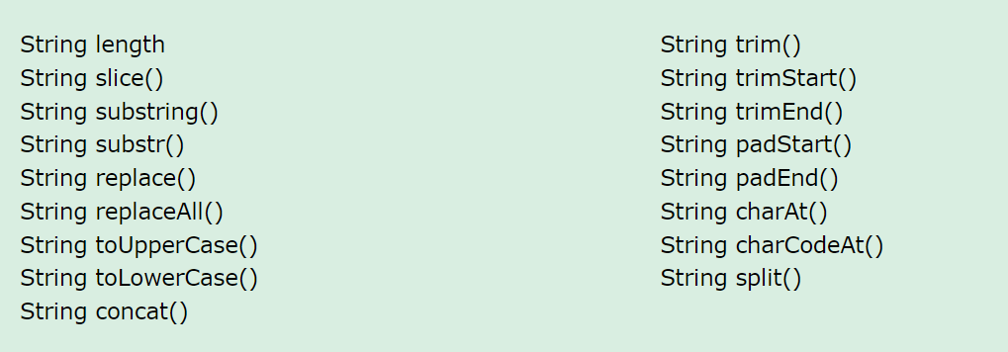

### **Collections**

Map Object - the Map type that holds a collection of key-value pairs.

1. An object always has a default key like the [prototype](https://www.javascripttutorial.net/javascript-prototype/).
2. A key of an object must be a [string](https://www.javascripttutorial.net/javascript-string/) or a [symbol](https://www.javascripttutorial.net/es6/symbol/), you cannot use an object as a key.
3. An object does not have a property that represents the size of the map.

let userRoles = new Map([

[john, 'admin'],

[lily, 'editor'],

[peter, 'subscriber']

]);

Key is use din map methods=>map.set(john:’admin’), map.has(john);map.delete(john); map.clear()

let john = { name: 'John Doe' },

lily = { name: 'Lily Bush' },

peter = { name: 'Peter Drucker' };

let userRoles = new Map([

[john, 'admin'],

[lily, 'editor'],

[peter, 'subscriber'],

]);

for (const user of userRoles.keys()) { //can be used .values() {value to be returned} instead of .keys() or .entries {}

console.log(user.name);

}

for (let role of userRoles.values()) {

console.log(role);

}

for (const role of userRoles.entries()) {

console.log(`${role[0].name}: ${role[1]}`);

}

for (let [key, value] of chars.entries()) {

console.log(key === value);

}

chars.forEach(role => console.log(role.toUpperCase()));

Here are the main difference between a Map and a WeekMap:

* Elements of a WeakMap cannot be iterated.
* Cannot clear all elements at once.
* Cannot check the size of a WeakMap.

Set Object - the Set type that holds a collection of unique values.

let setObject = new Set();

let chars = new Set(['a', 'a', 'b', 'c', 'c']);

let size = chars.size;

chars.add('d');

let exist = chars.has('a');

console.log(exist);// true

chars.delete('d');

chars.clear();

for (let role of chars) {

console.log(role);

}

WeakSets

A WeakSet is similar to a Set except that it contains only objects. Since objects in a WeakSet may be automatically garbage-collected, a WeakSet does not have size property. Like a WeakMap, you cannot iterate elements of a WeakSet, therefore, you will find that WeakSet is rarely used in practice. In fact, you only use a WeakSet to check if a specified value is in the set.

Conditional loops and conditions:

If(i==10){  
}

Else if(i==11){

}

else{

}

while(i!=10){

}

for(int i=0;i<10;i++){

}

switch(case){

}

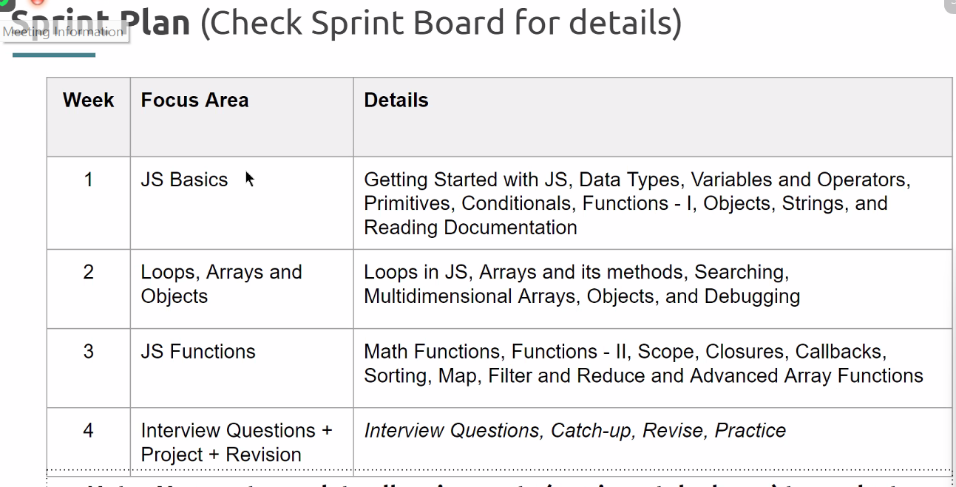

incase requirement is returnig the mutlple values, then maping them into object is works, so the names must be same in object.

### Array Advance Functions

map > returns the altered new array

filter > based on the check filters the array and returns new one

find > returns the first found value in array with new array

findIndex > returns the index of first value which passed the condition

forEach > nothing returns just iterates through the array.

### Object global methods

**Object.keys(obj):**

This function returns an array containing all the enumerable property names (keys) of an object.

Object.keys(country_state_obj).forEach(country => console.log(country));

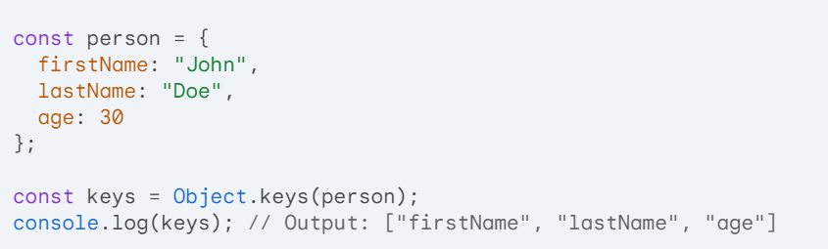

**Object.values(obj):**

This function returns an array containing all the enumerable property values of an object. Can do with array advance functions

Object.values(country).forEach(val => console.lo(val));

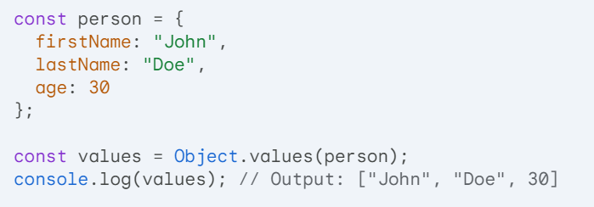

**Object.entries(obj):**

This function returns an array of key-value pairs from an object. Each pair is represented as a sub-array with the key at index 0 and the value at index 1.

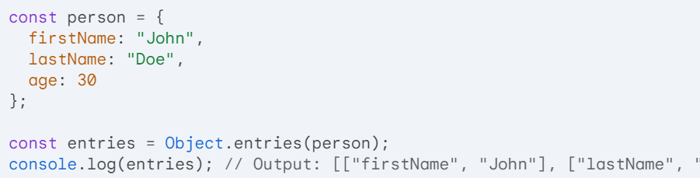

**Object.assign(target, ...sources):**

This function copies enumerable own properties from one or more source objects (sources) to a target object. It modifies the target object directly and returns the target object.

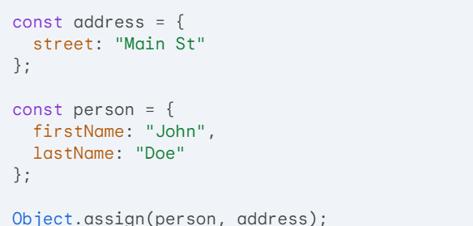

**console.log(person); // Output: { firstName: "John", lastName: "Doe", street: "Main St" }**

**Object.freeze(obj):**

* This function prevents further modifications to the properties of an object (including adding, removing, or changing the value of properties). It returns the frozen object.

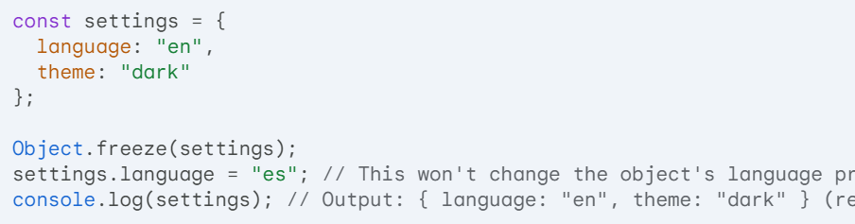

**Object.seal(obj):**

* Similar to Object.freeze, this function prevents adding new properties to the object but allows modification of existing properties. It returns the sealed object.

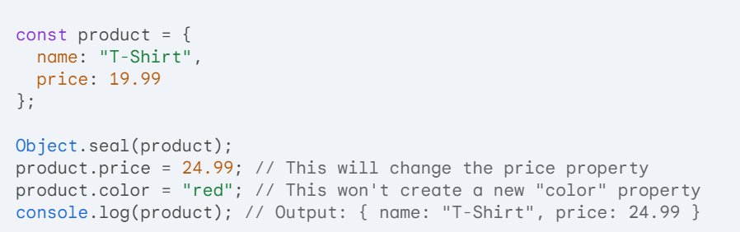

# **React JS**

React components are JS functions which returns JSX code, these functions are render via dom and the a root is created using JS in index.html.

Refer the Git Hub repository - [**React_Expenses_Project**](https://github.com/sudhaScode/React_Expenses_Project)

const root = ReactDOM.createRoot(document.getElementById('root'));

### **Getting started with React**

**==========================================================**

To setup client by learning below commands

$mkdir client

$npx create-react-app expenses

$npm install {all dependencies like react, react-dom, and react-scripts, webpack webpack-dev-server webpack-cli --save}

$cd expenses

$npm start

===================================================================

setup server

$npm init -y

$npm install {all server dependencies like express cors nodemon}

$npm start

**==========================================================**

### **Components in React**

Every components have two parts, one is for UI component, another for logic behind the component.

### **State, props, and Events**

* State management
* Components splitting and props
* Returning components conditionally

To send data from Parent to child can use JS variables inside the {} (JSX) at component calling**. [calling parent variable inside child component]**

To send data from child to parent can use event Listener functions with props at component calling, then calling that function inside of the child with object parameter(**props.parentfun(childdata)**), then the parent uses the objects inside it. **. [calling parent function inside child component, which handle the data send to that from child]**

Dynamic component return use achieved by useState hook and with ternary or conditional statements. And using .map can update list of objects for a component dynamically.

Dynamic style updating for components is achieved by inline style {{}} or className = {`exp+${with JS variable}`}

Dynamic styling React components

* >> **npm install –save styled-**components {import styled from ‘styled-components’;} const button = styled.button`css bricks`; inside back ticks for nested elements use &
* **Inline styling**
* **CSS Modules –** className = {props.styles}

<https://github.com/academind/react-complete-guide-code/tree/06-styling>

**Debugging React apps:** use console are result of npm start or npm run watch

**Styling:**

Inline CSS : style ={{}}

CSS-Module : className = {classes.button} [App.module.css]

Custom Error Handling : based on the value of the state, rendering a component

const submitHandler =(event)=>{

        event.preventDefault();

        if(userName.length === 0 || userAge.length === 0){

            setError({

                title:"Invalid input",

                message:"Please enter a valid name and age (non-empty values).",

            });

            setUsername(null);

            setUserage(null);

        }

        else if(+userAge<1){

            setError({

                title:"Invalid age",

                message: "  please enter a valid age > 0",

            });

            setUsername(null);

            setUserage(null);

        }

        else{

        const userData ={

            name:userName,

            age: userAge,

        }

        props.onAdd(userData);

        setUsername('');

        setUserage('');

    }

    }

**UI Cards:**  
it uses a props.children as data

UI cards are used to wrap the components in card components, it is possible by passing the dynamic classnames to extending the CLASS NAME of UI card component.

import classes from './Page.module.css';

function Page(props){

    return (

        <div className={`${classes.card} ${props.className}`}>{props.children}</div>

    );

}

export default Page;

.card{

    background: rgb(63, 63, 63);

    box-shadow: 0 2px 8px rgba(0,0,0,0.26);

    border-radius: 10px;

}

Wrapping among individual components

<Page className={classes.data}> components </Page>

### **Fragments, Portals & Refs -Hooks, React-Context**

Hooks are helper functions.

Types of Hooks:

1. **State Hooks** – useState(); useReducer()

[useState](https://react.dev/reference/react/useState) declares a state variable that you can update directly.

[useReducer](https://react.dev/reference/react/useReducer) declares a state variable with the update logic inside a [reducer function.](https://react.dev/learn/extracting-state-logic-into-a-reducer)

1. **Context Hooks** – useContext()

*Context* lets a component [receive information from distant parents without passing it as props.](https://react.dev/learn/passing-props-to-a-component)

1. **Ref Hooks** – useRef(), useImaprativeHandle() - *Refs* let a component [hold some information that isn’t used for rendering](https://react.dev/learn/referencing-values-with-refs)

[useRef](https://react.dev/reference/react/useRef) declares a ref. You can hold any value in it, but most often it’s used to hold a DOM node.

[useImperativeHandle](https://react.dev/reference/react/useImperativeHandle) lets you customize the ref exposed by your component. This is rarely used.

1. **Effect Hooks –** useEffect(), *Effects* let a component [connect to and synchronize with external systems.](https://react.dev/learn/synchronizing-with-effects)

[useEffect](https://react.dev/reference/react/useEffect) connects a component to an external system.

1. **Performance Hooks -**useMemo(), useCallback() . A common way to optimize re-rendering performance is to skip unnecessary work.

To skip calculations and unnecessary re-rendering, use one of these Hooks:

* [useMemo](https://react.dev/reference/react/useMemo) lets you cache the result of an expensive calculation.
* [useCallback](https://react.dev/reference/react/useCallback) lets you cache a function definition before passing it down to an optimized component.

1. Resource Hooks – use(). *Resources* can be accessed by a component without having them as part of their state.

To read a value from a resource, use this Hook:

* [use](https://react.dev/reference/react/use) lets you read the value of a resource like a [Promise](https://developer.mozilla.org/en-US/docs/Web/JavaScript/Reference/Global_Objects/Promise) or [context](https://react.dev/learn/passing-data-deeply-with-context).

**Other Hooks**

These Hooks are mostly useful to library authors and aren’t commonly used in the application code.

* [useDebugValue](https://react.dev/reference/react/useDebugValue) lets you customize the label React DevTools displays for your custom Hook.
* [useId](https://react.dev/reference/react/useId) lets a component associate a unique ID with itself. Typically used with accessibility APIs.
* [useSyncExternalStore](https://react.dev/reference/react/useSyncExternalStore) lets a component subscribe to an external store.

useState hook updates the value of the variable in next re-render, where useRef make updates the value instantly without waiting for re-render it don’t cause to rerender – no display of update value – when just to read .

const usernameRef =useRef();

ref ={usernameRef}

enteredName = usernameRef.current.value;

React.forwardRef(( props, ref)

|  |  |
| --- | --- |
| **useState()** | **useReducer()** |
| * The main state management “tool”. * Great for independent pieces of state/data. * Great if state updates are easy and limited to a few kinds of updates. * Causes a re-render. | * Great if you need to add more power. * Should be consider if you had related pieces of data/state. * Can be helpful if you have more complex state updates. |

<React.Fraagment>

//it wraps the children components and without adding a node to DOM

</React.Fraagment>

const root = ReactDOM.createRoot(document.getElementById(‘root’));

root.render(<React.StrictMode> <App/></React.StrictMode>);

<https://github.com/academind/react-complete-guide-code/tree/09-fragments-portals-refs/code>

sideEffects:

useEffect: useEffect ((()=>{ //The code will run here},[//dependency])); When component mounted at least the useEffect blocked to code will runs , if dependency is given useeffect listens the change of the array elements, as per the change useeffect re-renders the updated components.

To make a component responsive with side effects(user interacts), based on current state of component.

**Cleanup** function in useEffect , use return at code block.

useEffect(()=>{

const identifier = setTimeout(()=>{

console.log(‘checking form validity’);

setFormInvalid(enteredEmail.includes(‘@’) && enteredPassword.trim().length>6);

}, 500);

return ()=>{

cosole.log(‘clean up!’);

clearTimeout(identifier);

};

}, [enteredEmail, enteredPassword]);

**useReducer:** One reducer equal to two useState hook, only one reducer is enough to use&set and validate the state

cosnt [state, dispatchFn] = useReducer(resucerFn, initialSate, initFn);

useCallback: this hook is used to improve the performance of an component by saving the implementation and invoking the implementation based on the state changes of component variables(keeping as dependencies[]). Normally used for functional changes.

usecallback(()=>{},[]);

useMemo also a similar hook used to improve performance by optimizing complex calculation based on dependencies.

React.memo is used to trace the props changes send to the child component and if changes are made to the props values then the component re renders other wise it won’t allow to re render. It is used at exporting syntax. **export default React.memo(App);**

**React Context: Manage state (Shared state among componenets)**

**To create context:**

Example:

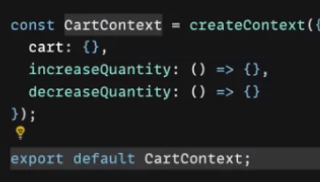

**To use context:**

Create a Reducer(state, action) function and pass to useReducer.

**const ctx = useContext(**React.createContext());

const   [cartSate, dispatchCartAction] =useReducer(cartReducer, defaultCartState);

**To update context:**

<CartContext.Provider> some code to share the global state share</ CartContext.Provider >

**const ctx = useContext(**React.createContext());

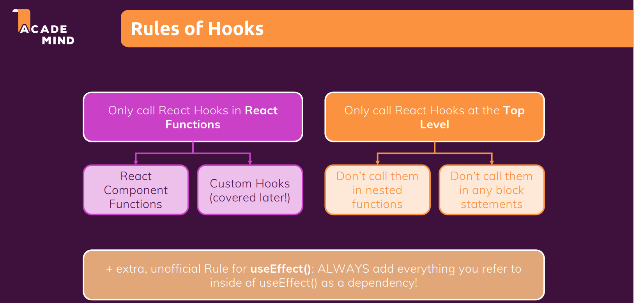

<https://github.com/academind/react-complete-guide-code/tree/10-side-effects-reducers-context-api>

**Backdrop and overlay in React application:**

**Add overlay id in index.html at public folder.**

import styles from './Modal.module.css';

import { Fragment } from 'react';

import ReactDOM from 'react-dom';

const Backdrop =props=>{

        return <div className={styles.backdrop} onClick ={props.onClose}></div>

};

const ModalOverlay  = props =>{

    return(

        <div className={styles.modal}>

            <div className={styles.content}>{props.children}</div>

        </div>

    );

};

const portalElement = document.getElementById('overlays');

const Modal = props=>{

    return(

    <Fragment>

        {ReactDOM.createPortal(<Backdrop onClose={props.onClose}/>, portalElement)}

        {ReactDOM.createPortal(<ModalOverlay>{props.children}</ModalOverlay>, portalElement)}

    </Fragment>

    );

};

export default Modal;

Using context hook getting the props of distant component is availed by following process: (Food- Order project)

Follow Up 1: create context

const Cartcontext = React.createContext({

    items:[],

    totalAmount:0,

    addItem: (item) =>{},

    removeItem: (id)=>{},

})

This Cartcontext works as a wrapper element.

Follow Up 2: create a component for provider, here the prop objects are handled

import Cartcontext from "./cart-context"

import { useReducer } from "react";

const defaultCartState = {

    items:[],

    totalAmount:0,

};

const cartReducer = (state, action) =>{

    if (action.type === 'ADD'){

        const updatedItems = state.items.concat(action.item);

        const updatedTotalAmount = state.totalAmount + action.item.price*action.item.amount;

        return{

            items:updatedItems,

            totalAmount:    updatedTotalAmount

        };

    }

    return defaultCartState;

};

const CartProvider = props=>{

    const   [cartSate, dispatchCartAction] =useReducer(cartReducer, defaultCartState);

    const addItemToCartHandler =(item) =>{

        dispatchCartAction({type:'ADD', item: item })

    };

    const removeItemFromCartHandler =(id) =>{

        dispatchCartAction({type: 'REMOVE', id: id})

    };

    const cartContext = {

        items:cartSate.items,

        totalAmount: cartSate.totalAmount,

        addItem: addItemToCartHandler,

        removeItem: removeItemFromCartHandler,

    };

    return(

        <Cartcontext.Provider value={cartContext}>

            {props.children}

        </Cartcontext.Provider>

    );

}

export default CartProvider;

Follow Up 3: Fast forwarding the user input by useRef

import classes from './Input.module.css';

import React from 'react';

const Input = React.forwardRef(( props, ref) =>{

    return(

        <div className={classes.input}>

            <label htmlFor={props.input.id}>

               {props.label}

            </label>

            <input ref ={ ref} id ={props.input.id} {...props.input}/>

        </div>

    );

});

export default Input;

Follow Up 4: get the user input from child to parent and update the context object:

import classes from './MealItem.module.css';

import MealItemForm from './MealItemForm';

import { useContext } from 'react';

import Cartcontext from '../../../store/cart-context';

const MealItem = props =>{

    const cartCtx = useContext(Cartcontext);

    const price = `$${props.price}`;

    const onAddtoCartHandler = amount =>{

        cartCtx.addItem({

            id: props.id,

            name: props.name,

            amount:amount,

            price: props.price

        });

    };

    return(

        <li className={classes.meal}>

            <div>

                <h3>{props.name}</h3>

                <div className={classes.description}> {props.description}</div>

                <div className={classes.price}>{price}</div>

            </div>

            <div>

                <MealItemForm id = {props.id} onAddtoCart ={onAddtoCartHandler}/>

            </div>

        </li>

    );

}

export default MealItem;

Follow Up 5: render the context property in current component where needs to render:

import { useContext } from "react";

import CartIcon from "../Cart/CartIcon";

import styles from './HeaderCartButton.module.css';

import Cartcontext from "../../store/cart-context";

const HeaderCartButton = props =>{

    const cartCtx = useContext(Cartcontext);

    const numberofCartItems = cartCtx.items.reduce((current,item)=>{

        return current+item.amount},0);

    return(

        <button className={styles.button} onClick ={props.onClick}>

            <span className={styles.icon}>

                <CartIcon/></span>

            <span>Your Cart</span>

            <span className={styles.badge}>{numberofCartItems}</span>

        </button>

    );

};

export default HeaderCartButton;

**Conditional Rendering with logical && and Ternary operator can be implemented.**

### UI CARD

This type of components are used to wrap the react components to maintain consistency.

Create a card with props.childeren,

function Card (props){

    return (

        <div className = {`${styles.card} ${props.className}`}>

           {props.children}

        </div>

    );

}

.card{

    border-radius: 4px;

    background: wheat;

    box-shadow: 0 2px 8px rgba(160, 129, 129, 0.26);

}

Where above component is wrapped to component with claasName , the className contains css properties

### Class based components

class comp extends components{\

constructor(){

super();

this.state = { hasError:false};

}

render(){

return(

<h1>Class component<h1>

)  
 }

}

Class based components can’t use React Hooks.

<https://github.com/academind/react-complete-guide-code/tree/13-class-based-cmp>

### Database connectivity for React Apps

**Using the Star Wars API**

In the next lecture, you will be introduced to our demo backend that will be used in this course section: The Star Wars API.

I will use this page: <https://swapi.dev/>

Loading this page (and hence accessing this backend) **might fail** - if that is the case for you, you can **use this alternative**: <https://swapi.py4e.com/>

<https://github.com/academind/react-complete-guide-code/tree/14-sending-http-requests>

### **API FECTH CALL:**

This fetch call is implemented for routing components.

export async function loader(){

    const response = await fetch('http://localhost:8080/events');

    if(!response.ok){

     // return {isErorr: true, message:"Couldn't"}

     throw new Response(JSON.stringify({title: "error", message:"Couldn't load data"}),

     {status: 500})

    }

    else{

      //  const resData = await response.json();

        return response;

    }

}

API POST CALL:

This post call is implemented to get data from nested route component using request.formData() and sending to server.

export async function action({request, params}){

    const data = await request.formData();// getting data from router component where action property is initialized.

    const eventData = {

      title: data.get('title'),

      image: data.get('image'),

      date: data.get('date'),

      description: data.get('description')

    }

    console.log(eventData)

const response = await fetch('http://localhost:8080/events',  {

  method:'POST',

  headers: {'Content-Type': 'application/json'},

  body: JSON.stringify(eventData),

});

if(!response.ok){

  throw json({title:"Server is not responding",message:"Data can't sent" }, {status: 500} );

}

return redirect('/events');

}

Delete API Call:  
this delete API call implemented for route level action using submit hook

export async  function action({request , params}){

  const id = params.eventid; // it takes path id from route deffination

  console.log(id);

  const response = await fetch('http://localhost:8080/events/'+id, {method:request.method,});

  if(!response.ok){

    throw   json({message:"deleting is failed"},{status: 500});

  }

  return redirect('/events');

}

PUT/PATCH CALL:

export async function action({request, params}){

    const data = await request.formData();

    const method = request.method;

    const eventData = {

      title: data.get('title'),

      image: data.get('image'),

      date: data.get('date'),

      description: data.get('description')

    }

    console.log(method)

    let url =   'http://localhost:8080/events';

    if(method === 'PATCH'){

      const eventid = params.eventid;

      url ='http://localhost:8080/events/'+ eventid;

    }

const response = await fetch(url,  {

  method: method,

  headers: {'Content-Type': 'application/json'},

  body: JSON.stringify(eventData),

});

if(response.status === 422){

     return response;

}

if(!response.ok){

  throw json({title:"Server is not responding",message:"Data can't sent" }, {status: 500} );

}

return redirect('/events');

}

Custom Hooks:

<https://github.com/academind/react-complete-guide-code/tree/15-building-custom-react-hooks>

https://academind.com/tutorials/reactjs-a-custom-useform-hook/

const value = useCustom();

## Redux:

What is Redux?

A State management system for cross-component or app-wide state.

**Local State:**  
State that belongs to a single component.

Eg: listening to user input in a input filed; toggling a “show more ” details filed.

Should be managed component-internal with useState() / useReducer().

**Cross-Component State:**

State that effects multiple components.

Eg. Open/Closed state of a modal overlay.

Requires props chains/ props drilling./React context or Redux

**App-Wide State**

State that affects the entire app (most/all components)

Eg: user authentication status

Requires props chains/ props drilling. /React context or Redux

**Why Redux? React Context potential disadvantages:**

>>>Complex Setup by context

>>> Performance – not recommended for high frequency apps

**Central Data (State) Store:**

Indeed, the React Redux team now recommends the usage of an extra package called **Redux Toolkit** and another way of creating the Redux store.

**To create store**: import { configureStore } from '@reduxjs/toolkit';

>>> createStore, reducer function => state

* 1. Create a initial state with needed state variables
  2. Using the initial state update the value using reducer function

Reducer must be pure, side effect free, synchronous functions

import { configureStore } from '@reduxjs/toolkit';

const initialState = { counter: 0, showCounter: true}; // Initial state for your reducer

const counterReducer = (state = initialState, action) => {

  if (action.type === 'increment') {

    return {

      counter: state.counter + 1,

      showCounter: state.showCounter

    };

  }

  if (action.type === 'increase'){

    return{

      counter: state.counter + action.amount,

      showCounter: state.showCounter

    }

  }

  if (action.type === 'decrement') {

    return {

      counter: state.counter - 1,

      showCounter: state.showCounter

    };

  }

  if (action.type === 'toggle'){

    return{

      showCounter: !(state.showCounter),

      counter: state.counter

    }

  }

  return state;

};

const rootReducer = {

  counter: counterReducer,

  // You can add more reducers here if needed

};

const store = configureStore({

  reducer: rootReducer,

  // Other store configuration options if needed

});

export default store;

**To update Store:** , useDispatch() and dispatch ({action.type=== ‘incremanet’})

**To use Store:** import {useSelector, useDispatch} from 'react-redux';

>>> useSelector(state. counter. counter),

## **Redux Toolkit**

**To configure store:**

configureStore();

assign a object with reducer property

const store = configureStore({

  reducer: {counter: counterSlice.reducer, auth:authSlice.reducer},

  // Other store configuration options if needed

});

export const counterActions = counterSlice.actions;

export const authActions = authSlice.actions;

export default store;

**To create Store:**

Declare a initial state

Using createSlice implement the functions in reducers.

import { createSlice } from '@reduxjs/toolkit';

const initialAuthActionState = {isAuthenticated: false};

const authSlice = createSlice({

    name: "authentication",

    initialState: initialAuthActionState,

    reducers:{

      login(state){

        state.isAuthenticated = true;

      },

     logout(state){

      state.isAuthenticated = false;

     },

    }

  });

  export default authSlice;

**To use and update Store:**

useDisptach(), useSelector(),

Update

 const dispatch=useDispatch();

    const signinHandler = ()=>{

        dispatch(authActions.login());

    };

    const signoutHandler =()=>{

        dispatch(authActions.logout());

    }

Use

const auth = useSelector(state => state.auth.isAuthenticated);

The auth is the name that we give to reducer in configure store.

## Advanced Redux

* Handling async tasks with redux
* The Redux dev tools

**Redux and Async Code:**

Reducer must be pure, side effect free, synchronous functions and any aysnc API calls must not be run in reducers.

Instead of calling API calls in reducers functions implement inside components (like useEffects()) or inside action items.

Where should our logic (code) go?

|  |  |
| --- | --- |
| Synchronous, side-effect free code (i.e data transformation) | Asynchronous, side-effect code |
| Prefer Reducers  Avoid actions creators and components | Avoid Reducers  Prefer actions creators and components |

**Redux DevTools: extension**

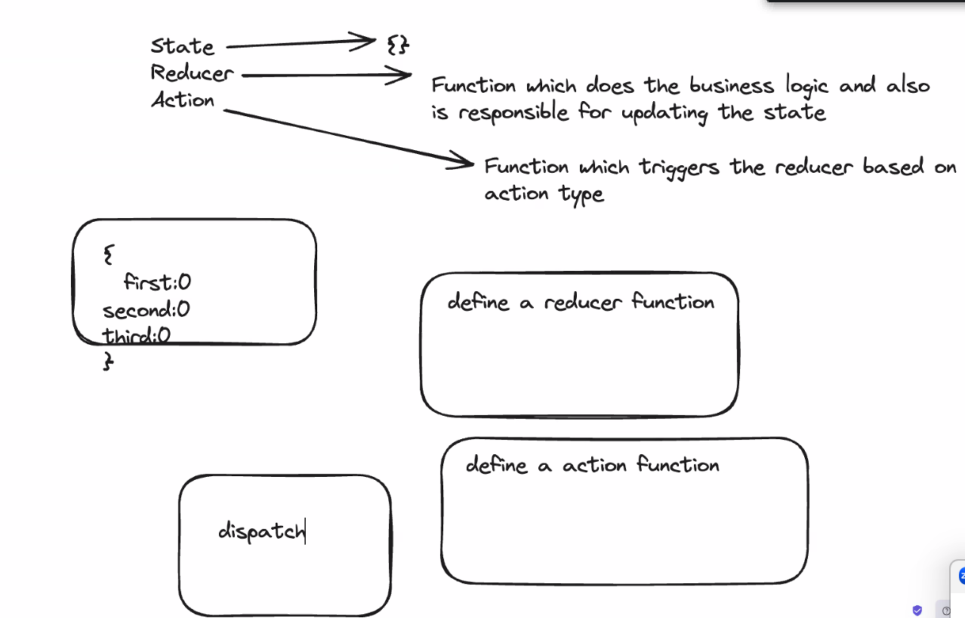

## React Router – Single page application routing

Client-side routing – using React-Router package. -**npm install react-router-dom**

**Navigation:**

* Process: When the user interacts with a navigation element (link, button, etc.), the browser typically updates the current page's content without making a full request to the server. The browser uses the href attribute (for links) or JavaScript code to manipulate the Document Object Model (DOM).
* URL Manipulation: The URL in the address bar might change to reflect the new content, but this can be controlled by the developer using techniques like client-side routing (e.g., React Router).
* Server Interaction (Optional): While navigation usually doesn't involve a server request, JavaScript code triggered during navigation might fetch data from the server. This can be done using techniques like AJAX (Asynchronous JavaScript and XML) to update the page dynamically without a full reload.
* History Management: Browser history is updated with the new page's state, allowing the user to use the back and forward buttons to navigate back and forth.

**Redirection:**

* Process: Redirection involves the server instructing the browser to fetch a different resource (a new web page) altogether. This is typically initiated by the server sending a specific HTTP status code (e.g., 301 Moved Permanently, 302 Found) along with a Location header containing the URL of the new page.
* URL Change: The URL in the address bar always changes to reflect the newly requested page's URL.
* Server Interaction: Redirection is always initiated by the server, typically in response to a user's request or based on server-side logic.
* History Management: Browser history might not always be updated in the same way as navigation. For temporary redirects (302 Found), the original URL might remain in the history, while permanent redirects (301 Moved Permanently) might update the history with the new URL.

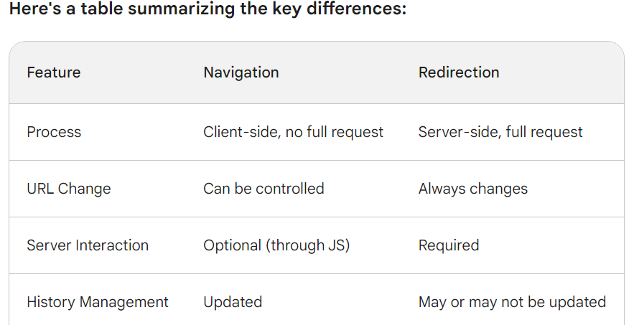

**What is Routing** - Changing the URL end point/parameter as per client request.

**Defining Router:**

**Object based approach:**

Import createBrowserRouter =>>> const router = createBrowserRouter([_PATH_]);

const router = **createBrowserRouter**([

{ path :’/’, element : <HomePage/>}

{path: ‘/products’, element: <ProductPage/>}

]);

**<RouterProvider router ={router}/> -** it is interface component to call and render the nav component

**<Outlet/>** is responsible to rendering the route defined component

**To make dynamic paths use “:” colon >** ‘products/:poductId’

**Link** feature in react-router-dom, to replace anchor tag(<a><a/>, which cause a requesting html pages from server)

**NavLink -**Updated version of Link

<li>

            <NavLink to = "/"

            className={({isActive})=>isActive? classes.active:undefined} end >Home</NavLink>

            </li>

**Dynamic Routing**

**const params = useParams()** >> to use url endpoint id params.productId

const params = useParams();

<p>{params.id}</p>

**useNavigate –** to navigate programmatically

const navigate = useNavigate();

   const navigateHandler = ()=>{

      navigate('/events/new');

   }

**useNavigation –**

const navigation = useNavigation();

const isSubmitting = navigation.state === 'submitting';

**Relative and Absolute paths**

<Link to = "../.." relative="path">Back</Link>

In relative path the parent path navigate to child paths

Where absolute path every navigation is independent of parent.

**Index Routes**

const router = createBrowserRouter(

  [{

    path:'/',

    element:<RootLayout/>,

    errorElement: <ErrorPage/>,

    children:[

  //{path:'', element: <HomePage/>},

  {index:true, element: <HomePage/>},

  {path: 'events', element: <EventsPage/>},

  {path: 'events/eventDetails/:id', element:<EventDetailPage/>},

  {path:'events/new', element:<NewEventPage/>},

  {path: 'events/:id/edit', element:<EditEventPage/>}],

},

]);

**useLoader from route definition**

useLoader is used to get fetched data from server API at loader property.

const events = useLoaderData();

**useRouteLoaderData(“id”);** - when there is no element property in that path , using id property can get the loader data. Best use for the case when the neighbour loader data is need to use, then making the loader as parent can work. Argument is id property from route

 const data = useRouteLoaderData("event-detail");

**useActionLoader();** is used to get the response from backend API call retuned VALIDATION data

const data = useActionData(); // from backend

**useSubmit()** is used to pass the action and method to the respective delete call

function startDeleteHandler() {

    const procced = window.confirm("Are you sure?");

    if(procced){

    submit(null, {method:"delete"})

    }

  }

When dealing with router and its components , possibility of props- lifting state up working is low, because in routing a single component is mapped to different parent component. Because of that state up is only intended to specific parent component.

**Loader** to fetch the data from server and where **action** is used to post/patch data to server.

**formData()** is used to get the data from **form**

const data = await request.formData();

**useFetcher()** is used tom get the returned response from action function of the component, **useFetcher() to invoke action or loader without loading the page or route.**

const fetcher = useFetcher(); // to get respose of action

    const {data, state} = fetcher;

**redirect() is** used to navigate to a specific path.

return redirect('/events');

**defer() –** is used to improve the performance of the fetch API by using the loaded part of data. **asynchronous data loading and render**

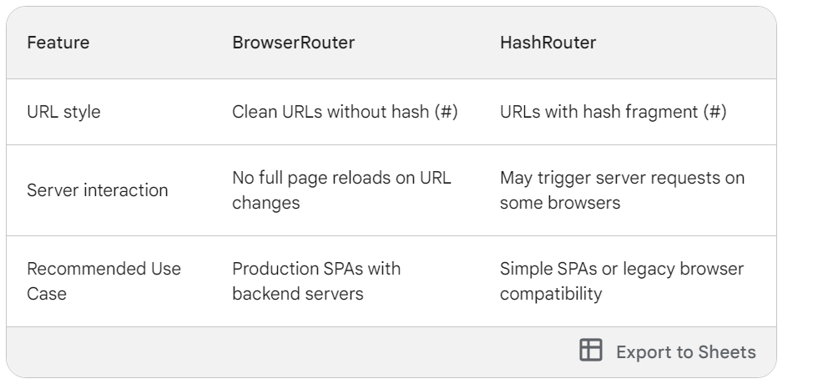

# Express JS:

Node JS framework to develop Rest API server, eazy to connect with Mysql and Mango DB.

npm init -y # Creates a package.json file for package manage

npm install express

**what does pnpm-lock.yaml file do?**

The pnpm-lock.yaml file in a Node.js project using the pnpm package manager serves a similar purpose to package-lock.json in projects using npm or yarn. Here's a breakdown of its role:

**Dependency Lockfile:**

* It's a lockfile that records the exact versions of all dependencies (direct and transitive) used in your project.
* This ensures reproducible builds and deployments, meaning that anyone with the pnpm-lock.yaml file and access to the same package registry can install the exact set of dependencies used in your project.

**Key Functionalities:**

* **Reproducibility:** Guarantees that the same versions of dependencies are installed across different environments, regardless of potential changes in the available package versions on the registry.
* **Consistency:** Ensures consistency between development, testing, and production environments by using the exact set of dependencies specified in the lockfile.
* **Conflict Prevention:** Helps prevent version conflicts by locking down the specific versions of dependencies, avoiding potential issues that might arise from installing incompatible versions.

**Comparison with** package.json**:**

* While package.json specifies the required dependencies and their version ranges (e.g., ^1.2.3), pnpm-lock.yaml captures the exact versions that were actually installed, based on the resolution process and available packages in the registry.

**How** pnpm-lock.yaml **is Generated:**

* Whenever you run pnpm install in your project, pnpm resolves the dependencies, including their transitive dependencies, and creates the pnpm-lock.yaml file. This file reflects the resolved versions based on the version ranges specified in package.json and the available packages in the registry.

**Best Practices:**

* **Version Control:** Always commit pnpm-lock.yaml to your version control system (e.g., Git) alongside your package.json file. This ensures that anyone collaborating on the project can reproduce the exact project environment.
* **Updates:** While the lockfile promotes consistency, you might occasionally need to update dependencies. Use pnpm update to fetch the latest compatible versions within the specified ranges in package.json, and pnpm-lock.yaml will be updated accordingly.

By understanding the role of pnpm-lock.yaml, you can effectively manage dependencies in your Node.js projects using pnpm, ensuring reproducibility, consistency, and conflict prevention across different environments.

**lowdb: A Simple JSON File Database:**

* **Functionality:** Lowdb is a lightweight, in-memory JavaScript library that provides a simple and flexible way to manage data using JSON files as the data store. It offers a convenient wrapper around the JSON object, allowing you to interact with your data programmatically.

**Package:** Lowdb is available as a standalone Node.js package named lowdb. You can install it using npm or yarn: npm install lowdb

**Core Concepts:**

* **Database:** In lowdb, your data is stored in a JSON file. It acts as a simple database where you can create, read, update, and delete data entries.
* **Object:** Lowdb treats your JSON data structure as a JavaScript object. You can access and modify data using familiar object notation.
* **API:** Lowdb provides a simple and intuitive API for interacting with your data. It includes methods for getting, setting, updating, and deleting data.

**Key Advantages:**

* **Lightweight:** Lowdb has a small footprint, making it suitable for projects where performance and resource efficiency are important.
* **Easy to Use:** The API has a low learning curve, making it accessible even for developers less familiar with complex database systems.
* **JSON-Based:** Lowdb uses JSON files as its storage mechanism, which is a human-readable and widely supported format.
* **In-Memory Caching (Optional):** Lowdb can optionally cache data in memory, improving performance for frequently accessed data.

**Typical Use Cases:**

* **Simple configuration management:** Store configuration data (e.g., API keys, application settings) in a JSON file and access it using lowdb.
* **Temporary data storage:** For applications that need to store data temporarily within a session or process, lowdb can be a suitable choice.
* **Prototyping and development:** Lowdb's simplicity allows for quick prototyping and data management during development phases.

**Beyond Just** require("lowdb")

While require("lowdb") imports the core lowdb library, you'll typically use it in conjunction with other lowdb-related packages to create a complete data management solution:

* **lowdb/file-sync:** A lowdb adapter for synchronizing with JSON files on the disk.
* **lowdb/file-async:** Similar to file-sync but uses asynchronous file operations.
* **lowdb/memory:** Stores data entirely in memory (no JSON file).
* **lowdb/adapters:** This package provides adapters for other storage mechanisms (e.g., localStorage, IndexedDB).

# React Forms:

Do more with FormData and FileReader API for file reading and process.

**1. FileReader:**

* **Purpose:** Used for asynchronously reading the contents of a file stored on the user's device.
* **Functionality:**
  + Creates a new FileReader object using const reader = new FileReader();
  + Reads the content of a selected file using methods like readAsText(file), readAsArrayBuffer(file), or readAsDataURL(file).
  + Returns the file content as text, binary data (ArrayBuffer), or a data URL (string containing encoded file data and type), depending on the method used.
  + Useful for processing file content (e.g., displaying an image preview, uploading data to a server)
* **Example:** Used to read a selected image file and display a preview in an <img> element.

**2. FormData:**

* **Purpose:** Used to construct a multipart/form-data object for submitting form data, including files, to a server.
* **Functionality:**
  + Creates a new FormData object using const fileData = new FormData();
  + Allows attaching form data using methods like append(key, value). You can append key-value pairs for text data and use append(key, file, filename) to attach files.
  + The FormData object builds the internal structure for sending form data with proper boundaries and content-type headers for each included item (text or file).
  + Used when submitting form data (including files) using techniques like Ajax or Fetch API.
* **Example:** Used to create a form that allows users to upload a profile picture along with other information (name, email) and submit it to a server for processing.

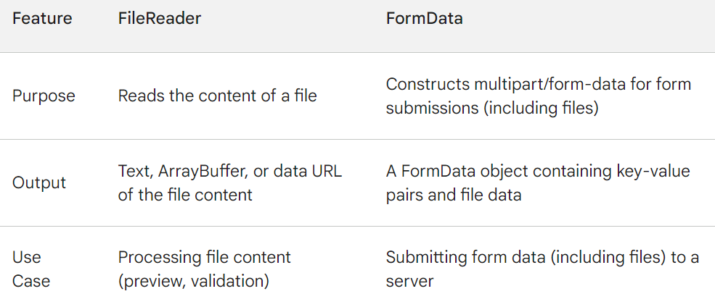

**Choosing the Right Tool:**

* Use FileReader when you need to **read and process the content** of a file on the client-side (e.g., displaying an image preview, validating file type/size).
* Use FormData when you need to **construct and submit form data** (including files) to a server for further processing. FormData ensures proper formatting for multipart form data submissions.

**In Summary:**

* FileReader focuses on reading file content, while FormData focuses on structuring data for form submissions. They can work together in scenarios where you need to process file content before submitting it as part of a form.

## **can append the file read from fileReader to the FormData to send to server**

Yes, you can definitely append the file read from FileReader to a FormData object for sending it to the server. Here's how to achieve that:

**Steps:**

1. **Obtain File Object:**
   * The user selects an image file using an <input type="file"> element.
   * In the onchange event handler for the file input element, access the selected file object using event.target.files[0].
2. **Create** FileReader **and** FormData **Objects:**
   * Create a new FileReader object using const reader = new FileReader();
   * Create a new FormData object using const formData = new FormData();
3. **Read File Content (Optional):**
   * If you need to perform any client-side processing on the image data before sending it to the server, you can use the FileReader to read the content:

JavaScript

reader.readAsDataURL(file); // Read as data URL (encoded image data as a string)

1. **Handle** onload **Event (Optional):**
   * If you performed client-side processing using FileReader, attach an onload event listener to the reader object:

JavaScript

reader.onload = (event) => {

// Process the dataURL (if needed)

const processedDataURL = /* Your processing logic */;

// Use the processedDataURL or the original file object in the next step

};

1. **Append File to FormData:**
   * Once you have the file object (original or processed data URL), use the append method of the FormData object to include the image data:

JavaScript

formData.append('image', file, filename); // Use the original file object

// OR (if using processed dataURL)

formData.append('image', processedDataURL);

* + - Here:
      * 'image' is the key you'll use to access the image data on the server-side. You can choose a more descriptive name if needed.
      * file is the selected file object (if not using dataURL).
      * processedDataURL is the processed data URL string (if used).
      * filename (optional) is the name you want to associate with the file on the server (defaults to the original filename if not provided).

1. **Submit the FormData:**
   * Use techniques like Ajax or Fetch API to send the formData object to your server-side script for further processing.

**Complete Example:**

JavaScript

const fileInput = document.getElementById('image-upload');

const formData = new FormData();

fileInput.onchange = (event) => {

const file = event.target.files[0];

// Check if the file is an image (optional)

if (!file.type.match('image/.*')) {

alert('Please select an image file!');

return;

}

const reader = new FileReader();

// Optionally read as dataURL for client-side processing (comment out if not needed)

reader.readAsDataURL(file);

reader.onload = (event) => {

// Process the dataURL (if needed)

const processedDataURL = /* Your processing logic */;

formData.append('image', processedDataURL); // Use processed dataURL

};

// If not using dataURL processing, directly append the file object

formData.append('image', file, filename);

// Submit the formData using Ajax or Fetch API (code not shown here)

};

**Explanation:**

* This code demonstrates both approaches: appending the original file object and (optionally) appending a processed data URL.
* You can choose the approach that best suits your needs, depending on whether you require any client-side processing before sending the image data.

# Sever Side Rendering V/S Client-Side Rendering :

# Client-side

A client-side route happens when the route is handled internally by the JavaScript that is loaded on the page. When a user clicks on a link, the URL changes but the request to the server is prevented. The adjustment to the URL will result in a changed state of the application. The changed state will ultimately result in a different view of the webpage.

Pros

* Because less data is processed, routing between views is generally faster.
* Smooth transitions and animations between views are easier to implement.

Cons

* The whole website or web-application needs to be loaded on the first request. That’s why the initial loading time usually takes longer.

SSR is a way to render application more efficiently

Server-side rendering is when content on your webpage is rendered on the server and not on your browser using JavaScript.

SSR apps offer faster initial load times and better SEO performance compared to client-side rendered apps, there are some downsides. First, every request leads to a new page being re-rendered from the server to the browser. This means all the scripts, styles, and templates will be reloaded on the browser each time a request is sent to the server, resulting in a poor user experience.

## **What are single-page applications?**

Single-page applications (SPAs), or client-side rendered (CSR) applications, render content in the browser using JavaScript rather than refreshing pages with each request sent to the server. The server sends raw HTML documents while the content is rendered to the HTML document via the browser’s JavaScript.

Server-side rendering initially means every page is rendered and loaded from the server.

As we covered in this post, the benefits include:

1. Performance
2. Search engine visibility
3. User experience
4. Social sharing

## React SSR frameworks:

### Next.js

[Next.js](https://nextjs.org/) is a great framework with a robust community. Next.js offers a lot of inbuilt features and you don’t have to worry about bundling, minification, or hot reloading. You are able to create pages as React components within files.

### Razzle

[Razzle](https://github.com/jaredpalmer/razzle), a project by Jared Palmer, has been gaining a lot of traction lately. From [its GitHub page](https://github.com/jaredpalmer/razzle):

*“Razzle is a tool that abstracts all complex configuration needed for SSR into a single dependency — giving you the awesome developer experience of*[*create-react-app*](https://github.com/facebookincubator/create-react-app)*, but then leaving the rest of your app’s architectural decisions about frameworks, routing, and data fetching up to you.”*

It’s easy to get started with Razzle, and it uses React Router 4 by default (unlike Next.js, which does not have an inbuilt router).

### Remix

[Remix](https://remix.run/) is a React framework with server-side rendering, easy data fetching and mutations, and resilient developer experience which makes it easy to build web applications with great user experience.

[Remix provides quick page loads and fluid transitions](https://blog.logrocket.com/remix-guide-newly-open-sourced-react-framework/) by utilizing distributed systems and native browser features rather than clumsy static builds. Because it uses the Web Fetch API rather than Node, it can run everywhere.